Jerry  
  
Space windmills  
<https://editor.p5js.org/Jerry-812/sketches/0ZU7zSW4f>  
  
Evolution process of universe  
  
Instructions  
Click on the mouse to explore  
  
In this sketch, i used the image of windmills to simulate the process of the Big Bang.

The Big Bang event is a physical theory that describes how the universe expanded from an initial state of high density and temperature. From this, i created the process as a burst from inner space to outer one. As is known to all, before the Big Bang happened, the universe what we know today did not exist. So, i thought the whole things should be in a background which is completely blank and empty. Therefore, i used the white background and an imagined image of Big Bang(fake). As soon as it boomed, there emerged many galaxies-which i used windmills to represent. So, the second scene is about the instant that the explosion happened, and the galaxies are rotating around the core of the universe.

After this moment the galaxies started to travel out, but i don’t want to let them disappear, so i use the function bounce to keep them staying . Also, i set the transparency for the windmills to track their movements. And in each galaxy, there are many planets rotating around one planet. While each planet may have their own targets, so i tried to express this idea. I let my windmills target randomly, a crazy attempt. Moreover, the planets are rotating all their lives, and when they are going to the end of their life, they breaks, so i use a beautiful image as the symbol of their endings-the meteors. When we are waiting the meteors passing by, the passage can be directly felt. It’s a meaningful scene for me, because when i think about time, i usually there are still a lot of time. But the ten seconds for the complete collapse of a planet teach me that life is short. When everything fades away, then it’s time for the END.

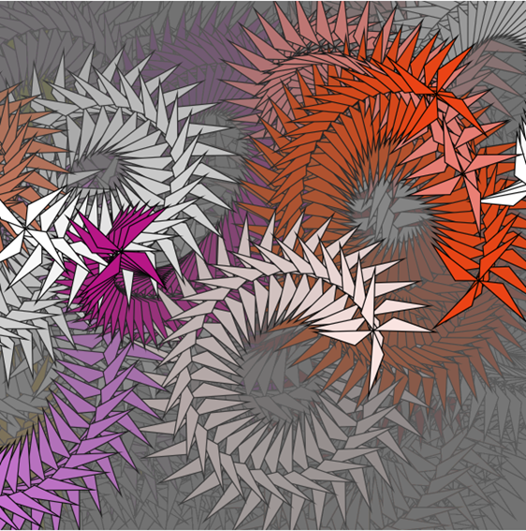

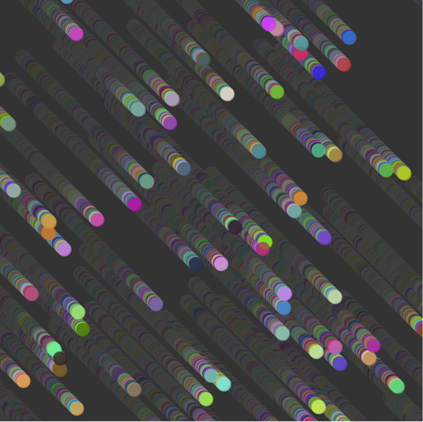

the instant of the bombing

the targeting of galaxies

the meteors