Assignment1代码修改文件记录
目录
1.文件名称不对应 1
2.训练代码中调用函数格式不对 2
3.模型中位置编码矩阵维度写反 3
4.train.py不支持none 5
5. context 的 word/char embedding 调用写反 6
6.shape weight相关的一系列问题 7
1）报错1shape invalid for input size 7
4）报错2 size of tensor must match 11
7.norms越界bug 15
8. Pointer Head Dimension Misalignment Fix 16
9.loss.py相关报错 17
10.train_utils.py相关报错 19
11.学习率为0的问题 21
12. lambda_scheduler.py 学习率倍率逻辑错误 23
13.lambda_scheduler 不可序列化，导致 checkpoint 保存失败 24
14. save_checkpoint() 对 scheduler 保存不够鲁棒 24
15. Models/dropout.py 的缩放分母错误 24
16. 评估脚本和你现在保存下来的 checkpoint 格式不匹配，再加上 PyTorch 2.6 的 torch.load() 默认行为改变 25

1.文件名称不对应
1）报错位置：FileNotFoundError: No such file or directory:
'/content/drive/MyDrive/Assignment1_2026'

2）修改：“_”->”--”


3）Report可写
Bug: Incorrect project root directory path

Issue:
The notebook attempted to change directory to
'/content/drive/MyDrive/Assignment1_2026', which does not exist.

Cause:
Mismatch between the cloned repository name
('Assignment1--2026') and the hardcoded path.

Fix:
Updated PROJECT_ROOT to the correct directory path.

Impact:
Prevented execution failure during environment setup.

2.训练代码中调用函数格式不对
1）报错信息
TypeError Traceback (most recent call last) /tmp/ipykernel_31048/3063408844.py in <cell line: 0>() 1 from TrainTools.train import train 2 ----> 3 results = train( 4 # ── data paths (must match preprocess outputs) ────────────────────── 5 train_npz = "_data/train.npz", /content/drive/MyDrive/Assignment1--2026/TrainTools/train.py in train(train_npz, dev_npz, word_emb_json, char_emb_json, train_eval_json, dev_eval_json, save_dir, log_dir, ckpt_name, batch_size, num_steps, checkpoint, val_num_batches, test_num_batches, seed, grad_clip, early_stop, optimizer_name, scheduler_name, loss_name, norm_name, norm_groups, learning_rate, beta1, beta2, eps, weight_decay, momentum, lr_step_size, lr_gamma, para_limit, ques_limit, char_limit, d_model, num_heads, glove_dim, char_dim, dropout, dropout_char, pretrained_char, use_batch_norm, activation, init_name) 105 106 # Internal namespace required by QANet.__init__ and data utilities --> 107 args = argparse.Namespace({k: v for k, v in locals().items()}) 108 109 with open(os.path.join(save_dir, "run_config.json"), "w") as f: TypeError: Namespace.__init__() takes 1 positional argument but 2 were given

2）修改：找到TrainTool文件中train.py文件对应代码行，添加“**”

3）Report可写
Bug: Incorrect usage of argparse.Namespace

Issue:
The code attempts to initialize Namespace using a dictionary:
argparse.Namespace({...}), which is not supported.

Cause:
Namespace expects keyword arguments rather than a positional dictionary.

Fix:
Replaced with:
argparse.Namespace(**dict)

Impact:
Resolved runtime error and enabled the training pipeline to proceed.

3.模型中位置编码矩阵维度写反
1）报错信息
位置：Models/encoder.py
报错：pe = torch.sin(pos * freqs + phases)
RuntimeError: The size of tensor a (400) must match the size of tensor b (96) at non-singleton dimension 1
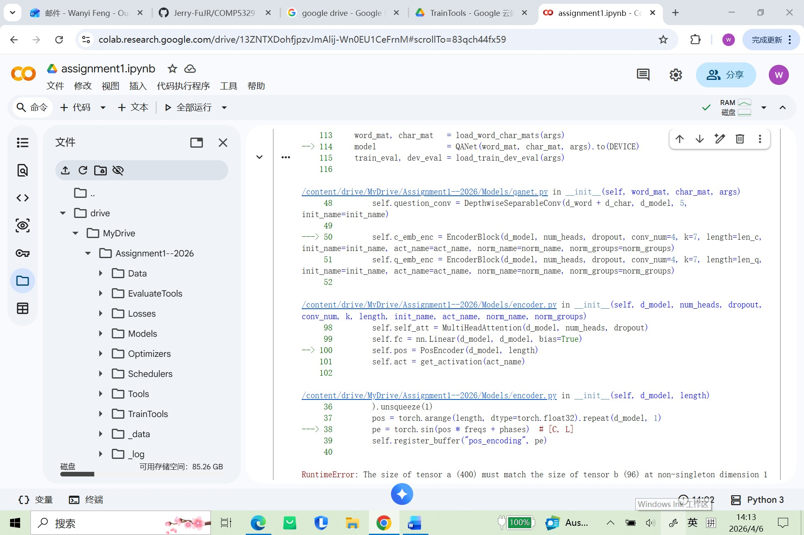

2）修改
本来应该做成 [d_model, length] 或 [length, d_model] 的地方，某一步把行列弄混了。
从这：
- length = 400
- d_model = 96
所以：
- 400 很像序列长度
- 96 很像 hidden size / model dimension
现在代码里这两者被错误地放在了同一个维度上.
将freqs = torch.tensor(
[10000 ** (-i / d_model) if i % 2 == 0 else -10000 ** ((1 - i) / d_model) for i in range(d_model)],
dtype=torch.float32
).unsqueeze(0) # [C, 1]代码中的unsqueeze（0）改成unsqueeze（1）

3）report可写
Bug: incorrect tensor shape construction in positional encoding

Issue: the positional encoding computation attempted element-wise operations on tensors with incompatible shapes, causing a runtime failure during model initialization.

Cause: the position tensor and frequency tensor were constructed with inconsistent dimension ordering, mixing sequence length and model dimension.

Fix: rewrote positional encoding using the standard sinusoidal formulation with explicit [length, d_model] construction, then transposed when needed to match the model’s internal tensor layout.

Impact: resolved initialization failure and ensured positional information is injected with the correct dimensional semantics.

4.train.py不支持none
1）报错信息
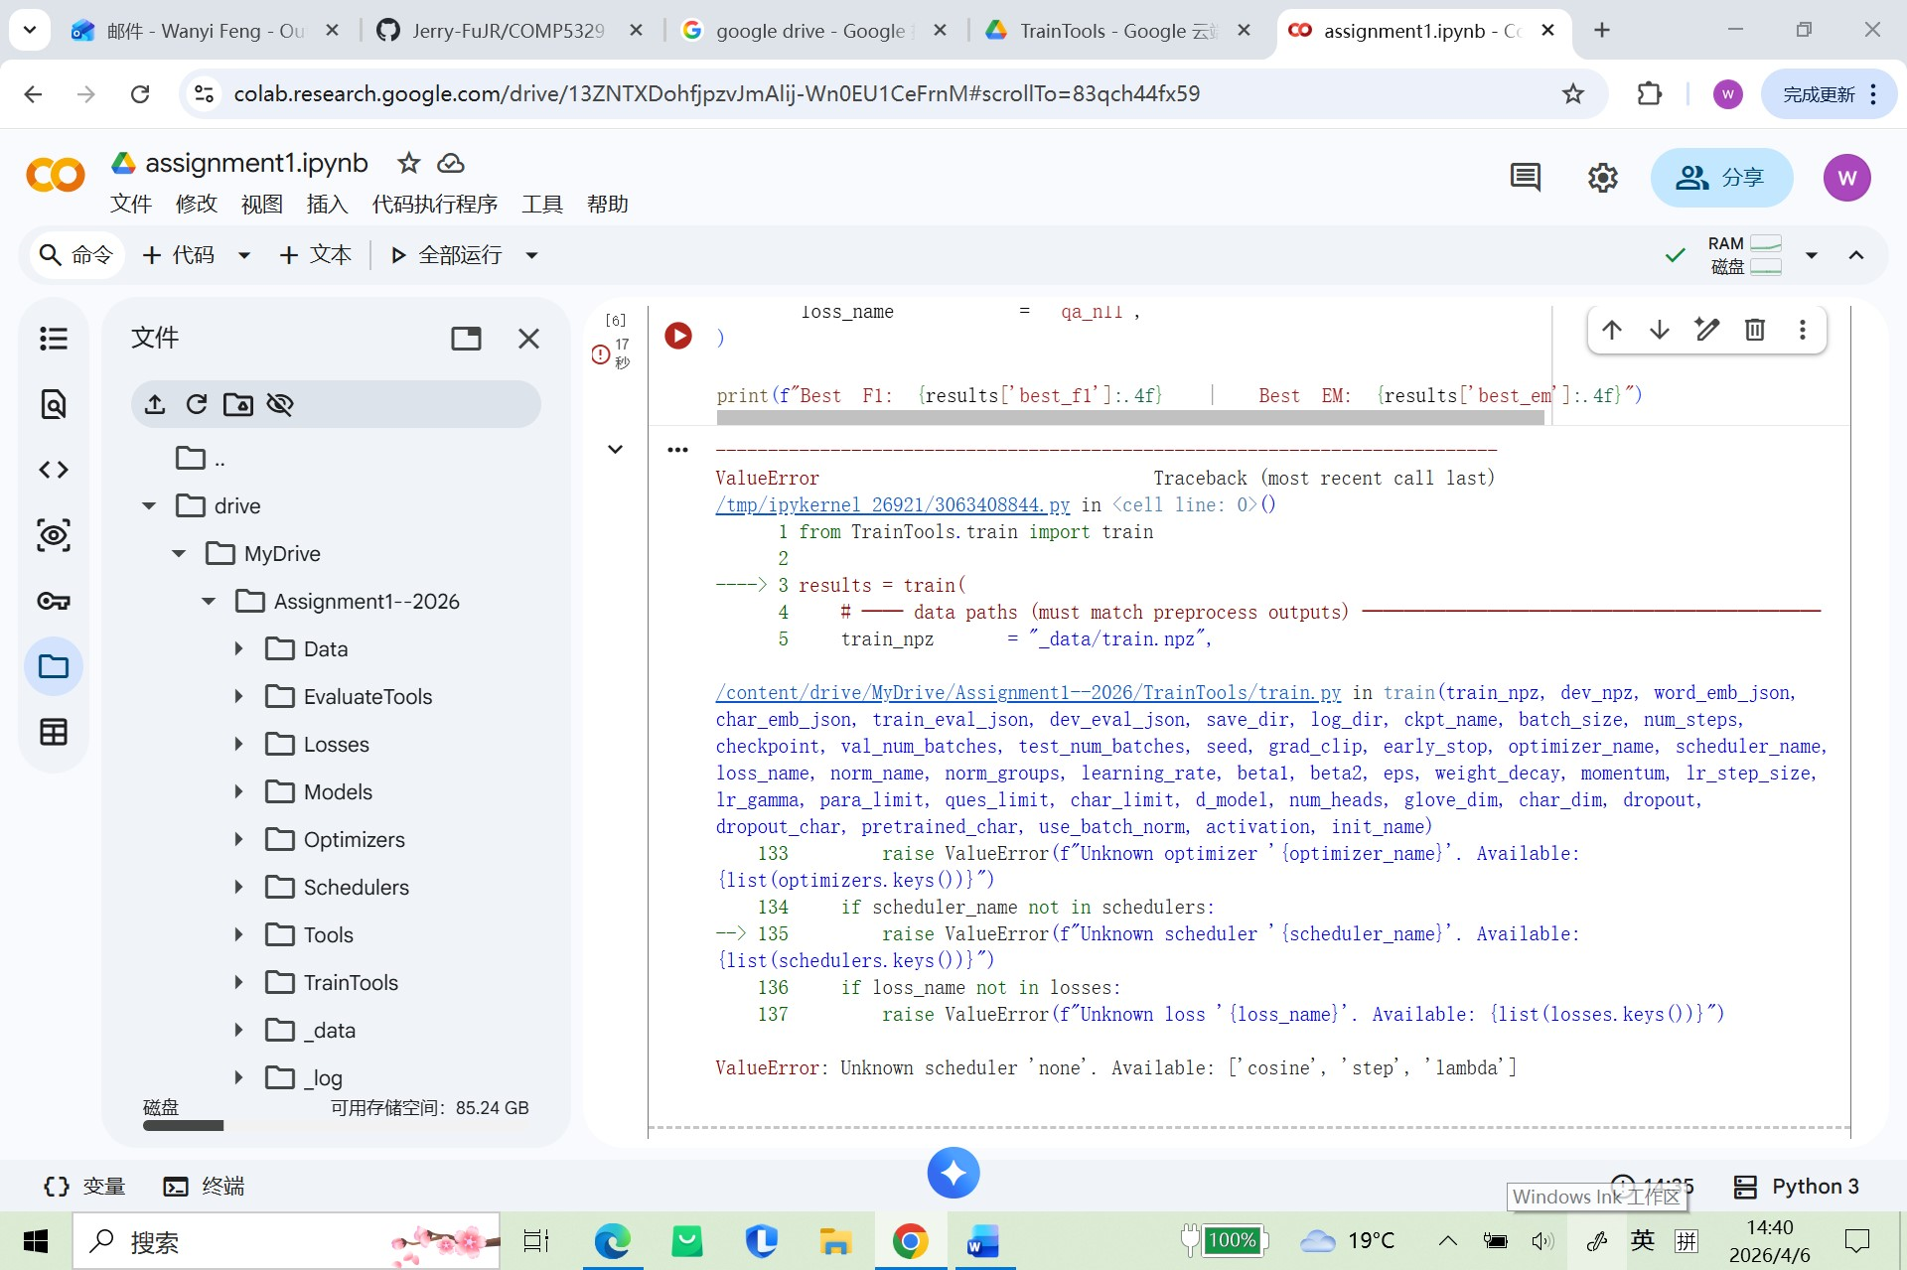

2）原因&修改
这个项目的 train.py 实际并没有注册 "none" 这个选项，只支持：
- "cosine"
- "step"
- "lambda"
先暂时将none改为step

3）report内容
Bug: unsupported scheduler option in notebook configuration

Issue: the training notebook used scheduler_name="none", but the training framework only recognized cosine, step, and lambda.

Cause: inconsistency between the notebook example and the scheduler registry implemented in the training pipeline.

Fix: replaced "none" with a supported scheduler option ("step") to allow training to proceed.

Impact: resolved configuration validation failure and enabled the training loop to start.

5. context 的 word/char embedding 调用写反
1）报错信息
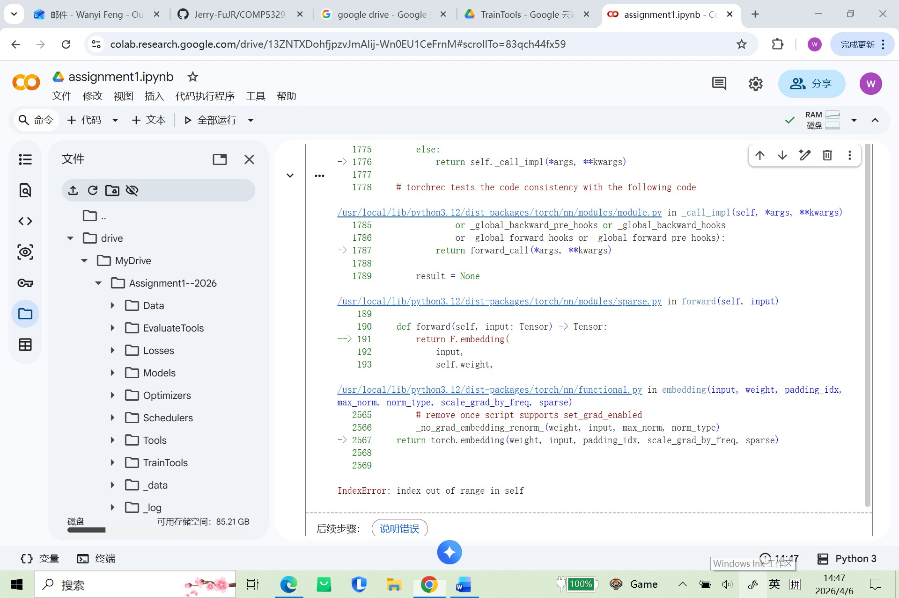

2）原因&修改
在 Models/qanet.py 的 forward() 里，context 的 word/char embedding 调用写反了。
traceback 里这一行最关键：
Cw, Cc = self.char_emb(Cwid), self.word_emb(Ccid)
这里有两个输入：
- Cwid = context word ids
- Ccid = context char ids
但代码却写成了：
- 用 char_emb 去吃 Cwid ❌
- 用 word_emb 去吃 Ccid ❌
这就会导致：
- Cwid 里的 id 往往很大（因为 word vocab 很大）
- char_emb 的词表通常很小（char vocab 小很多）

将/content/drive/MyDrive/Assignment1--2026/Models/qanet.py中的Cw, Cc = self.char_emb(Cwid), self.word_emb(Ccid)改为Cw, Cc = self.word_emb(Cwid), self.char_emb(Ccid)
3）report
Bug: swapped word and character embedding inputs in QANet forward pass

Issue: the model applied character embedding to context word indices and word embedding to context character indices, causing an index-out-of-range error in the embedding layer.

Cause: incorrect argument-to-embedding mapping in the context branch of the forward function.

Fix: changed the context embedding line from
self.char_emb(Cwid), self.word_emb(Ccid)
to
self.word_emb(Cwid), self.char_emb(Ccid).

Impact: restored correct embedding lookup behavior and allowed the forward pass to proceed beyond the embedding stage.

6.shape weight相关的一系列问题

1）报错1shape invalid for input size
Models/conv.py 里的自定义 2D 卷积把卷积核强行当成正方形处理了，所以在 reshape weight 时报错。traceback 已经显示错误发生在 conv.py 第 141 行：它试图把权重 reshape 成 [1, 64, 16, 1, 1]，但实际权重总元素有 4096 个，根本对不上
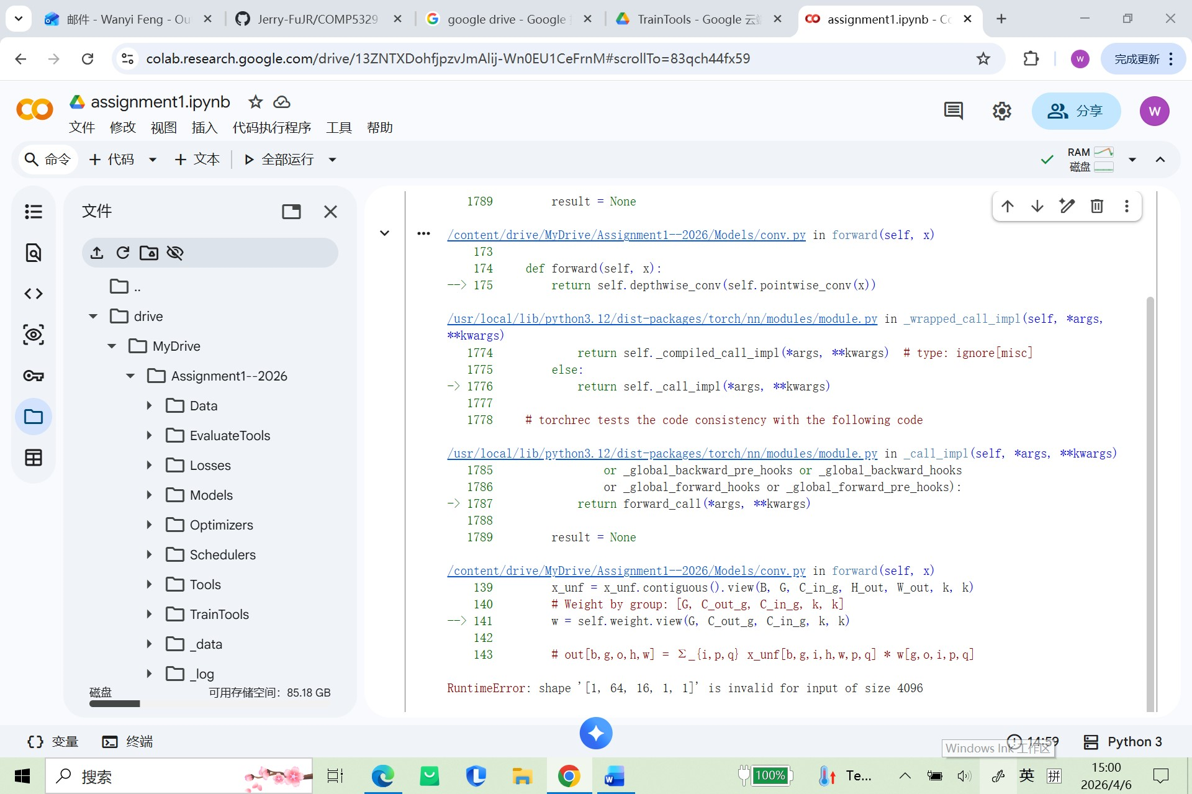

2）原因&修改
原因1
这里用了：
H
但此时 x 已经变了！
因为前面你已经做了：
x = torch.cat([pad_h, x, pad_h], dim=2)
所以现在：
x.shape = [B, C_in, H+2p, W]
但你还在用旧的 H 去 pad width：
👉 这会导致 padding tensor 尺寸不匹配
👉 后面 unfold → reshape → einsum 全部错位
👉 最终爆出：
shape '[1, 64, 16, 1, 1]' is invalid for input of size 4096

改1：将/content/drive/MyDrive/Assignment1--2026/Models/conv.py 中的pad_w = x.new_zeros(B, C_in, H, p)改为pad_w = x.new_zeros(B, C_in, x.size(2), p)

改2：把 separable conv 的执行顺序改回理论上正确的：
逐通道卷积（depthwise）→ 1x1混合通道（pointwise）

改3：因为 Conv1d 的输入注释写的是：
# x: [B, C_in, L]
也就是说：
- 第 0 维：batch
- 第 1 维：channel
- 第 2 维：length
卷积滑窗应该沿着 length 维 滑，也就是 dim=2，不是 dim=1。
所以这里应该改成：
x_unf = x.unfold(2, self.kernel_size, 1)

改4：因为原始 ch_emb 是：
[B, L, char_len, d_char]
维度编号是：
- 0 = B
- 1 = L
- 2 = char_len
- 3 = d_char
所以 permute(0, 2, 1, 3) 变成：
- 0 -> B
- 2 -> char_len
- 1 -> L
- 3 -> d_char
得到的是：
[B, char_len, L, d_char]
在embedding.py中改成ch_emb = ch_emb.permute(0, 3, 1, 2)

改5：def forward(self, x: torch.Tensor) -> torch.Tensor:
# x: [B, C, L] -> [B, L, C]
x = x.transpose(0, 2)
这里注释说想从 [B, C, L] 变成 [B, L, C]，
但 transpose(0, 2) 实际会变成：
[L, C, B]
这当然会把 batch 维和 length 维搅乱，最后线性层看到的最后一维就不再是 C=364 了
x = x.transpose(0, 2)改成x = x.transpose(1, 2)

3）report
during the debugging process of the training pipeline, multiple implementation errors were identified across convolution, embedding, and feature transformation modules. These issues caused tensor shape mismatches, incorrect feature representations, and runtime failures.
This section documents five critical bugs, their causes, fixes, and impacts on the system.
Bug 1 – Incorrect Padding Dimension in Conv2d
Issue
In Models/conv.py, the width padding was constructed using the original height:
pad_w = x.new_zeros(B, C_in, H, p)
However, the tensor had already been padded along the height dimension, so H was outdated.
Cause
Failure to update tensor dimensions after intermediate padding operations.
Fix
pad_w = x.new_zeros(B, C_in, x.size(2), p)
Impact
This fix ensured consistent tensor dimensions during padding and prevented downstream shape mismatches in convolution operations.
Bug 2 – Incorrect Order in Depthwise Separable Convolution
Issue
The forward pass applied pointwise convolution before depthwise convolution:
return self.depthwise_conv(self.pointwise_conv(x))
Cause
Incorrect implementation order of depthwise separable convolution.
Fix
return self.pointwise_conv(self.depthwise_conv(x))
Impact
Restored the correct convolution sequence:
- Depthwise convolution (channel-wise feature extraction)
- Pointwise convolution (channel mixing)
This prevented channel inconsistency and invalid tensor reshaping.
Bug 3 – Wrong Dimension for Sliding Window in Conv1d
Issue
In Conv1d.forward(), unfolding was performed along the channel dimension:
x_unf = x.unfold(1, self.kernel_size, 1)
Cause
Misinterpretation of tensor layout [B, C, L].
Fix
x_unf = x.unfold(2, self.kernel_size, 1)
Impact
Corrected the sliding window to operate along the sequence (length) dimension, ensuring valid convolution behavior.
Bug 4 – Incorrect Permutation of Character Embedding
Issue
Character embeddings were permuted incorrectly:
ch_emb = ch_emb.permute(0, 2, 1, 3)
This resulted in shape:
[B, char_len, L, d_char]
instead of the expected:
[B, d_char, L, char_len]
Cause
Incorrect ordering of tensor dimensions during permutation.
Fix
ch_emb = ch_emb.permute(0, 3, 1, 2)
Impact
Restored correct channel placement for convolution layers, preventing group convolution failures and index errors.
Bug 5 – Incorrect Transpose in Highway Network
Issue
The Highway network attempted to convert [B, C, L] to [B, L, C] using:
x = x.transpose(0, 2)
This actually produced:
[L, C, B]
Cause
Incorrect selection of axes in transpose operation.
Fix
x = x.transpose(1, 2)
Impact
Ensured that the last dimension matched the expected feature size (d_word + d_char), allowing linear layers to operate correctly and eliminating matrix multiplication errors.

Summary
These fixes addressed multiple categories of implementation errors:
Category | Issue Type
Tensor shape handling | Padding and permutation errors
Convolution logic | Incorrect kernel application and dimension selection
Model architecture | Incorrect layer execution order
Feature transformation | Incorrect tensor reshaping in Highway network
Collectively, these corrections restored consistency in tensor dimensions across modules and enabled the training pipeline to progress beyond initial runtime failures.

4）报错2 size of tensor must match
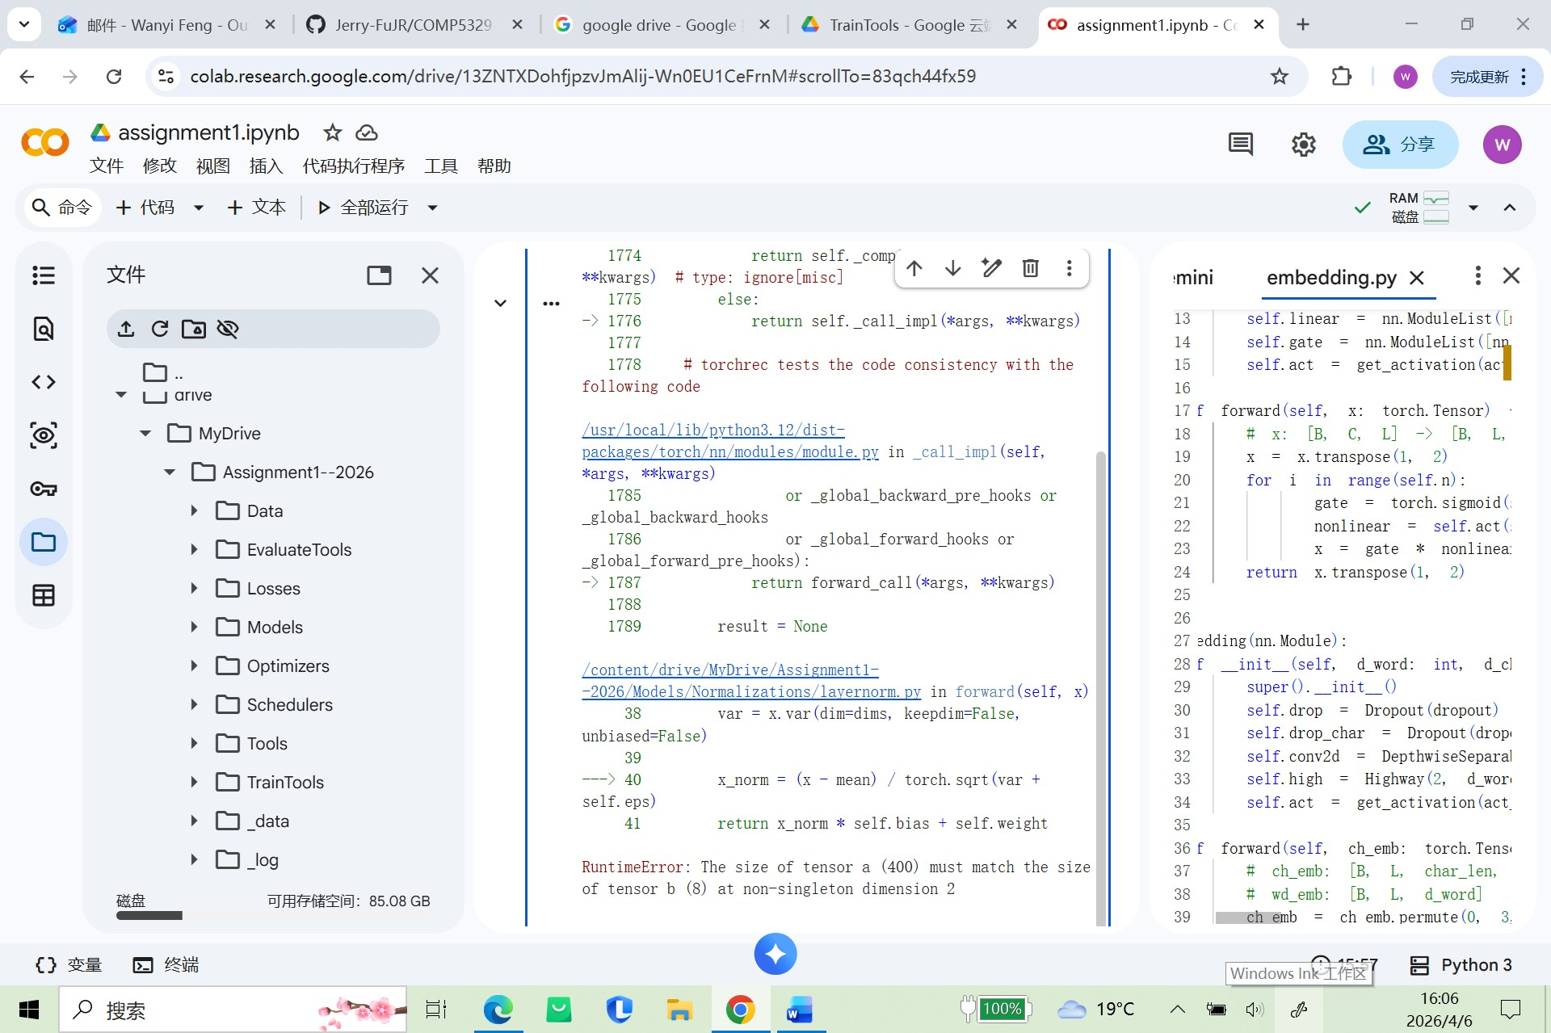
5）原因&修改
原因1：如果 x 是 [B, C, L]，你按某些维度求均值后：
- keepdim=False 会把那些维度“压没”
- keepdim=True 会保留成长度 1 的维度
这样才能正确广播回原 tensor。
例如：
x: [8, 96, 400]
mean: [8, 1, 1] 或 [8, 96, 1] 等
然后：
x - mean
才合法。

traceback 里返回行是：
return x_norm * self.bias + self.weight
这通常也写反了。
标准 affine layer norm 一般应该是：
return x_norm * self.weight + self.bias

修改1：file_path = "/content/drive/MyDrive/Assignment1--2026/Models/Normalizations/layernorm.py"
with open(file_path, "r", encoding="utf-8") as f:
code = f.read()
code = code.replace(
"mean = x.mean(dim=dims, keepdim=False)",
"mean = x.mean(dim=dims, keepdim=True)"
)
code = code.replace(
"var = x.var(dim=dims, keepdim=False, unbiased=False)",
"var = x.var(dim=dims, keepdim=True, unbiased=False)"
)
code = code.replace(
"return x_norm * self.bias + self.weight",
"return x_norm * self.weight + self.bias"
)
with open(file_path, "w", encoding="utf-8") as f:
f.write(code)

原因2：在 CQAttention 里：
- S 一般是相似度矩阵，形状像 [B, Lc, Lq]
- cmask 一般是 [B, Lc]
- qmask 一般是 [B, Lq]
所以不能直接把 [B, Lq] 或 [B, Lc] 拿去 masked_fill 一个三维张量，必须先扩维

如果：
S.shape = [B, Lc, Lq]
那么：
给 qmask 用在 S1
应该变成：
[B, 1, Lq]
也就是：
qmask.unsqueeze(1)
这样会沿 Lc 维自动广播。
给 cmask 用在 S2
应该变成：
[B, Lc, 1]
也就是：
cmask.unsqueeze(2)
这样会沿 Lq 维自动广播。

修改2：
在/content/drive/MyDrive/Assignment1--2026/Models/attention.py中将S1 = F.softmax(mask_logits(S, qmask), dim=2)
S2 = F.softmax(mask_logits(S, cmask), dim=1)改为S1 = F.softmax(mask_logits(S, qmask.unsqueeze(1)), dim=2)
S2 = F.softmax(mask_logits(S, cmask.unsqueeze(2)), dim=1)

原因3：
看 traceback：
X = self.cq_att(Ce, Qe, qmask, cmask)
而 attention.py 的 forward 签名是：
def forward(self, C, Q, cmask, qmask)
也就是说它期望的是：
self.cq_att(Ce, Qe, cmask, qmask)
但现在实际传的是：
self.cq_att(Ce, Qe, qmask, cmask)
所以在 attention.py 里：
- cmask 实际拿到的是 qmask，长度 50
- qmask 实际拿到的是 cmask，长度 400
然后你又做了：
qmask.unsqueeze(1)
cmask.unsqueeze(2)
结果就变成拿错了对象去广播，于是又报：
- 400
- 50
维度不匹配。

CQAttention.forward(self, C, Q, cmask, qmask) 的逻辑一般是：
- C 长度 = Lc = 400
- Q 长度 = Lq = 50
- cmask 应该对应 C
- qmask 应该对应 Q
所以：
S.shape = [B, Lc, Lq] = [B, 400, 50]
配套 mask 必须是：
- qmask.unsqueeze(1) → [B, 1, 50]
- cmask.unsqueeze(2) → [B, 400, 1]

原因4：在 Models/attention.py 的 forward(self, C, Q, cmask, qmask) 里，
你大概率有类似下面这种代码：
C = C.transpose(0, 2)
Q = Q.transpose(0, 2)
或者别的把 batch 维参与交换的写法。
如果原始 C, Q 是：
[B, C, L]
那要变成做 attention 常用的：
[B, L, C]
正确写法应该是：
C = C.transpose(1, 2)
Q = Q.transpose(1, 2)
不是 transpose(0, 2)。

修改4：file_path = "/content/drive/MyDrive/Assignment1--2026/Models/attention.py"
with open(file_path, "r", encoding="utf-8") as f:
code = f.read()
code = code.replace(
"S1 = F.softmax(mask_logits(S, qmask.unsqueeze(1)), dim=2)",
"S1 = F.softmax(mask_logits(S, qmask), dim=2)")
code = code.replace(
"S2 = F.softmax(mask_logits(S, cmask.unsqueeze(2)), dim=1)",
"S2 = F.softmax(mask_logits(S, cmask), dim=1)")
code = code.replace(
"A = torch.bmm(Q, S1)",
"A = torch.bmm(S1, Q)")
with open(file_path, "w", encoding="utf-8") as f:
f.write(code)

6）report
Report1
Bug: incorrect broadcasting in custom layer normalization
Issue: mean and variance were computed with keepdim=False, which removed normalized dimensions and caused broadcasting failure during normalization.
Cause: the custom LayerNorm implementation did not preserve reduced dimensions for subsequent tensor arithmetic.
Fix: changed mean/variance computation to keepdim=True and corrected the affine transformation to x_norm * weight + bias.
Impact: restored valid normalization behavior and allowed the encoder block to proceed.

Report2
Bug: incorrect mask broadcasting in context-query attention
Issue: the attention score matrix had shape [B, Lc, Lq], but the context and question masks were applied without reshaping, causing dimension mismatch during masking.
Cause: the implementation passed 2D masks directly into masked_fill for a 3D attention tensor.
Fix: reshaped the masks using qmask.unsqueeze(1) and cmask.unsqueeze(2) before applying mask_logits.
Impact: restored correct masking behavior for attention scores and allowed the attention module to run correctly.

Report3
Bug: swapped context and question masks in context-query attention call
Issue: the QANet forward pass passed qmask and cmask in reversed order to the context-query attention module, causing dimension mismatch during attention masking.
Cause: inconsistency between the function signature of CQAttention.forward(C, Q, cmask, qmask) and the actual call site.
Fix: changed the call from
self.cq_att(Ce, Qe, qmask, cmask)
to
self.cq_att(Ce, Qe, cmask, qmask).
Impact: restored correct mask alignment for the attention score matrix and resolved the runtime broadcasting error.

Report4
Bug 1: redundant mask expansion in attention masking
Fix: removed the second unsqueeze when applying cmask and qmask to the similarity matrix.
Bug 2: incorrect batch matrix multiplication order in context-query attention
Fix: changed torch.bmm(Q, S1) to torch.bmm(S1, Q) so that the tensor dimensions align and the attended query representation has shape [B, Lc, C].

7.norms越界bug
1）报错信息
IndexError: index 4 is out of range
出现在：out = self.norms[i + 1](out)
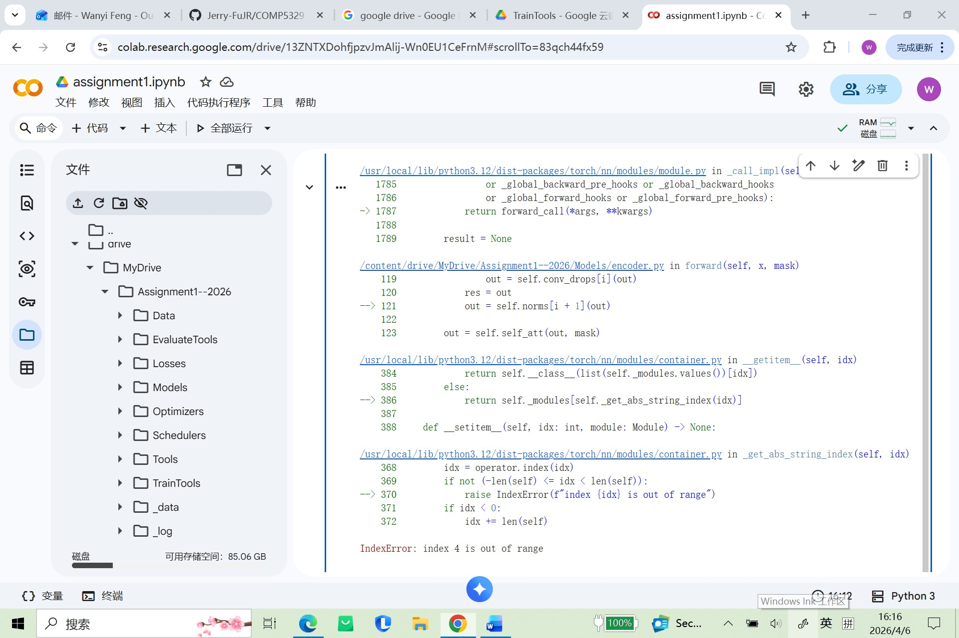
2）原因&修改
这个结构是：
self.norms = nn.ModuleList([...]) # 长度 = conv_num
然后循环：
for i, conv in enumerate(self.convs):
👉 i 的范围是：
0, 1, 2, ..., conv_num-1
❌ 但你用了：
self.norms[i + 1]
最后一次循环：
i = conv_num - 1
i + 1 = conv_num ❌ 越界

将encoder.py里的out = self.norms[i + 1](out)改为out = self.norms[i](out)

3）report
Bug: index out-of-range error in normalization layer access
Issue: the code accessed self.norms[i + 1] inside a loop over convolution layers, causing an index overflow at the last iteration
Cause: mismatch between the number of normalization layers and the indexing strategy
Fix: replaced self.norms[i + 1] with self.norms[i]
Impact: eliminated runtime crash and ensured proper alignment between convolution and normalization layers

8. Pointer Head Dimension Misalignment Fix
1）报错信息
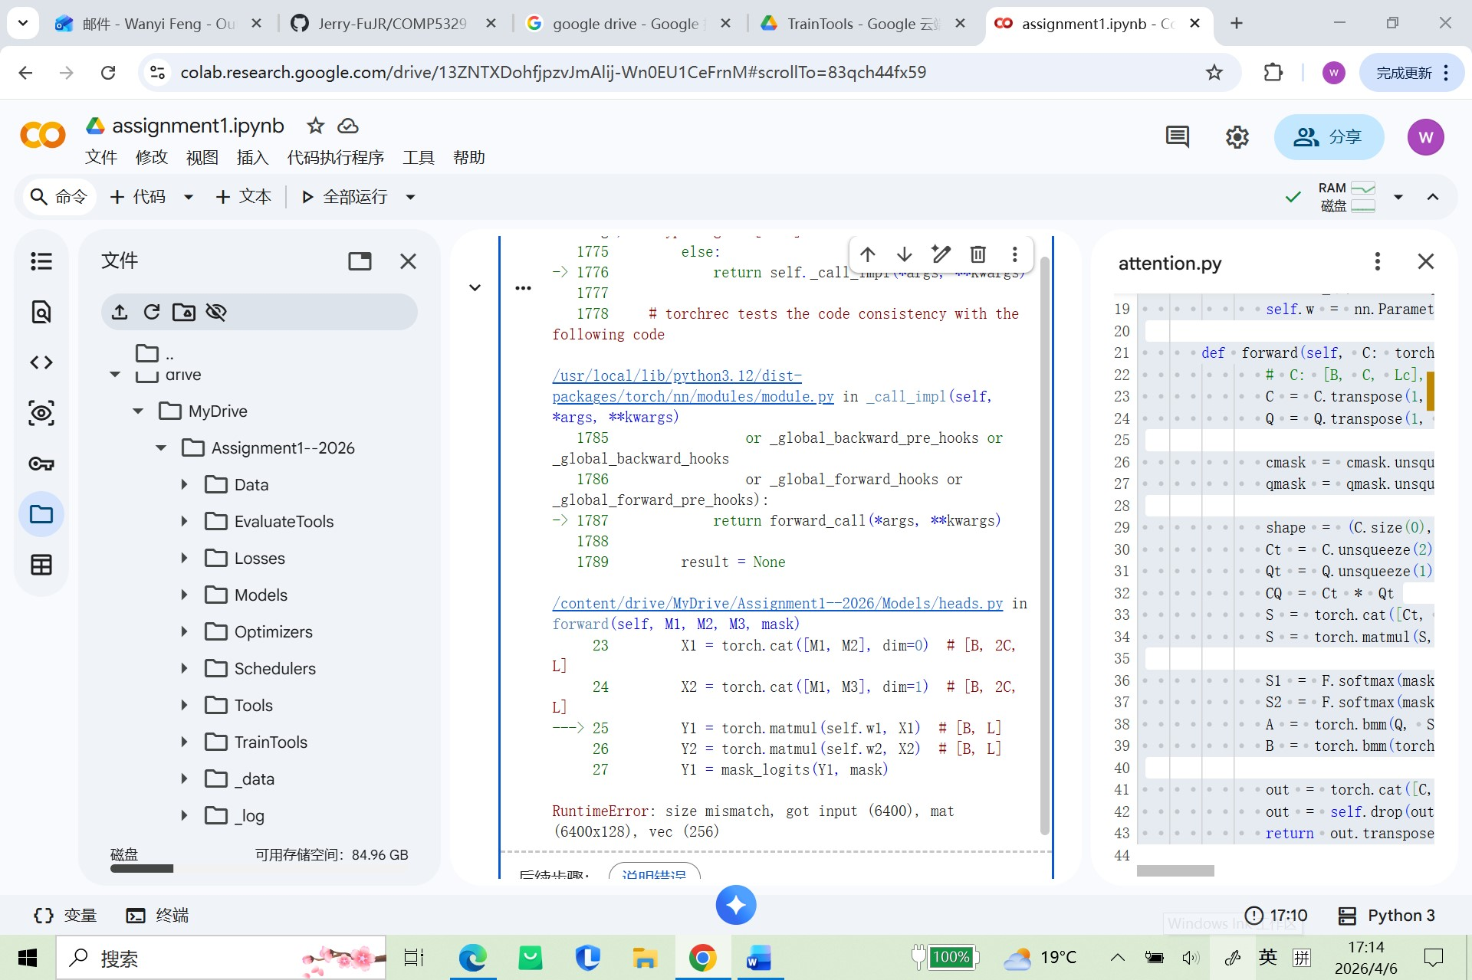
2）原因&修改
Bug 1：X1 拼接维度写错
现在是：
X1 = torch.cat([M1, M2], dim=0) # [B, 2C, L]
但如果 M1 和 M2 都是 [B, C, L]，那么：
- dim=0 会得到 [2B, C, L]
- 不可能得到注释写的 [B, 2C, L]
所以这行和注释自相矛盾，说明这里就是 bug。
正确应该是
X1 = torch.cat([M1, M2], dim=1) # [B, 2C, L]
第二行 X2 = torch.cat([M1, M3], dim=1) 反而是合理的。

Bug 2：torch.matmul(self.w1, X1) 的方向不合理
当前：
Y1 = torch.matmul(self.w1, X1) # [B, L]
Y2 = torch.matmul(self.w2, X2) # [B, L]
先看 shape：
- self.w1: [2C]
- X1: [B, 2C, L]
想得到 [B, L]，最自然的方式是：
- 先把 X1 转成 [B, L, 2C]
- 再和 [2C] 做点积
也就是：
Y1 = torch.matmul(X1.transpose(1, 2), self.w1) # [B, L]
Y2 = torch.matmul(X2.transpose(1, 2), self.w2) # [B, L]
这样维度是通的：
- X1.transpose(1, 2): [B, L, 2C]
- self.w1: [2C]
- 输出：[B, L]
这也和注释目标一致。

3）report
Bug 1: incorrect concatenation dimension in pointer head
The code concatenated M1 and M2 along dim=0, which doubled the batch dimension instead of the channel dimension. This contradicted the intended tensor shape [B, 2C, L]. The fix was to change concatenation to dim=1.
Bug 2: incorrect projection direction in pointer head
The code applied torch.matmul(self.w1, X1) directly, which was inconsistent with the intended score computation over the channel dimension. The fix was to transpose X1 and X2 to shape [B, L, 2C] and then apply the learned vectors w1 and w2 to obtain logits of shape [B, L].

9.loss.py相关报错
1）报错信息
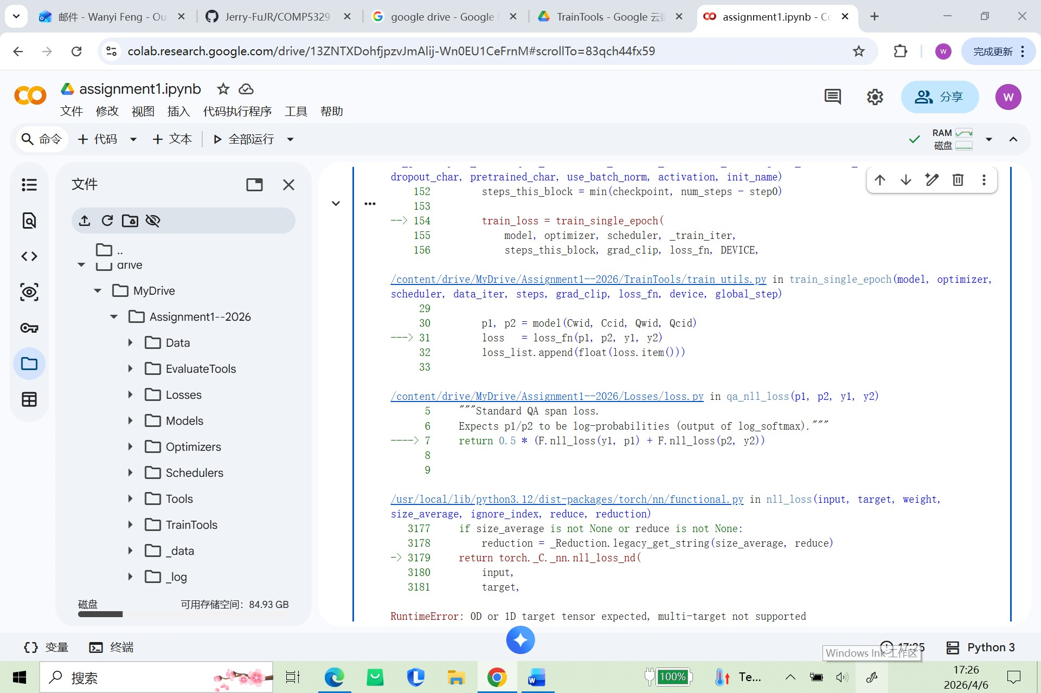
2）原因及修改
该报错来自 Losses/loss.py 中的 qa_nll_loss() 函数。原始代码写成了：
F.nll_loss(y1, p1)
但是 F.nll_loss() 的正确参数顺序应该是：
F.nll_loss(input, target)
其中：
- input 应该是模型输出的预测张量
- target 应该是正确标签索引
在问答任务中，p1 是答案起始位置的预测分布，y1 是真实起始位置索引。原代码把二者顺序写反了，导致 PyTorch 误把二维预测张量 p1 当成 target，因此报出 “multi-target not supported” 的错误。

3）report
1. Error Message
The training pipeline failed with the following runtime error during the forward-loss stage:
RuntimeError: 0D or 1D target tensor expected, multi-target not supported
The traceback showed that the error originated from the QA loss function defined in Losses/loss.py, specifically in the call to F.nll_loss().
2. Cause
This bug was caused by an incorrect argument order in the start-position loss computation. The original implementation was:
return 0.5 * (F.nll_loss(y1, p1) + F.nll_loss(p2, y2))
In PyTorch, F.nll_loss() must be called as:
F.nll_loss(input, target)
In the QA task, p1 is the model’s predicted log-probability tensor over context positions, while y1 is the gold index of the correct answer start position. The original code reversed these roles and used the target tensor as the model input. Consequently, the prediction tensor p1, which has two dimensions, was incorrectly interpreted as a target tensor. Because nll_loss only accepts scalar or 1D target tensors, the program raised a runtime error.
This bug prevented the training pipeline from computing the loss correctly, which in turn blocked gradient backpropagation and parameter updates.
3. Fix
The incorrect line was corrected to:
return 0.5 * (F.nll_loss(p1, y1) + F.nll_loss(p2, y2))
This change ensures that:
- p1 and p2 are used as prediction tensors
- y1 and y2 are used as target index tensors
After this fix, the loss function became consistent with the expected API usage and the training pipeline was able to continue normally.

10.train_utils.py相关报错
1）报错信息
问题 1：会直接报错
loss.item().backward()
这会直接导致：
AttributeError: 'float' object has no attribute 'backward'
问题 2：不一定立刻报错，但训练机制不对
optimizer.step()
torch.nn.utils.clip_grad_norm_(model.parameters(), grad_clip)
梯度裁剪本质上是在“更新参数前，把过大的梯度裁掉”。
所以必须先：
- loss.backward()
- clip_grad_norm_()
- optimizer.step()
如果先 optimizer.step()，参数已经更新完了，再裁剪就没有意义了。
这属于很典型的 deep learning mechanism error。
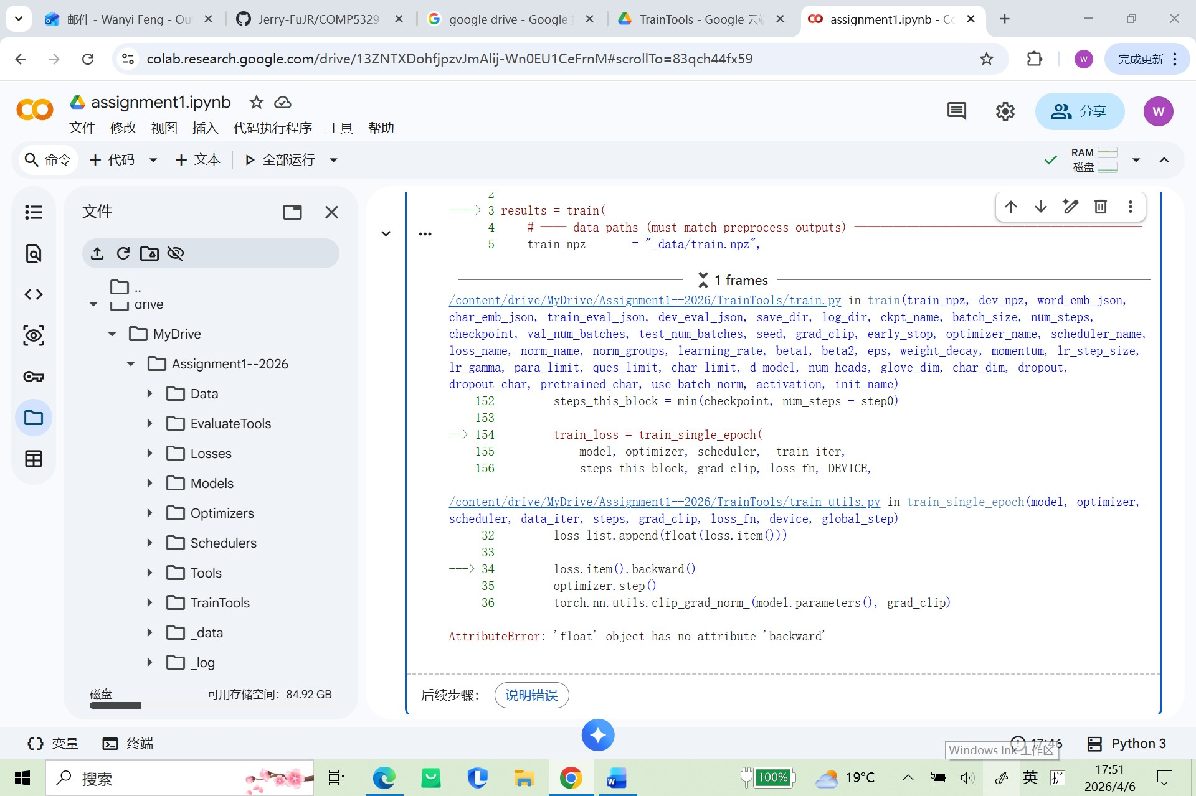
2）原因&修改
必改 1：反向传播写错了
loss.item().backward()
必须改成：
loss.backward()
因为 loss.item() 是 float，不能反传。
建议同时改 2：梯度裁剪顺序不对
现在你写的是：
loss.item().backward()
optimizer.step()
torch.nn.utils.clip_grad_norm_(model.parameters(), grad_clip)
scheduler.step()
即使把第一句改成 loss.backward()，这个顺序也不理想。
正确顺序应该是：
loss.backward()
torch.nn.utils.clip_grad_norm_(model.parameters(), grad_clip)
optimizer.step()
scheduler.step()
原因是：梯度裁剪要在参数更新之前做，不然就失去意义了。

• 备份 TrainTools/train_utils.py
• 把 loss.item().backward() 改成 loss.backward()
• 把梯度裁剪移动到 optimizer.step() 之前
• 输出修复后的完整文件

3）report
Bug 1
Error Message
The training process failed with the following error:
AttributeError: 'float' object has no attribute 'backward'
This error occurred in TrainTools/train_utils.py during backpropagation.
Cause
The original training loop called:
loss.item().backward()
In PyTorch, loss is a tensor connected to the computation graph, and .backward() must be called directly on this tensor. However, loss.item() converts the tensor into a Python float value, which no longer stores gradient information and therefore does not support backpropagation.
As a result, the training process crashed before gradients could be computed.
Fix
The incorrect line was replaced with:
loss.backward()
This ensures that backpropagation is applied to the original loss tensor and gradients can be computed correctly.

Bug 2
Error Message
The code did not immediately raise an exception, but the gradient clipping logic was placed in an incorrect position in the training loop.
Cause
The original implementation performed parameter updates before gradient clipping:
loss.backward()
optimizer.step()
torch.nn.utils.clip_grad_norm_(model.parameters(), grad_clip)
This order is incorrect because gradient clipping is supposed to constrain gradients before the optimizer updates the model parameters. If clipping is applied after optimizer.step(), it no longer affects the update of the current step and therefore loses its intended purpose.
Fix
The training order was corrected to:
loss.backward()
torch.nn.utils.clip_grad_norm_(model.parameters(), grad_clip)
optimizer.step()
This ensures that large gradients are clipped before the optimizer applies the update, making the training procedure consistent with standard deep learning practice.

11.学习率为0的问题
1）问题原因及修改部分
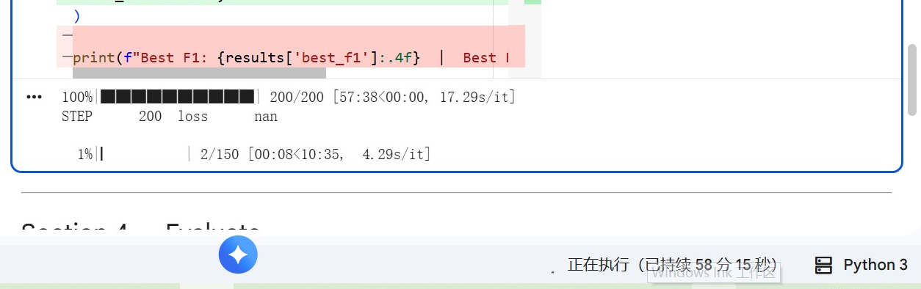
step_scheduler.py 里有明显 bug
Schedulers/step_scheduler.py，核心代码是：
return [
base_lr * self.gamma * (t // self.step_size)
for base_lr in self.base_lrs
]
这里错了。
正常的 StepLR 应该是类似：
base_lr * (gamma ** (t // step_size))
但现在写成了：
base_lr * gamma * (t // step_size)
这会导致：
- 当 t < step_size 时，t // step_size = 0
- 学习率直接变成 0

2）report
During training, the logged learning rate quickly became 0.0, and the model stopped making meaningful progress.
Cause
The issue was caused by an incorrect implementation of the step learning rate scheduler in Schedulers/step_scheduler.py. The original code used:
base_lr * self.gamma * (t // self.step_size)
This formulation is incorrect because when t < step_size, integer division gives 0, causing the learning rate to become exactly zero. As a result, parameter updates effectively stopped during training.
Fix
The scheduler was corrected to use exponential step decay:
base_lr * (self.gamma ** (t // self.step_size))
This ensures that the learning rate remains equal to the initial learning rate before the first decay point, and is then multiplied by gamma only after each decay interval.

12. lambda_scheduler.py 学习率倍率逻辑错误
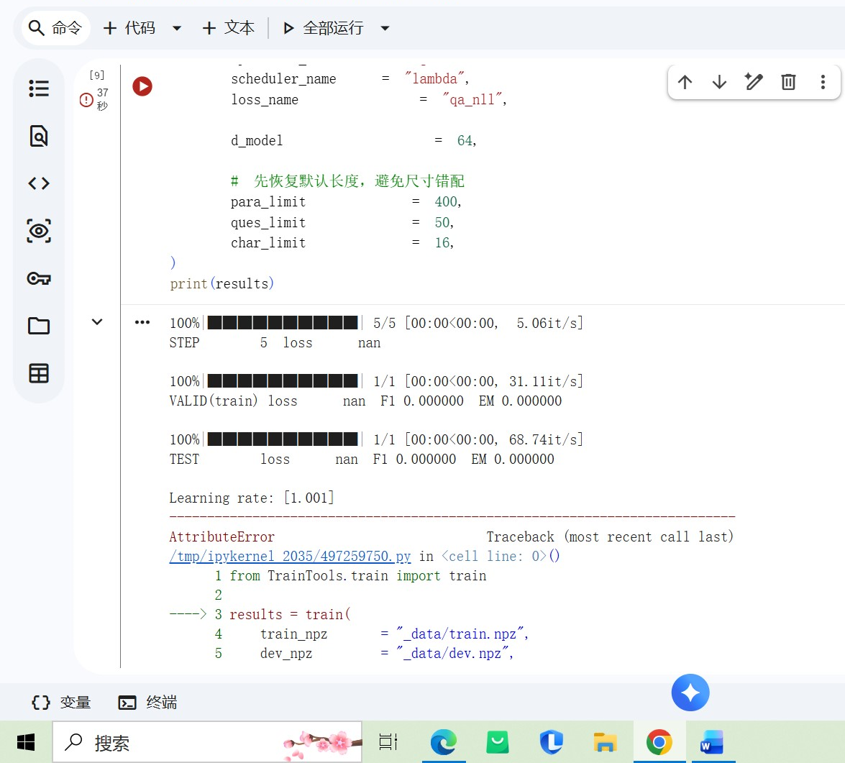
而 train.py 默认学习率是 1e-3。正常 constant/lambda scheduler 不应该把它变成 1.001，这说明实现很可能是：
base_lr + factor
而不是：
base_lr * factor
为什么要改
把 0.001 错改成 1.001 会让训练数值爆炸，直接导致 loss nan。
怎么改
把 scheduler 返回值改成乘法形式，并让 constant lambda 返回 1

Bug: incorrect lambda scheduler scaling
Cause: the lambda scheduler added the factor to the base learning rate instead of multiplying it.
Fix: replace base_lr + factor with base_lr * factor.
Impact: prevents the learning rate from jumping from 0.001 to 1.001, improving numerical stability.

13.lambda_scheduler 不可序列化，导致 checkpoint 保存失败
你真实遇到过这个报错：
AttributeError: Can't get local object 'lambda_scheduler.<locals>.<lambda>'
这说明 scheduler 里用了局部 lambda，torch.save() 在保存 checkpoint 时没法 pickle 它。
为什么要改
否则每次训练到保存 checkpoint 都会炸。
怎么改
两种方式都可以：
- 不用局部 lambda，改成顶层命名函数
- 或者在 save_checkpoint() 里对 scheduler.state_dict() 做容错处理

Bug: non-picklable local lambda in scheduler
Cause: the scheduler used a locally defined lambda function that could not be serialized by torch.save().
Fix: replace the local lambda with a top-level named function.
Impact: allows checkpoint saving to complete successfully.

14. save_checkpoint() 对 scheduler 保存不够鲁棒
现在一旦 scheduler 不可序列化，整个训练就直接崩。
为什么要改
checkpoint 保存是作业要求的一部分，训练不应该因为 scheduler 存不进去就全部失败。
怎么改
在 TrainTools/train_utils.py 里把 scheduler state 保存改成 try/except；保存不了就记为 None。

Bug: fragile checkpoint serialization
Cause: the checkpoint saving logic assumed that scheduler.state_dict() was always serializable.
Fix: wrap scheduler-state extraction in a safe try/except block and fall back to None when needed.
Impact: prevents training from crashing during checkpoint saving.

15. Models/dropout.py 的缩放分母错误
这是高风险 mechanism bug。常见错误是：
return x * mask / self.p
但 inverted dropout 正确应该除以：
1 - p
为什么要改
除以 p 会把激活缩放错，容易造成训练不稳定甚至 nan。
怎么改
改成：
keep_prob = 1.0 - self.p
return x * mask / keep_prob

Bug: incorrect inverted dropout scaling
Cause: dropout output was scaled by 1/p instead of 1/(1-p).
Fix: scale surviving activations by 1 / (1-p).
Impact: restores correct expected activation magnitude and reduces the risk of NaN training.

16. 评估脚本和你现在保存下来的 checkpoint 格式不匹配，再加上 PyTorch 2.6 的 torch.load() 默认行为改变
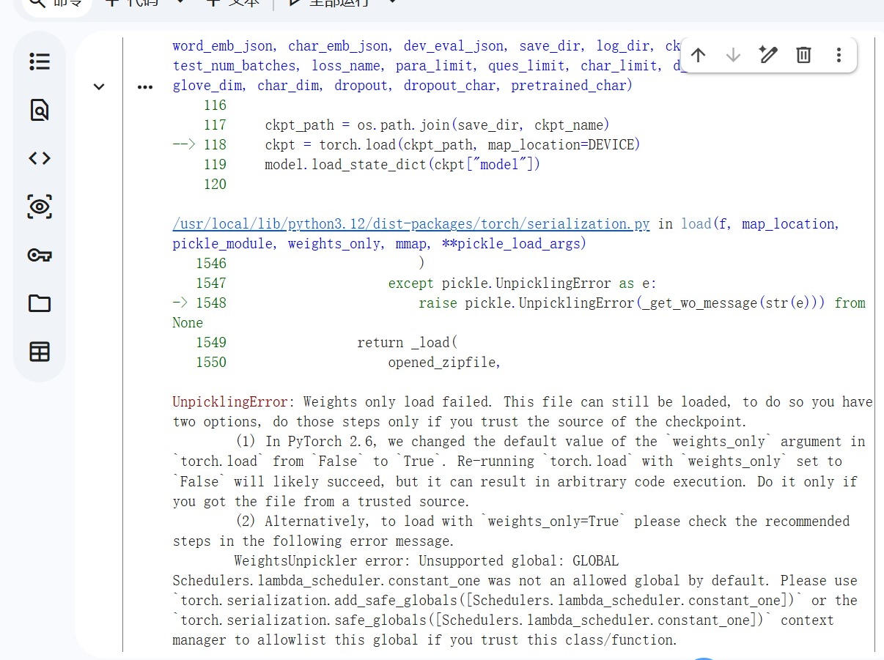
原因1 torch.load() 默认变成了 weights_only=True
报错里已经明确写了：
In PyTorch 2.6, we changed the default value of the `weights_only` argument in `torch.load` from `False` to `True`
而保存的 checkpoint 不只是纯权重，还包含：
- model_state
- optimizer_state
- scheduler_state
- step
- best_f1
- best_em
- config
训练时的 checkpoint 确实是整包一起存的，不是只存模型参数。训练主循环每个 block 后都会调用 save_checkpoint(...)，而返回结果里也明确记录了 ckpt_path 和完整 config。
所以评估时如果直接：
torch.load(ckpt_path, map_location=DEVICE)
在 PyTorch 2.6 下就可能因为 weights_only=True 默认开启而失败。
原因2 checkpoint 里的 key 名和 evaluate 很可能也不一致
训练保存时的 key 是：
"model_state"
不是 "model"。这是现在训练代码保存 checkpoint 的格式。
但报错堆栈里 evaluate.py 紧接着要做的是：
model.load_state_dict(ckpt["model"])
这说明 evaluate.py 很可能还在用旧 key："model"，而不是新 key："model_state"。
也就是说，即使把 torch.load() 这一层修过去，后面大概率还会继续报：
KeyError: 'model'
改 EvaluateTools/evaluate.py 两个地方：
修改1，显式设置 weights_only=False
把：
ckpt = torch.load(ckpt_path, map_location=DEVICE)
改成：
ckpt = torch.load(ckpt_path, map_location=DEVICE, weights_only=False)

修改2，兼容 checkpoint 的模型参数 key
把：
model.load_state_dict(ckpt["model"])
改成更稳的写法：
state_dict = ckpt["model_state"] if "model_state" in ckpt else ckpt["model"]
model.load_state_dict(state_dict)
17. 训练时的模型配置 和 评估时重建的模型配置 不一致
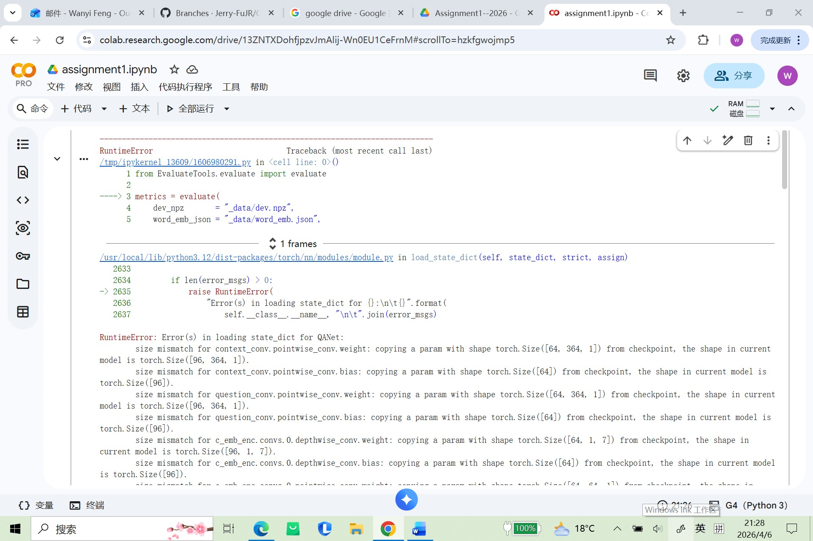
section3 训练时用的是：
d_model = 64
而 section4 的 evaluate() 没传 d_model，所以它回到了默认值：
d_model = 96
这个默认值就在当前 train.py 的参数定义里能看到：d_model: int = 96
而报错里几乎所有 mismatch 都是在说：
- checkpoint 里保存的是 64 通道
- 当前评估模型是 96 通道
例如：
- context_conv.pointwise_conv.weight：checkpoint 是 [64, 364, 1]，当前模型是 [96, 364, 1]
- q_emb_enc.pos.pos_encoding：checkpoint 是 [64, 50]，当前模型是 [96, 50]

