gatys_summary

Core Concept
- The authors introduce a neural algorithm that uses a Convolutional Neural Network ( VGG-Network) to independently separate and recombine the content of a photograph with the artistic style of a painting.
- The key finding of this paper is that the representations of content and style in the Convolutional Neural Network are separable. That is, we can manipulate both representations independently to produce new, perceptually meaningful images.
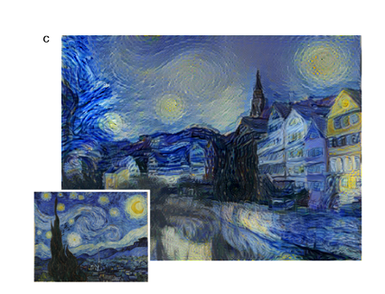
Understanding Content Representation
- The network processes visual information hierarchically, meaning different layers extract different levels of detail.
- Lower layers simply reproduce the exact pixel values of the original image.
- Higher layers capture the high-level content, such as specific objects(like buildings) and their global spatial arrangement, without restricting the exact pixel values.
Understanding Style Representation
- Style is defined by the correlations between different filter responses across the spatial extent of the feature maps.
- Mathematically, these feature correlations are computed using a Gram matrix.
- By calculating these correlations across multiple layers simultaneously, the system builds a stationary representation that captures texture, color, and other localized elements, while ignoring the global scene arrangement.
- When matching the style representations up to higher layers in the network, local images structures are matched on an increasingly large scale, leading to a smoother and more continuous visual experience.
The Synthesis Process
- To generate the final stylized output, the system starts with a random white noise image and uses gradient descent to manipulate it.
- It jointly minimizes a loss function consisting of two well-separated terms: one measuring the distance from the photograph's content representation, and the other measuring the distance from the artwork's style representation.
- The balance between preserving the original photograph's content and adopting the artwork's style can be smoothly adjusted by changing the weighting factors within this loss function.
MODEL DESCRIPTION
- The results presented in the main text were generated on the basis of the VGG-Network
- The Authors used the feature space provided by the 16 convolutional and 5 pooling layers of the 19 layer VGG Network.
- For image synthesis the authors found that replacing the max-pooling operation by average pooling improves the gradient flow
- the squared-error loss between the two feature representations :
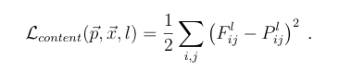
The derivative of this loss with respect to the activations in layer l equals
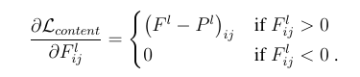
- The authors built a style representation that computes the correlations between the different filter responses.
These feature correlations are given by the Gram matrix G^{l} ∈ R^{Nl×Nl}, where G^{l}_{ij} is the inner product between the vectorised feature map 10 i and j in layer l
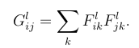

REFERENCE :
[1508.06576] A Neural Algorithm of Artistic Style

