Timeline of key milestones and innovations in style transfer and generative models :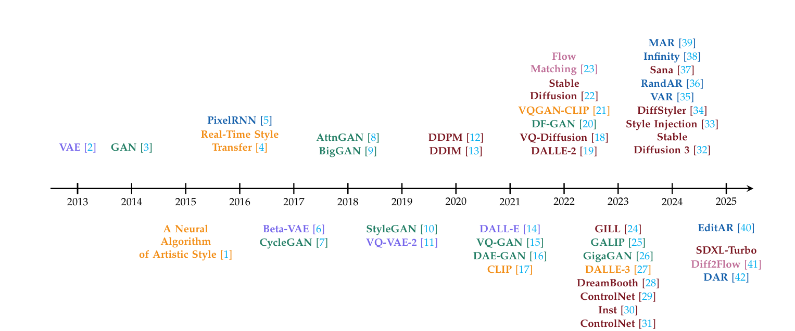

Overview
The survey traces the evolution of style transfer from the earlier, slow optimization methods (like Gatys) to the fast, real time feed forward methods (like AdaIN), and finally into the modern era of deep generative models. Over the decade, the field has shifted focus on achieving better realism, more precise controllability, and handling arbitrary styles across different mediums.
Main Developments (Post-AdaIN) :
Following the foundational neural style transfer models, the field split into several advanced generative approaches:
- VAE-Based Methods (Variational Autoencoders): These models excel at learning a structured, continuous latent space. VAEs are great at maintaining the structural consistency of the original content, but they traditionally struggle to capture the complex, diverse details of artistic styles compared to newer models.
- GAN-Based Methods (Generative Adversarial Networks): Models like CycleGAN and StyleGAN brought photorealistic fidelity and excellent real time processing speeds. They allow for precise control over both high level content and low level stylistic details (like brushstrokes). However, they are difficult to train and suffer from mode collapse, which restricts the diversity of their outputs.
- Diffusion-Based Models: Emerging between 2022 and 2025, diffusion models generate images by reversing a noise process , revolutionized the field with incredible image quality and training stability. They are currently the gold standard for textural realism, though they require heavy computational power and their generation process makes precise, localized changes difficult without causing unintended global changes.
- Autoregressive (AR) Models: AR models generate images sequentially (pixel by pixel / token by token). They are unmatched when it comes to maintaining structural fidelity and layout control, but their step by step generation process creates a massive bottleneck in inference speed, making them very slow for high resolution images.
- CLIP and Text-Guided Methods: The introduction of language image encoders like CLIP allowed style cues to be expressed directly as text prompts. This cross modal approach allows users to drive style transfer purely through natural language (like typing : impressionist sunset like the starry night), vastly improving user controllability.
The Broader Direction of the Field
The main challenge of modern style transfer is figuring out how to trade perceptual fidelity for speed and diversity without requiring massive computational power. Moving forward, the field is heading in a few specific directions:
- Hybrid Frameworks: Researchers are looking to combine the strengths of different models, such as using AR models for structural scaffolding and diffusion models for high fidelity textural rendering.
- Multimodal Expansion: Style transfer is no longer just for 2D images; the same underlying generative theories are being actively applied to video transformation, 3D asset creation, and even text-style rewriting (like changing the politeness of a sentence).
- Ethics and Safety: With the rise of highly realistic generation, the field is increasingly focused on the ethical implications of style transfer, specifically regarding copyright protection, prevention of deepfakes, and ensuring cultural sensitivity

