Angularjs unit test guide

## Purpose

This guide is aim to lead us how to setup env and how to run angular unit test, I will guide you step by step.

## Preparation

I assume you have installed nodejs env,so I skip how to install nodejs env, for running angular unit-test, you should use Karma module of nodejs to run, so the first step is that use npm to install karma, see the command below:

syntax : npm install –g karma-cli

this will provide a global env to use karma command.

additional dependencies:

npm install karma.

npm install karma-jasmine

Please note I have setup an env for u, I have config all necessary nodejs modules for unit-test,you just execute two commands,see below:

1. npm install(will download all necessary modules for unit-test)
2. npm install –g karma-cli

## run unit-test

as I have provided an env for u, you do NOT need to waste extra time on how to setup the unit-test env, based on above steps, all you need to do is run below command:

karma start karma.conf.js

after you ran this command,the chrome browser will be opened automatically and you will see the info like below on you command console.

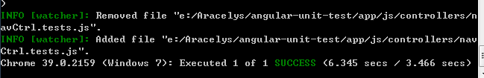

from this info, we can see that we have 8 unit-tests to run and all unit-tests are passed.

A warm reminder: if you just want to disable some unit-test, you just need to add a ‘x’ to the ‘describe’ key or ‘it’ key in unit-test, eg:

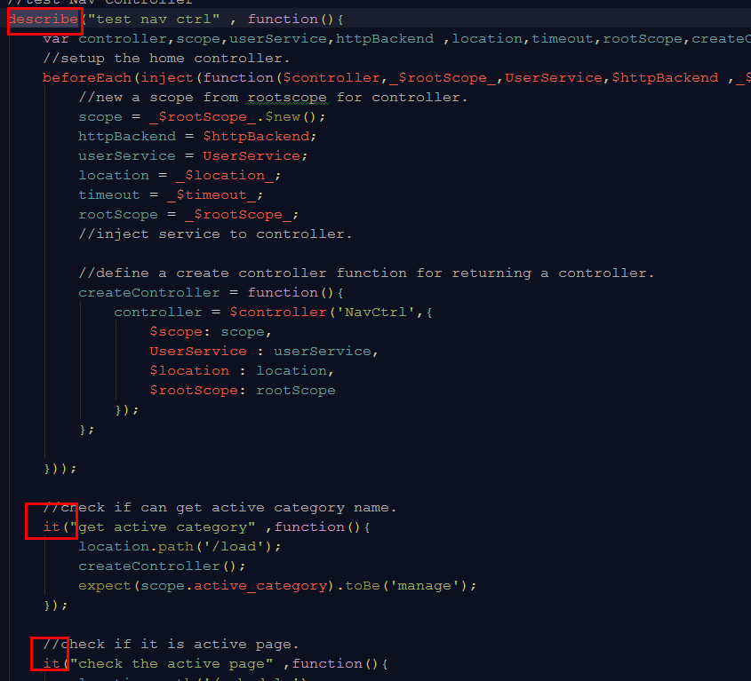

from this captured screen, we can see that , there are one ‘describe’ key and two ‘it’ key, if you do not want to any uni-test of this home controller, you just add ‘x’ in the front of ‘describe’ key,see the screenshot belew:

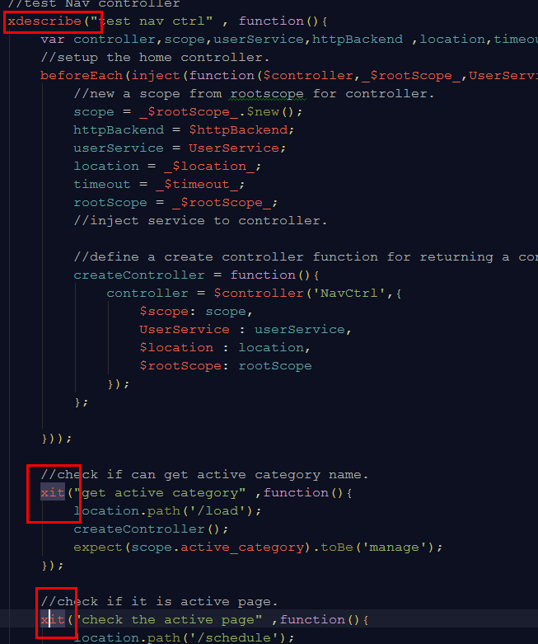

after you did this, all unit-test in this ‘describe’ section will skip to run.

but you just want to run one or two unit-test in this ‘describe’ section, it is easy to disable the unit-test which you not want to run, see below:

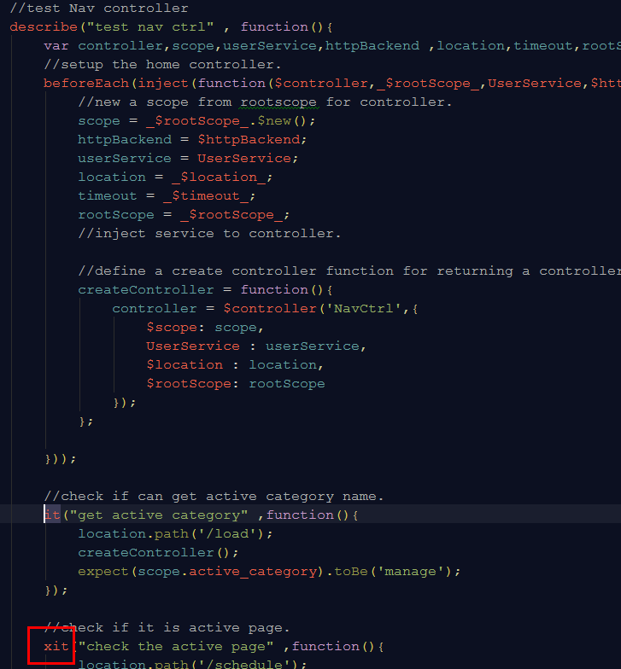

# Any questions?