Data Analysis Report (EDA)
Automated Regression Engine + UI for Brand × Channel Volume Sales Modeling
Big Chalk Analytics × Northwestern MSDS Capstone — Summer 2026
Team: Feifan Liu · Boqi Niu · Jiahao Li Faculty: Abid Ali Sponsor contact: Alex Hathcock July 14, 2026

1. Introduction and Dataset Overview
This report presents our exploratory analysis of the sponsor-provided dataset (Anonymized Data for Project.xlsx), the data gaps we found, the risks those gaps carry, and their impact on the final deliverable — an automated regression engine that models weekly Volume Sales for every Brand × Retailer-Channel combination, wrapped in an analyst-facing dashboard.
The workbook contains a General Data Dictionary tab plus one tab per brand (Brand 1–10). The grain is one row per Channel (Geography) × Brand (Product) × Week: 156 week-ending dates spanning January 2023 – December 2025, up to nine channels per brand, and 12,391 rows in total. Columns per brand range from 96 to 148 (the dictionary's nominal 113 is only an average — an early, useful discovery: nothing about the layout can be hard-coded). Predictors span own price, category and competitive price, own distribution (ACV, items per store, total points of distribution), trade execution (Weighted Weeks by merchandising condition), 12 media-spend channels, ~18 macroeconomic series, trend and seasonality indices, and Competitor 1–6 distribution/trade measures.

2. Descriptive Statistics
Weekly Volume Sales by brand (all channels pooled; volumes in units):
Brand | Rows | Cols | Channels | Weeks | Mean | Median | Max | CV | Skew
Brand 1 | 1,248 | 113 | 9 | 156 | 18,726 | 5,144 | 188,175 | 1.46 | 2.11
Brand 2 | 1,248 | 107 | 9 | 156 | 40,915 | 27,460 | 261,874 | 1.19 | 1.71
Brand 3 | 1,248 | 118 | 8 | 156 | 641,877 | 434,897 | 4,168,135 | 1.22 | 1.57
Brand 4 | 1,248 | 128 | 8 | 156 | 187,387 | 75,295 | 1,138,940 | 1.25 | 1.51
Brand 5 | 1,248 | 123 | 8 | 156 | 13,690 | 3,854 | 74,790 | 1.45 | 1.38
Brand 6 | 1,248 | 101 | 8 (+1 #N/A) | 156 | 45,345 | 6,526 | 220,023 | 1.37 | 1.23
Brand 7 | 1,248 | 129 | 8 | 156 | 28,275 | 10,600 | 178,286 | 1.38 | 1.47
Brand 8 | 1,248 | 148 | 8 | 156 | 60,725 | 33,707 | 352,629 | 1.26 | 1.57
Brand 9 | 1,159 | 127 | 8 | 156 | 43,010 | 9,607 | 289,359 | 1.30 | 1.49
Brand 10 | 1,248 | 96 | 8 | 156 | 121,618 | 62,401 | 683,533 | 1.20 | 1.73
- Scale varies ~50× across brands (Brand 5 mean ≈ 13.7K vs Brand 3 ≈ 642K weekly units) and further across channels within a brand. One global model is untenable — supporting the per-slice modeling design.
- Every brand is strongly right-skewed (skew 1.2–2.1, CV 1.19–1.46): most weeks sit near a modest base with occasional large promotional spikes. Mean ≫ median throughout.
- Data are remarkably complete at the cell level: zero missing values in 9 of 10 sheets. The exception is Brand 6, where 99 rows carry #N/A in Geography (an entire pseudo-channel of unusable rows, handled by exclusion).
- Brand 9 has 1,159 rows instead of 1,248 — one channel's history is truncated, consistent with a later launch (see coverage analysis, §4).

3. Target Behavior: Trend, Seasonality, Distribution
We profile the target on the deepest slice (Brand 1 × Channel 1) and then generalize. Weekly volume shows a declining multi-year trend punctuated by sharp promotional spikes, a New-Year seasonal peak, and a visibly weaker 2025:
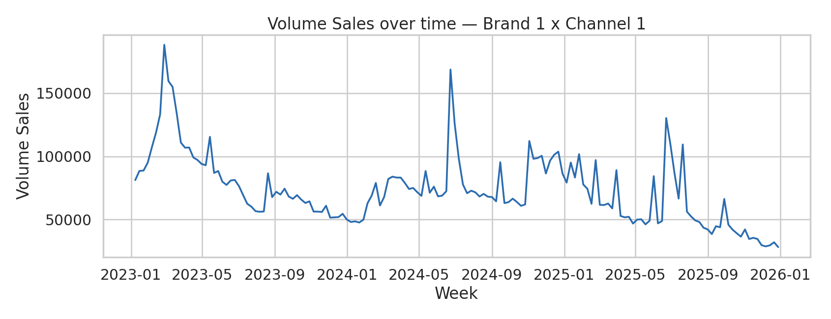
Figure 1 — Volume Sales over time, Brand 1 × Channel 1: declining trend, promotional spikes, weak Q4 2025.
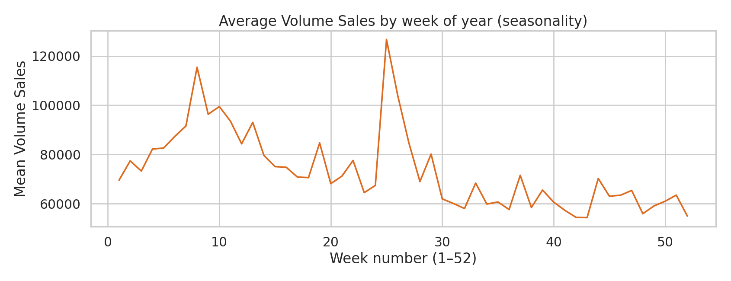
Figure 2 — Seasonality profile: systematic within-year pattern justifying the Seasonality_Index / week-number predictors.
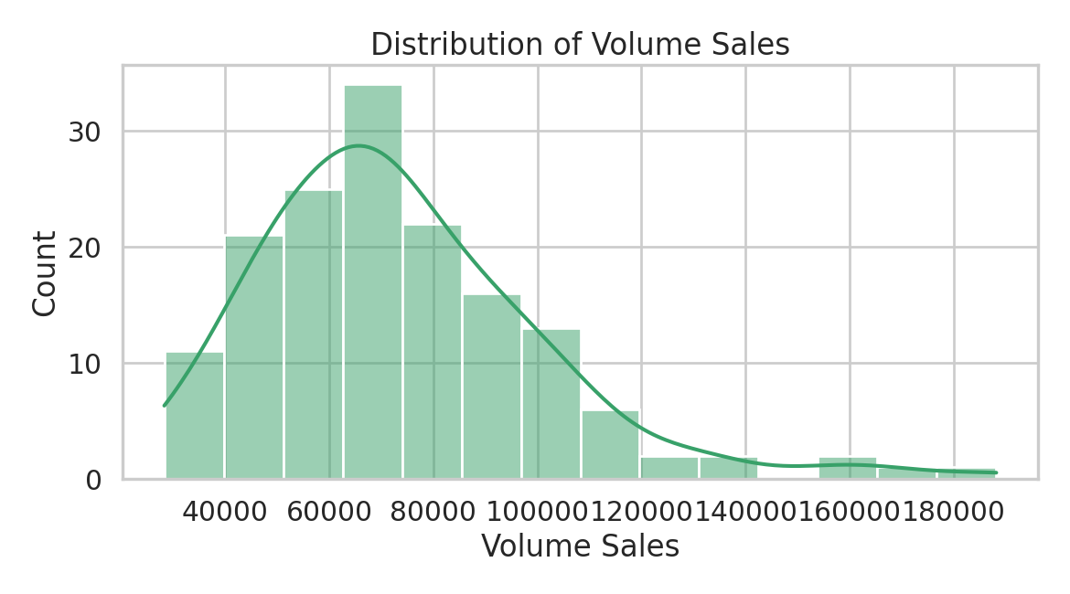
Figure 3 — Weekly volume distribution: right-skewed with a long promotional tail.
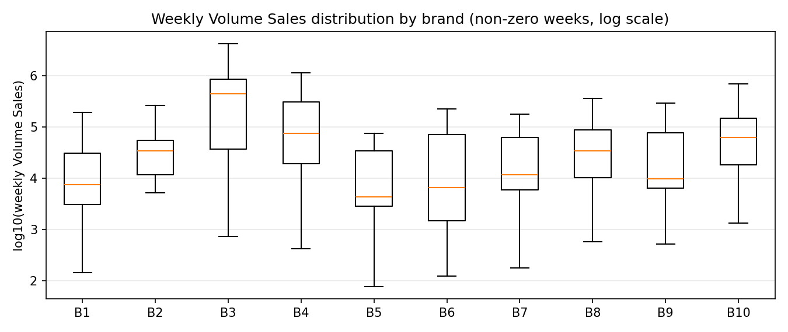
Figure 4 — Distribution by brand (log scale, non-zero weeks): every brand shows the same skew shape at very different scales.
Two modeling consequences follow. First, the promotional spikes are exactly what the trade-execution predictors (Feature, Display, Price Reductions Weighted Weeks) exist to explain — they are signal, not outliers to be removed. Second, the visibly lower 2025 level for some slices previews the structural-change risk quantified in §5.

4. Predictor Relationships and the Leakage Finding
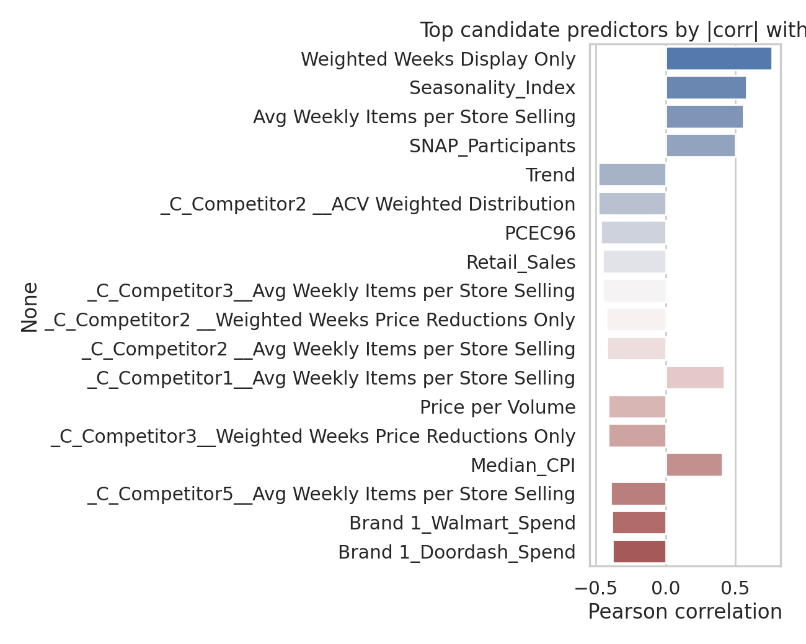
Figure 5 — Top candidate predictors by |correlation| with Volume Sales, Brand 1 × Channel 1 (after leakage exclusion).
- Target leakage — the most important EDA finding. The columns most correlated with Volume Sales are its own algebraic decompositions: Dollar Sales (= price × volume) and every “Volume/Dollar Sales by merch condition” column. Including any of them yields inflated, meaningless fit. All target-decomposition columns are excluded as predictors, enforced dynamically for whichever target is chosen.
- Legitimate drivers correlate sensibly: trade display execution (r ≈ +0.75), seasonality, and distribution depth lead; own price and competitor activity correlate negatively — matching business priors and seeding the sign-constraint table.
- Collinearity is pervasive: distribution measures track each other, macro series share trends, media spends are co-scheduled. VIF-based pruning is required before any regression is interpretable; pairwise checks alone would miss multi-variable redundancy.
- Media spend needs adstock: raw weekly spend is spiky and its instantaneous correlation with volume is weak or even negative; the dictionary and sponsor confirm advertising carryover should be modeled via geometric adstock (normalized so totals are preserved, per-media decay).
- Naming quirks: Brand 2's media columns are prefixed “Brand 0210_*” and one column is literally named 0 (a numeric header that crashed sheet parsing once — now a regression test). Column sets differ per brand, so all variable mapping is config-driven.

5. Coverage and Data Gaps
Cell-level completeness hides the real gaps, which are structural — some Brand × Channel slices simply have little or no sales history:
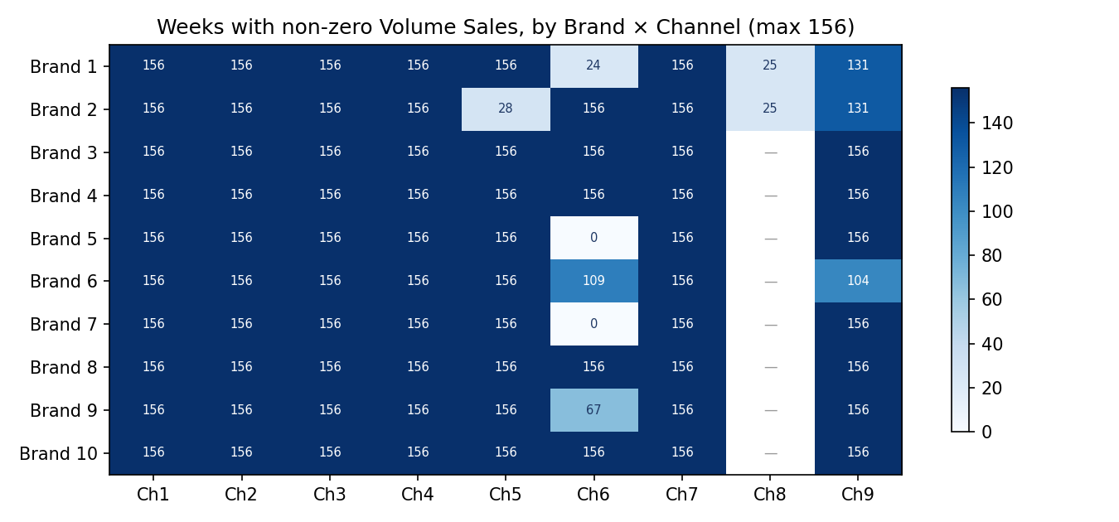
Figure 6 — Weeks with non-zero Volume Sales per slice (max 156). “—” = channel absent from the sheet.
Gap | Where | Detail
All-zero target | 2 of 82 slices | Brand 5 × Ch6, Brand 7 × Ch6 — brand not sold in the channel; no model is possible (engine skips with reason)
Short history | 4 slices | Brand 1 × Ch6 (24 non-zero wks), Brand 1 × Ch8 (25), Brand 2 × Ch5 (28), Brand 2 × Ch8 (25) — far below the 104-week modeling window
Partial history | 5 slices | Brand 1 × Ch9 (131), Brand 2 × Ch9 (131), Brand 6 × Ch6 (109), Brand 6 × Ch9 (104), Brand 9 × Ch6 (67) — launches or distribution changes mid-series
Channel absent | Brands 3–10 | Channel 8 exists only for Brands 1–2; other brands carry 8 channels, not 9
Unusable rows | Brand 6 | 99 rows with #N/A Geography (no channel key) — excluded
Unobserved events | Unknown | No columns record delistings, recalls, supply disruptions, or assortment resets — e.g., the suspected late-2025 Brand 1 event (§6)

6. Risks and Impact on the Final Project
Each gap maps to a concrete risk and a design decision already reflected in the engine:
Risk (from gap) | Impact if unmanaged | Mitigation in the final project
Modeling on all-zero or near-empty slices | Nonsense models presented as valid; analyst trust destroyed | Engine skips all-zero slices with an explicit reason; short-history slices flagged in the batch overview rather than silently fitted
Short/partial histories leave too few effective observations | Unstable coefficients, huge standard errors on ~25-week slices | 104-week set-year window with minimum-data checks; such slices reported as low-confidence, candidates for pooling or exclusion after sponsor input
Structural change absent from predictors (suspected Brand 1 late-2025 delisting) | Systematic over-prediction: our case study saw 73% holdout MAPE, all errors biased high | Force-variable workflow recovers part of the signal (73% → 32% by forcing ACV distribution); 8 high-MAPE slices flagged to sponsor; event-dummy overlay scoped as an extension
Target leakage via decomposition columns | Spectacular but fake in-sample fit; model teaches nothing causal | Dynamic exclusion of all decompositions of the chosen target, enforced in code, not by hand-maintained lists
Heterogeneous layouts across brands (96–148 cols, renamed media, numeric headers) | Pipeline breaks on every new client file | Config-table variable mapping; auto-detection of sheets/targets; validated against a synthetic alien-format workbook
Skew and 50× scale differences across slices | A single pooled model would be dominated by large slices | One model per Brand × Channel; MAPE computed on non-zero actuals; fit judged per slice

7. Conclusions
The dataset is unusually clean at the cell level but structurally uneven: 71 of 82 slices carry full 156-week histories and support the standard modeling window, 9 need flagged, reduced-confidence treatment, and 2 cannot be modeled at all. The dominant analytical risks are target leakage (solved by construction), collinearity (solved by VIF pruning), and unrecorded structural events (partially mitigated by the analyst-override workflow; fully solvable only with sponsor knowledge of the events). These findings directly shaped the engine's design — per-slice models, config-driven variable mapping, minimum-data guards, and human-in-the-loop overrides — and none of the identified gaps threatens the project's ability to deliver its core scope.

