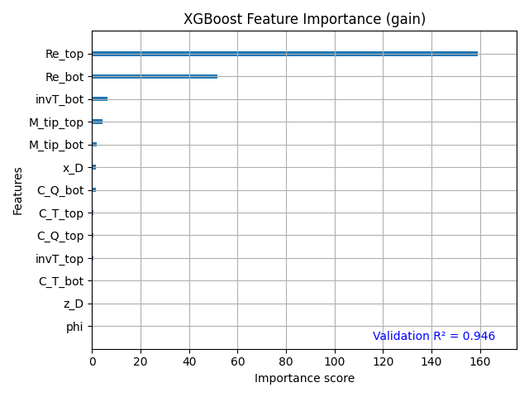
I combined all the data from 3 dimension and split them into train set and validation sets. The decision tree is then applied, and the most influential features are plotted. Noticeably, the Reynolds Number shows a strong impact on the noise output. (Notably, normalizing the data doesn’t change the result). I select the top 4 features and try to only use them as input, the R2 score has a moderate drop, and using other 4 features has a similar output, I guess when the number of pi feature exceed the DOF, some of the features become dependent.
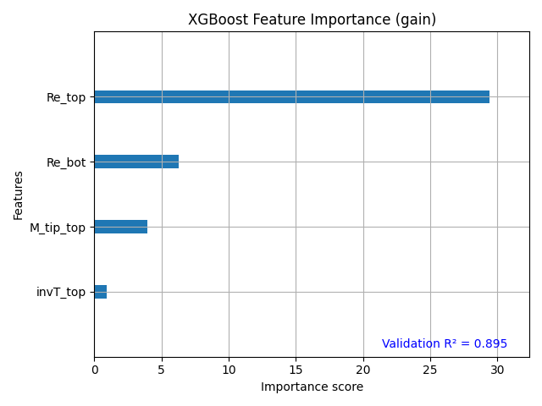
However, when using only Reynolds Number and normalized separation, the R2 score on the validation set get close to 1, which is a very promising result.
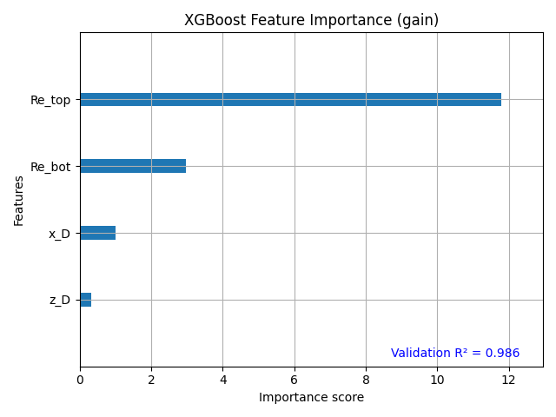

New thing to try,
- for the possible dependent features, try to reduced it and try different combination
- Include propeller radius and see what happened
- Figure out a way to generate a template for each of the noise component
- Validate the result from the decision tree

