Introduction to ITWS

Quiz 2: November 4, 2019

Place your name on the top of this document in the header

Enter your answers directly into this document (with the exception of #1)

All answers should be in be in Your Own Words, and use proper grammar

Make sure your answers use an alternative font and/or color – (not black or red)

Save this document as ITWS1100-F19-Quiz2-*yourname*-*yourRCSID*.docx

Place all documents including this one in a folder named

ITWS1100-F19-Quiz2-*yourname*-*yourRCSID*

When finished with the quiz, zip your folder and all related files into a file named

ITWS1100-F19-Quiz2-*yourname*-*yourRCSID*.zip

And submit it to LMS

1. Technology (coding): (35 points, 30 minutes)
   1. Given the Quiz2.html, .css, and .js files, make the following modifications;

In the HTML;

1. Change whatever is necessary to ensure the file(s) adhere to html5 syntax.
2. Connect your html file to jQuery either locally or via CDN
3. Add your name in an h4 tag below the h1 tag
   1. Add additional tagging (your choice) that may be used to identify when your last name is selected (eg clicked)
4. Add a button at the bottom of the page with an id of your choosing that is labeled ‘Go’ on the page.

In the JavaScript file:

1. Show an alert that the page is about to load
2. Add a function that will execute when the document is finished loading to the browser and will (HINT: You will need the jQuery ready function)
   1. Set the title of the page to “Intro to ITWS - Quiz 2” to act as the default
   2. Using JavaScript with or without jQuery :
      1. When ‘Go’ is clicked and the title is set to the default
         1. Change the title of the page to ‘*yourname* – Quiz 2’
      2. When ‘Go” is clicked and the title is other than the default
         1. Change the title back to the default
      3. When the user hovers the mouse over your last name
         1. Add a class of makeItPurple to your last name
         2. Remove it when the user is no longer hovering over your last name

In the CSS;

1. Add the CSS necessary to change the properties of something with a class of ‘makeItPurple’ show in purple, italic and in small caps.
2. Make the content of the h1 and h4 tags centered

Your webpage (and the alert – which I moved for clarity) should look similar to the following before and after the button is clicked, and while the name is being hovered over;

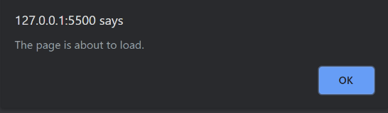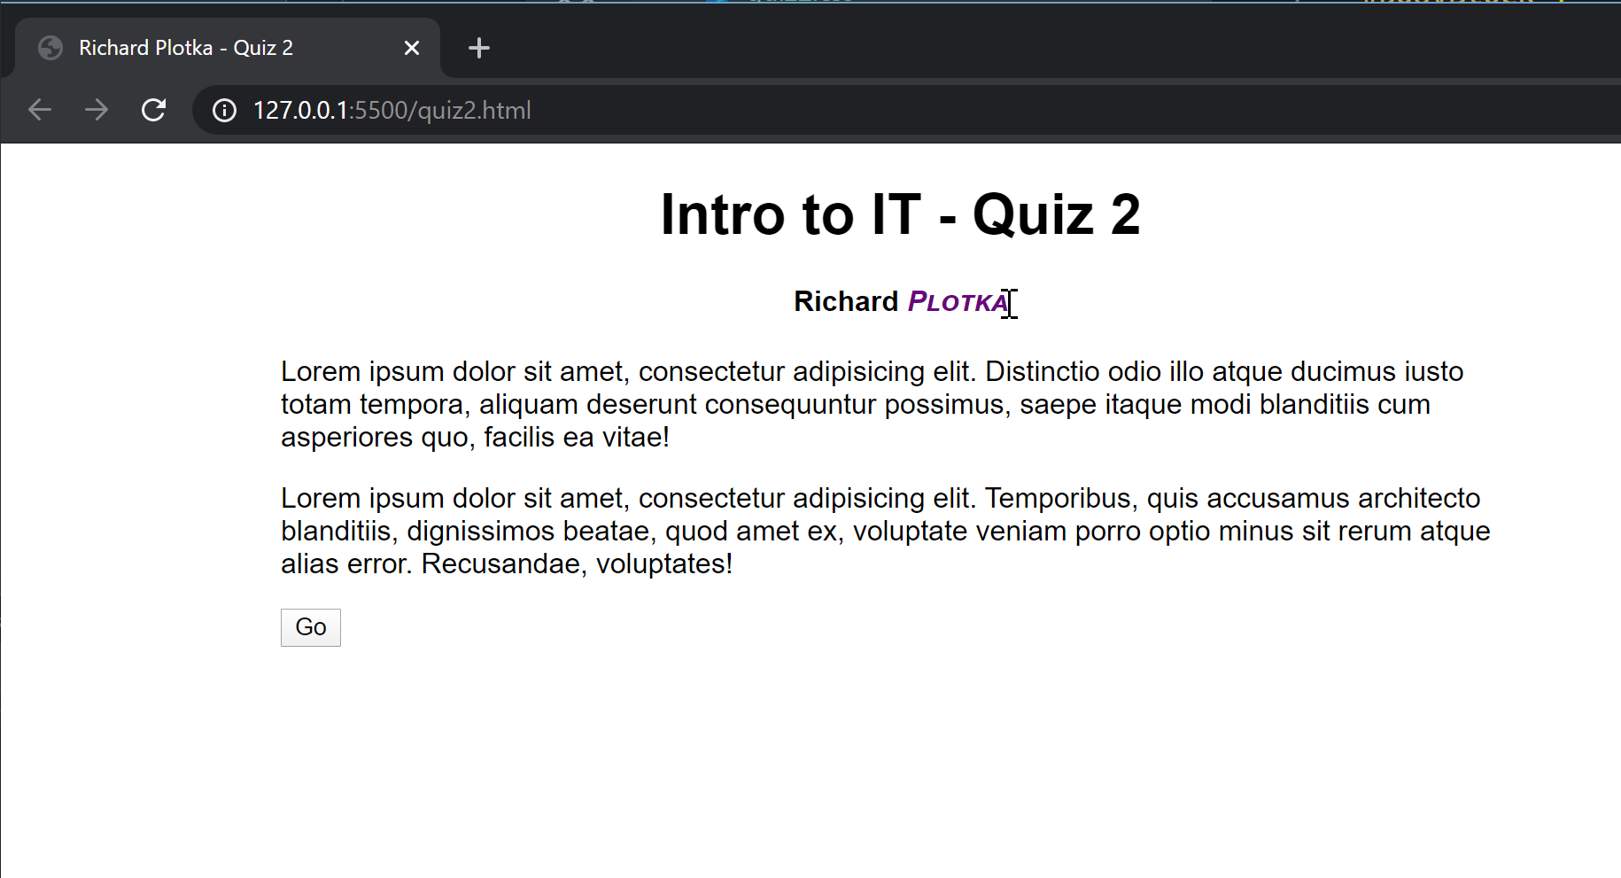

1. Technology (description) (25 points, 20 minutes): Web Development
   1. Based on the discussions in class, what is a namespace and what does it mean for us. Explain in detail, and in your own words, and provide 2 examples from class discussions/labs (10 points)

It tells computer what language you are using. If you include <http://www.w3.org/1999/xhtml>, it knows that you are using html and it will follow the syntax provided by the namespace <http://www.w3.org/1999/xhtml> to progress your code.

For example:

<http://www.w3.org/1999/xhtml> is html name space.

e.g. <html xmlns="http://www.w3.org/1999/xhtml"><html>

http://www.w3.org/2005/Atom is Atom name space.

e.g. <rss xmlns:atom="http://www.w3.org/2005/Atom" version="2.0"><rss>

* 1. We have learned the jQuery function in class. Explain what the ‘$’ does as it pertains to jQuery. Also explain what we would do if another API set is already using the $ (10 points)

$ tells computer that we are using jQuery.

If another API set is already using the $, we can do it in the following way:

var a = jQuery().noConflict();

a(document).ready(function () {

a("p").hide();

});

* 1. Recalling the HCI discussion in class, what is a paper computer and what is a prototype and what purpose do they serve? Explain in your own words, and give an example as it pertained to your projects. (5 points)

Paper computer is the paper prototype that is created to show the function (user interface) of the application or website that we are making. A prototype is an original model that we create for our application or website. It can clearly demonstrate what we want our application or website be like. How do users interact with it. It can expose a lot of flaws in our product. For example, I want to create a map application, by creating a paper computer I will know how to make the application easier for user to use and how to increase their using experience.

1. “The Great Hack” Discussion (20 points, 20 minutes)
   1. How did Cambridge Analytica gain access to the user data that became the basis for their algorithms? (6 points) What was illegal about how Cambridge Analytica collected this data? (4 points)

They get the user data from Facebook. Those data are not authorized by those users to give to Cambridge Analytica and are exposed to Cambridge Analytica without users notice. This is a privacy violation.

* 1. According to Brittany Kaiser, what term did Cambridge Analytica use to describe their primary targets? (2 points)

They describe their primary targets as dog.

* 1. How did Cambridge Analytica derive value from the data they collected? How did they turn the raw data into a form they could use as part of their business practices? How did this relate to their primary targets? (8 points)

They gathered the data and used it to train their algorithm to predict person’s psychology (personality). They use them to form the output of the predicted votes of different states in US. With everyone’s personality and the votes in general they can advertising different people using different method. If you like sports, they will use advertisement relate to sports to intrigue you first. Because they are mining the data, primary targets help them to dig out more information, such as the information of their friends.

1. “Voice War” Case (20 points, 20 minutes)
   1. As discussed in class, identify and then describe two reasons why adoption rates for smart speakers been faster than any other consumer device. (8 points)

Firstly, with media getting more and more various and advanced, the advertisement can reach out to more people and are became more effective. The spreading speed of the new-generation-product smart speakers will definitely be the fastest.

Secondly, smart speakers are easy to use. People don’t need operate anything, they just need to talk to the speakers like talking to a real servant and it will do thing s for you. So many people now are using smart speakers instead of smart phones.

* 1. How does Amazon’s business model give them an advantage over Google as well as set them up to “win” within the voice assistant industry? (6 points)

Not really. When it comes to smart speakers, Amazon indeed have a big advantage. However, voice assistant is not just about smart speakers. There are also voice assistant in smart TV and smart phones. When it comes to smart phones, Google has a huge advantage. Google have the state-of-art voice recognize technology and the various novel functions for their voice assistance.

* 1. Identify one advantage Google has over Amazon within the voice assistant industry and discuss how Google can use this advantage to chip away at Amazon’s lead in the industry. (6 points)

One of the advantage is that Google have the state-of-art voice recognize technology and the various novel functions for their voice assistance. Google’s voice recognition accuracy as much higher than Amazon’s Alexa. By creating the best using experience, Google have the opportunity to become the lead of this industry.