**Applying Well-Separated Pairs to the Travelling Salesman Problem**

Jerry Qian

University of Maryland

May 19, 2021 (Draft)

[jerryq@umd.edu](mailto:jerryq@umd.edu)

**Abstract**

Well-separated pair decomposition offers geometric insights on distance closeness for sets of points in Euclidean space. We investigate the role of well-separated pairs in solving the travelling salesman problem. WSPs can improve existing TSP algorithms and be the basis for new ones. Additionally, we run experiments to find the pros and cons of using Point, PR, and PMR quadtrees when finding WSPDs for the travelling salesman problem.

**1 Introduction**

Well-separated pairs (WSPs) have been used in a large variety of distance problems. The well-separated pair decomposition gives us geometric insights on the closeness between sets of points in Euclidean space. We apply WSPs to improve the performance of existing TSP algorithms and present a new polynomial-time algorithm.

**2 Related Work**

The brute

**3 Brute Force with WSP Pruning**

The brute force algorithm examines all (n-1)! permutations and takes the shortest permutation as the solution tour. This algorithm runs in exponential time, so it quickly becomes impractical in larger problems.

We present a quick and easy way to use WSPs to reduce the size of the permutation search space. At each step of the permutation branching, we prune away point choices that are well-separated from the set of the current point. The pseudocode is shown in Algorithm 1.

/* Build well-separated dictionary */

ws <- dict{point -> point set}

for wsp in wspd:

for point pair (pA,pB) in wsp:

ws[pA].add(pB)

ws[pB].add(pA)

/* Spawn Permutation branching instances

starting from each point */

permutations <- []

for point in points:

rem <- TSP points

initPerm <- [point]

perms <- buildPerm(initPerm, rem)

permutations += perms

/* Build Permutations by branching to points

that are not well-separated */

func buildPerm(perm, rem):

perms = []

if len(rem) == 0:

perms += perm

last <- last item from perm

while len(rem) > 0:

for next in rem:

if ws[last] not contains next

nextPerm <- perm.add(next)

nextRem <- rem.remove(next)

perms += buildPerm(nextPerm, nextRem)

return perms

Algorithm 1: Brute force with WSP Pruning.

|  |  |  |
| --- | --- | --- |
| Data set | Total permutations | Permutations with WSP pruning |
| 3 Clusters  N=11 | 3,628,800 | 5,472 |
| 2 Clusters  N=11 | 3,628,800 | 17,280 |
| Uniform  N=11 | 3,628,800 | 1,406,160 |

Table 1: Permutations checked for the Brute Force Algorithm with and without WSP Pruning. The data sets can be found in the GitHub repository.

By pruning away choices, we separate the larger problem into many smaller problems. In Table 1, we show the performance improvements on different data sets. We see more time savings for point sets with well-separated clusters. Each cluster is treated like a separate problem and cheaply connected to the points not in the cluster.

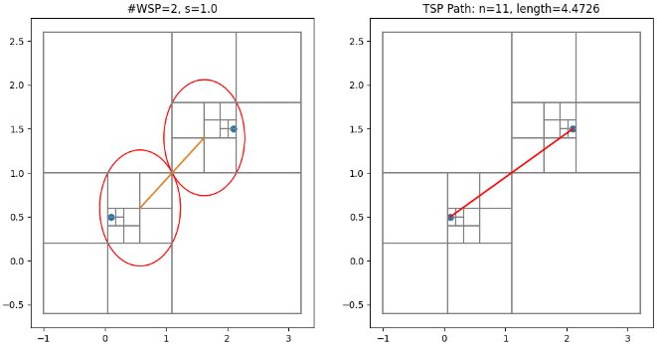

Figure 2: BFP run on data set with two clusters.

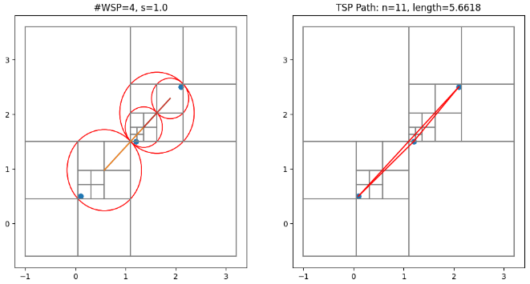

Figure 1: BFP run on data set with three clusters.

The data set with three clusters (Figure 1) only checks 5,472 permutations compared to the one with two clusters (Figure 2), with 17,280 permutations. Three WSPs were found in the data set with three clusters. This breaks the 11 point problem into a three point and two four point subproblems. A single WSP was found in the data set with two clusters. This breaks the 11 point problem into a five point and a six point subproblem.

**4 WSP Subproblem Algorithm**

In practice, the optimal tour is not always necessary. We introduce a new polynomial-time approximation algorithm that combines the nearest neighbor **method** with subproblem formed by well-separated pairs.

**4.1. Motivation and Overview**

A problem with the regular nearest neighbor method is that by greedily taking the nearest neighbor as the next point of the tour, it often leaves points in corners of the space. It must backtrack after leaving the neighborhood sometimes causing long jumps near the end of the tour. To prevent this behavior, we take a top-down approach breaking the problem into multiple recursive subproblems. We force the tour to visit every point in a neighborhood before visiting another. Each neighborhood becomes a subproblem. This process happens within subproblems until it cannot be broken down further. Then we connect subproblems.

**4.2. Finding Subproblems**

We use the well-separated pair decomposition of the point set to break the space into subproblems.

**4.3. Connecting and Solving Subproblems**

Connecting subproblems is the same as solving subproblems. We connect subproblems in a top-down fashion. Each subproblem contains a set of points. At each level, we use run the brute force solution to find a high-level path going through subproblems, treating each subproblem like a single point. Instead of taking the distance between points, we take the minimum projection between subproblems. For each subproblem in the high-level path, we have an entry and exit point found by the minimum projections to its preceding and succeeding subproblems. We use the entry and exit points to solve each subproblem.

**4.2. Finding Subproblems**

We

**5 Quadtree WSPD Performance**

**6 Conclusion**

Python implementations for all algorithms in this paper can by found in the GitHub repository.