Criterion A: Planning

Defining the problem

My client, Mr.xx is a business manager of a food courier company. In Mr.xx company, there are thousands of deliverymen who receive orders from the guests and send foods or drinks to their homes.

When the consumers make requests, they order foods and drinks in a phone application. Then, a deliveryman gets the positions of the stores and the consumers home address. However, a deliveryman usually gets several orders at the same times. Although, the positions are marked on the map in the application, the deliveryman need to arrange the route by himself.

The problem is, however, that consumers sometimes have to wait for a long time before they get their foods, especially when there are lots of consumers order at the same time. Therefore, Mr.xx want to further speed up the delivery process in order to improve this situation.

After discussing with my computer science teacher, we think we are able to design Mr.xx a new function for map application that the deliverymen use. This function can calculate and recommend the shortest routes for the deliverymen, and show the routes on the map.

Rationale for the proposed solution

Criterion B: Design

Input:

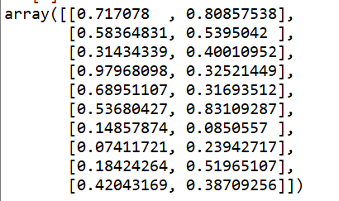

Develop:

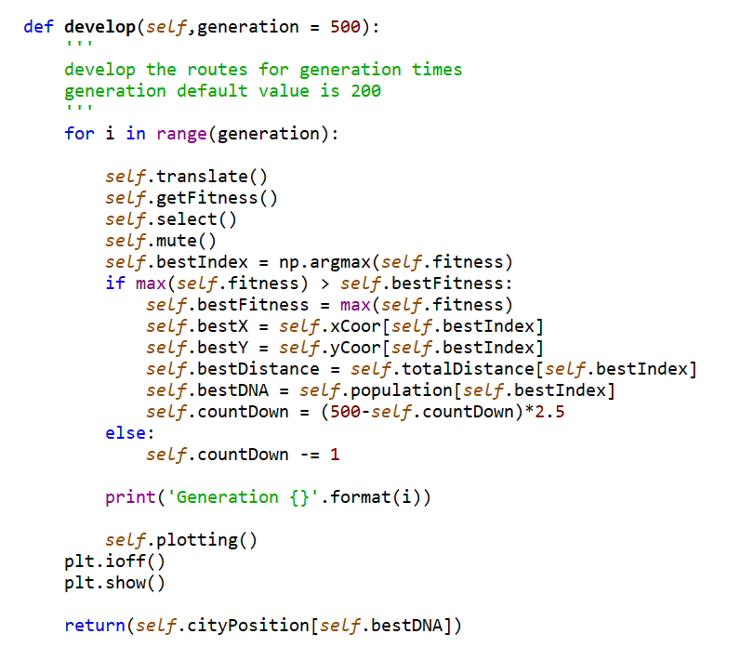

Output:

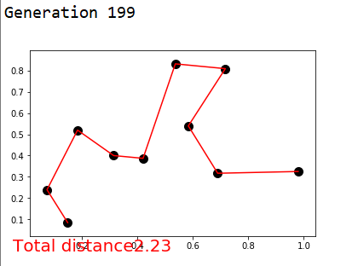

Select suitable DNA for input data:

Generate random DNA population:

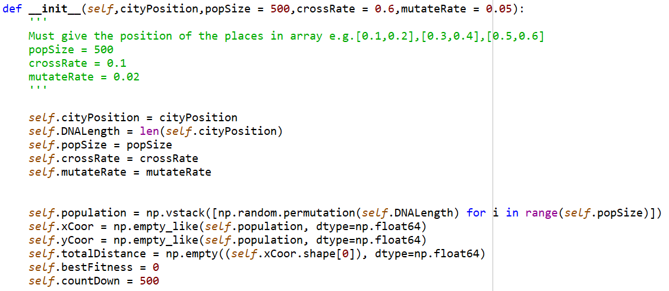

Translate DNA:

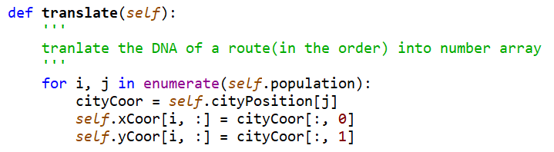

Natural Selection:

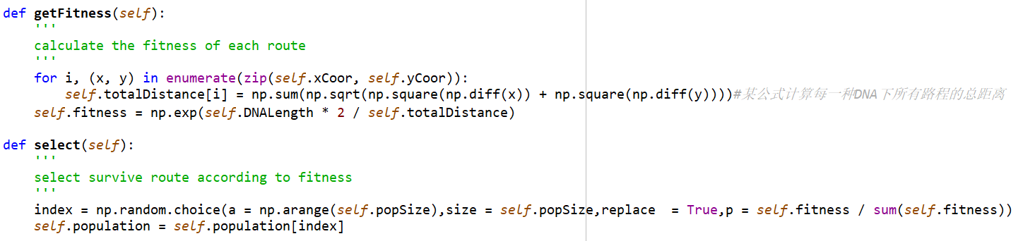

Mute:

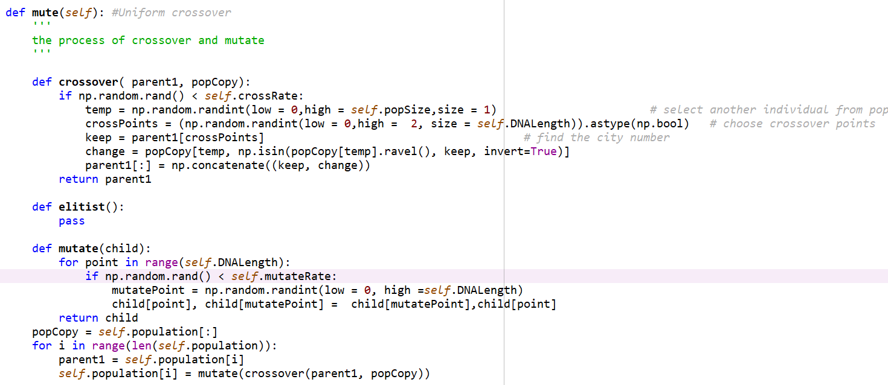

Crossover:

Mutation:

Illustrate:

