Nov 2017 option B

1. Distinguish between a computer model and a computer simulation. [4]

(a) Award up to [4 max].

A computer model is a representation of a system;

Made up of variables and formulae/mathematical representation;

Whereas a computer simulation is a process that uses the model;

In order to see the outcome(s) when different values are used for the variables

(in the model); [4]

(b) Identify two reasons why some systems are difficult to model successfully. [2]

Computer simulations are often used in situations where practical experimentation is,

for some reason, not possible. One of these reasons could be an ethical issue.

(b) Either all of the variables are not known/difficult to define;

Or the relationships between them cannot be expressed

accurately/mathematically; [2]

(c) (i) With clear reference to the ethical issue, describe one example where practical

experimentation would not be possible for ethical reasons. [3]

(i) Example

Experiments on living animals in a high school science class;

Such as effects of altering diet;

It is not ethically acceptable to harm animals (for such purposes);

Note: Accept reasonable examples, provided they are sufficiently

explained. [3]

(ii) State three other advantages, apart from ethical reasons, of simulating a

computer model rather than constructing a physical one. [3]

(ii) Award up to [3 max].

Computer models/simulations allow the designers to:

Make alterations and quickly see the outcomes;

Repeat tests several times over;

Model dangerous situations safely;

Learn from “what if?” scenarios;

Saves costs if several different models have to be built; [3]

2. A manufacturing company that produces several products is using spreadsheet software to model its finances. This includes calculations that will estimate diﬀerent quantities including

the profit that the company will make in future years.

The model involves the use of spreadsheet software which will be organized using diﬀerent

sheets for diﬀerent areas of the company’s finances. Previously less sophisticated methods

were used to keep track of costs and sales.

1. By including examples where appropriate, describe a basic structure for this model. [6]

(a) Award up to [6 max].

Different sheets will be dedicated to different categories, eg salaries, running

expenses, sales, different products, different months etc.;

Note: Award [2 max] for identifying at least two categories.

Each sheet will contain a list of items for that category including associated

values;

Formulas will be included as necessary;

Each sheet/category will include a formula that totals the values in that category;

Intermediate values will be calculated, eg tax to be paid;

The final profit will be determined from the previous totals; [6]

(b) Suggest how the reliability of the model could be tested. [2]

The company has established certain profit targets that it wishes to achieve over the next

three years.

(b) Figures from previous years can be entered into the model;

With the results checked against the previously calculated results; [2]

(c) Explain how this model can be used to investigate diﬀerent strategies that will reach

these targets. [4]

(c) Award up to [4 max].

Different (“what-if”) scenarios can be run;

In which the values of different variables are changed;

For example, the number of items sold / the increase in the level of salaries;

Note: Award [2 max] for identifying at least two items.

Selling prices/other (acceptable) parameters can be adjusted to achieve the

desired profit; [4]

3. Weather forecasters use computer models which are able to simulate future weather

patterns. These forecasts were originally limited to the near future. However, modern

systems can now produce long range forecasts.

(a) Suggest two reasons why these simulations have improved both in their accuracy and

their range. [4]

(a) Award up to [4 max].

Modern computer systems have become increasingly more powerful;

Which allows more complicated systems to be simulated;

In a short/acceptable period;

The understanding of (the science of) weather has steadily improved/more

historic weather patterns can be accessed;

Allowing more accurate modelling to take place;

More data can now be retrieved;

Through satellites, ground stations etc; [4]

1. Suggest why forecasts become less accurate the more long range they become. [4]

(b) Only the major/known variables can be input into the model;

Approximations have to be made to represent complex processes;

These or other minor/unknown variables will not have a significant effect in the

short term;

But will have (unknown) effects in the long-term/small errors have a cumulative

effect over the long-term/butterfly effect; [4]

1. Discuss whether historical data can be accurately used to forecast future weather. [5]

(c) Award [1] for each valid point discussed, and a further [1] up to [5 max] for a

good expansion of this point.

Investigate past weather patterns in order to see if past forecasts were correct or

not and make adjustments to your model appropriately;

Look at specific events in the past (eg appearance of El Nino) to see how they

affected future weather patterns in different areas, and then apply this to new

occurrences of these events;

However, historical data does not take into account new factors, such as how

carbon emissions are contributing to global warming; [5]

The simulation of the weather forecasting models produces specifc data which can be output

in a variety of ways.

1. (i) Defne the term visualization. [2]

(i) The representation of (abstract) data;

In a way that is understandable by humans; [2]

(ii) With the help of examples, discuss how the development in the way such data

is visualized has made the results of these simulations more accessible to the

general public. [6]

(ii) Standard simulations produce numerical values (which are not easily

understood by the general public);

Modern simulations include

Graphics that are related to the data output;

eg rain drops/a smiling sun;

CGI/animation can produce motion;

eg showing a belt of rain crossing the country;

Which are more easily understood by the general public; [6]

4.

Artifcial neural networks (ANNs) are being used in a variety of applications, including pattern

recognition, game playing, classifcation and data mining.

(a) Explain one reason why ANNs are suitable for solving the types of problems found in

these areas. [3]

An ANN is being trained to recognize handwritten numbers by identifying them as a digit

from 0 to 9.

(a)

The functions/mathematical relationships in these types of problems;

Which are required for use with traditional algorithms/non-ANN algorithms;

And are difficult/impossible to define; [3]

(b) Describe an appropriate set of data that could be used to train the network. [2]

Assume that each digit to be identifed is input as an image made up of 30×30 pixels.

Award up to [2 max].

Many sets of digits;

Using different pens/colours/thicknesses etc;

Written by different people; [2]

(c) State the number of neurons that would be in

(i) the input layer. [1]

(i) 900; [1]

(ii) the output layer. [1]

(ii) 10; [1]

A simplified version of an ANN is shown below.

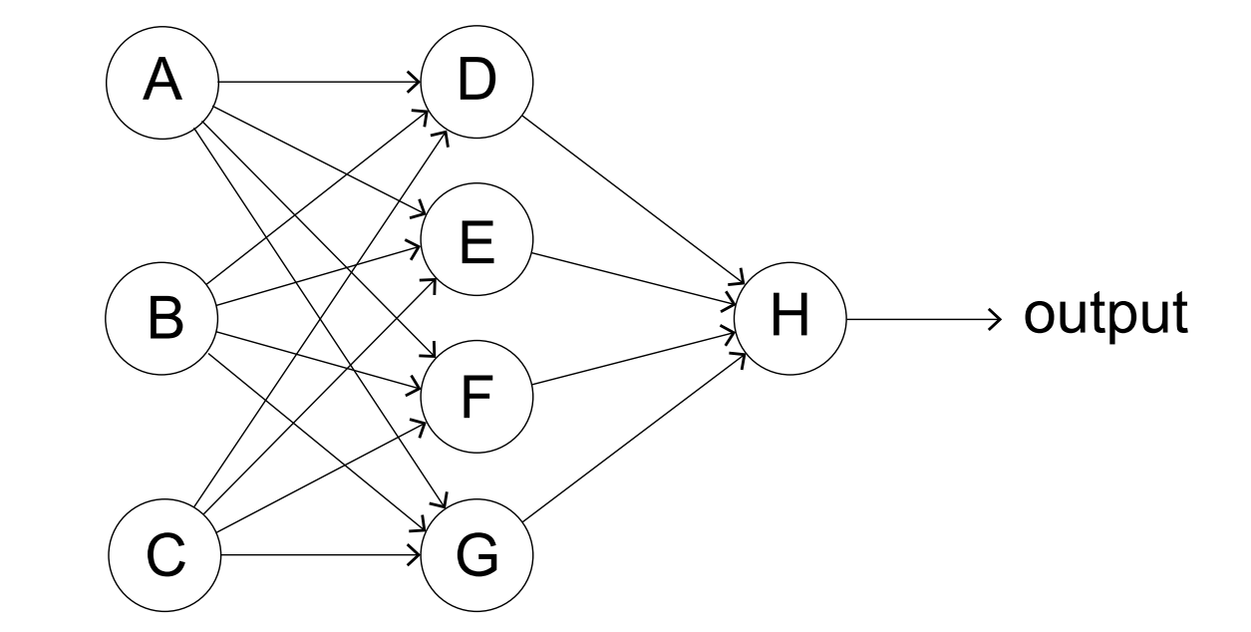

(d) Explain the way in which the output from neuron D will be determined. [3]

The network is set up with initial values. The outputs are compared with the desired outputs.

(e) Identify the steps that now take place to train the network. [5]