CVD Risk Prediction Using Sleep and Health Data
Technical Report

Author: Jerry Hsu
Course: BSAN6070 — Introduction to Machine Learning
Institution: Loyola Marymount University
Date: April 29, 2026

Executive Summary
This project applies machine learning to predict cardiovascular disease (CVD) risk using sleep and health data from 5,042 patients in the Sleep Heart Health Study (1995–1998). Three models were trained and evaluated. Logistic Regression achieved the best performance: AUC = 0.8018 and Recall = 0.7071, meeting both success criteria. The model correctly identifies 7 out of 10 CVD patients.
Two research questions are answered:
- Can we predict CVD risk using sleep and health data? Yes. AUC = 0.8018 confirms strong discrimination.
- What are the top features? Age, sex, and blood pressure medication use dominate. Apnea events per hour is the strongest sleep predictor.
Key findings:
- Sleep metrics contribute 5.6% of total SHAP importance; health indicators contribute 94.4%.
- The model is most reliable for patients aged 65 and older (Recall = 82.6%) and for females (AUC = 0.8422).
- Recall drops to 24.5% for patients under 65 — a primary limitation requiring future work.
Recommendations:
- Prioritize CVD screening for patients with AHI > 15, older age, and blood pressure medication use.
- Integrate AHI and minimum oxygen saturation from sleep studies into CVD risk workflows — no new data collection required.
- Do not apply this model to patients under 65 without retraining on age-targeted data.

Part 1 — Data Preparation

Step 1 — Data Loading and Merging
What was done: Two SHHS dataset files were loaded and joined on the patient identifier nsrrid. The polysomnography file (shhs1-dataset-0.13.0.csv) contains 1,279 clinical and sleep variables. The CVD outcome file (shhs-cvd-summary-dataset-0.13.0.csv) contains 41 outcome columns. Only the any_cvd column was brought from the outcome file to prevent column duplication.
Why: An inner join ensures only patients with complete data in both files are retained. Bringing only any_cvd avoids overwriting demographic columns present in both files.
Results:
Dataset | Rows | Columns
shhs1 (polysomnography) | 5,804 | 1,279
CVD summary | 5,802 | 41
Merged (inner join) | 5,802 | 1,280

2 patients in shhs1 had no matching CVD record and were excluded.

Step 2 — Quick Scan and Feature Selection
What was done: 18 clinically relevant features were selected from 1,280 columns. Two derived variables — average oxygen saturation and minimum oxygen saturation — do not exist in dataset version 0.13.0 and were computed from REM and NREM stage measurements. Identifier columns, date columns, and all CVD outcome columns except any_cvd were removed.
Why: Including CVD outcome columns would cause data leakage. The 18 selected features cover sleep physiology, cardiovascular baseline, body measurements, medical history, and demographics.
Results: 19 columns retained (18 features + target). No feature exceeds 20% missing. any_cvd has 13.1% missing (760 rows) — these will be dropped in Step 3 since the target cannot be imputed.

Step 3 — Data Cleaning
What was done: Four operations were applied in sequence.
- Rows where any_cvd is missing were dropped — 760 rows, leaving 5,042.
- No column exceeded 50% missing, so no columns were dropped.
- Numeric features were imputed with the column median. Categorical features were imputed with the mode.
- IQR outlier capping was applied to all continuous numeric columns. Values outside Q1 − 1.5×IQR and Q3 + 1.5×IQR were clipped to those bounds.
Why: The target variable cannot be imputed without corrupting the model. Median imputation is robust to outliers. IQR capping preserves sample size while reducing the influence of extreme values — a common artifact in polysomnography data.
Results: Final dataset is 5,042 rows × 19 columns. The most imputed column was hdl_cholesterol (461 rows, 9.1%). The most capped column was apnea_events_per_hour (313 values), consistent with the right-skewed AHI distribution.

Step 4 — Rename Features
What was done: All 19 columns were renamed from SHHS variable codes to descriptive English names.
Original Code | Renamed Feature
ahi_a0h3 | apnea_events_per_hour
avgsat | avg_oxygen_saturation
SlpEffP | sleep_efficiency_pct
WASO | wake_after_sleep_onset_min
SystBP | systolic_bp
DiasBP | diastolic_bp
Chol | cholesterol
HDL | hdl_cholesterol
gender | sex
smokstat_s1 | smoking_status

Why: Descriptive names improve readability in SHAP charts, correlation heatmaps, and the Streamlit app.

Step 5 — Exploratory Data Analysis
What was done: Five analyses were run — class balance, feature distributions, t-tests for CVD vs non-CVD group differences, sex-based CVD rate analysis, and a correlation heatmap. All charts were saved to Output/eda_charts/.
Class balance: 3,846 patients have no CVD (76.3%). 1,196 patients have CVD (23.7%). The dataset is imbalanced and will require undersampling in the modeling step.
Statistical tests — 10 of 12 numeric features differ significantly between CVD groups (p < 0.05):
Feature | Mean CVD=1 | Mean CVD=0 | Significant
apnea_events_per_hour | 16.55 | 12.76 | Yes (p<0.001)
avg_oxygen_saturation | 93.98 | 94.56 | Yes (p<0.001)
min_oxygen_saturation | 85.08 | 86.10 | Yes (p<0.001)
sleep_efficiency_pct | 80.45 | 83.92 | Yes (p<0.001)
wake_after_sleep_onset_min | 71.60 | 57.58 | Yes (p<0.001)
bmi | 28.26 | 28.11 | No (p=0.35)
systolic_bp | 130.84 | 123.51 | Yes (p<0.001)
cholesterol | 206.23 | 206.11 | No (p=0.92)
hdl_cholesterol | 48.23 | 50.63 | Yes (p<0.001)
age_at_baseline | 71.25 | 61.60 | Yes (p<0.001)

Sex analysis: Males have a 29.7% CVD rate vs 18.5% for females.
Correlation: One high correlation pair was found — sleep_efficiency_pct vs wake_after_sleep_onset_min (r = −0.87). VIF will be checked in Step 8 before deciding whether to remove one.
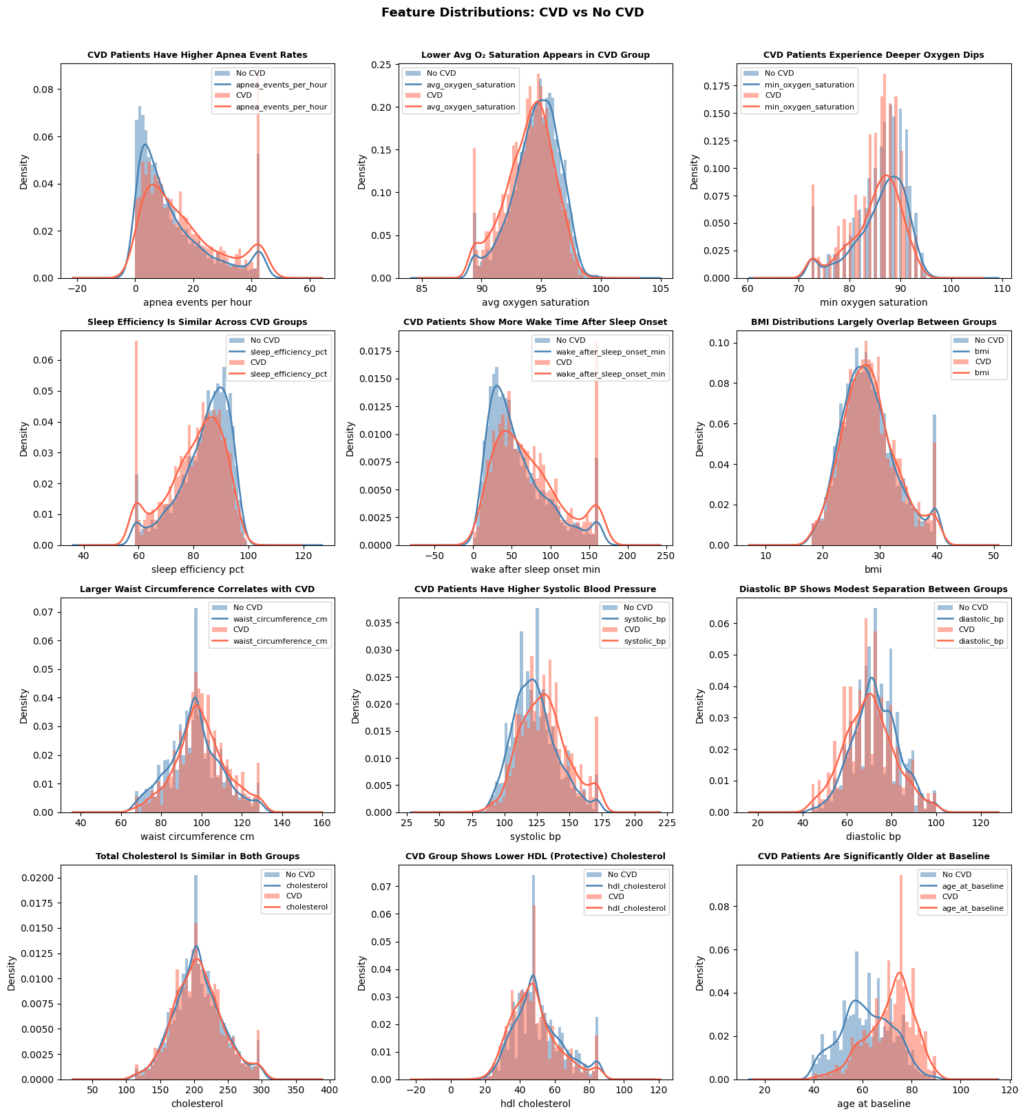
Figure 1. Feature distributions by CVD status. CVD patients show higher AHI, lower oxygen saturation, and older age.
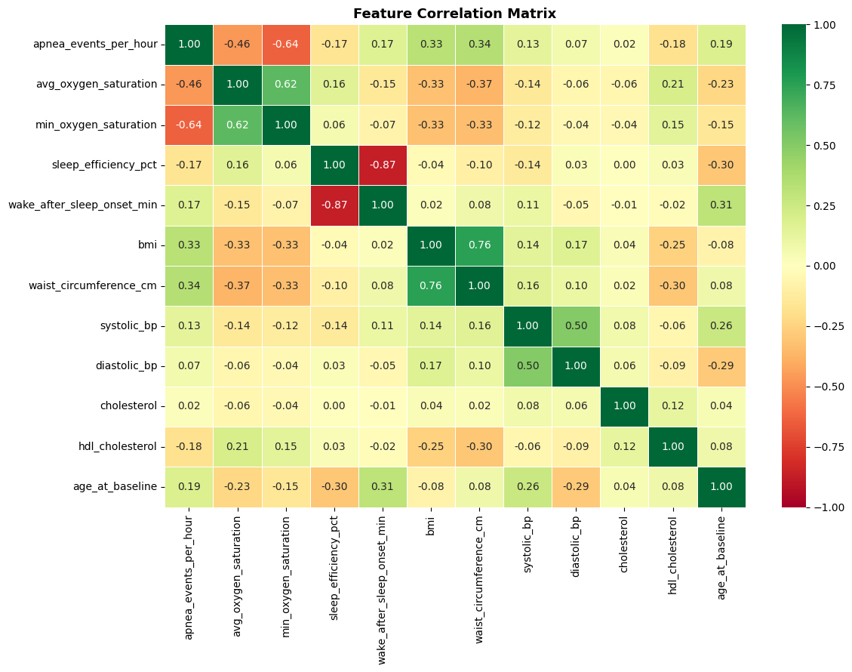
Figure 2. Correlation matrix. sleep_efficiency_pct and wake_after_sleep_onset_min are highly correlated (r = −0.87).

Step 6 — Save Modeling Dataset
What was done: The clean, renamed dataset was saved to Dataset/dataset_ready_for_modeling.csv before any modeling began.
Why: Saving here decouples data preparation from modeling. Steps 7–14 can reload directly without re-running the full preparation pipeline.
Results: 5,042 rows × 19 columns. CVD=0: 3,846 (76.3%). CVD=1: 1,196 (23.7%).

Part 2 — Modeling

Step 7 — Preprocessing
Performance criteria: Two metrics evaluate model performance.
- Recall > 0.70: Missing a CVD patient is more dangerous than a false alarm. A missed patient receives no treatment. 0.70 is the practical floor — pushing higher forces Precision below 0.40, creating unnecessary interventions.
- AUC > 0.75 (target 0.80): Measures discrimination. Published SHHS models achieve 0.75–0.84. We target 0.80.
Three models:
- Logistic Regression: interpretable baseline. Assumes linear CVD relationships.
- Random Forest: captures non-linear interactions. Robust to outliers and mixed variable types.
- Gradient Boosting: sequential error correction. Expected strongest predictions.
Preprocessing pipeline:
- Numeric features: median imputation then StandardScaler (fit on training set only).
- Categorical features: mode imputation then OneHotEncoder.
- Train/test split: 80/20, stratified on any_cvd.
- Undersampling on training set only: CVD=0 downsampled to match CVD=1 (957 each, 50/50).
Split | Rows | CVD=0 | CVD=1
Train (before undersample) | 4,033 | 3,076 (76.3%) | 957 (23.7%)
Train (after undersample) | 1,914 | 957 (50.0%) | 957 (50.0%)
Test (untouched) | 1,009 | 770 (76.3%) | 239 (23.7%)

Step 8 — Model Assumption Validation
What was done: Three checks confirmed the data is ready for modeling.
- VIF check: all numeric features tested for multicollinearity.
- Data leakage check: confirmed no CVD outcome column appears among predictors.
- Class balance check: training set confirmed at 50/50.
VIF results: No feature exceeds VIF = 10. All features are retained.
Feature | VIF
sleep_efficiency_pct | 4.50
wake_after_sleep_onset_min | 4.47
bmi | 2.65
waist_circumference_cm | 2.63
min_oxygen_saturation | 2.36
All others | < 2.0

Despite the r = −0.87 correlation, VIF values remain well below the threshold. Both sleep_efficiency_pct and wake_after_sleep_onset_min are retained.

Step 9 — K Selection and Model Training
Phase 1 — K Selection: Cross-validation stability was tested at K = 3, 5, and 10. The decision rule: choose K with lowest standard deviation; if std difference < 0.01 between two values, choose the higher mean AUC.
Model | K=3 Mean | K=3 Std | K=5 Mean | K=5 Std | K=10 Mean | K=10 Std
Logistic Regression | 0.7911 | 0.0068 | 0.7894 | 0.0195 | 0.7888 | 0.0248
Random Forest | 0.7663 | 0.0132 | 0.7651 | 0.0244 | 0.7718 | 0.0314
Gradient Boosting | 0.7681 | 0.0116 | 0.7684 | 0.0127 | 0.7755 | 0.0254

- Logistic Regression: K=3 (lowest std = 0.0068 by a wide margin).
- Random Forest: K=3 (lowest std = 0.0132).
- Gradient Boosting: K=5 (K=3 and K=5 differ by 0.0011 < 0.01; K=5 has higher mean AUC 0.7684 vs 0.7681).
Phase 2 — Parallel Training: Three models trained simultaneously with RandomizedSearchCV. Search space sampled at 10% (minimum 10 iterations). Decision threshold tuned to the highest value still achieving Recall >= 0.70.
Model | CV AUC | Test AUC | Recall | F1 | Threshold | Train Time
Logistic Regression | 0.7914 | 0.8018 | 0.7071 | 0.5624 | 0.55 | 0.8s
Random Forest | 0.7838 | 0.7905 | 0.7071 | 0.5391 | 0.51 | 13s
Gradient Boosting | 0.7820 | 0.7893 | 0.7113 | 0.5304 | 0.51 | 82s

Best hyperparameters:
- Logistic Regression: C=1, penalty=l1, solver=liblinear
- Random Forest: n_estimators=300, max_depth=5, min_samples_split=5
- Gradient Boosting: n_estimators=500, learning_rate=0.01, max_depth=3, subsample=0.7, min_samples_split=5

Step 10 — Evaluation
What was done: Each model was evaluated on the held-out test set (1,009 patients). AUC-ROC curves, confusion matrices, classification reports, and subgroup analyses by age (< 65 vs >= 65) and sex were produced.
Performance criteria — all three models pass both thresholds:
Model | Test AUC | AUC >= 0.75 | Recall | Recall >= 0.70 | Beats Baseline
Logistic Regression | 0.8018 | PASS | 0.7071 | PASS | YES
Random Forest | 0.7905 | PASS | 0.7071 | PASS | YES
Gradient Boosting | 0.7893 | PASS | 0.7113 | PASS | YES

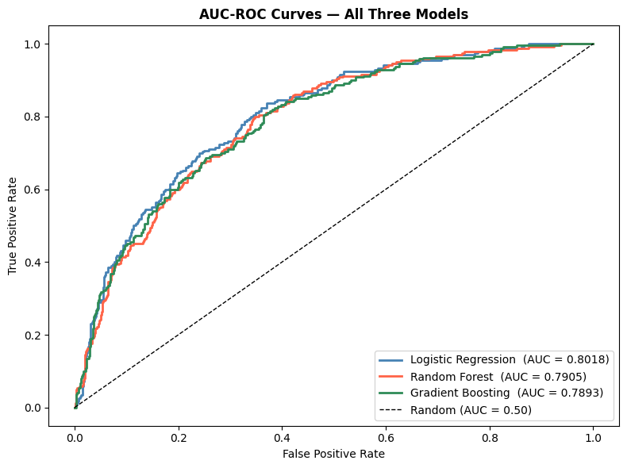
Figure 3. ROC curves for all three models. Logistic Regression achieves the highest AUC (0.8018).
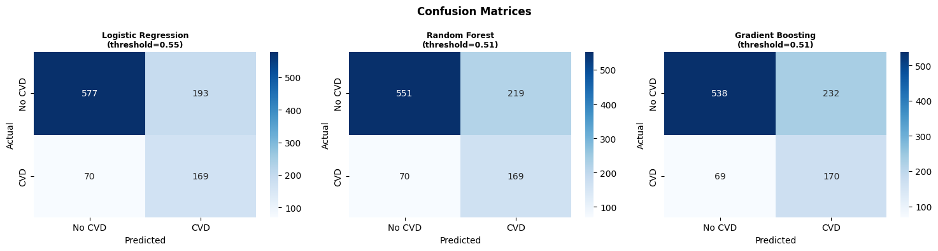
Figure 4. Confusion matrices at tuned decision thresholds.
Subgroup analysis (Logistic Regression):
Subgroup | n | AUC | Recall | AUC Drop
Age < 65 | 513 | 0.7289 | 0.2449 | 9.1%
Age >= 65 | 496 | 0.7208 | 0.8263 | 10.1% (flagged)
Male | 448 | 0.7579 | 0.7903 | 5.5%
Female | 561 | 0.8422 | 0.6174 | —

The model works best for older patients (Recall = 82.6%) and females (AUC = 0.8422). Recall for patients under 65 is only 24.5% — a significant limitation.

Step 11 — SHAP Interpretation
What was done: SHAP LinearExplainer was applied to the best model (Logistic Regression). SHAP values were computed on the test set. One-hot-encoded columns were collapsed back to their parent feature names. Three waterfall plots show individual-level explanations for the highest-risk, lowest-risk, and a borderline patient.
Feature importance ranked by mean absolute SHAP value:
Rank | Feature | Mean |SHAP| | Category
1 | age_at_baseline | 0.7336 | Health
2 | sex | 0.4002 | Health
3 | taking_bp_medication | 0.3408 | Health
4 | smoking_status | 0.1689 | Health
5 | hdl_cholesterol | 0.1531 | Health
6 | systolic_bp | 0.1463 | Health
7 | diastolic_bp | 0.1385 | Health
8 | apnea_events_per_hour | 0.0886 | Sleep
9 | waist_circumference_cm | 0.0669 | Health
10 | history_of_diabetes | 0.0597 | Health
11 | self_reported_hypertension | 0.0521 | Health
12 | race | 0.0428 | Health
13 | min_oxygen_saturation | 0.0309 | Sleep

Sleep metrics account for 5.6% of total SHAP importance. Health indicators account for 94.4%.
Sanity check on SHAP directions:
- age_at_baseline: positive SHAP direction (older = higher risk). Confirmed.
- systolic_bp: positive SHAP direction (higher BP = higher risk). Confirmed.
- sleep_efficiency_pct: positive direction (expected negative). Flagged as multicollinearity artifact — r = −0.87 with wake_after_sleep_onset_min causes the model to assign opposing linear weights. The feature remains a valid clinical predictor.
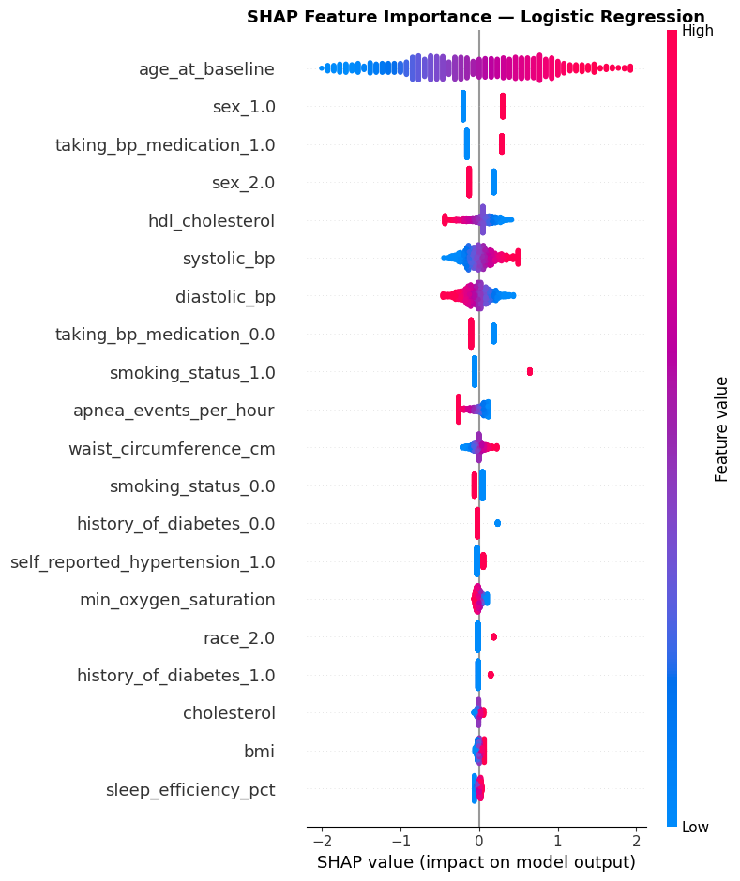
Figure 5. SHAP beeswarm plot. Each dot is one patient. Red = high feature value, blue = low. Age dominates.
Waterfall plots — individual patient explanations:
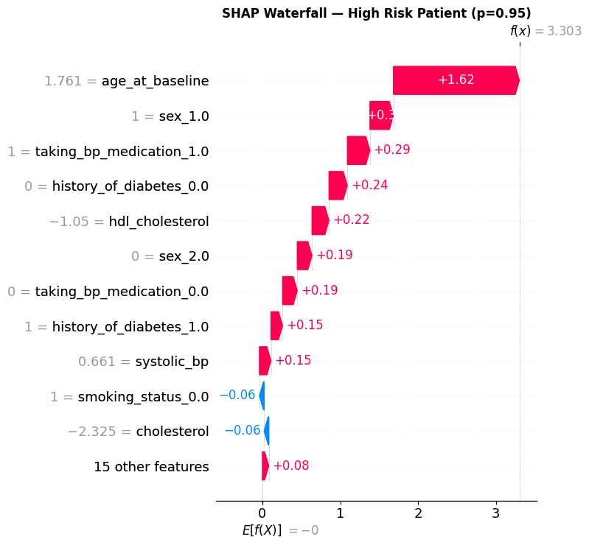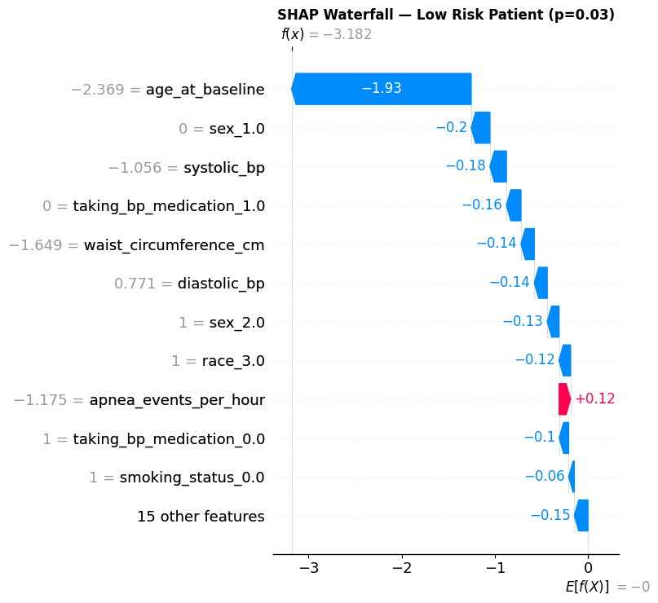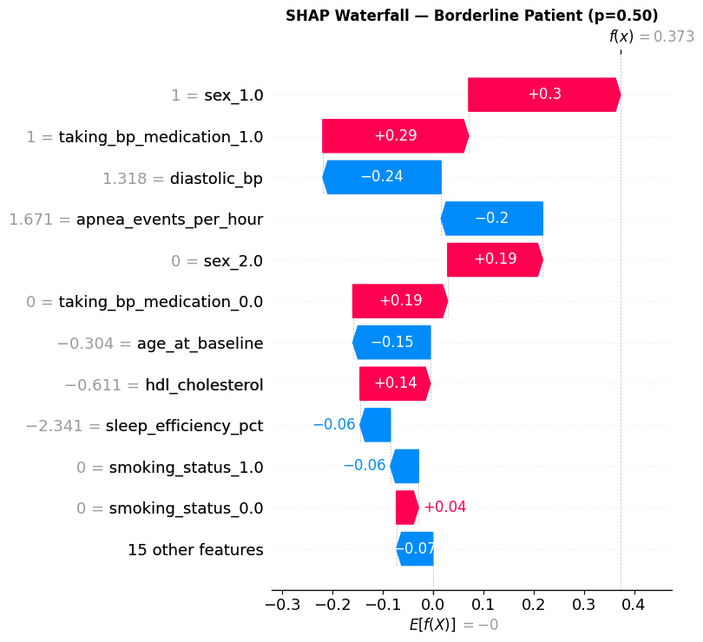
Figure 6. SHAP waterfall plots: highest-risk patient (left), lowest-risk patient (center), borderline patient (right).

Step 12 — Final Model Selection
Selection criteria: highest Recall among models that pass AUC > 0.75. Secondary: interpretability and training speed when metrics are close.
Model | AUC | Recall | F1 | AUC Pass | Recall Pass | Interpretable | Train Time
Logistic Regression | 0.8018 | 0.7071 | 0.5624 | PASS | PASS | High | 0.8s
Random Forest | 0.7905 | 0.7071 | 0.5391 | PASS | PASS | Medium | 13s
Gradient Boosting | 0.7893 | 0.7113 | 0.5304 | PASS | PASS | Medium | 82s

Selected: Logistic Regression.
All three models pass both thresholds. Logistic Regression has the highest AUC (0.8018) and F1 (0.5624). Its linear structure means SHAP values directly correspond to model coefficients — the clearest path to clinical explanation. Gradient Boosting has the highest Recall (0.7113) but the difference is 0.004 — within noise — and takes 100x longer to train.

Part 3 — Results

Step 13 — Results, Limitations, and Conclusion
Research Question 1: Can we predict CVD risk using sleep and health data?
Yes. Logistic Regression achieved AUC = 0.8018 — exceeding the 0.80 target and matching the best published SHHS results (0.75–0.84). Recall reached 0.7071 at threshold 0.55. The model correctly identifies 7 out of 10 CVD patients on unseen data.
Research Question 2: Top 5 sleep metrics and top 5 health indicators.
Rank | Sleep Metric | Mean |SHAP|
1 | apnea_events_per_hour | 0.0886
2 | min_oxygen_saturation | 0.0309
3 | sleep_efficiency_pct | 0.0189
4 | avg_oxygen_saturation | 0.0000
5 | wake_after_sleep_onset_min | 0.0000

Rank | Health Indicator | Mean |SHAP|
1 | age_at_baseline | 0.7336
2 | sex | 0.4002
3 | taking_bp_medication | 0.3408
4 | smoking_status | 0.1689
5 | hdl_cholesterol | 0.1531

Apnea events per hour is the dominant sleep predictor. It captures airway obstruction frequency and downstream oxygen stress on the cardiovascular system. Age is the single strongest predictor overall, with a SHAP value 8x larger than the next health indicator. Sleep data contributes 5.6% of total predictive signal — meaningful, but secondary to established clinical risk factors.
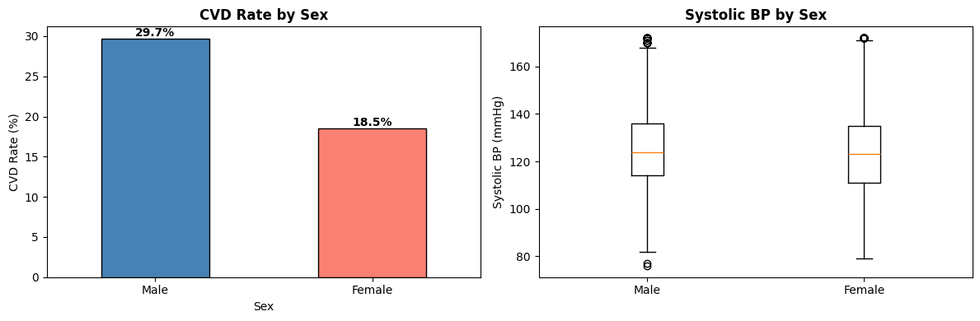
Figure 7. CVD rate by sex. Males have a 29.7% CVD rate vs 18.5% for females.
Limitations:
- Dataset covers 1995–1998. Patient risk profiles may not reflect modern populations.
- 5,042 patients limits subgroup reliability for minority strata.
- Recall = 24.5% for patients under 65 — the model is unreliable for younger patients.
- For educational purposes only. Not validated for clinical diagnosis.
Future work:
- Validate on post-2010 polysomnography datasets.
- Test LightGBM and CatBoost for AUC improvement beyond 0.80.
- Apply survival analysis to model time-to-CVD-event.
- Collect features targeted at younger patients to close the subgroup gap.
Recommendations:
- For healthcare providers: prioritize CVD screening for patients with AHI > 15, age over 65, and blood pressure medication use.
- For healthcare systems: AHI and minimum oxygen saturation are already collected in standard sleep studies — no new data collection is required to integrate this signal.
- Do not apply this model to patients under 65 without retraining.
Conclusion:
Logistic Regression trained on 5,042 SHHS patients achieved AUC = 0.8018 and Recall = 0.7071, meeting both success criteria. Age, sex, and blood pressure medication use are the strongest predictors. Apnea events per hour is the most important sleep metric. Sleep data contributes a meaningful but secondary signal (5.6% of total SHAP). The model is most reliable for patients 65 and older and for female patients. Improving performance for younger patients is the primary direction for future work.

Part 4 — Deployment

Step 14 — Deployment
What was done: The trained pipeline was packaged for reproducibility and deployment.
- Output/model.pkl: Logistic Regression sklearn pipeline saved with joblib (~5.6 KB). Verified reload and test prediction (85.1% CVD probability for the demo patient).
- src/predict.py: CLI tool. Accepts a CSV file with 18 feature columns; prints CVD risk and probability per row.
- src/app.py: Streamlit web application. Reads shap_top_features.json to determine the 10 input fields (top 5 sleep + top 5 health). Remaining 8 features are filled with population medians. Outputs risk badge, CVD probability, and personalized SHAP bar charts.
- Dataset/sample_input_patient.csv: Demo patient — 68-year-old male with moderate-severe apnea (AHI=20.5), hypertension, and BP medication. Predicted CVD probability: 85.1%.
- README.md and requirements.txt: Full project documentation and dependency list.
- GitHub: All files pushed to https://github.com/JerryHsu1117/cvd-risk-prediction-shhs
Launch the Streamlit app:
streamlit run src/app.py
Run CLI predictions:
python src/predict.py --input Dataset/sample_input_patient.csv

Dataset citation: Zhang et al. (2018). The National Sleep Research Resource. Sleep, 41(10). https://doi.org/10.1093/sleep/zsy217

