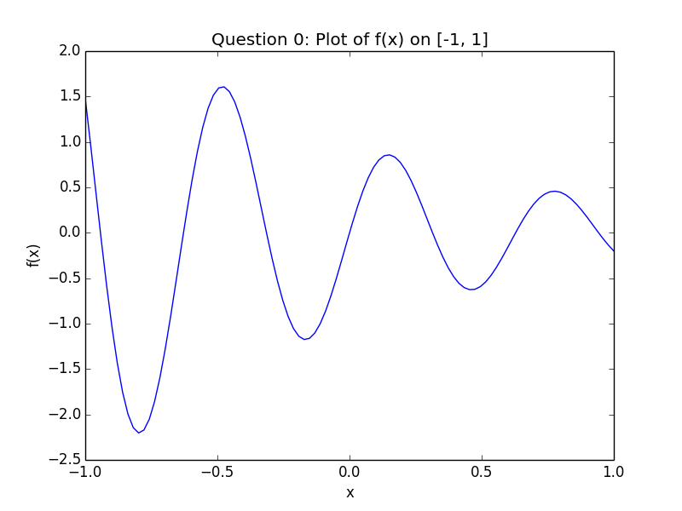

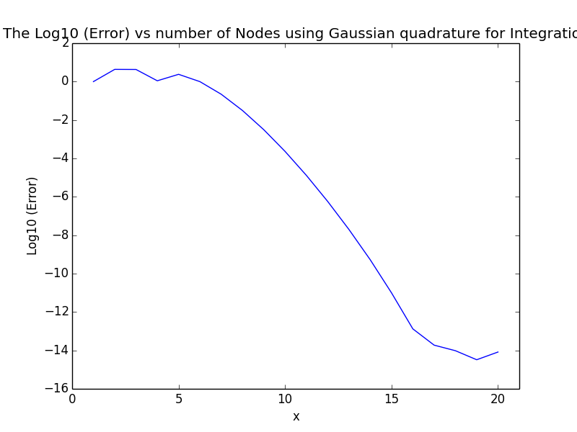

/System/Library/Frameworks/Python.framework/Versions/2.7/bin/python2.7 "/Users/Jerry/Google Drive/2017 fall/CS 514/Homework/hw5/hw5.py"

Istar is -0.178639805625

The result and relative error calculated by Composite trapezoidal rule with 100 points is : -0.17613229854 -0.0140366648797

The result and relative error calculated by Composite trapezoidal rule with 200 points is : -0.17756733892 -0.00600351473826

The result and relative error calculated by Composite Simpson rule with 100 points is : -0.177446216623 -0.00668153997538

The result and relative error calculated by Composite Simpson rule with 200 points is : -0.178043876161 -0.00333592763754

The result and relative error calculated by Gaussian quadrature rule with 10 points is : -0.17868114503 0.000231412054206

The result and relative error calculated by Gaussian quadrature rule with 20 points is : -0.178639805625 -8.23470168072e-15

Composite trapezoidal rule: The reduction ratio in error when doubling n is : 2.33807452662

Composite Simpson rule: The reduction ratio in error when doubling n is : 2.00290315059

Gaussian quadrature rule: The reduction ratio in error when doubling n is : 28102056780.9

Process finished with exit code 0