Problem 1: Search Algorithms

1. Depth-First Search

The solution is found.

The squares expanded in order: W-N-Y-R-I-B-M-D-J-S-H

The solution path: W-N-Y-R-I-B-M-J-S-H

1. Iterative-Deepening Search

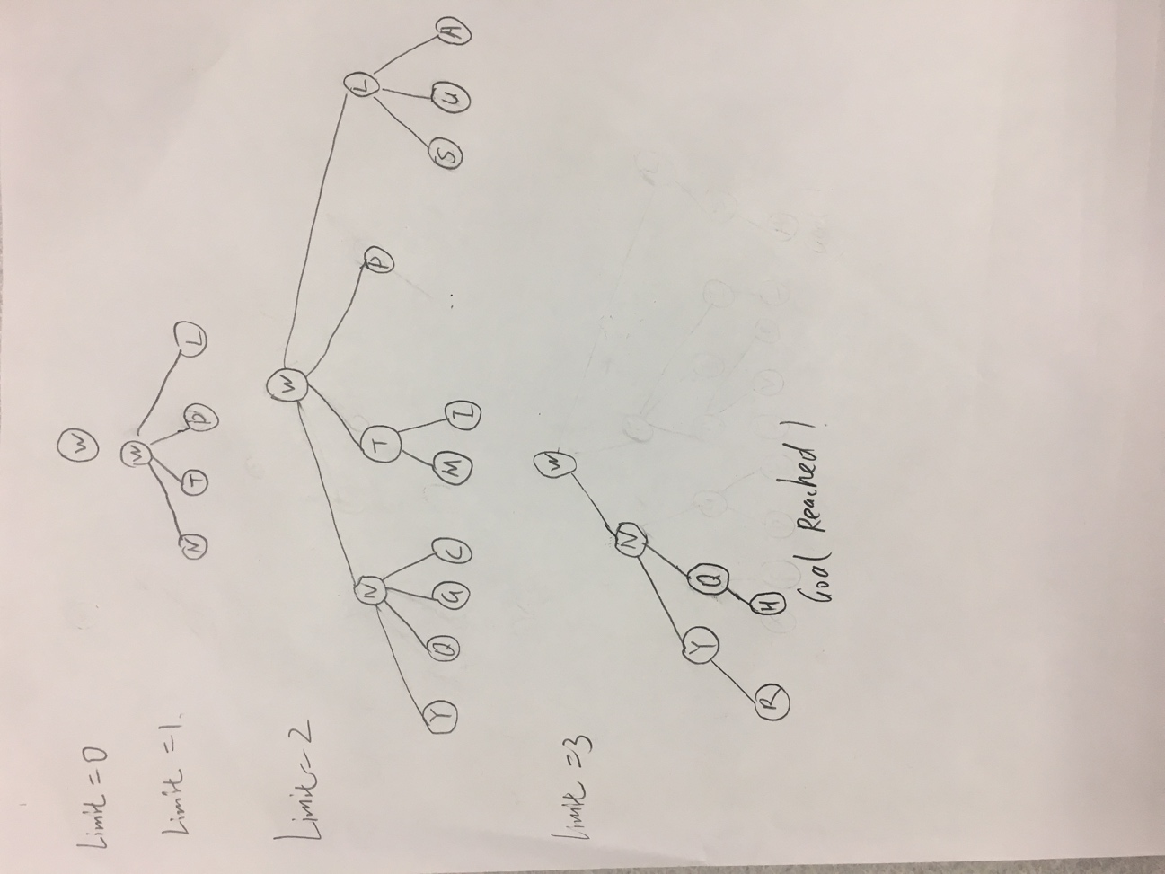

1. Heuristic Function

The h(n) is not admissible. Due to the definition of the admissible heuristic function, h(n) <= h*(n), with h*(n) refers to the actual cost of the minimum-cost path from n to goal. However, on the board, the h(n) could sometimes be larger than h*(n). For example, in the board, suppose the knight is at position Q and the goal is at position H, the minimum cost of moving from n to goal is just 1 because each move of the knight has cost 1 and knight just need one move to reach the goal. However, the heuristic function h(n) would give a value of 3 in this case. h(n) > h*(n) in this case, so h(n) is not admissible.

1. Algorithm A Search {State(fvalue, parent, gvalue)}

|  |  |  |
| --- | --- | --- |
| Step | Frontier{State(fvalue, parent, gvalue)} | Expanded(State, gvalue) |
| 1 | W(3,null,0) | --- |
| 2 | L(3,W,1), N(3,W,1), P(5,W,1),T(5,W,1) | (W,0) |
| 3 | C(3,L,2), I(3,L,2), N(3,W,1), A(5,W,2), P(5,W,1), S(5,L,2), T(5,W,1), U(7,L,2) | (W,0) (L,1) |
| 4 | I(3,L,2), N(3,W,1), A(5,W,2), F(5,C,3), J(5,C,3), P(5,W,1), S(5,L,2), T(5,W,1), U(7,L,2) | (W,0) (L,1) (C,2) |
| 5 | N(3,W,1), A(5,W,2), B(5,I,3), F(5,C,3), J(5,C,3), P(5,W,1), R(5,I,3), S(5,L,2), T(5,W,1), U(7,L,2) | (W,0) (L,1) (C,2) (I,2) |
| 6 | G(3,N,2), A(5,W,2), B(5,I,3), F(5,C,3), J(5,C,3), P(5,W,1), Q(5,N,2), R(5,I,3), S(5,L,2), T(5,W,1), U(7,L,2), Y(7,N,2) | (W,0) (L,1) (C,2) (I,2) (N,1) |
| 7 | A(5,W,2), B(5,I,3), D(5,G,3),F(5,C,3), J(5,C,3), P(5,W,1), Q(5,N,2), R(5,I,3), S(5,L,2), T(5,W,1), U(7,L,2), Y(7,N,2) | (W,0) (L,1) (C,2) (I,2) (N,1), (G,2) |
| 8 | H(3,A,3), B(5,I,3), D(5,G,3),F(5,C,3), J(5,C,3), P(5,W,1), Q(5,N,2), R(5,I,3), S(5,L,2), T(5,W,1), U(7,L,2), Y(7,N,2) | (W,0) (L,1) (C,2) (I,2) (N,1), (G,2), (A,2) |
| 9 | B(5,I,3), D(5,G,3),F(5,C,3), J(5,C,3), P(5,W,1), Q(5,N,2), R(5,I,3), S(5,L,2), T(5,W,1), U(7,L,2), Y(7,N,2) | (W,0) (L,1) (C,2) (I,2) (N,1), (G,2), (A,2), (H,3) Goal Found! |