Jieru Hu

Problem 1 Minimax and Alpha-Beta

(a)

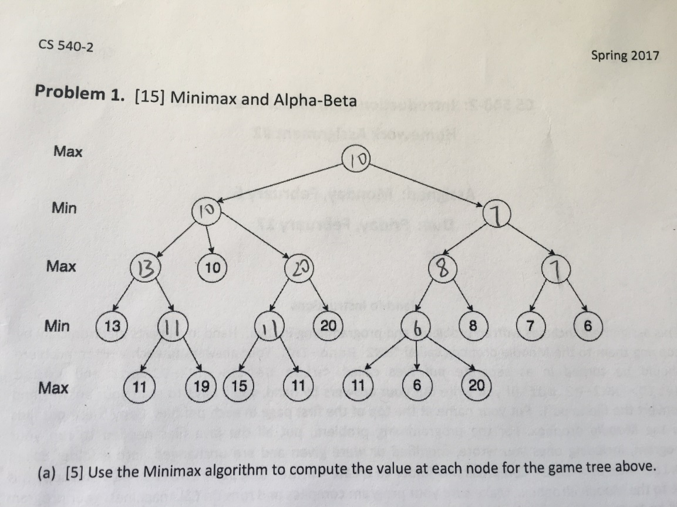

(b)

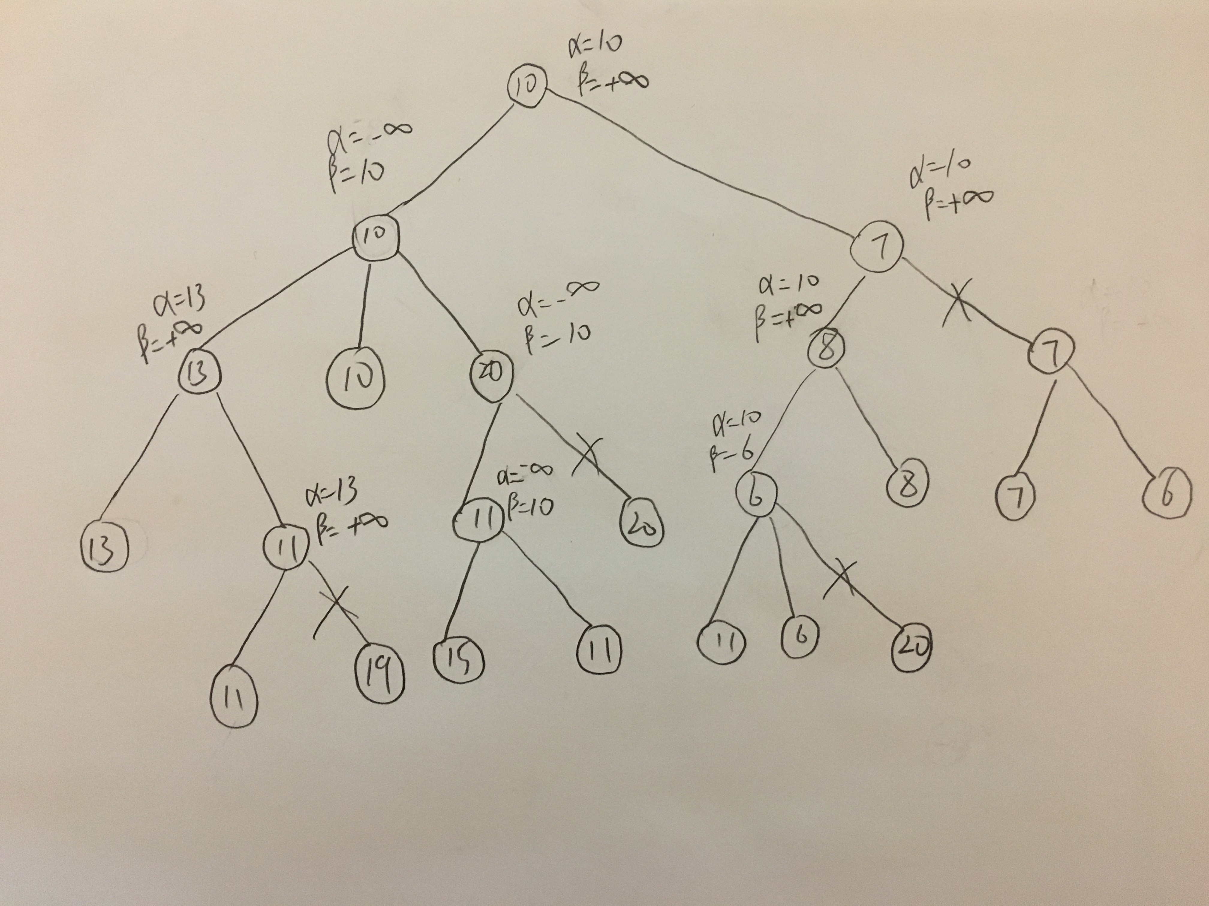

(c) No, they would produce the same move. This is because both minimax and alpha-beta algorithm is optimal and would always find the best solution, returns the best heuristic function value. So if they are using the same tie breaking rule, their next move predicted would be the same.