Problem 2 **Neural Networks and Back-Propagation**

|  |  |  |
| --- | --- | --- |
| A | B | (A ∨ ¬B) ∧ (¬A ∨ B) |
| 0 | 0 | 1 |
| 1 | 0 | 0 |
| 0 | 1 | 0 |
| 1 | 1 | 1 |

(a)

It is not possible to implement it using a perceptron.

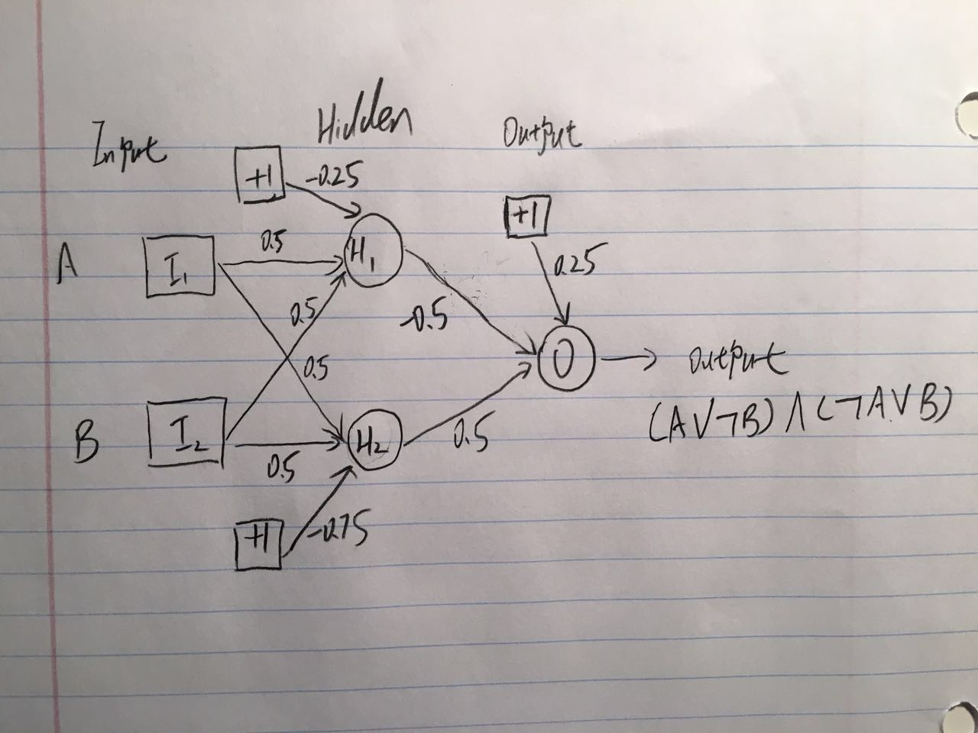

Case (A=0, B=0) => H1 = 0, H2 =0 => Output = 1

Case (A=1, B=0) => H1 = 1, H2 =0 => Output = 0

Case (A=0, B=1) => H1 = 1, H2 =0 => Output = 0

Case (A=1, B=1) => H1 = 1, H2 =1 => Output = 1

(b)

(i)

The sigmoid function: g(x) = 1/(1+e-x) g(x)’ = g(x)*(1-g(x))

D_in = 0.3*0.3 + 0.8*0.3 + 0.1*0.3 + 1*0.2 = 0.56

D_a = g (0.56) = 0.6365

E_in = 0.3*-0.1 + 0.8*-0.1 + 0.1*-0.1 + 1*0.2 = 0.08

E_a = g (0.08) = 0.5200

F_in = 0.636*0.3 + 0.52*-0.1 + 1*0.2 = 0.3388

F_a = g (0.3388) = 0.5839

The output of D is 0.6365, the output of E is 0.5200 and the output of F is 0.5839.

(ii)

Delta_F = (1-0.5839)*0.5839*(1-0.5839) = 0.1011

Delta_D = 0.6365*(1-0.6365)*0.3*0.1011 = 0.0070

Delta_E = 0.52*(1-0.52)*-0.1*0.1011 = -0.0025

wdf = 0.3+ 0.2*0.6365*0.1011 = 0.3129

wef = -0.1 + 0.2*0.5200*0.1011 = -0.0895

w1f = 0.2 + 0.2*1*0.1011 = 0.2202

wad = 0.3 + 0.2*0.3*0.0070 = 0.3004

wae = -0.1 + 0.2*0.3*-0.0025 = -0.1002

wbd = 0.3 + 0.2*0.8*0.0070 = 0.3011

wbe = -0.1 +0.2*0.8*-0.0025 = -0.1004

wcd = 0.3 + 0.2*0.1*0.0070 = 0.3001

wce = -0.1 + 0.2*0.1*-0.0025 = -0.1001

w1d = 0.2 + 0.2*1*0.0070 = 0.2014

w1e = 0.2 + 0.2*1*-0.0025 = 0.1995