To run the file, type: python P3_2.py

Sample Input:

The test cases cover all different cases for point’s location corresponding to the triangle.

testPoints.txt:

0 6

2 9

5 0

8 9

10 6

2 6

7 8

3 4

5 5

7 4

3 8

5 9

8 6

Sample Output:

The number of Triangles is 18

The number of vertices is 13

The number of edges is 29

The output graph is attached as following:

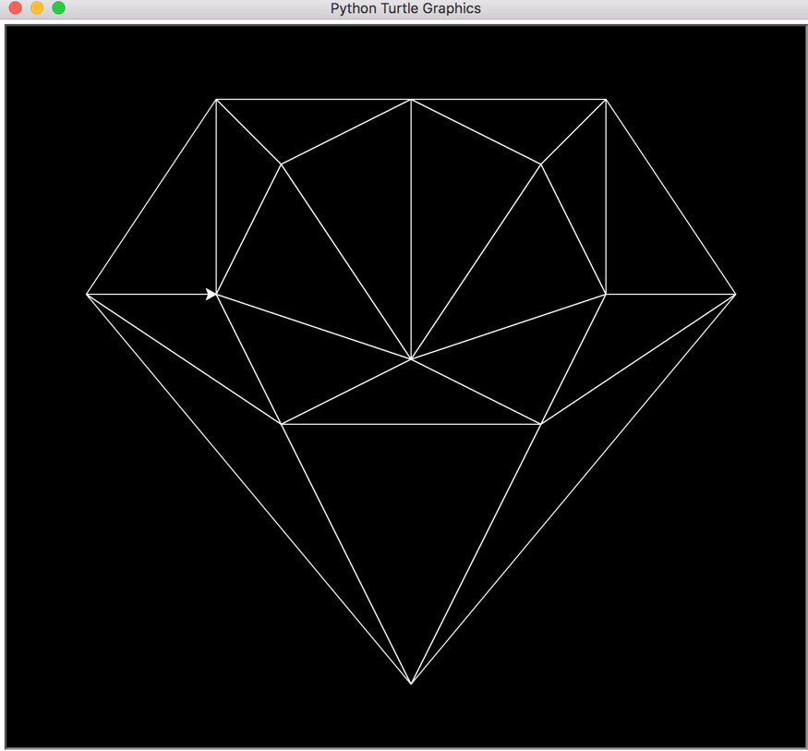

The code also runs correctly on the sample runs given on the moodle.