To run the file, type: python P4.py

Part 1

For the voronoi diagram part, only uncomment the drawVoronoi method and leave the main method like this.

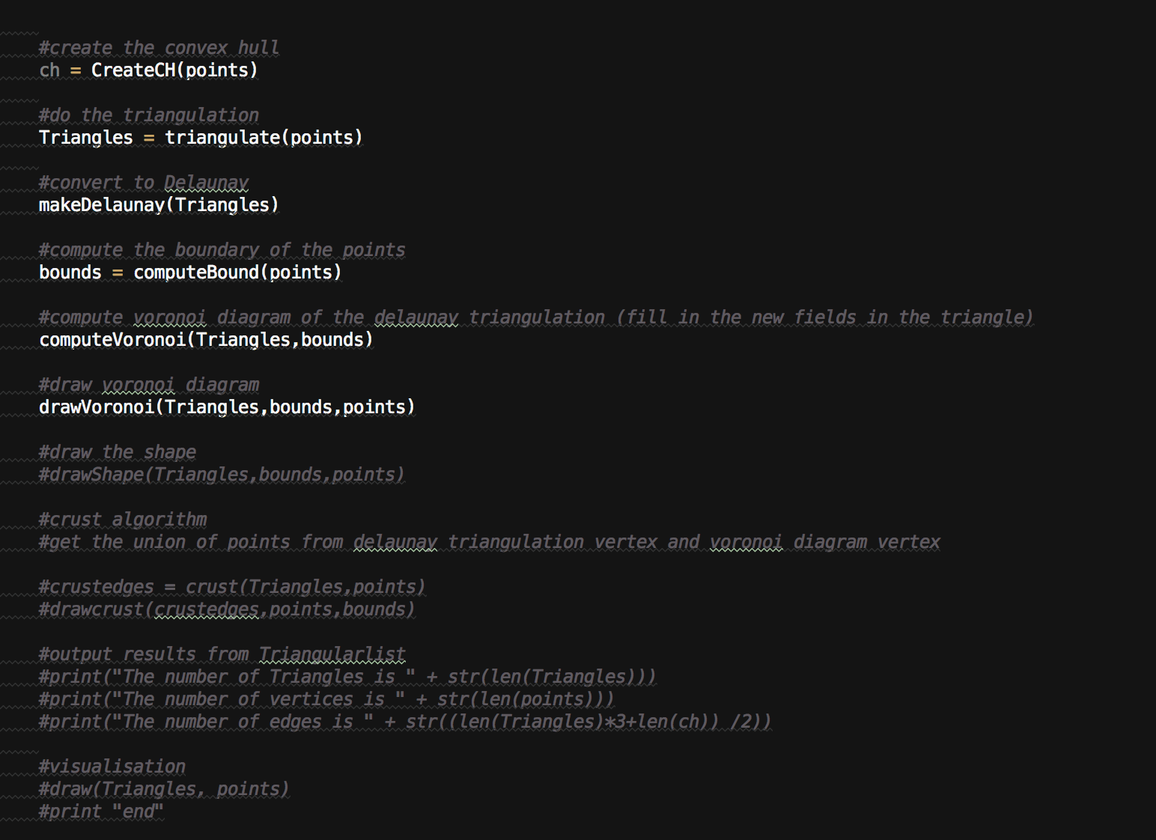

Case 1:

Sample Input:

testPoints.txt:

0 6

2 9

5 0

8 9

10 6

2 6

7 8

3 4

5 5

7 4

3 8

5 9

8 6

Sample Output graph:

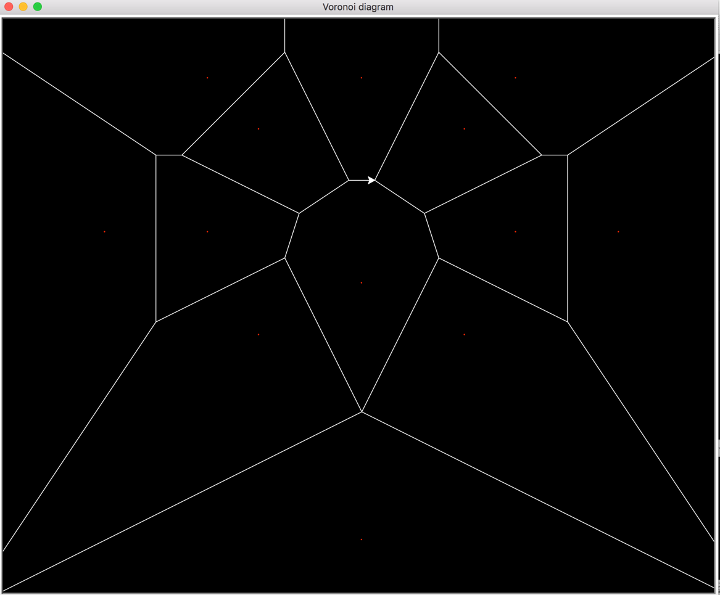

Case 2:

Sample Input:

Points generated by the curve from mathworld

testPoints.txt:

0.0 5.0

0.0159201731166 5.20298728715

0.125462075961 5.78818260276

0.412934841426 6.68711859307

0.944863763835 7.79474338865

1.76312651683 8.98173420845

2.88031915723 10.1093721264

4.27777478026 11.0450272701

5.90642036859 11.6762670399

7.69040339459 11.9218427614

9.53317178546 11.7382927731

11.3254710973 11.1215475746

12.9545508048 10.1036372351

14.3137628617 8.74527647606

15.3116998495 7.12564032522

15.8800603099 5.33096741689

15.9795416718 3.44369720342

15.6032364547 1.53365956128

14.7772295208 -0.347572215757

13.5583432226 -2.16861122191

12.0292311147 -3.91653131029

10.2912567978 -5.59212387174

8.45579139178 -7.20322234428

6.63470348857 -8.75743222081

4.93088671122 -10.2556279925

3.42966582215 -11.687377036

2.19184308036 -13.029063734

1.24899931943 -14.244984012

0.601462169518 -15.2911473768

0.219115030239 -16.1210500702

0.0449661557514 -16.692347324

0.00115025517124 -16.97320909

-0.00318259623904 -16.9472135332

-0.0628047546177 -16.615901621

-0.266994473948 -15.9985366437

-0.690615692389 -15.1291115687

-1.38650039927 -14.0511388159

-2.37982333809 -12.8111566209

-3.66498058865 -11.4521242175

-5.20525957453 -10.0079121095

-6.93533827169 -8.49991533933

-8.76639816731 -6.93645427524

-10.5934014578 -5.31513799044

-12.3038889975 -3.62783088203

-13.7875189455 -1.86737390961

-14.9454991182 -0.0348521180406

-15.6990747214 1.85396532858

-15.9963166458 3.76432345899

-15.8166064122 5.64134042941

-15.1724186761 7.41257484055

-14.1082426566 8.99425982031

-12.6967384805 10.3005496329

-11.0324704778 11.2545865902

-9.22377498119 11.7998213689

-7.38348590508 11.9098736752

-5.61934253737 11.5953335172

-4.02493152014 10.9062673269

-2.67196649085 9.92975988962

-1.60458863108 8.78251216494

-0.836190178798 7.59922581235

-0.3490369913 6.51813150897

-0.0967156927582 5.66546481242

-0.00917818686347 5.14089084988

Sample output graph:

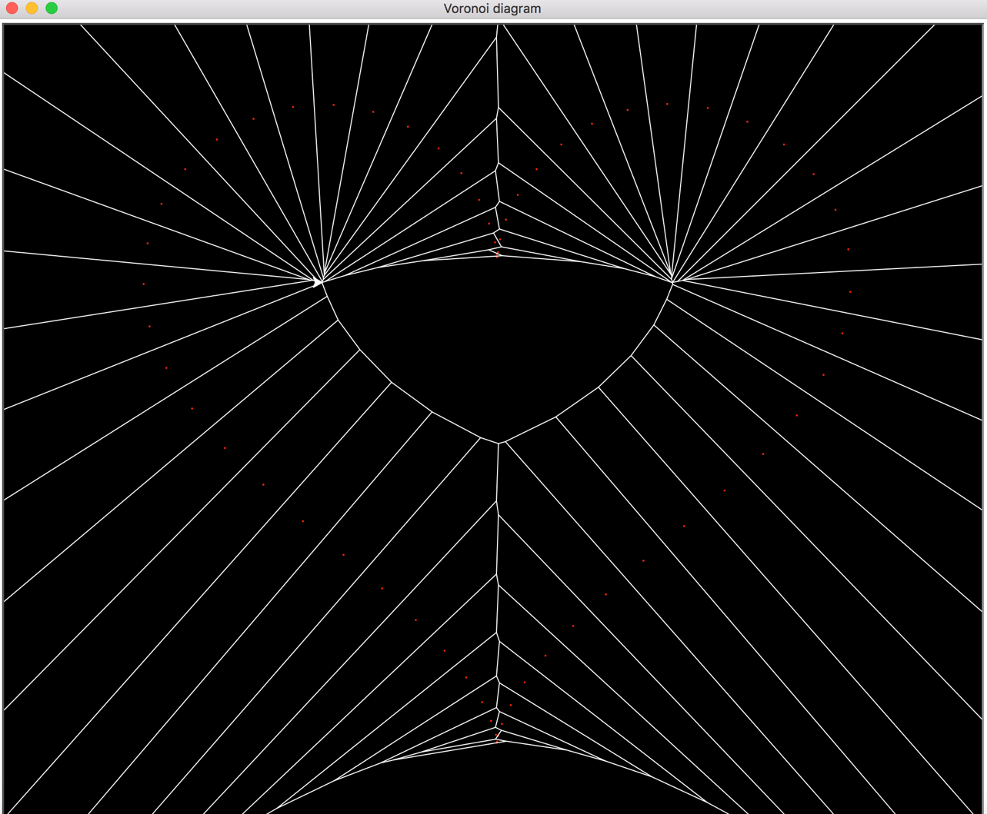

Part 2:

For the shape reconstruction part, only uncomment the drawShape method and leave the main method like this.

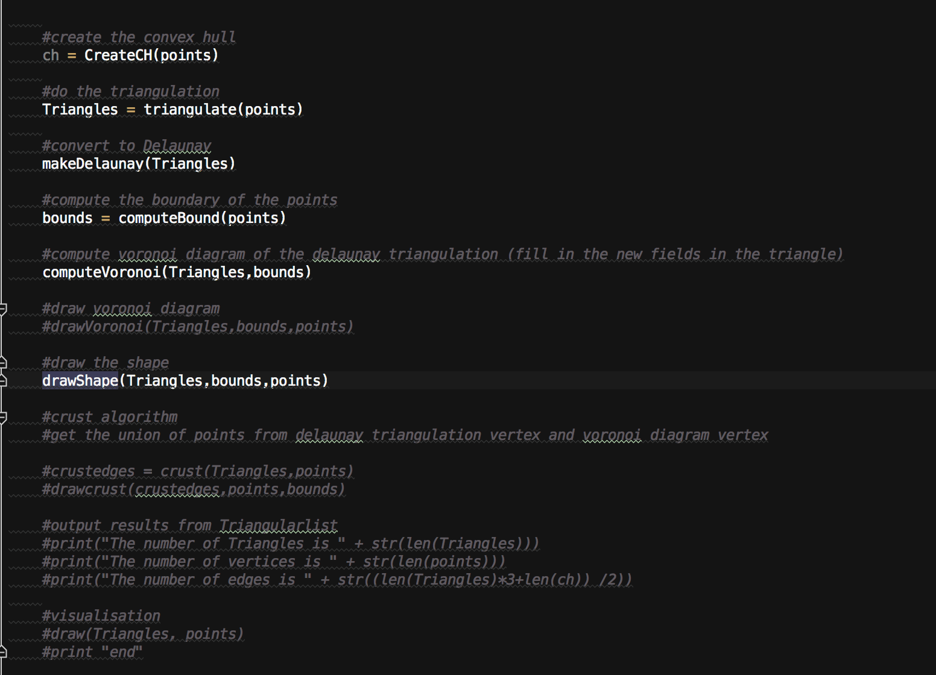

Sample Input:

Points generated by the curve from mathworld

testPoints.txt:

0.0 5.0

0.0159201731166 5.20298728715

0.125462075961 5.78818260276

0.412934841426 6.68711859307

0.944863763835 7.79474338865

1.76312651683 8.98173420845

2.88031915723 10.1093721264

4.27777478026 11.0450272701

5.90642036859 11.6762670399

7.69040339459 11.9218427614

9.53317178546 11.7382927731

11.3254710973 11.1215475746

12.9545508048 10.1036372351

14.3137628617 8.74527647606

15.3116998495 7.12564032522

15.8800603099 5.33096741689

15.9795416718 3.44369720342

15.6032364547 1.53365956128

14.7772295208 -0.347572215757

13.5583432226 -2.16861122191

12.0292311147 -3.91653131029

10.2912567978 -5.59212387174

8.45579139178 -7.20322234428

6.63470348857 -8.75743222081

4.93088671122 -10.2556279925

3.42966582215 -11.687377036

2.19184308036 -13.029063734

1.24899931943 -14.244984012

0.601462169518 -15.2911473768

0.219115030239 -16.1210500702

0.0449661557514 -16.692347324

0.00115025517124 -16.97320909

-0.00318259623904 -16.9472135332

-0.0628047546177 -16.615901621

-0.266994473948 -15.9985366437

-0.690615692389 -15.1291115687

-1.38650039927 -14.0511388159

-2.37982333809 -12.8111566209

-3.66498058865 -11.4521242175

-5.20525957453 -10.0079121095

-6.93533827169 -8.49991533933

-8.76639816731 -6.93645427524

-10.5934014578 -5.31513799044

-12.3038889975 -3.62783088203

-13.7875189455 -1.86737390961

-14.9454991182 -0.0348521180406

-15.6990747214 1.85396532858

-15.9963166458 3.76432345899

-15.8166064122 5.64134042941

-15.1724186761 7.41257484055

-14.1082426566 8.99425982031

-12.6967384805 10.3005496329

-11.0324704778 11.2545865902

-9.22377498119 11.7998213689

-7.38348590508 11.9098736752

-5.61934253737 11.5953335172

-4.02493152014 10.9062673269

-2.67196649085 9.92975988962

-1.60458863108 8.78251216494

-0.836190178798 7.59922581235

-0.3490369913 6.51813150897

-0.0967156927582 5.66546481242

-0.00917818686347 5.14089084988

Sample output graph:

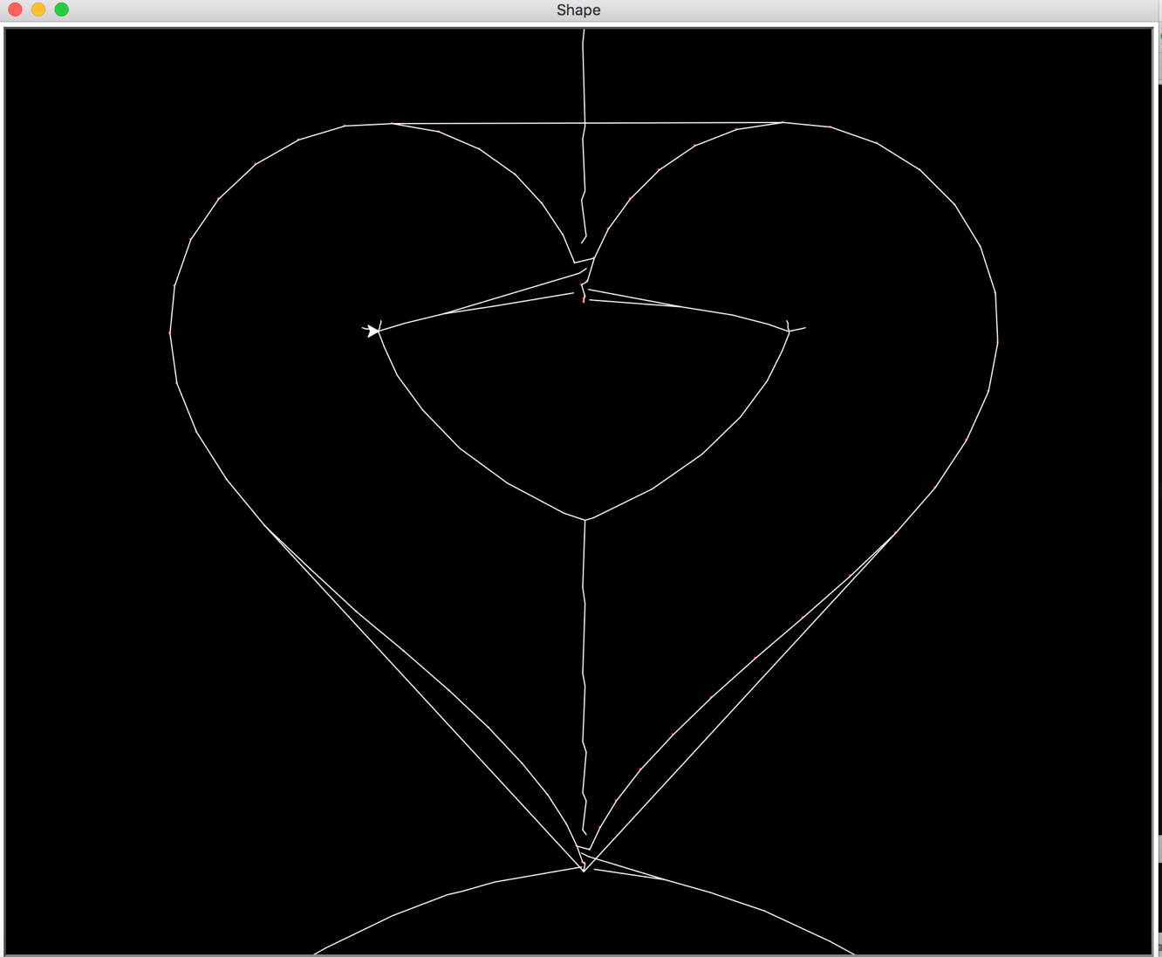

Part 3:

For the crust algorithm part, only uncomment the crust and drawcrust method, leave the main method like this.

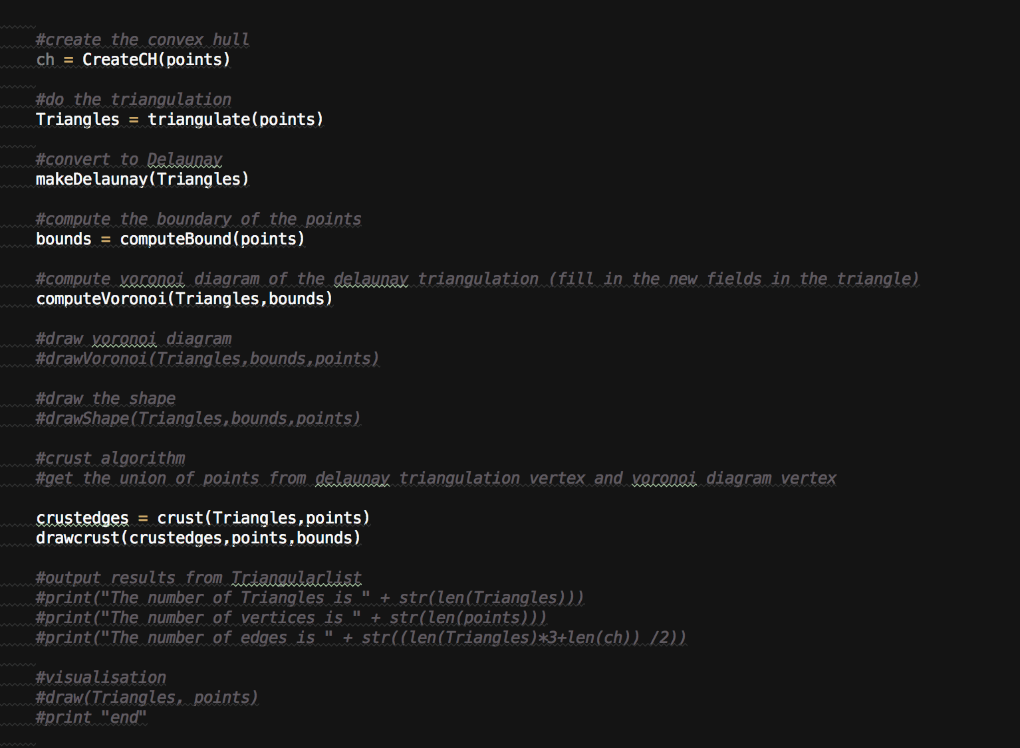

Sample Input:

Points generated by the curve from mathworld

testPoints.txt:

0.0 5.0

0.0159201731166 5.20298728715

0.125462075961 5.78818260276

0.412934841426 6.68711859307

0.944863763835 7.79474338865

1.76312651683 8.98173420845

2.88031915723 10.1093721264

4.27777478026 11.0450272701

5.90642036859 11.6762670399

7.69040339459 11.9218427614

9.53317178546 11.7382927731

11.3254710973 11.1215475746

12.9545508048 10.1036372351

14.3137628617 8.74527647606

15.3116998495 7.12564032522

15.8800603099 5.33096741689

15.9795416718 3.44369720342

15.6032364547 1.53365956128

14.7772295208 -0.347572215757

13.5583432226 -2.16861122191

12.0292311147 -3.91653131029

10.2912567978 -5.59212387174

8.45579139178 -7.20322234428

6.63470348857 -8.75743222081

4.93088671122 -10.2556279925

3.42966582215 -11.687377036

2.19184308036 -13.029063734

1.24899931943 -14.244984012

0.601462169518 -15.2911473768

0.219115030239 -16.1210500702

0.0449661557514 -16.692347324

0.00115025517124 -16.97320909

-0.00318259623904 -16.9472135332

-0.0628047546177 -16.615901621

-0.266994473948 -15.9985366437

-0.690615692389 -15.1291115687

-1.38650039927 -14.0511388159

-2.37982333809 -12.8111566209

-3.66498058865 -11.4521242175

-5.20525957453 -10.0079121095

-6.93533827169 -8.49991533933

-8.76639816731 -6.93645427524

-10.5934014578 -5.31513799044

-12.3038889975 -3.62783088203

-13.7875189455 -1.86737390961

-14.9454991182 -0.0348521180406

-15.6990747214 1.85396532858

-15.9963166458 3.76432345899

-15.8166064122 5.64134042941

-15.1724186761 7.41257484055

-14.1082426566 8.99425982031

-12.6967384805 10.3005496329

-11.0324704778 11.2545865902

-9.22377498119 11.7998213689

-7.38348590508 11.9098736752

-5.61934253737 11.5953335172

-4.02493152014 10.9062673269

-2.67196649085 9.92975988962

-1.60458863108 8.78251216494

-0.836190178798 7.59922581235

-0.3490369913 6.51813150897

-0.0967156927582 5.66546481242

-0.00917818686347 5.14089084988

Sample output graph:

