**RobotProject1 Using Agile with micro:bit Robot**

**Face Recognition**

This Project is in two parts. Part 1 will focus on planning using Agile methods and methodology, and part 2 will focus on Robot implementation and Presentation

**Part 1 – The Agile Process**

For a project focusing on Agile, consider a simplified, real-world application like a "face recognition" with Micro:bit robot, using a framework like Scrum, emphasizing iterative development, user stories, and collaboration.

**The Key Concepts to Emphasize are:**

* Iteration and Incremental Development: Emphasize that the project is developed in small, manageable increments.
* Collaboration: Encourage students to work together and communicate effectively.
* Feedback: Emphasize the importance of gathering feedback and adapting to changes.
* Prioritization: Teach students how to prioritize tasks based on value and importance.
* Time-boxing: Explain the importance of working within a defined time frame (sprint).

Here's a breakdown of how to approach the Agile phase:

**1. Project Ideas:**

• Micro:bit robot - Physical Programing - Face Recognition

**2. Agile Framework (Scrum):**

* Sprints: Divide the project into short timeboxes (sprints) of 3 days or 1 week. Including the Epics or functions you hope to complete.
* User Stories: Define project requirements for each Epic as user stories (e.g., "As a user, I want to be able to add a task so that I can remember it").
* Complete a Burndown Chart to document and manage your Sprints from the beginning of each sprint to the final actual implementation.

**3. Tools:**

* Project Management Software: Use tools like Excel to manage tasks, user stories, and sprints.
* Version Control: Use Git and GitHub for code management and collaboration.

**4. Example Project Structure**

Sprint 1: (2 Days)

* User Stories:
* As a developer, I want to be able to build a micro:bit robot.
* As a developer, I want to be able to show numbers on micro:bit led matrix
* Tasks:
* Set up project structure
* Implement task to build micro:bit robot
* Implement logic code to show user-defined numbers on micro:bit led matrix

Sprint 2: (3 Days)

* User Stories:
* As a developer, I want to be able to recognize different faces using micro:bit robot
* As a developer, I want to be able to link different face with different number image
* Tasks:
* Implement task to recognize faces
* Implement task to bind different face with different number image on led matrix

Sprint 3: (2Days)

* User Stories:
* As a developer, I want to be able to protect stored face images
* Tasks:
* Implement task to transform stored face images

**Burndown Chart Excel**

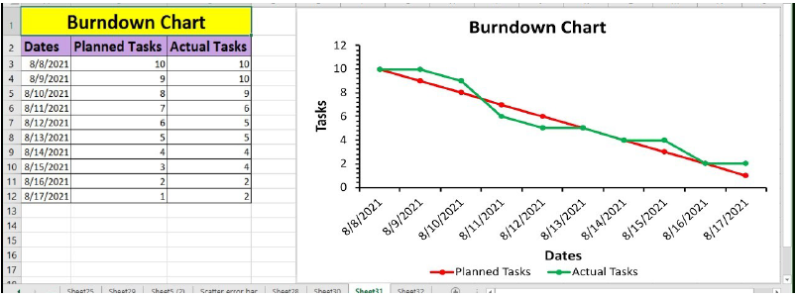

**Part 2 – Robot Project**

**Introduction**

For this Project, you will work in groups of TWO. You will each create your own Micro:bit/Components device. You group will create a new Remote Repository ProjectRobot1_2025. Assign a Maintainer to manage collaboration tasks. You will both act as Collaborators. Each member will use a unique Branch in the repository for their code. Merge the branches to main branch when the final version is complete. Do not delete the branches.

You’re going to make a robot using Micro:bit components and a Python script. This project gives you the opportunity to work collaboratively to create a robot. It also integrates closely with GitHub.

**1. Building the Robot**

‌Connect multiple components into a vision-enabled Intelligent Mini-car‌

**2. Display images on led matrix**

Create the Python program file to display different numbers, such as 1、2、3，on led matrix.

**3. Recognize faces**

Create the Python program file to recognize different faces, with different number images on led matrix.

**4. Protect face data**

Create the Python program file to hash recognized faces.

**5. Video Demo**

Create a 5 minute video demo / presentation of your project. Begin with a direct to camera introduction describing the purpose of the project. Then show clearly how the robot is set up.

Finally demonstrate the Project running, including the interaction with the physical components, as well as the screen output from the python program

**6. Submission**

* + ProjectRobot1 Report. PDF format. Including Cover Page and Table of Contents and Video URL.
* Part 1: Document The Agile Process
* Part 2: A report on the implementation of the project. Including
* Introduction
* Description of implementation: Tasks completed. Use screenshots, images of the final working components to support your report.
* Completed source code.
* Git command history for all team members using the remote repository on GitHub.
  + **Socio-Technical Analysis Report.** Follow the template attached.
  + Video Presentation: Upload Presentation video to bilibili or BaiduPan and share it. Include the URL Link and pwd (if required) to Presentation Video in your report.