Nanjing University of Information Science & Technology

Experiment (Internship) Report

|  |  |  |
| --- | --- | --- |
| 202283890036 | 黄家睿(Jerry Huang) | Internet of Things |

Extended Euclidean Algorithm

1．Experimental Purpose：

1. Understand the Extendd eulidean algorithm；
2. Implement and verify the Extended Euclidean Algorithm.

2．Experimental content：

1. Implement the Extended Euclidean Algorithm；
2. Run multiple examples to verify the cases where two numbers are coprime and not coprime.
3. Experimental steps
   1. Experiment code(Python):

Def EuclideanAlgorithm(a,b):

if b == 0:

return a

else:

x, y, res = EuclideanAlgorithm(b, a % b)

x, y = y (x-(a//b)*y)

return x,y res

return x, y, res

print(f"Please enter two numbers separated by a space:")

a, b = map(int, input().split())

X, y, res =EucliideanAlgorithm(a,b)

print(f"The greatest common divider of {a} and {b} is {EuclideanAlgorithm(a, b)}")

Print(f"And we also find the root of Xa + Yb =gcd(a,b), the equation is {x}*{a}+{y}*{b}={res}")

* 1. Expenriment result:
     1. Non-coprime case

Assume a=39, b=9, according to inference：

So the greatest common divisor of 39 and 3 is 3.

We input 39 and 9 into the code:

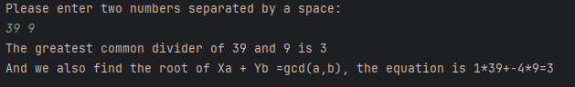

The result obtained is consistent with the prediction.

* + 1. Coprime case:

Assuming a=39, b=10, using the Euclidean algorithm, we can deduce that the greatest common divisor of a and b is 1.

We input a=39, b=10 into the code, and get:

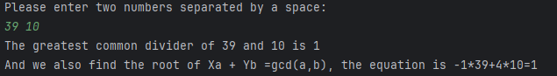

The result obtained is consistent with the prediction.

4．Experimental Analysis and Summarythm

This experiment solve the problem of the common divisor of two integers a and b, and we also find the root of the Xa+Yb=gcd(a,b). This algorithm is the basin algorithm of many function and the following algorithm.

The proof of the Expansion Euclidean Algorithm is: