D．User Interface Design

The GUI interface, or Graphical User Interface, is a type of user interface that allows users to interact with computer programs through graphical elements such as buttons, menus, icons, and more. The design of GUI interfaces should adhere to some fundamental principles, including usability, consistency, feedback, aesthetics, and others. In this CA assignment, we utilized Swing to implement the functionalities of the GUI.

1. MainWindow

In MainWindow, you can perform all operations, such as viewing the BakedGoodPanel, IngredientPane and other interfaces, adding BakedGood, Ingredient and Recipe, as well as save, load and search functions.

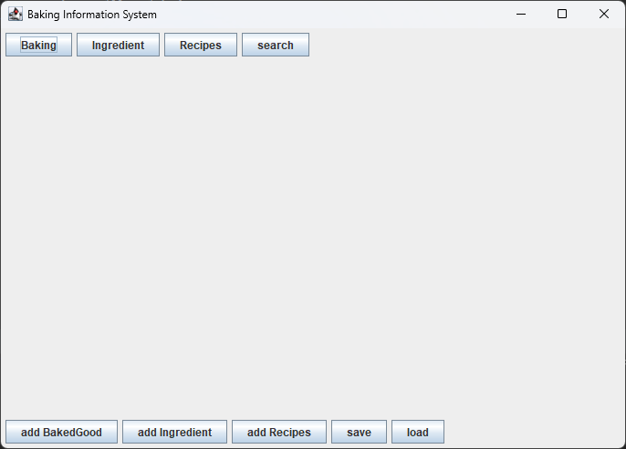

Figure: MainWindow show

* 1. BakingPanel

This button is on the above of the MainWindow and it is named as “Baking”.

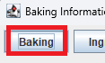

Figure: Baking Button show

Click this button, BakedGoodPanel will be showed in MainWindow.

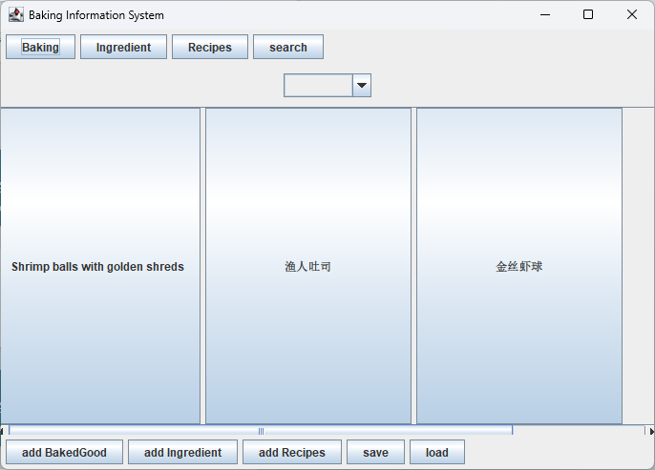

Figure: BakedGoodPanel show

You can see the BakedGood I added before.

* 1. IngredientPanel

This button is on the above of the MainWindow and it is named as “Ingredient”.



Figure: ingredient Button show

Click this button, IngredientPanel will be showed in MainWindow.

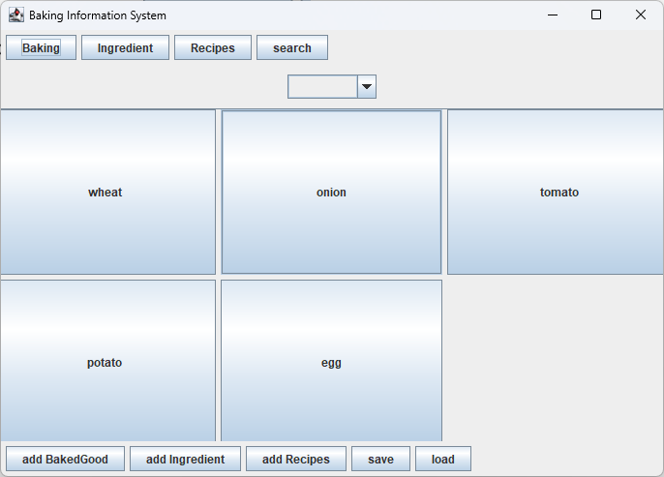

Figure: IngredientPanel show

You can see the ingredient I added before.

* 1. RecipePanel

This button is on the above of the MainWindow and it is named as “Recipe”.



Figure: recipe Button show

Click this button, IngredientPanel will be showed in MainWindow.

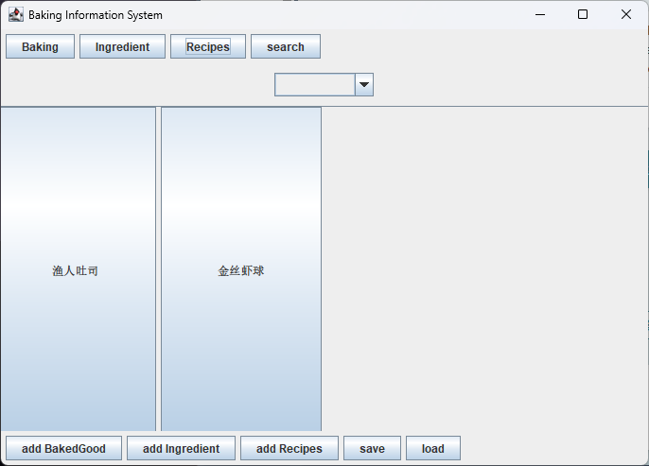

Figure: RecipePenal show

You can see the recipe I added before.

* 1. Search

This button is on the top of the MainWindow and it is named as “search”



Figure: search button show

Click this button, searchPanel will be showed in MainWindow.

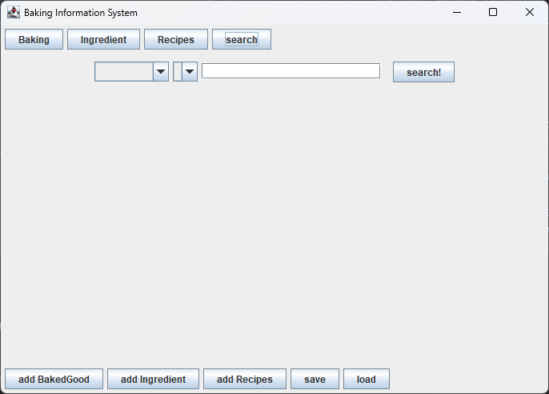

Figure: searchPanel show

In this panel, you can see two ComboBox, the first one is used to choose search type from

1. “BakedGood”
2. “Ingredient”
3. “Recipe”

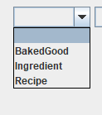

Figure: first ComboBox show

The second ComboBox only can be operated after you choose Item from the first ComboBox, otherwise the second ComboBox is empty.

If the first ComboBox select Item is BakedGood, the second ComboBox will appeal three Item to choose:

1. name
2. origin
3. description

If you choose “name”, enter the name of the BakedGood you want the TextField, then click the “Search” button, a dialog of the BakedGood you want will appear.

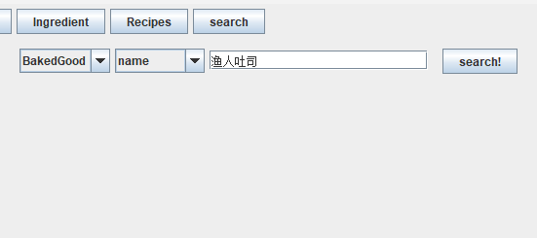 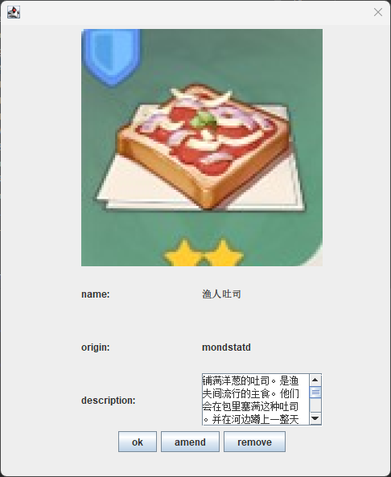

Figure: search BakedGood by name show

If you choose “origin”, enter the origin of the BakedGood you want the TextField, then click the “Search” button, a dialog of the BakedGood you want will appear.

If there are multiple BakedGood containing this origin, then all BakedGood containing it will appear.

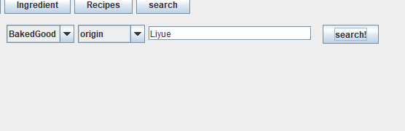 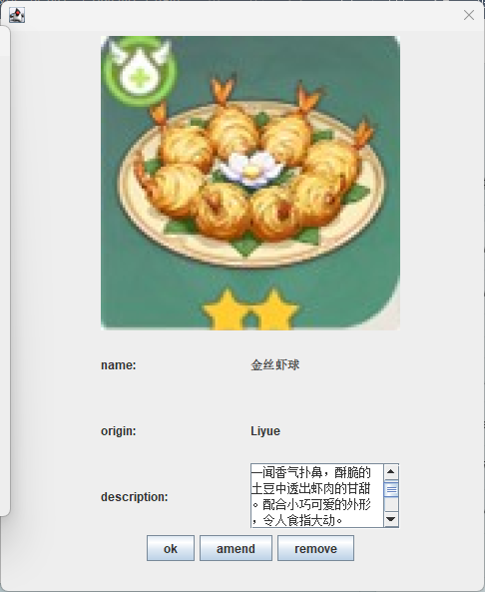

Figure: search BakedGood by origin show

If you choose “description”, enter the description of the BakedGood you want the TextField, then click the “Search” button, a dialog of the BakedGood you want will appear.

If there are multiple BakedGood containing this description, then all BakedGood containing it will appear.

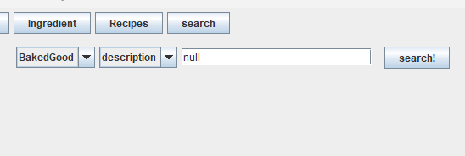 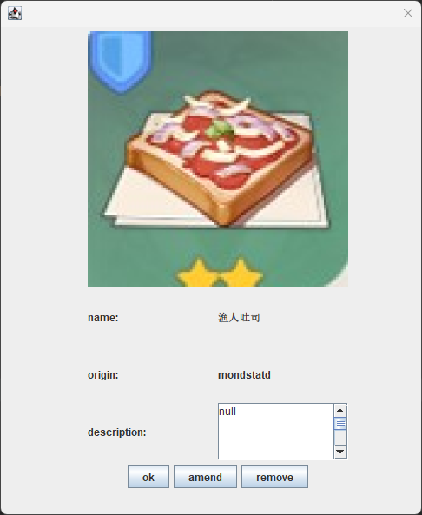

Figure: search BakedGood by description show

If the first ComboBox select Item is Ingredient, the second ComboBox will appeal three Item to choose:

1. name
2. description
3. calories

If you choose “name”, enter the description of the ingredient you want the TextField, then click the “Search” button, a dialog of the ingredient you want will appear.

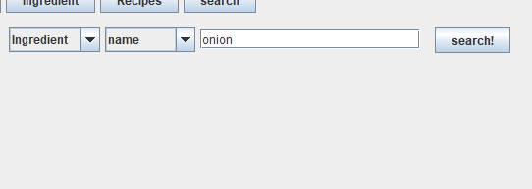 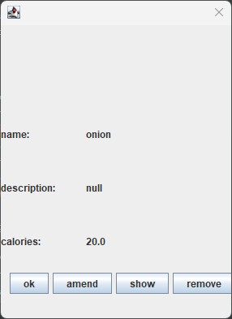

Figure: search ingredient by name show

If you choose “description”, enter the description of the ingredient you want the TextField, then click the “Search” button, a dialog of the ingredient you want will appear.

If there are multiple ingredients containing this description, then all ingredient containing it will appear.

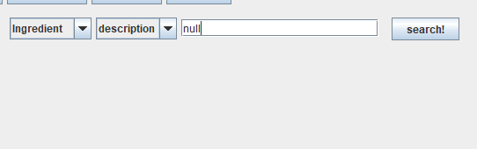 

Figure: search ingredient by description show

If you choose “calories”, enter the description of the ingredient you want the TextField, then click the “Search” button, a dialog of the ingredient you want will appear.

If there are multiple ingredients containing this description, then all ingredient containing it will appear.

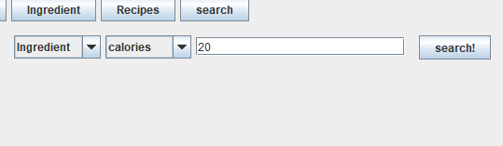 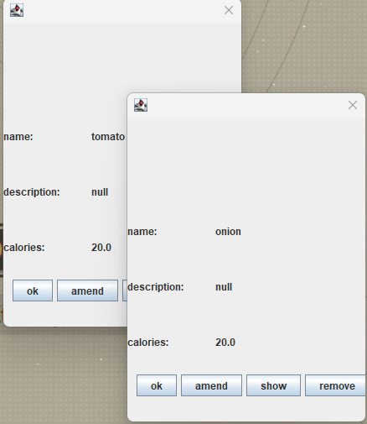

Figure: search ingredient by calories show

If the first ComboBox select Item is Ingredient, the second ComboBox will appeal two Item to choose:

1. name
2. calories

If you choose “name”, enter the name of the recipe you want the TextField, then click the “Search” button, a dialog of the recipe you want will appear.

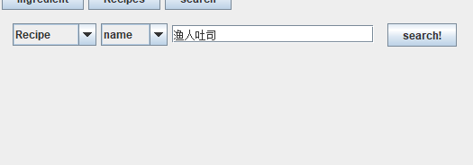 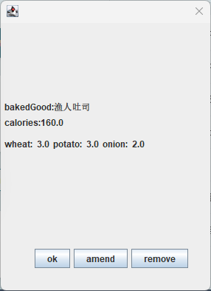

Figure: search recipe by name show

If you choose “calories”, enter the calories of the recipe you want the TextField, then click the “Search” button, a dialog of the recipe you want will appear.

If there are multiple recipes containing this “calories”, then all recipe containing it will appear.

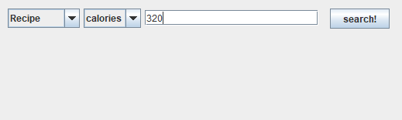 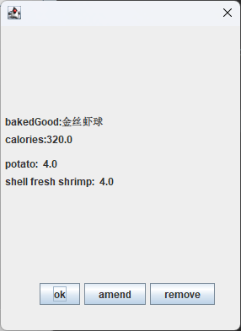

Figure: search recipe by calories show

* 1. ComboBox for different type of sort

This ComboBox provides different types to sort the Item contain in the panel.

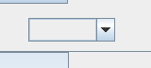

Figure: sort ComboBox show

If you are in BakingPanel, the item showed in the ComboBox is

1. name
2. origin
3. description

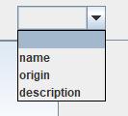

Figure: sort ComboBox in BakedGoodPanel show

If you choose “name”. The item showed in BakingPanel will be sorted by name.

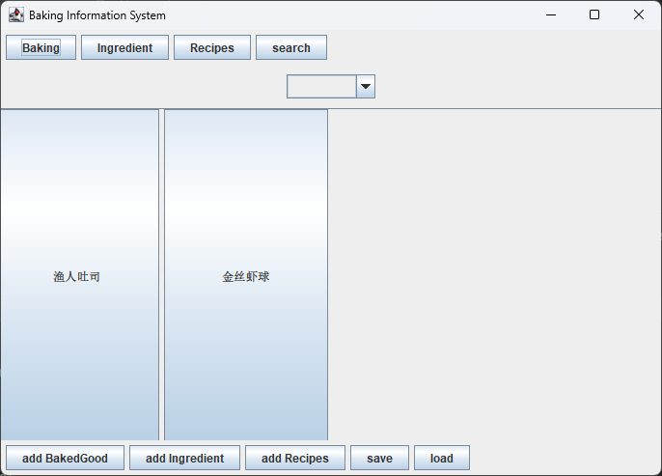

Figure: BakedGood after click sort ComboBox “name”

If you choose “origin”. The item showed in BakingPanel will be sorted by origin

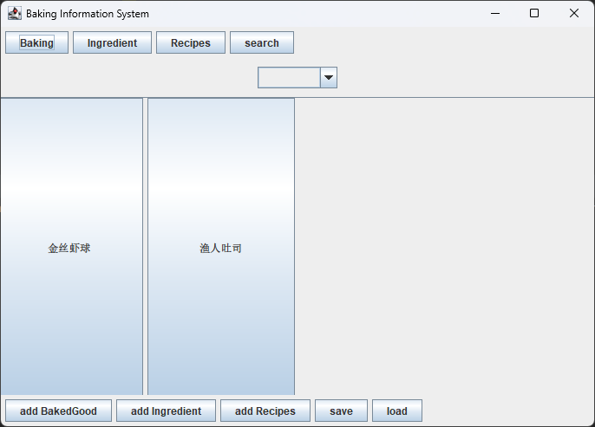

Figure: BakedGood after click sort ComboBox “origin”

If you choose “description”. The item showed in BakingPanel will be sorted by description.



Figure: BakedGood after click sort ComboBox “description”

If you are in IngredientPanel, the item showed in the ComboBox is:

1. name
2. description
3. calories

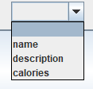

Figure: sort ComboBox in IngredientPanel show

If you choose “name”. The item showed in IngredientPanel will be sorted by name.

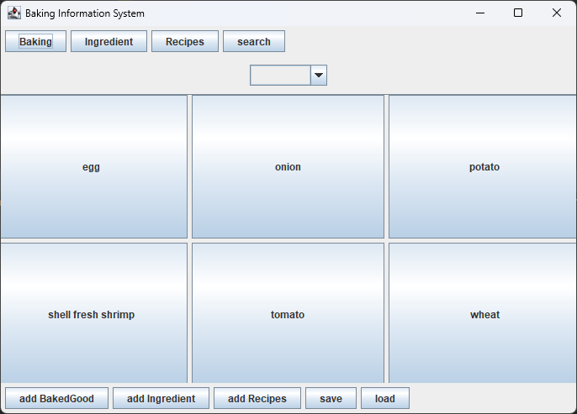

Figure: IngredientPanel after click sort ComboBox “name”

If you choose “description”. The item showed in IngredientPanel will be sorted by description.

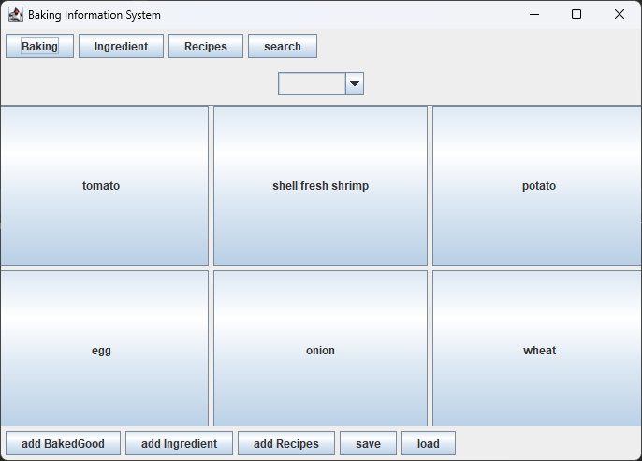

Figure: IngredientPanel after click sort ComboBox “description”

If you choose “calories”. The item showed in IngredientPanel will be sorted by calories.

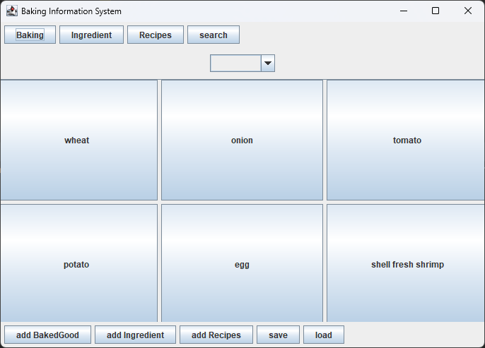

Figure: IngredientPanel after click sort ComboBox “calories”

If you are in RecipePanel, the item showed in the ComboBox is:

1. name
2. Total calories

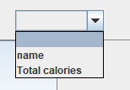

Figure: sort ComboBox in IngredientPanel show

If you choose “name”. The item showed in RecipePanel will be sorted by name.

If you choose “Total calories”. The item showed in RecipePanel will be sorted by total calories.

* 1. Add BakedGood Function

Click the button at the bottom, the addBaked panel will be showed in MainWindow.

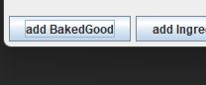

Figure: add BakedGood Panel show

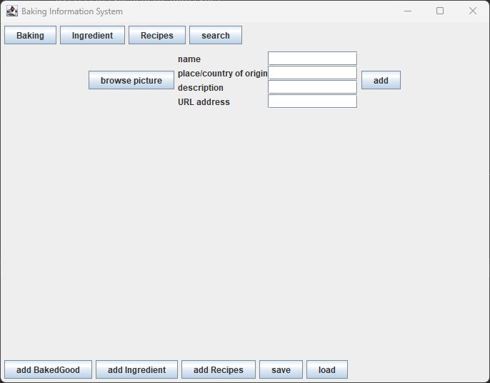

Figure: add BakedGood Panel show

In this panel, you should enter name, place/origin, description,

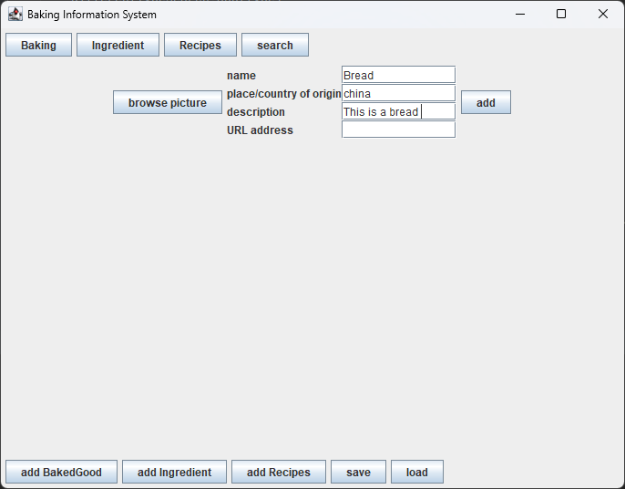

Figure: add new BakedGood show

Then click the browse picture button to browse URL from your computer.

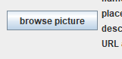

Figure: browse button show

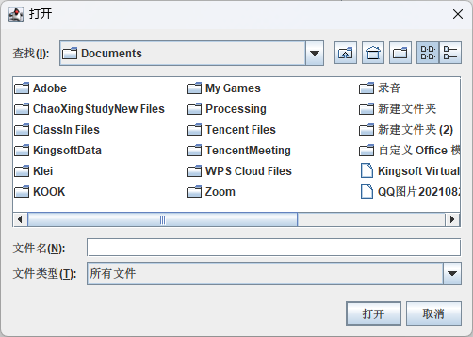

Figure: Window chooser show

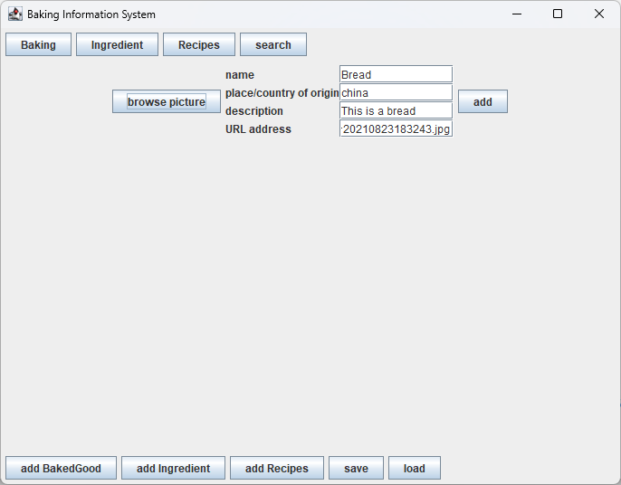

Figure: add completely show

Then click add Button.



Figure: add button show

Click Baking button again, you can see a new item appear in PanelBaking.

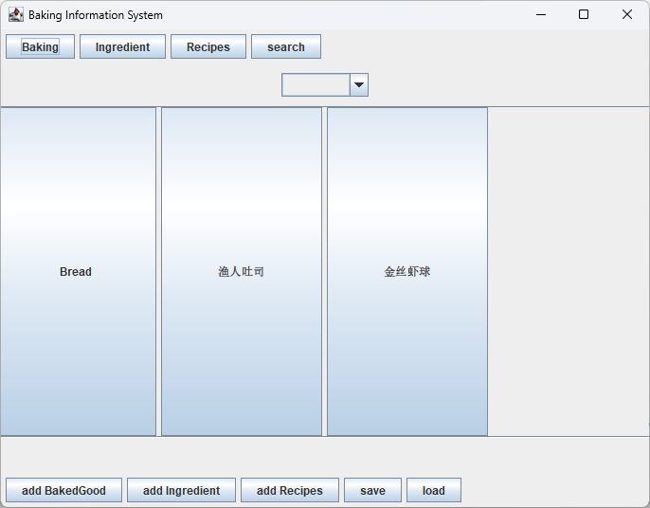

Figure: new item show

* 1. Add Ingredient Function

Click the button at the bottom, the addIngredient panel will be showed in MainWindow.

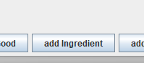

Figure: add ingredient Panel show

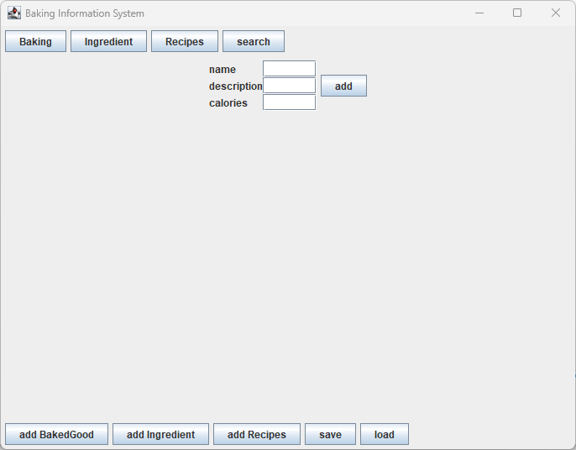

Figure: add Ingredient Panel show

In this panel, you should enter name, description and calories

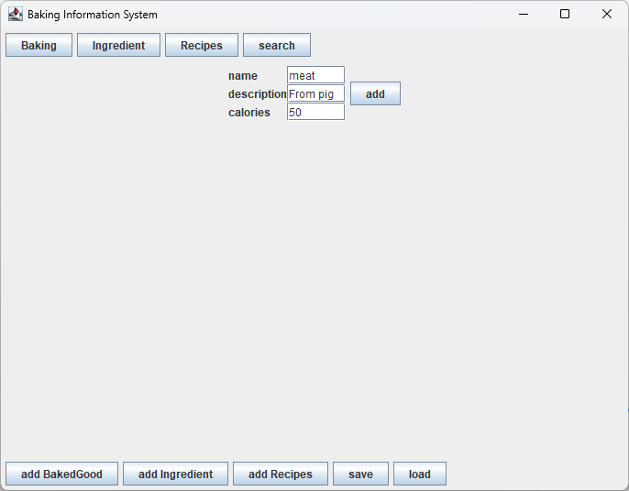

Figure: add new ingredient show

Then click add Button.



Figure: add button show2

Click Ingredient button again, you can see a new item appear in PanelIngredient..

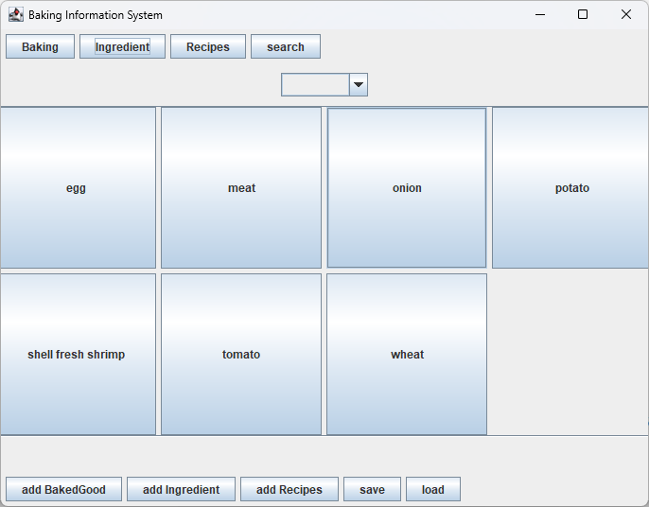

Figure: new ingredient show

* 1. Add Recipe Function

Click the button at the bottom, the addRecipe

panel will be showed in MainWindow.



Figure: add recipe Panel show

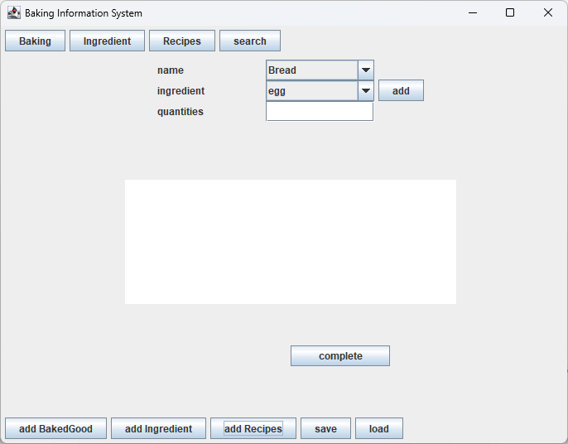

Figure: add recipe Panel show

In this panel, you can choose name from the BakedGoods have added.

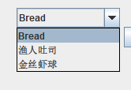

Figure: choose name from BakedGood show

and then choose ingredient from the ingredients have added.

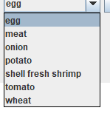

Figure: choose ingredient show

Enter the quantity of the ingredient

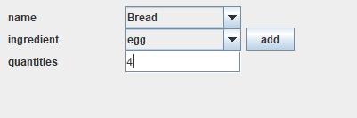

Figure: add quantity show

Click the add button



Figure: add show

You can see the ingredient has been added to this recipe

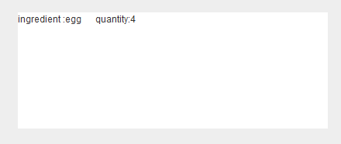

Figure: ingredient added show

You can add multiple ingredients to one recipe.

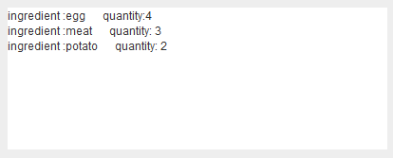

Figure: multiple ingredients added show

Click “complete” button.

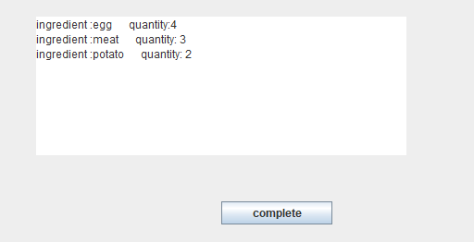

Figure: complete button show

Click Recipe button above again, you can see a new item.

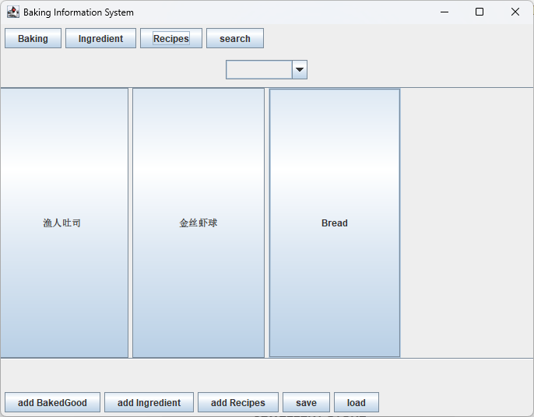

Figure: new recipe show

* 1. Save Function

Click the save button, the program will save the data of BakedGood, ingredient and recipe.

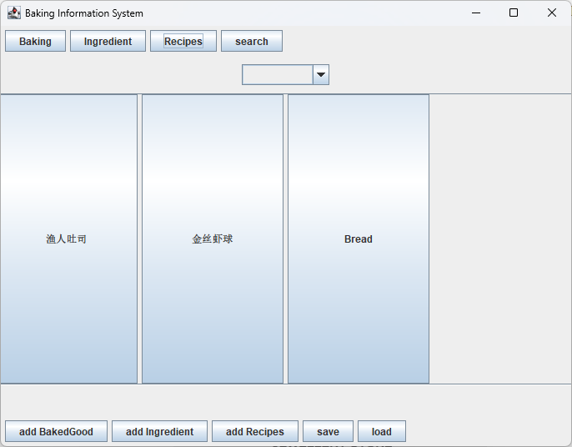

Figure: save button show

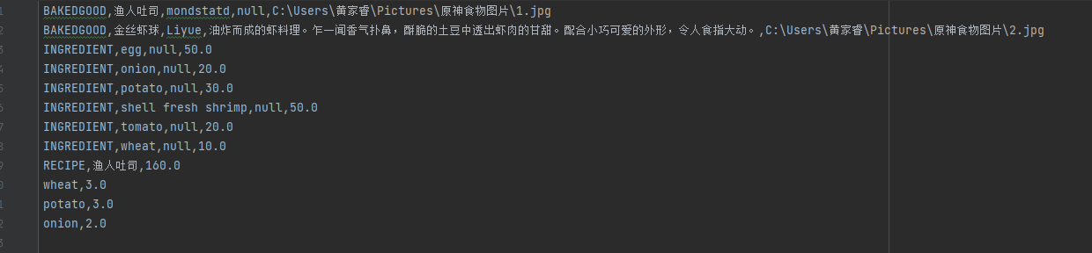

Figure: before save show

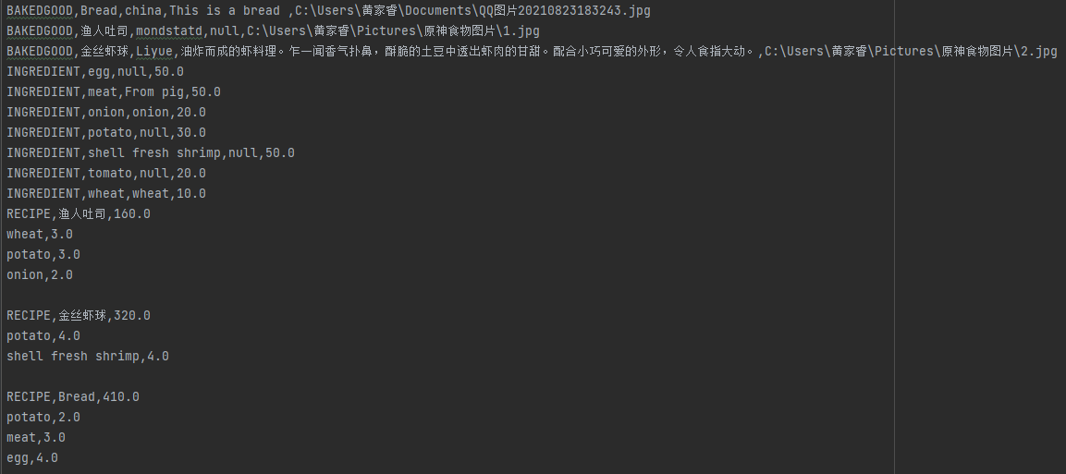

Figure: after save show

* 1. Load Function

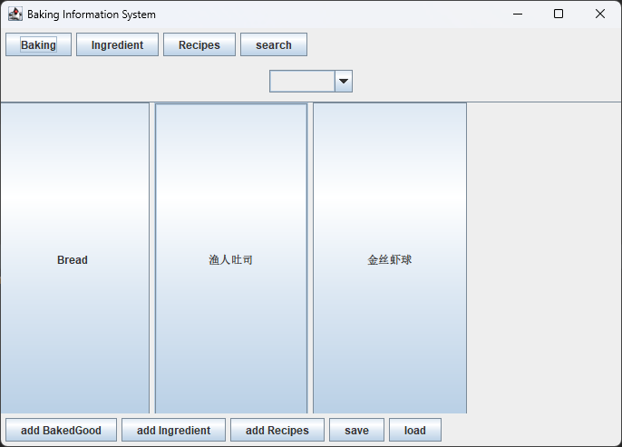

Figure: PanelBaking after load show

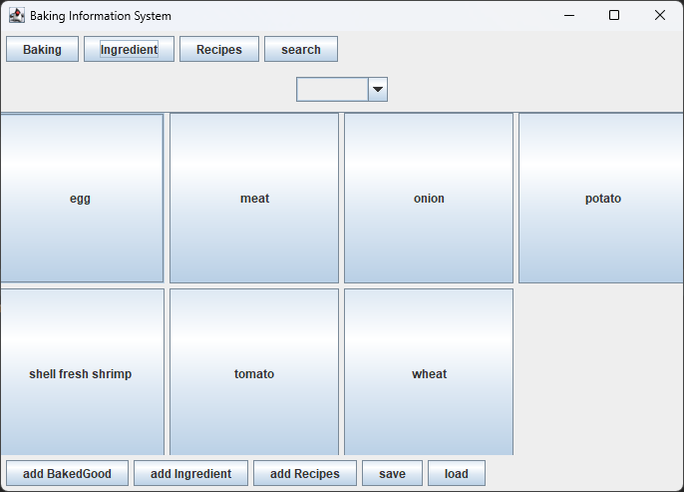

Figure: PanelIngredient after load show

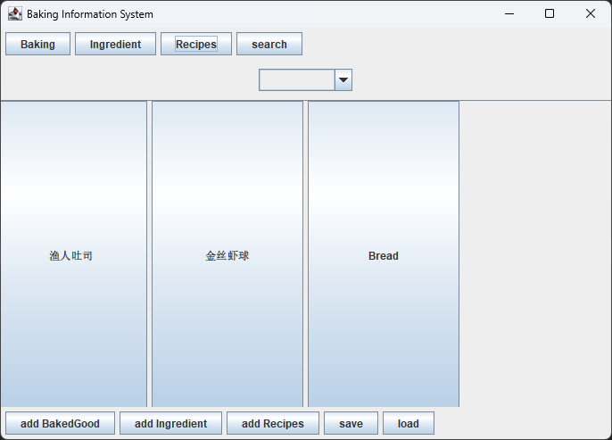

Figure: PanelRecipe after load show

1. DialogBaking

Click the item in Panel Baking, a dialog about this BakedGood detail information will appear.

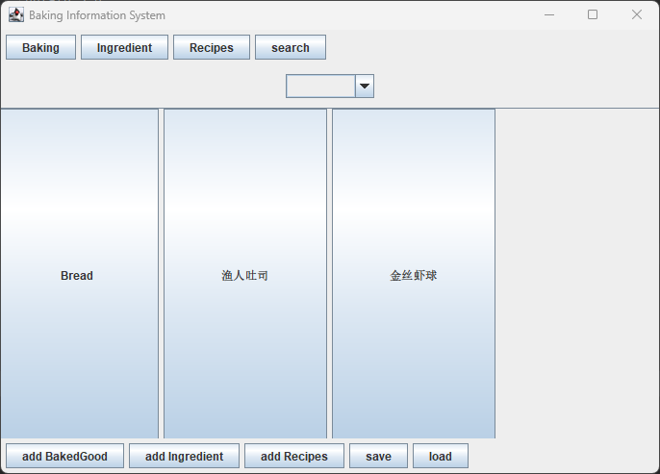 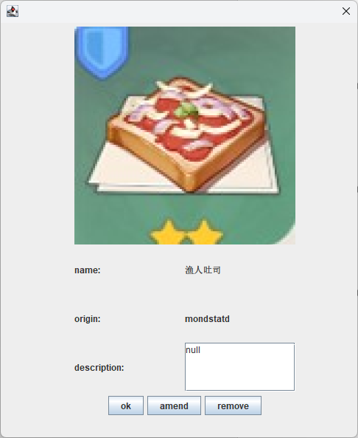

Figure: DialogBakedGood show

In the dialog, there are three buttons, “ok” can close this dialog, “amend” can amend information about this BakedGood, “remove” can delete this BakedGood.

* 1. amend button

click the “amend’ button, the amend dialog will appear.

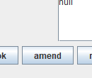

Figure: amend button show

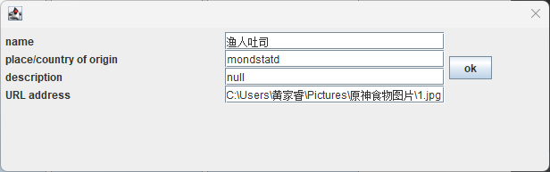

Figure: amend dialog show

You can amend name, origin, description and picture address in this dialog.

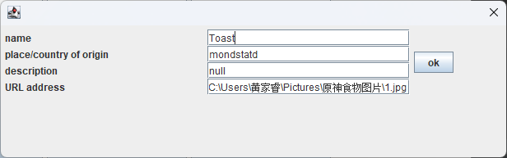

Figure: amend name show

Then click ok button



Figure: amend ok button show

You can see the item name has been changed.

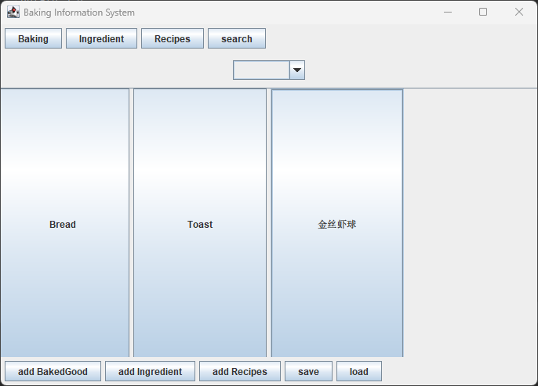

Figure: name change show

* 1. remove button

click this button, you can see this item has been deleted.

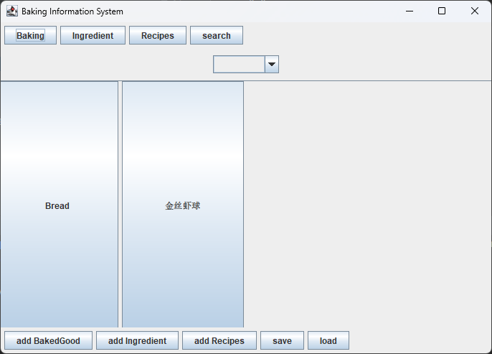

Figure: remove show

1. DialogIngredient

Click the item in Panel Baking, a dialog about this BakedGood detail information will appear.

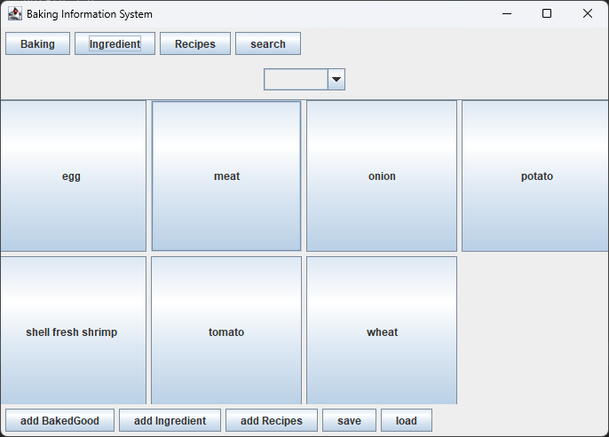 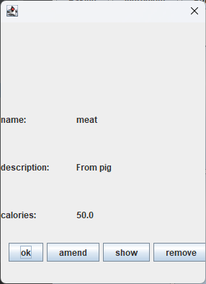

Figure: DialogIngredient show

In the dialog, there are four buttons, “ok” can close this dialog, “amend” can amend information about this BakedGood, “show“ button can show all BakedGood contain this ingredient and remove” can delete this BakedGood.

* 1. amend button

click the “amend’ button, the amend dialog will appear.

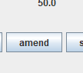

Figure: amend button show in ingredient change dialog

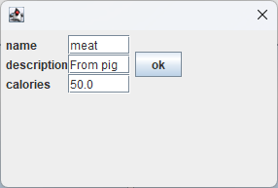

Figure: amend dialog show

You can amend name, description and calories in this dialog.

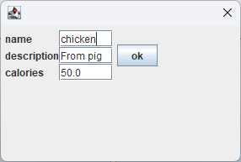

Figure: amend name show

Then click ok button



Figure: amend ok button show

You can see the item name has been changed.

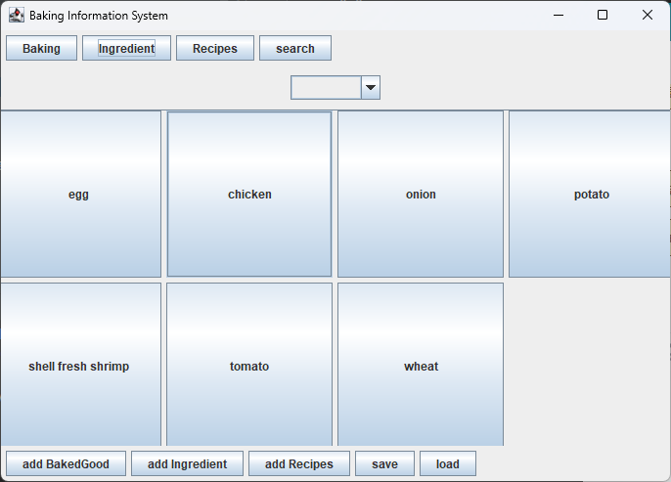

Figure: ingredient change show

3.2. show button

Click “show” button, all BakedGoods contain this ingredient will be displayed.

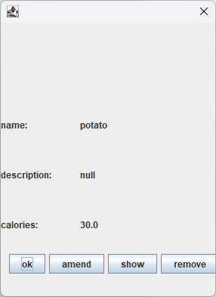 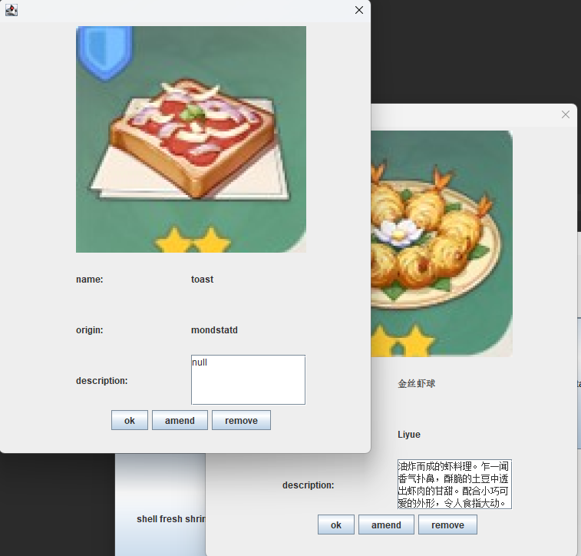

Figure: show button show

3.3 remove button

Click this button, you can see this item has been deleted.

 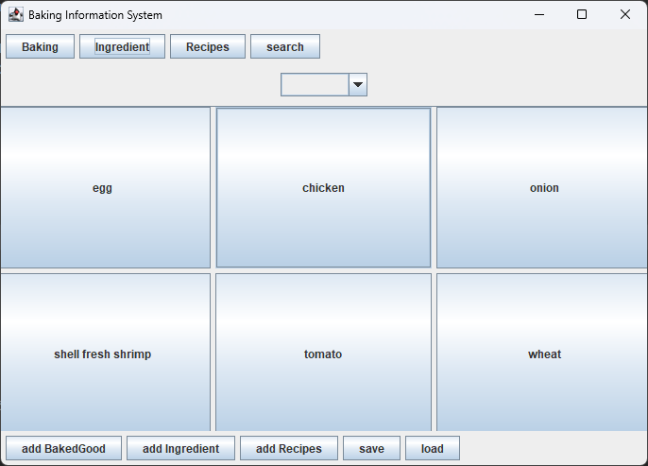

Figure: remove button show

1. DialogRecipe

Click the item in Panel Baking, a dialog about this BakedGood detail information will appear.

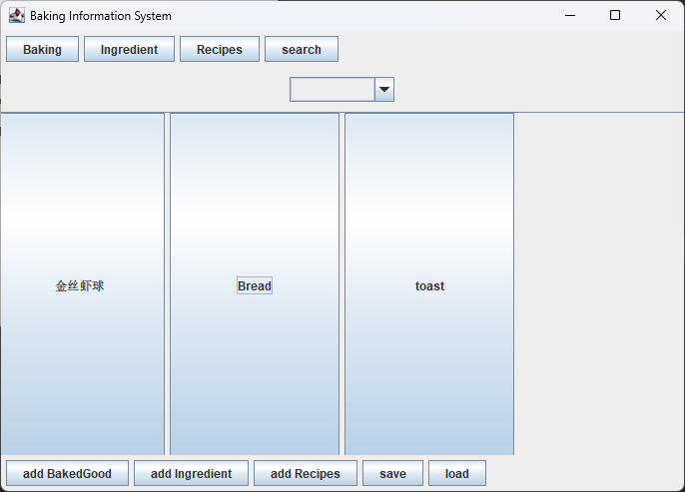 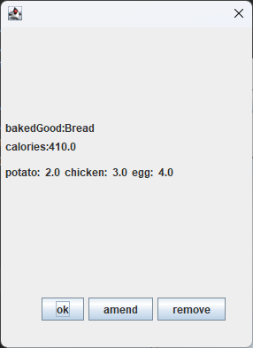

Figure: DialogRecipe show

In the dialog, there are three buttons, “ok” can close this dialog, “amend” can amend information about this recipe, “remove” can delete this recipe.

* 1. amend button

click the “amend’ button, the amend dialog will appear.



Figure: amend button show

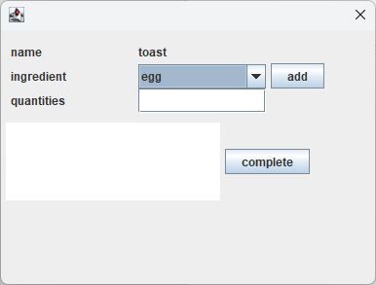

Figure: amend dialog show

You can amend name, ingredient and quantity in this dialog.

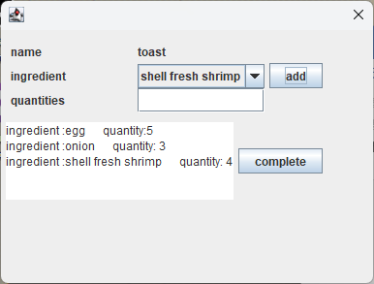

Figure: amend name show

Then click complete button



Figure: amend complete button show

You can see the ingredient and total calories have been changed.

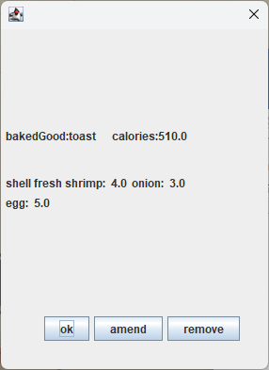

v

Figure: change show

* 1. remove button

click this button, you can see this item has been deleted.

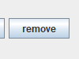



Figure: remove show

# Implementation

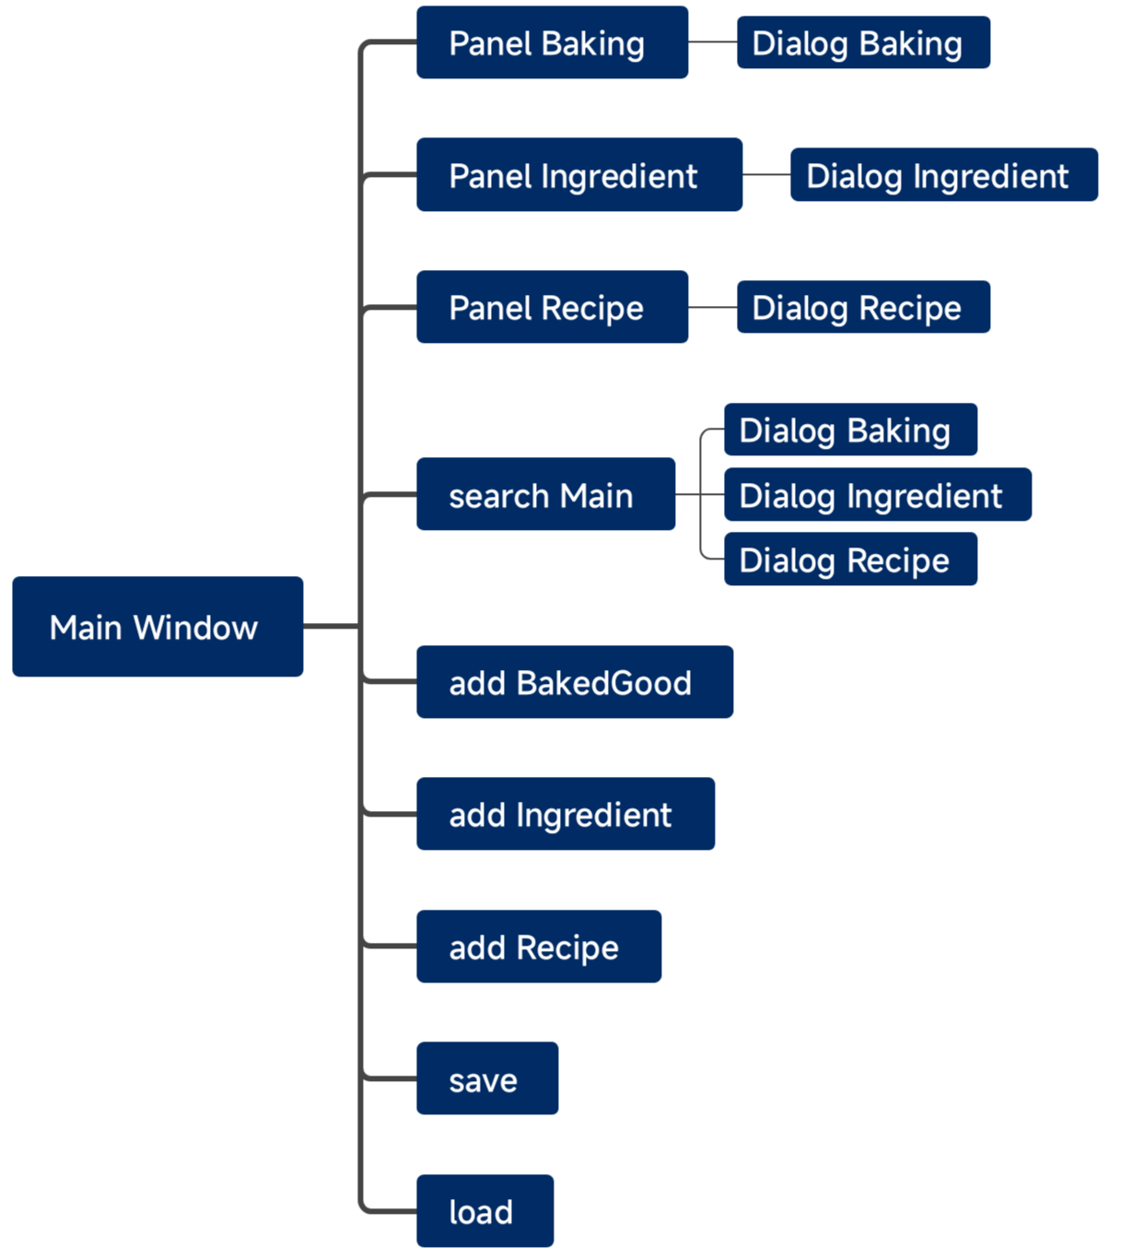

1. Main Window

Create a JFrame mainWindow, create a new JPanel panelButton, and add panels how to mainWindow, create a new JPanel panelShow, add nine buttons to panelButton, and add panelShow to mainWindow, set the panelShow layout is cardLayout.

1. Panel Baking

Using a for loop to create buttons, connect with mainWindow by panelButton.

1. Panel Ingredient

Using a for loop to create buttons, connect with mainWindow by panelButton.

1. Panel Recipe

Using a for loop to create buttons, connect with mainWindow by panelButton.

1. Search Main

Have two functions, one is set for the different type of search, another is set for different kind of search.

1. Add BakedGood

Using a Brid layout to add three label and three text fired. And using a window chooser to choose picture from computer. Add the picture address to the BakedGood.

1. Add Ingredient

Using a Bird Layout to add three labels and three text fired.

1. Add Recipe

Using two ComboBox to add name and ingredient.

1. Save
2. Load
3. Dialog Baking

Created a new dialog to show the information about the select BakedGood. Using Frow layout to add three panel, panel of picture, panel of information, panel of buttons.

1. Dialog Ingredient

Created a new dialog to show the information about the select ingredient. Using Frow layout to add two panels, panel of information, panel of buttons.

1. Dialog Recipe

Created a new dialog to show the information about the select ingredient. Using Frow layout to add two panels, panel of information, panel of buttons.