# Normalisation Lab

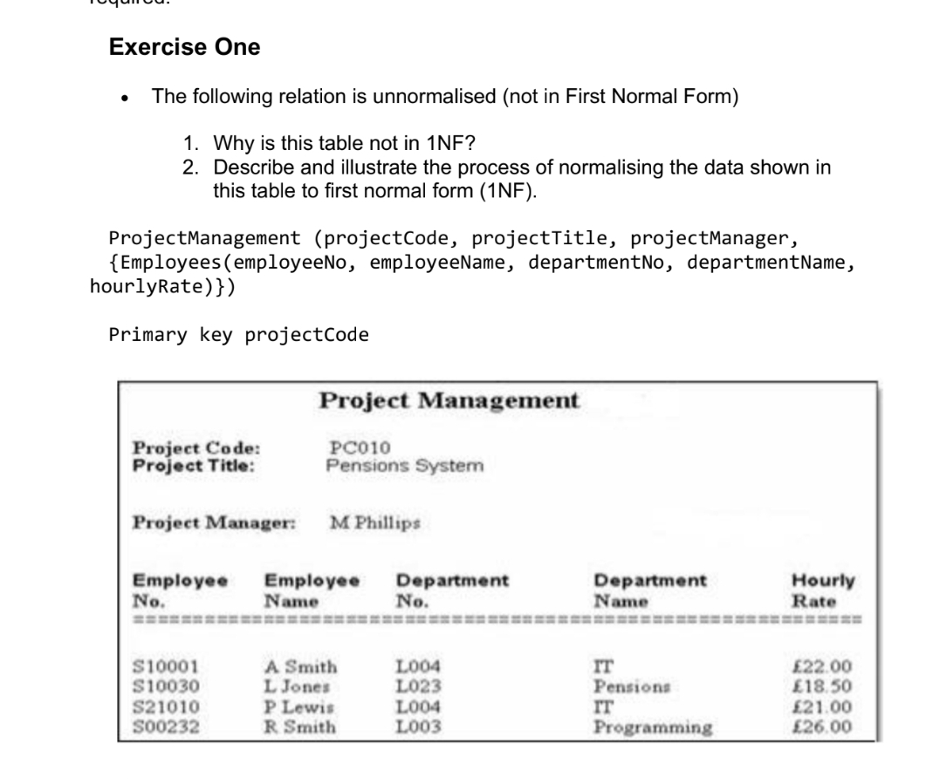

**Exercise one solution:**

**1:**

This table is a repeating group of attributes.

**2:**

projectManagement(project Code, project title, project manager)

Primary key: project Code

projectEmployee(project Code,EmployeeName, EmployeeName, DepartmentNo,DepartmentName, hourly)

Primary key:project Code,EmployeeNo

Foreign key project Code references projectManagement(project Code)

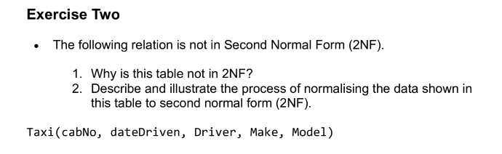

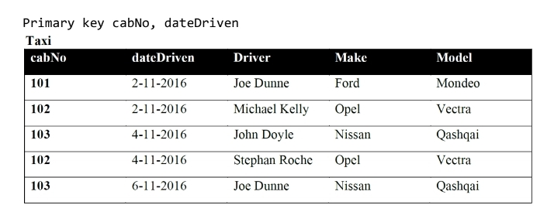

Exercise two solution:

1:

This table has two primary key, cabNo and dateDriven, driver is fully depend on dataDriven, as model is fully depend on cabNo, Make are fully depend on both primary key.

2:

Divide the table to two tables

Car(carNo,model)

Primary key:carNo

dateDri(dateDriven, driver)

Primary key:dateDriven,

dateDrivenAll(carNo, dateDriven, Make)

Primary key: carNo, dateDriven

Foreign key dateDriven references dateDri(dateDriven)

Foreign key carNo references car(carNo)

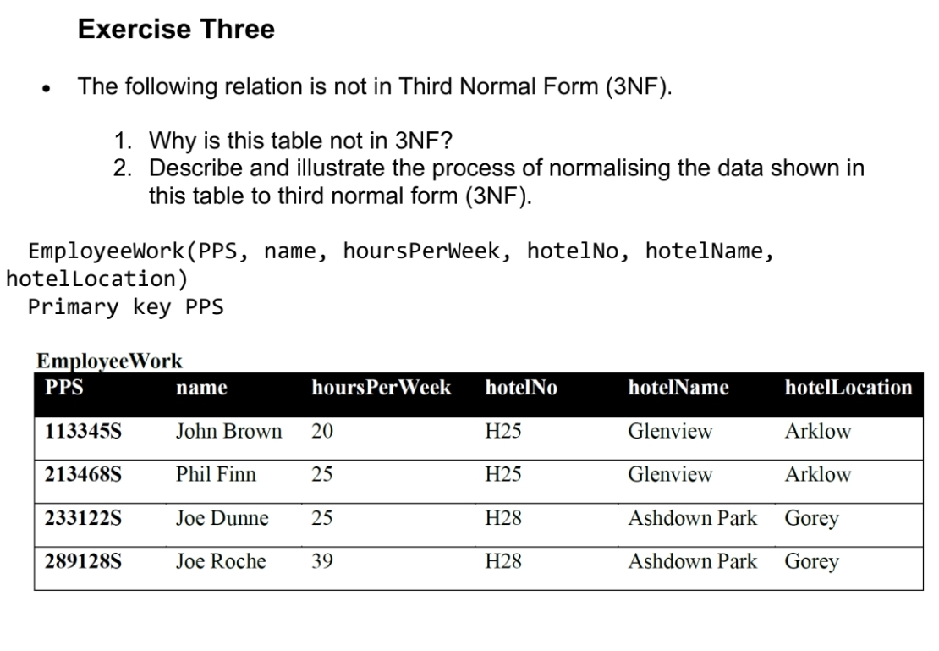

Exercise three sulotion

1:

This table contain transitive relation that hotelName depend on hotelNo and hotelNo is fully depend on PPS

2:

EmployeeHotel(hotelNo, holtelName, hotelLocation)

Primary key: hotelNo

EmployeeWord(PPS, name,hoursPerWeek,hotelNo)

Primary key : pps

Foreign key hotelNo reference EmployeeHotel(hotelNo)