# Lab_4

To do:

1:describe each table

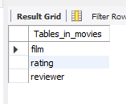

2:find the title of all films directed by Steven Spielberg

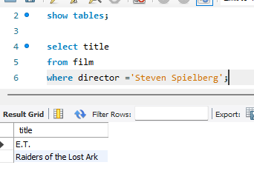

3:Return the title and year of all films produced from 1940 to 1990. Sort by title

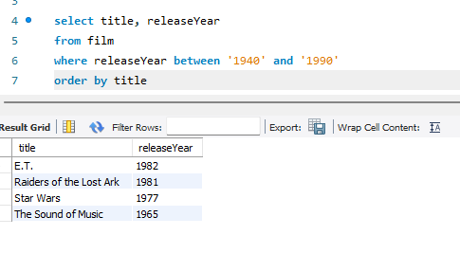

4:Return the title and length of all films whose length is 110 minutes or more. Sort by time

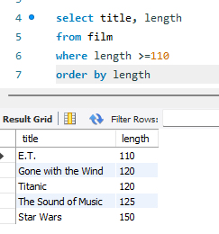

5: return the title and director of all films where the director`s surname begins with C

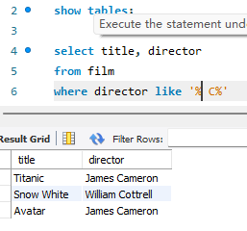

6:Return the number of stars, film Id (output as Film Id), and ratingdate of all movie ratings where the rating given is 4 or 5. Sort the output in descending order of the stars and then in ascending order of movie id.

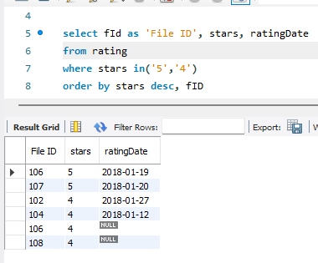

7:Some reviewers did not provide a date with their rating. Find the rID of all

reviewers who have ratings with a NULL value for the date.

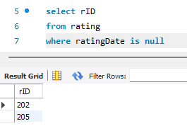

8:Return the number of films, Label the returned column Number of films

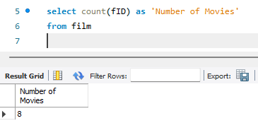

9:Return the number of reviewers. Label the returned column Number of

Reviewers.

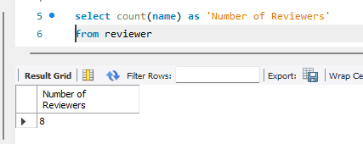

10:Return the number of ratings. Label the returned column for the calculation -Number of rating.

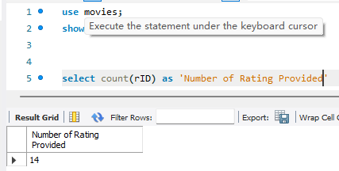

11:Return the number of films per director. Label the returned column for the calculation - Number of Films.

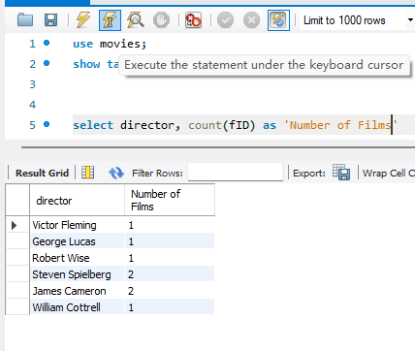

12:Return the number of ratings left by each reviewer. Label the returned column for the calculation - Number of Reviews (per Reviewer).

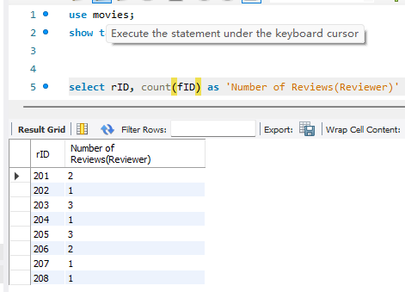

13:Return the average number of film minutes per director. Label the returned column for the calculation - Average Number of Minutes per Film. The returned value is to be output as a whole number (no decimal places).

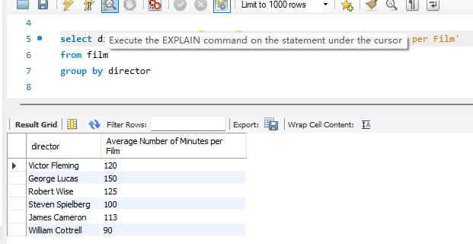

14: