# Lab_5

**Join Exercise**

1. Retrieve the title, copyId, publisher, and acquired date for all book copies that were acquired since June 1 2014.Sort the results in alphabetical order of title.

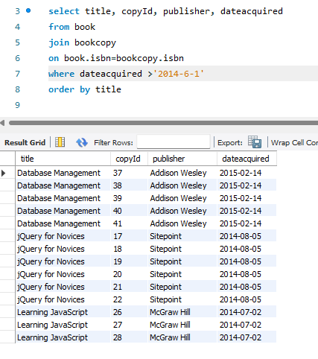

1. List the students (combined fname and lname) who have borrowed a book(s).

Return the student name only once even if he/she has more than one loan.

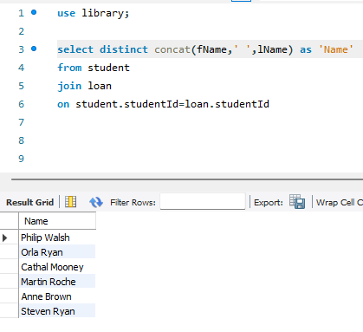

1. List the students (combined fname and lname) who have borrowed a book(s)

and has it still on loan (dateBack is empty). Return the student name only

once even if he/she has more than one loan.

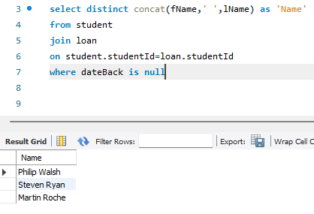

1. For each loan record, retrieve the student by Name (combined fname and

lname) who made the loan, and the copyId, dateOut and dateBack for each

book loaned.

Sort the results in alphabetical order of Name (fname sorted within lname).

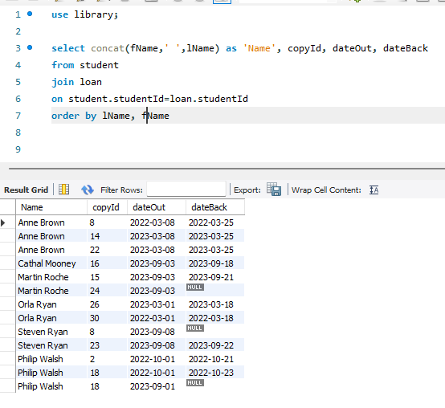

1. List the copyId and title for all books that are in service now (datedestroyed is

empty).

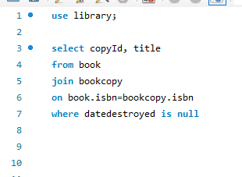

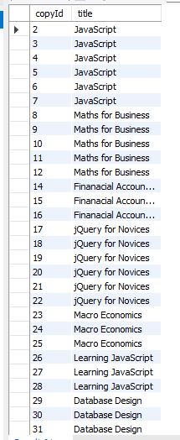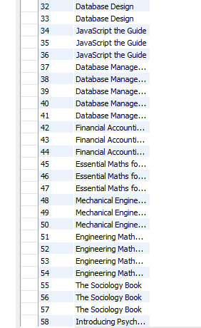

1. List the titles and authors by name for all books. Label the title Book Title and

label the author name Author. Sort in alphabetical order of title

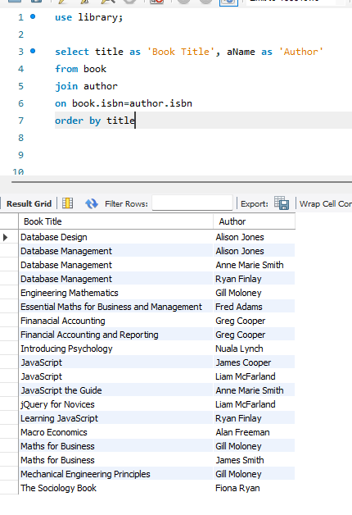

1. List the titles and authors by name for all books that have JavaScript in the

title. Label the title Book Title and label the author name Author. Sort in

alphabetical order of title.

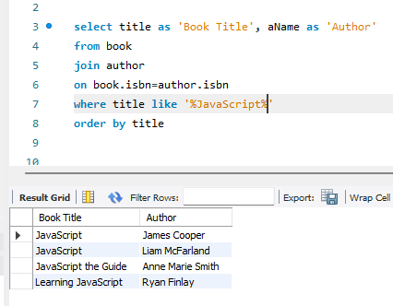

**More Join Exercise**

1. Return the book title and corresponding number of book copies for all books that have Database in the book title. Output the count with the label Number of Books.

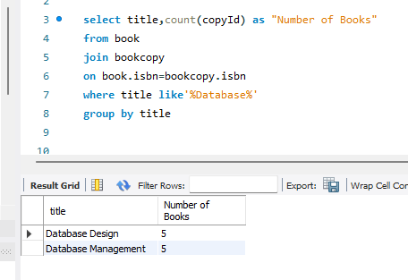

1. Return the number of loans per student (identified by name). Output the count with the label Number of Loans and identify each student by name (combined fname and lname). Note: Use the combined fname and lname in the Group By clause. Sort in alphabetical order by Last Name and then First Name

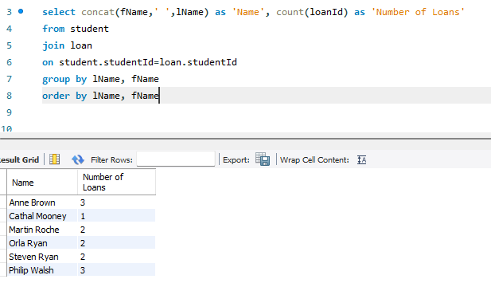

1. Return the number of loans that a student has at present (where dateBack is empty). Output the count with the label Number of Loans and again identify each student by name.

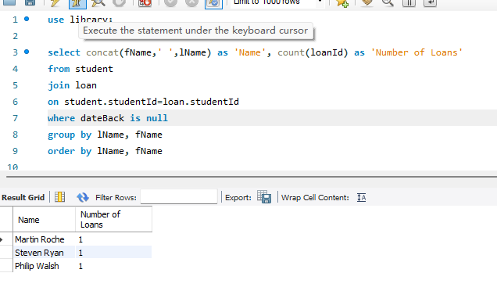

**Movies Database Exercise**

1. For each rating, return the reviewer id, film title, director, and number of stars.

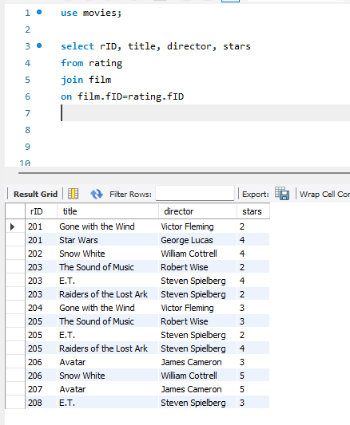

1. Return the number of reviews (in the ratings table) left by Chris Jackson. Label the output "Number of Chris’s Reviews.

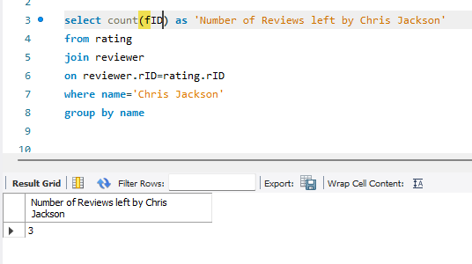

1. Return the number of reviews left by each reviewer (identified by name). Label the number of reviews (Number of Reviews).

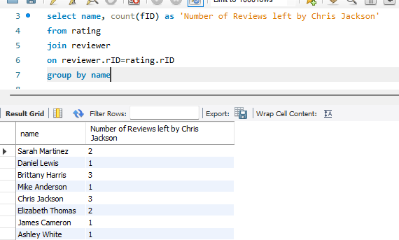

1. Return the number of reviews left for each film (identified by title). Label the number of reviews (Number of Film Reviews).

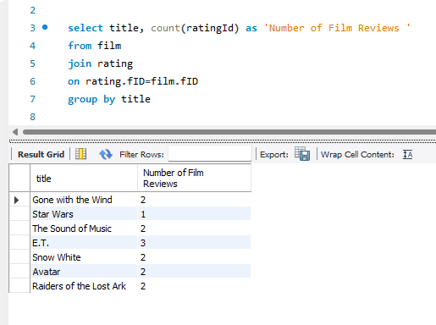

Geography Database Exercise

1. Describe each table

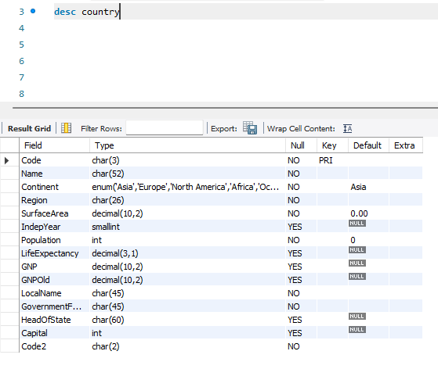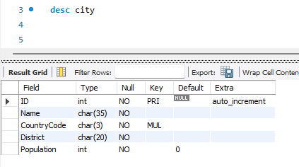

1. Return all the data from the Country able for Ireland

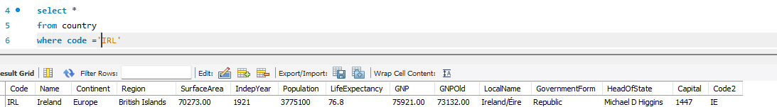

1. Return all the names of all cities for Ireland. Sort in alphbetical order

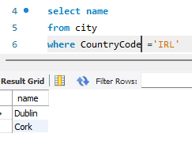

1. Return the country (by name), district, and city (by name) for Ireland and United Kingdom. Sort in alphbetical order of country, then district and then city
   1. Code:

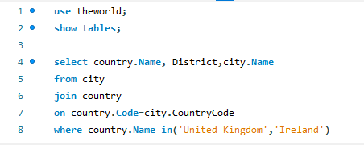

* 1. Output:

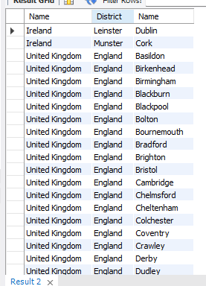

1. Return the country (by name), language and population (speaking the language) for Ireland, United Kingdom, France, and Spain. Sort in alphabetical order of country, and then language.

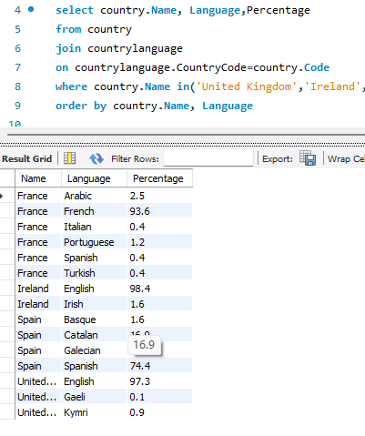

1. Return the country (by name) and number of cities per country for all countries in Europe. Sort in alphbetical order.

