# Lab_7

Exercise:

1:Describe each table

* 1. customer table:

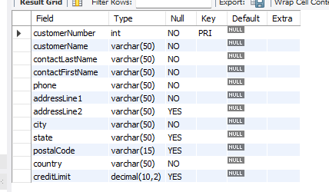

* 1. orderdetails table

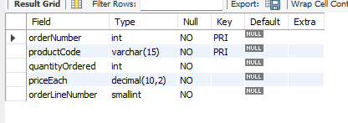

* 1. orders table

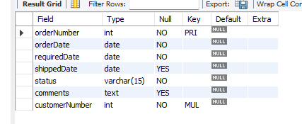

* 1. product table

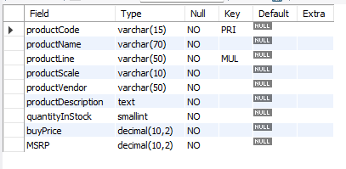

* 1. Productlines table

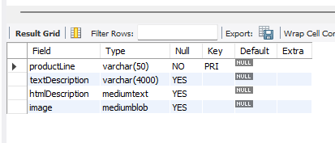

2: Return the customer name, contact name(concatenated) and phone number for all customers. Sort in alphabetical order of customer name.

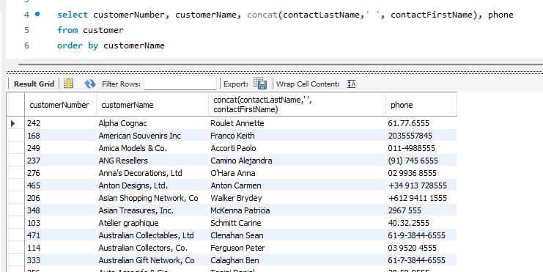

3:Return the customer name, contact name(concatenated), addressLine1, addressLine2, city, state, and phone number foe all customers from Ireland. Again sort in alphabetical order of customer name.

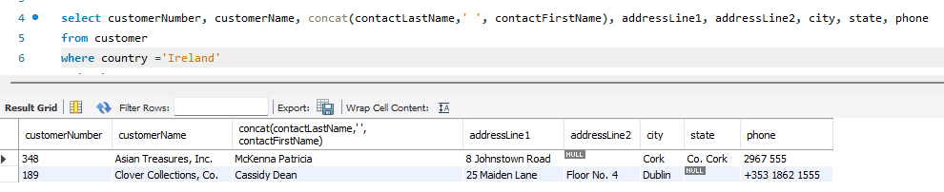

4: Return the customer name , order number and order date for all orders. Sort in alphabetical order of customer name and in descending order of order date.

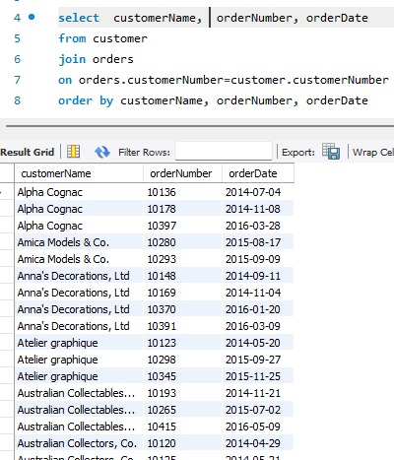

5: Return the customer name and the number of orders made for each customer who has made an order. Sort in alphabetical order of customer name.

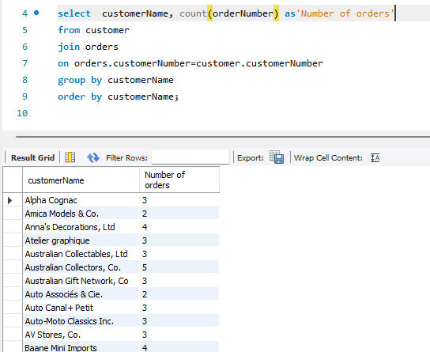

6:Return the number of orders for customer(Baane Mini Import). Label the output Number of Orders for Baane Mini Imports

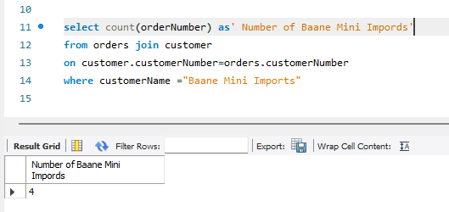

7: Return the product name, description and product line for all products. Sort in alphabetical order of product name.

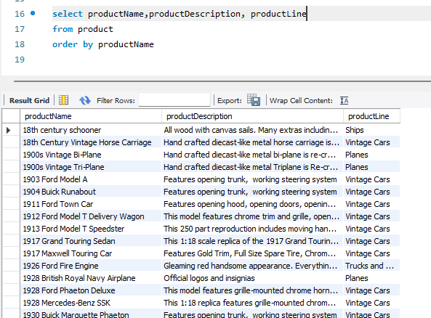

8: Return the product name, description, product line and text description for all products that include the term Chevrolet in the product name. Again, sort in alphabetical order of product name.

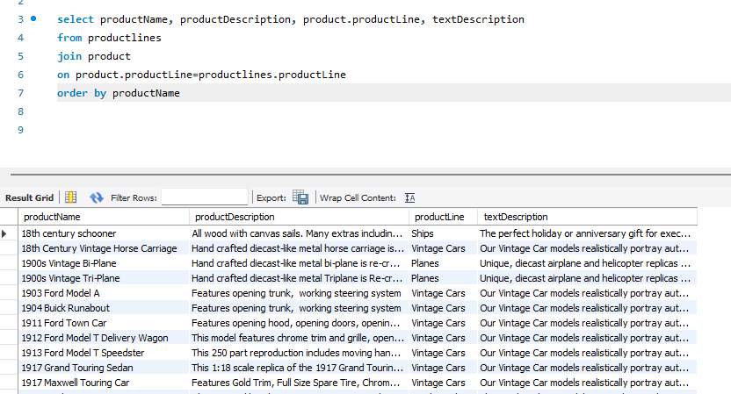

9:Return the product name and quantity ordered for all products identified by order number 10124. Again, sort in alphabetical order of product name.

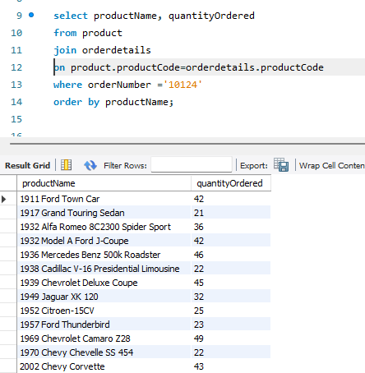

10:Return the order number, product name and quantity ordered for all products ordered by customer identified by customerNumber 242. Sort in ascending order of order number and then product name.

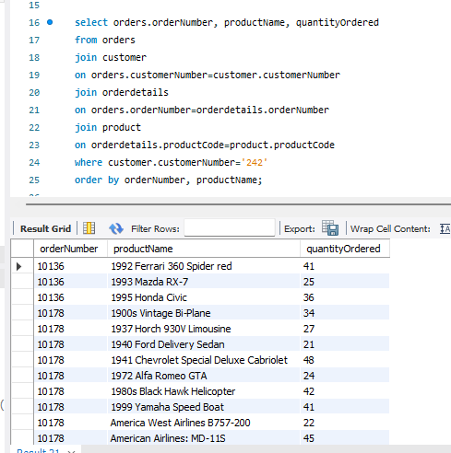

11:Return the order number, product name and quantity ordered for all products ordered by customer Baane Mini Imports. Sort in ascending order of order number and then product name.

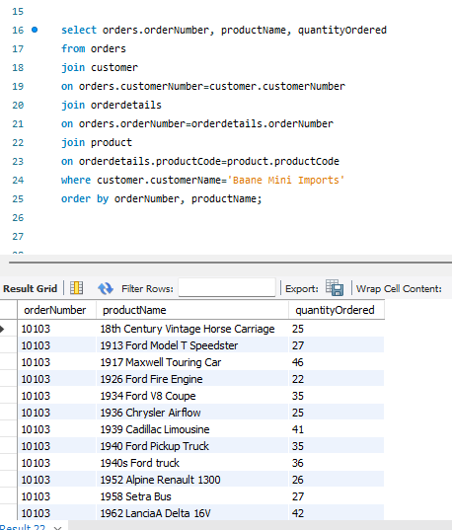

12.Return the customer name, order number and order date for all orders even if customers have placed no orders. Sort in alphabetical order of customer name and in descending order of order date.

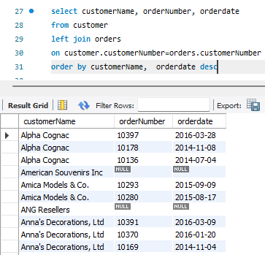

13.Return the customer name for all customers who have made no orders (orderNumber is NULL). Sort in alphabetical order of customer name.

