**Operating Systems**

Lab Report #4

**Network configuration**

Jiarui Huang

Student ID:202283890036

# Objectives

1. Teach the basic network configuration methods under Linux
2. Master the TCP/IP configuration files under Linux
3. Configure IP address, subnet mask, default gateway, and DNS server
4. Master the use of ping, traceroute, netstat, nslookup, and arp.

# Code and Execution

## Assignment 1: Linux internet configure

(1). If you do not have install net-tools, you should firstly install net-tools by

“ sudo apt install net-tools” command

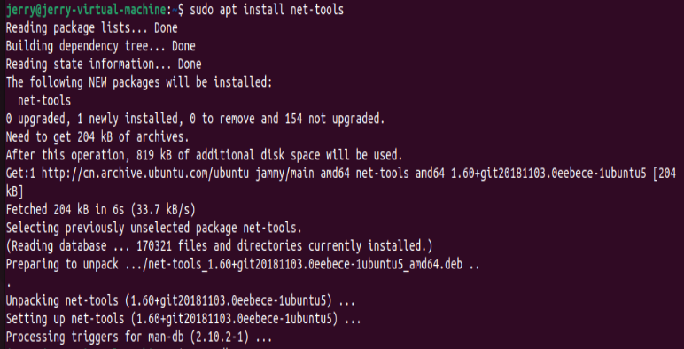

1. . Use “ifconfig” command to check the network card name

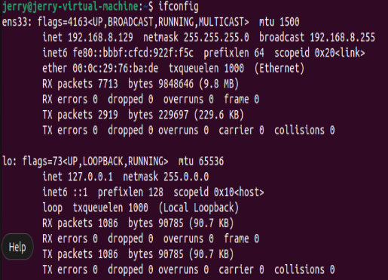

## Assignment 2:Configure Network File

The file to configure ubuntu `s network is in /etc/network/interfaces

Enter this command to edit network file:

Different version of uduntu has different command, my version is 22.04,the command is :

Sudo vi /etc/netplan/00-installer-config.yaml”

Use staticconfigure method to get ip configuration

Auto ens33(network name)

Iface ens33 inet dhcp

Address 192.168.0.2

Netmask 255.255.255.0

Gateway 192.168.0.2

Edit DNS address

Though /etc/netplan/00-installer-config.yaml

Add:” dns_nameservers 223.5.5.5”

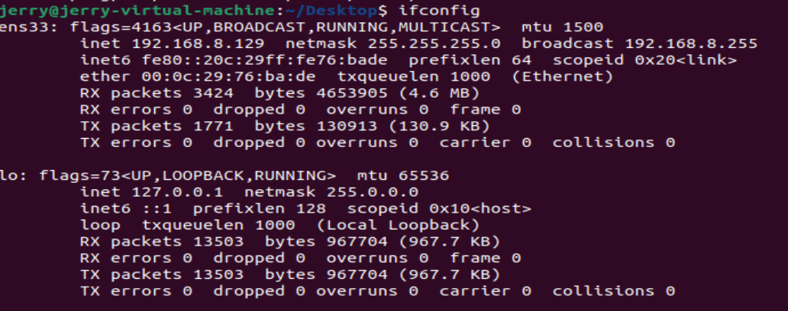

## Test Ping

Use the fully command:

Ping [www.baidu.com](http://www.baidu.com)

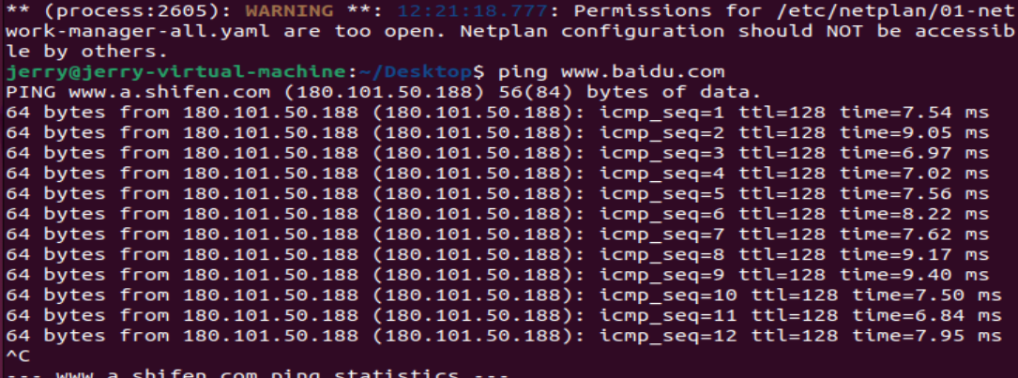if

# Analysis

Analyze the behavior of each program. Explain the observed outputs, discuss any challenges encountered, and how they were resolved.

# Conclusion

Summarize your findings and experiences from this lab assignment.

# References

List any references or resources you used to complete this lab assignment, if any.