**Operating Systems**

Lab Report #6

**File and print server configuration**

Name Jiarui Huang

Student ID 202283890036

# Objectives

1. Teach the configuration method of NFS and samba services under Linux
2. Linux How the client access the file server
3. Capable of configNFS services
4. Can of samba printer sharing.

# Code and Execution

## Assignment 1:Build nfs server

**Step 1: install nfs server**

*Sudo apt install NFS-kernel-server*

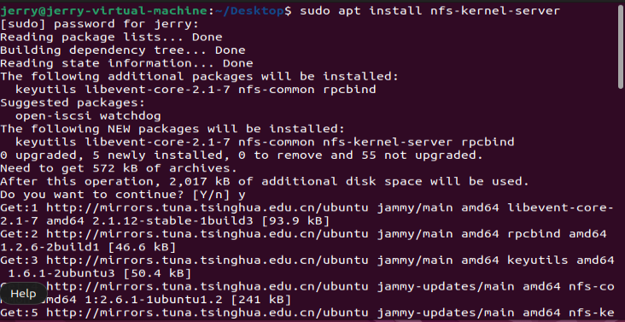

*Sudo apt install nfs-common*

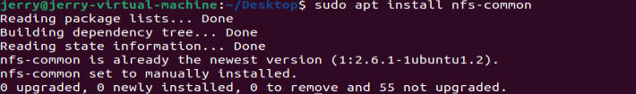

**Step 2: edit configure file**

*Sudo gedit /etc/exports*

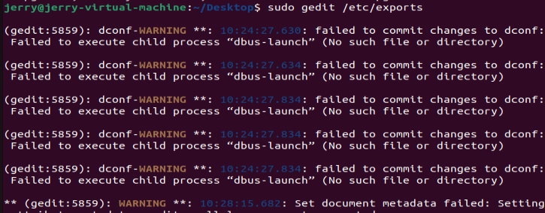

Add the following context into the configure file:

*/home/user/share*(rw,sync,no_root——squash）*

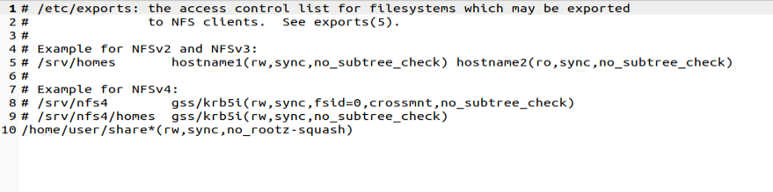

**Step 3: restart nfs server**

Sudo /etc/init.d/nfs-kernel-server restart



**Step 4: check whether the client and server are connected**

The ip address of this host is: 192.168.8.129

*Ping 192.168.8.129*

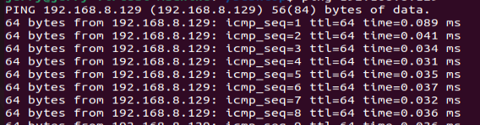

**Step 5: View the shared directory on the server**

*Showmount -e IP*

*Export list for IP: /home/user/share/\**

## Assignment 2: Build Samba server

**Step 1: install samba server**

*Sudo apt install samba*

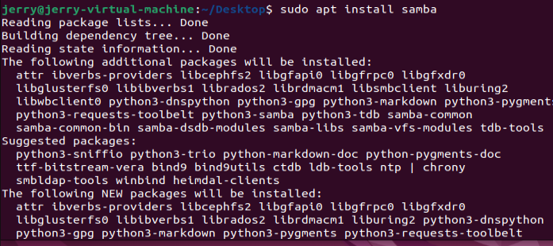

**Step 2: edit configure file**

Sudo gedit /etc/samba/smb.conf

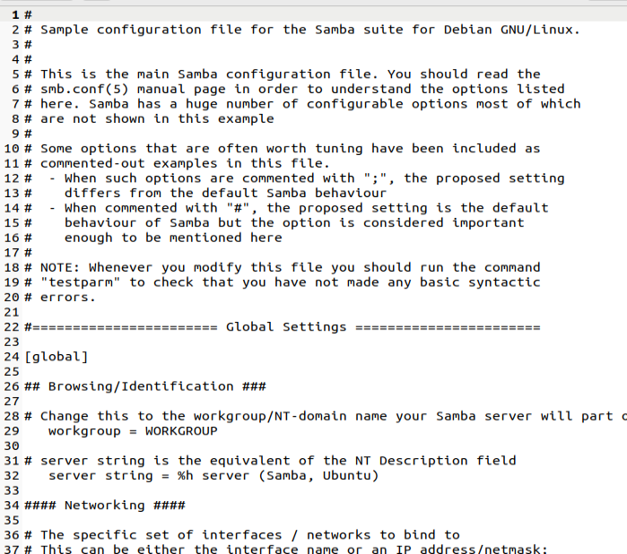

Write the following text:

*[share] # Windows 访问 Samba 服务器是显⽰⽬录名，顶格写*

*comment = share # 对该共享⽬录的描述，随便写*

*browseable = yes # 共享⽬录是否可⻅，no 不可⻅，yes 或不 写默认可⻅*

*path = /home/⽤⼾/share # 共享的⽬录路径*

*create mask = 0777 # 创建⽂件的默认权限*

*directory mask = 0777 # 创建⽬录的默认权限*

*valid users = ⽤⼾名 # 指定登录的⽤⼾，该项不写，则默认对 所有⼈可⻅*

*force user = nobody # 指定的⽤⼾可以进⾏登录，其他⽤⼾没有 权限登录，*

*nobody 不限制*

*force group = nogroup # 同上，指定⽤⼾组*

*public = yes # 是否对所有登录成功的⽤⼾可⻅*

*writable = yes # 写权限，⽬录的权限也要许可*

*available = yes # 同样是设置共享⽬录是否可⻅*

**step 3: Add user to Samba server**

*sudo smbpasswd -a user*

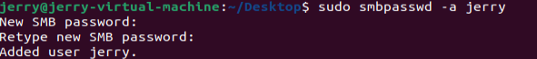

**Step 4: restart samba**

*Sudo service smbd restart*



## Assignment 3: Samba printer realize

**Step 1: install virtual printer**

*Sudo apt install printer-driver-cpus-pdf*

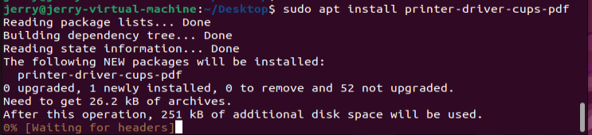

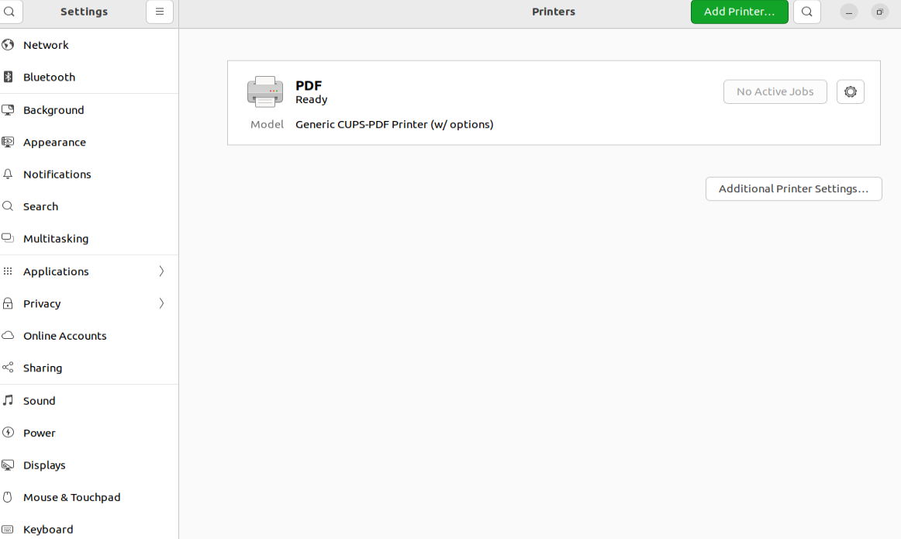

**Step 2: configure Samba file**

In printer part, edit :

*Browsable=yes*

*Guest ok=yes*

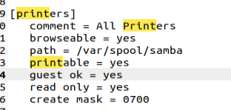

**Step 3: restart Samba service**

Sudo service smbd restart



# Analysis

Analyze the behavior of each program. Explain the observed outputs, discuss any challenges encountered, and how they were resolved.

# Conclusion

Summarize your findings and experiences from this lab assignment.

# References

List any references or resources you used to complete this lab assignment, if any.