**Operating Systems**

Lab Report #7

**Apache server configuration**

Name :Juarui Huang

Student ID: 202283890036

# Objectives

Briefly describe the objective of this lab assignment.

1. Master the basic methods and steps of Apache server, and be able to install Apache Web services
2. Understand the configuration method of access control, and understand the basic configuration of authentication and authorization
3. Master the configuration of port-based virtual host, IP address-based virtual host configuration, and domain name-based virtual host configuration.

# Code and Execution

## Assignment 1: download apache

*Sudo apt install apache2*

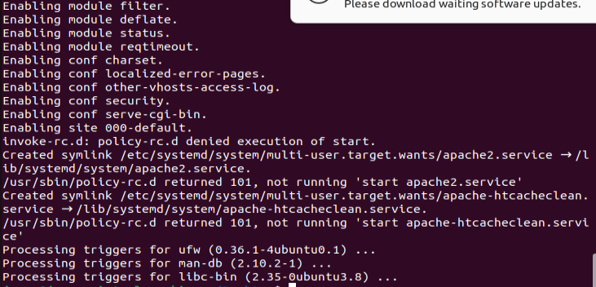

## Assignment 2: Configure UFW firewall

**Step 1:list the file of ufw**

*Sudo ufw app list*

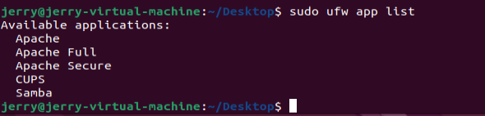

**Step 2: Allow apache on ufw an verify its status**

*Sudo ufw allow ‘APACHE’*

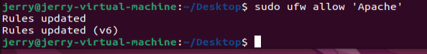

## Assignment 3: Configure apache web server

**Step1: verify that the ahe service is running**

*Sudo systemctl status apache2*

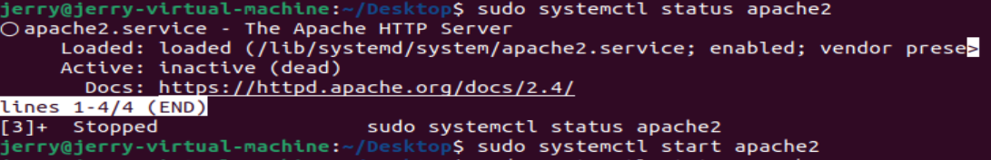

the output shows that apache server is stopped.

Enter : *sudo systemctl start apache* To start apache2 server

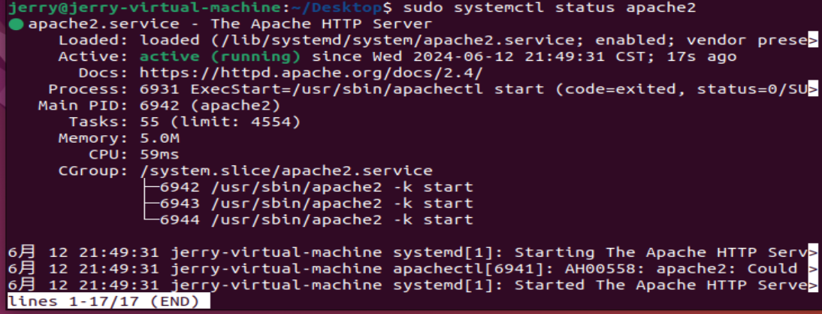

## Assignment 3: Set virtual machine

**Step 1: Create a directory**

*Sudo mkdir -p /var/www/example-1/html*

**Step 2: Assigning ownership of directory with the $USER environment variable**

*Sudo chown -R $USER:$USER /var/www/example_1.com/html*

**Step 3: make the permissions on your web root directory correct.**

*Sudo chown -R 755 /var/www/example_1.com*

**Step 4: use gedit to create a index.html page.**

*Sudo gedit /var/www/example_1.com/html/index.html*

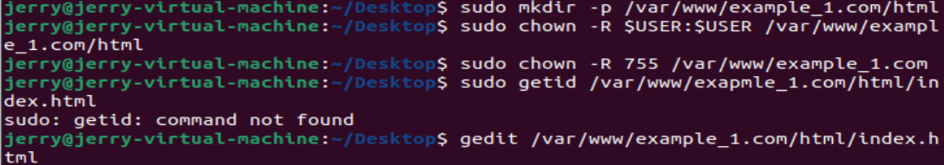

**Step 5: adding the following context into the index.html**

*<html>*

*<head>*

*<title>Welcome to Example-1.com!</title>*

*</head>*

*<body>*

*<h1>Success! The example-1.com server block is working!</h1>*

*</body>*

*</html>*

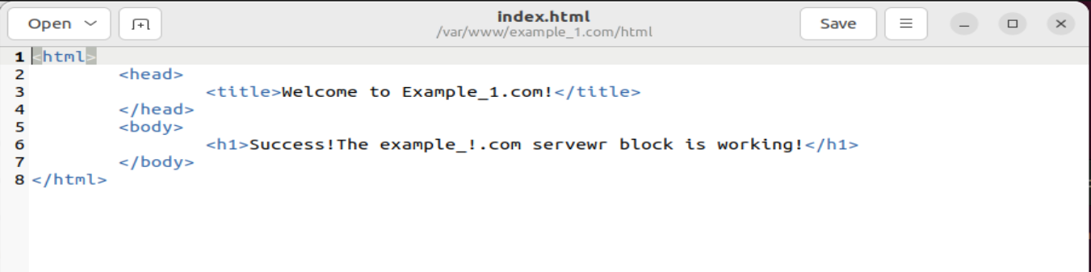

**Step 6: use correct command to create virtual machine file**

*Sudo gedit /etc/apache2/sites-available/example_1.com.conf*

Adding the following context into the file.

*<VirtualHost *:80>*

*ServerAdmin lijunlhc@foxmail.com*

*ServerName example-1.com*

*ServerAlias www.example-1.com*

*DocumentRoot /var/www/example-1.com/html*

*ErrorLog ${APACHE_LOG_DIR}/error.log*

*CustomLog ${APACHE_LOG_DIR}/access.log combined*

*</VirtualHost>*

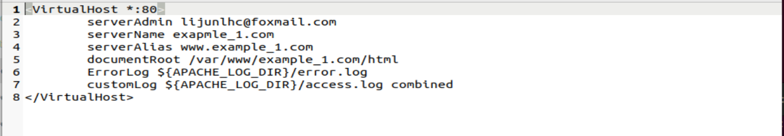

**Step 7: user asensite tool to start the file.**

*sudo a2ensite example_12.com.conf*

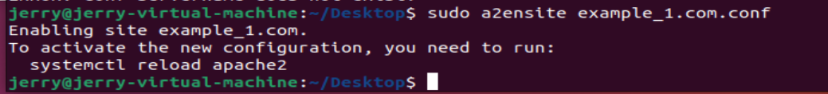

**Step 8: Disable the default site defined in 000-default.conf**

*sudo a2dissite 000-default.conf*

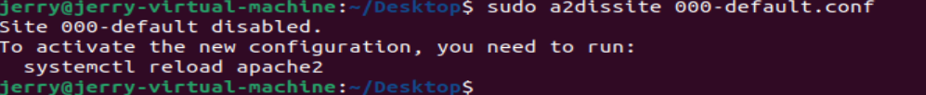

**Step 9: Restart Apache server**

*sudo systemctl restart apache2*

**Step 10: Test error of Apache server**

*sudo apache2ctl configtestsudop*

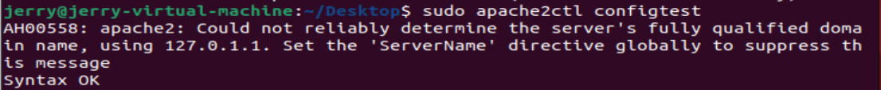

**Step 11: test virtual machine**

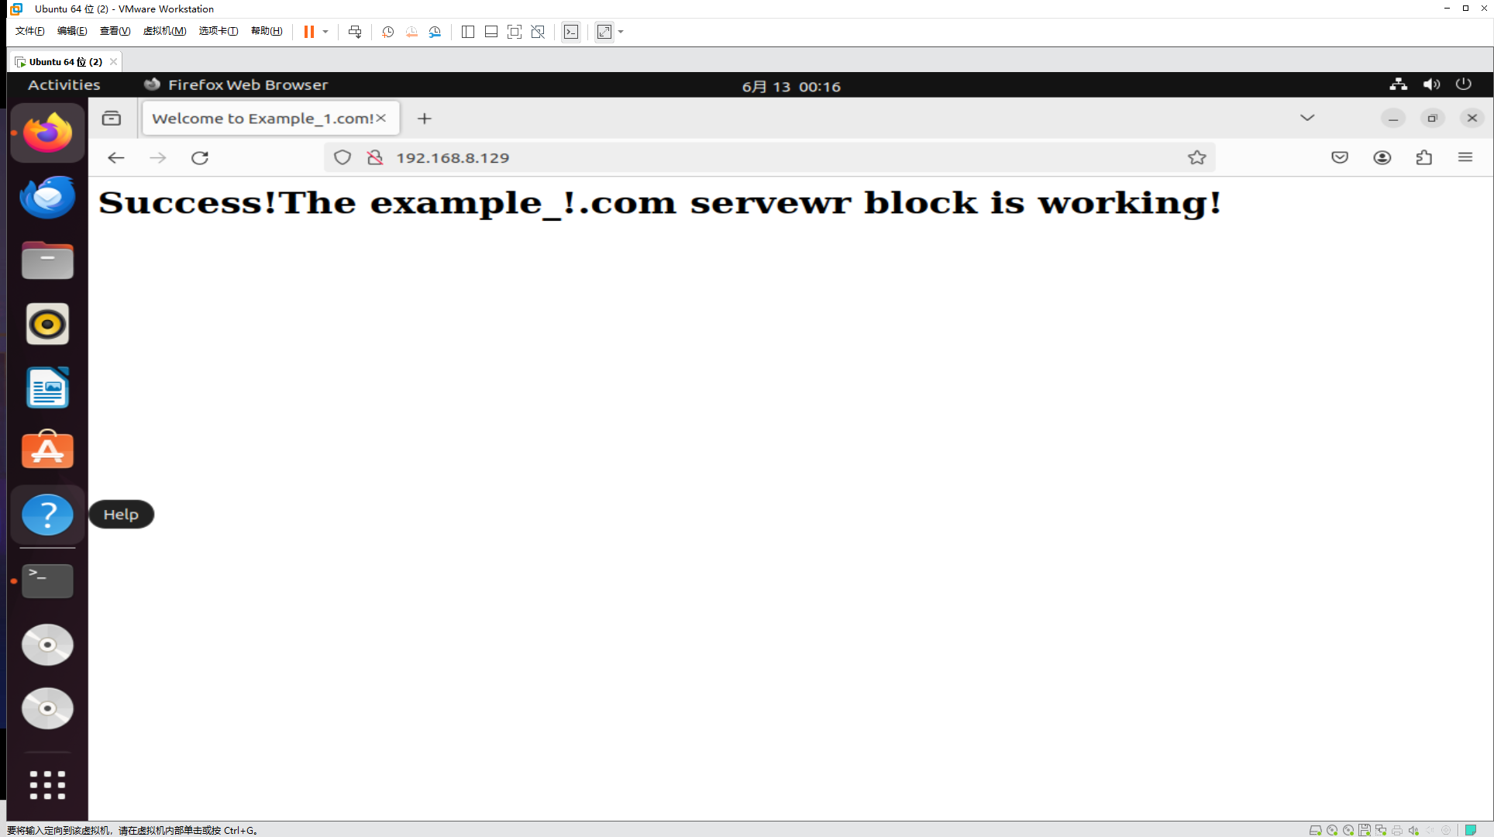

# Analysis

Analyze the behavior of each program. Explain the observed outputs, discuss any challenges encountered, and how they were resolved.

# Conclusion

Summarize your findings and experiences from this lab assignment.

# References

List any references or resources you used to complete this lab assignment, if any.