# Lab02# Report

|  |  |  |
| --- | --- | --- |
| 202283890036 | 黄家睿( Jerry Huang) | IOT major |

# Character Interface Operation Basics

## ls

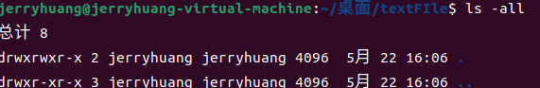

## cd



## pwd



## Touch



A new file text.txt exist in textFIle file folder

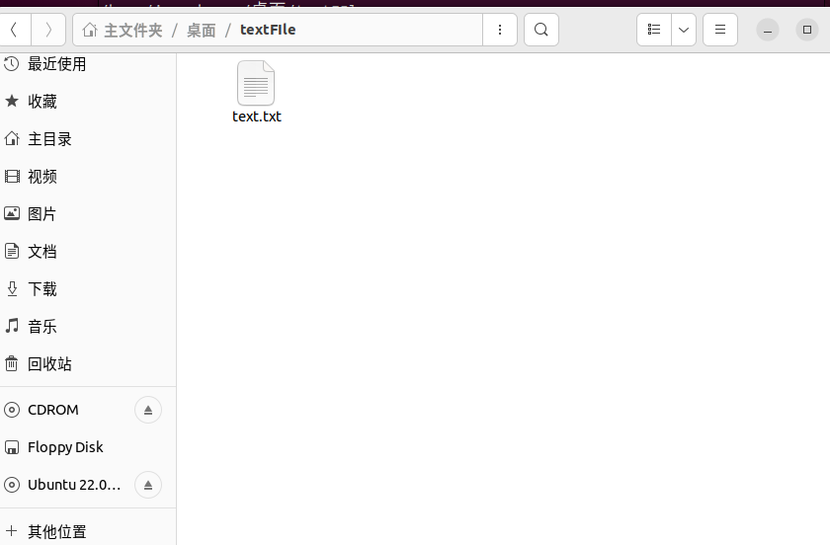

## rm

Now the text.txt file in textFIle file folder is not existing.

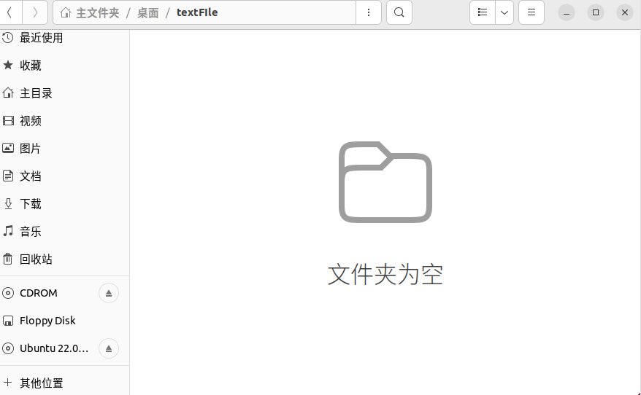

## mv

Let recreate text.txt in textFIle file folder.

Then move the address into the father folder

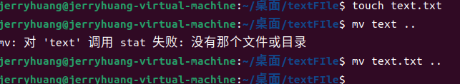

Check textFIle file folder, the text.txt is not there, it is in the father folder desktop file folder

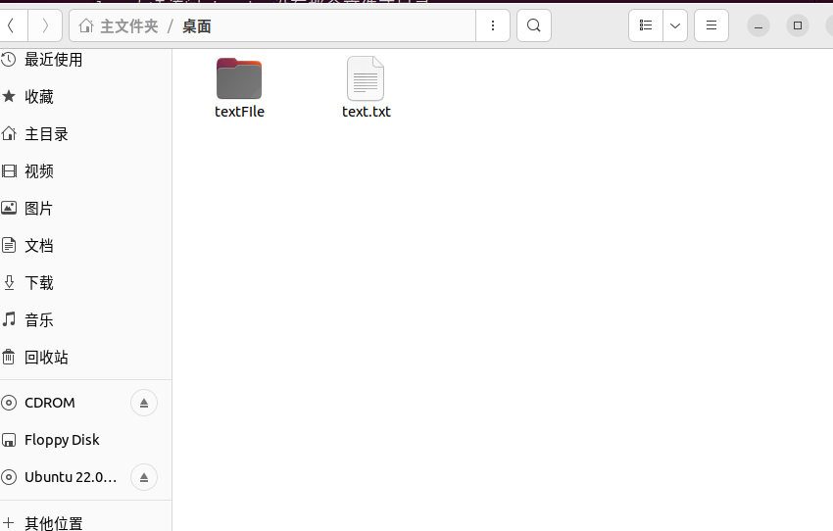

## mkdir

Create a new file textFile2

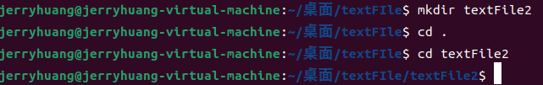

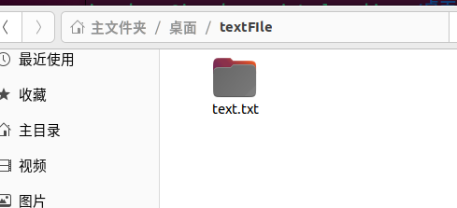

## cat

Create a file in textFile2.touch and edit the content.

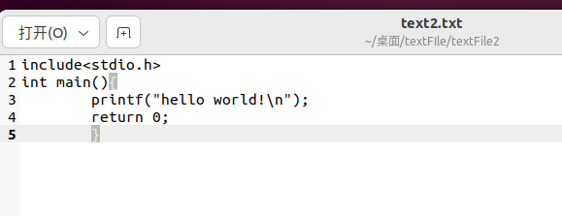

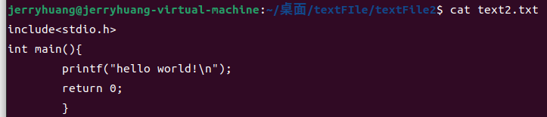

## cp

Copy the text2.txt into father folder



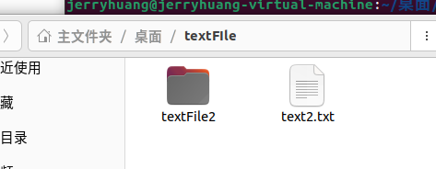

## Shotdown now

