# Lab05# report

|  |  |  |
| --- | --- | --- |
| 202283890036 | Jiarui Huang | IoT |

## Task1:

## Save user group data file & save user group password file

The command:

cat /etc/passwd：

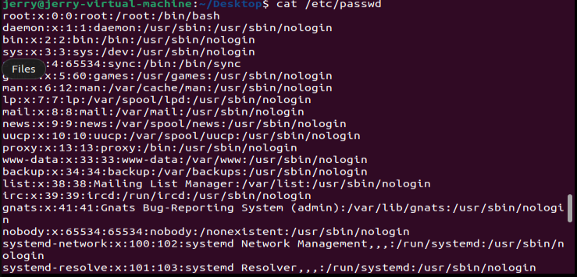

cat /etc/gshadow

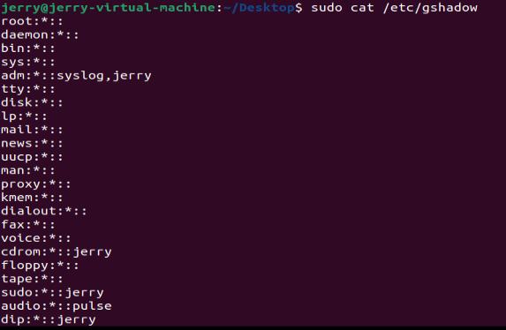

## Task2: Command foe managing users and user groups

### userAdd

Use useAdd command to create new user:

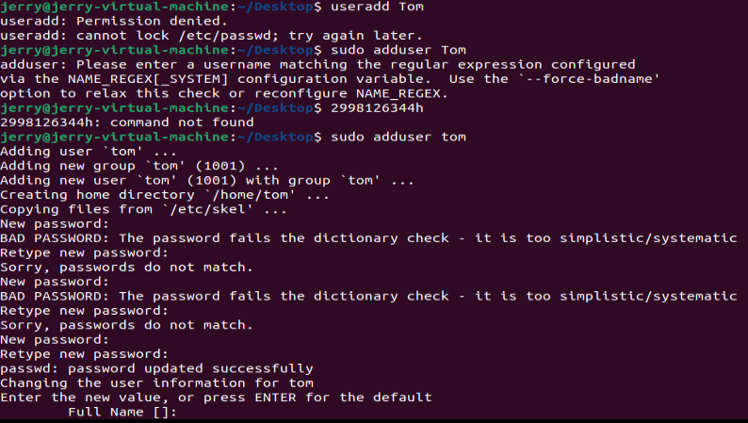 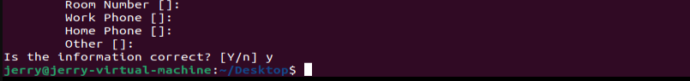

### Passwd command

Use passwd command to set password:

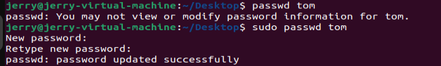

### Usermod command

Use usermod command to edit user information:

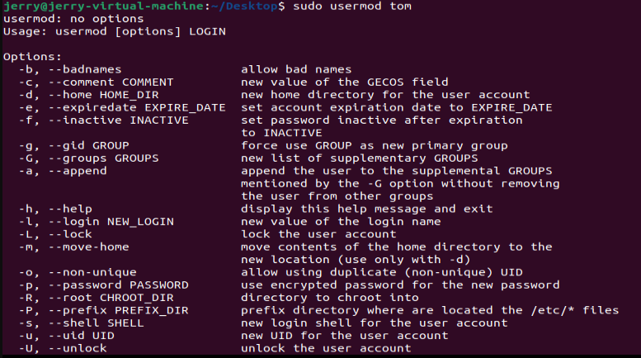

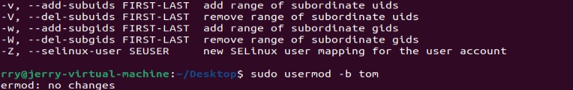

### Userdel command

Use userdel command to delete user information

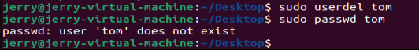

### Groupadd command



### gpasswd command

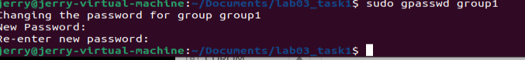

### groupmod command



## Task3: Authority management

### Chown command:

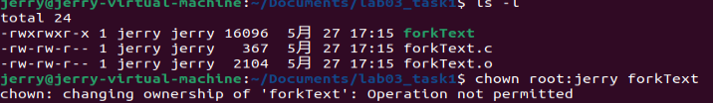

### chgrp command

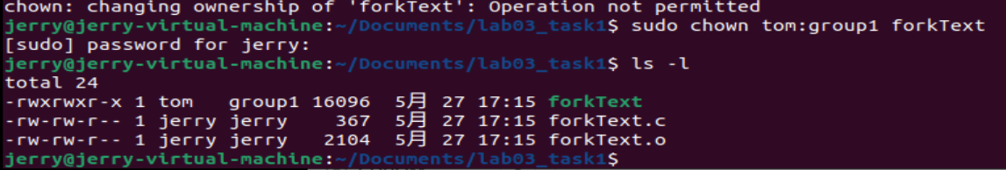

### Chmod command

