# Homework #2

|  |  |  |
| --- | --- | --- |
| 黄家睿 | 202283890036 | IOT |

Exercise 3.1



Solution:

5ED4 -07A4=5730

Exercise 3.3



Solution:

5ED4 in binary is 11010100

A single digit can represent up to16 patterns, which is enough to employ two hexadecimal digits for representing a single byte.

Exercise 3.8



Solution:

Because 185 in binary is 10111001, it is -57 in sign-magnitude format, so it become

-57-122=-178

-178 can not be represented in sign-magnitude format

Overflow happened

Exercise 3.12

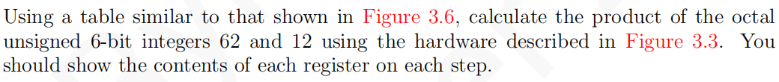

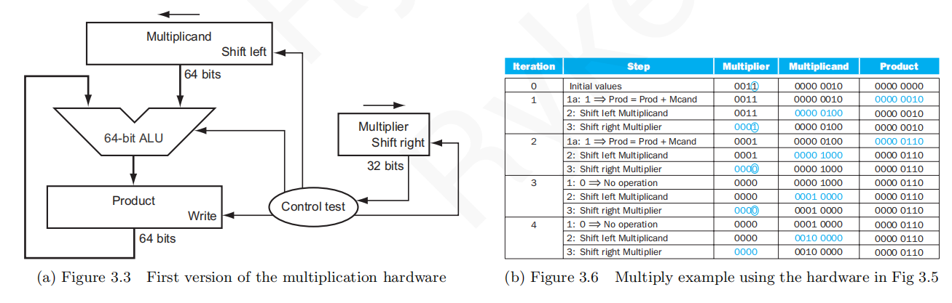

Solution:

|  |  |  |  |  |
| --- | --- | --- | --- | --- |
| Iteration | Step | Multiplier | Multiplicand | Product |
| 0 | Initial values | 001010 | 0000 0011 0010 | 0000 0000 0000 |
| 1 | 1:0→No operation | 001010 | 0000 0011 0010 | 0000 0000 0000 |
| 2: Shift left Multiplicand | 001010 | 0000 0110 0100 | 0000 0000 0000 |
| 3: Shift right Multiplier | 000101 | 0000 0110 0100 | 0000 0000 0000 |
| 2 | 1:1→Prod+=Multiplicand | 000101 | 0000 0110 0100 | 0000 0011 0100 |
| 2:Shift left Multiplicand | 000101 | 0000 1100 1000 | 0000 0011 0100 |
| 3:Shift right Multiplier | 000010 | 0000 1100 1000 | 0000 0011 0100 |
| 3 | 1:0→No operation | 000010 | 0000 1100 1000 | 0000 0011 0100 |
| 2:Shift left Multiplicand | 000010 | 0001 1001 0000 | 0000 0011 0100 |
| 3:Shift right Multiplier | 000001 | 0001 1001 0000 | 0000 0011 0100 |
| 4 | 1:1→Prod+=Multiplicand | 000001 | 0001 1001 0000 | 0001 1111 0100 |
| 2:Shift left Multiplicand | 000001 | 0011 0010 0000 | 0001 1111 0100 |
| 3:Shift right Multiplier | 000000 | 0011 0010 0000 | 0001 1111 0100 |
| 5 | 1:0→No operation | 000000 | 0011 0010 0000 | 0001 1111 0100 |
| 2:Shift left Multiplicand | 000000 | 0110 0100 0000 | 0001 1111 0100 |
| 3:Shift right Multiplier | 000000 | 0110 0100 0000 | 0001 1111 0100 |
| 6 | 1:0→No operation | 000000 | 0110 0100 0000 | 0001 1111 0100 |
| 2:Shift left Multiplicand | 000000 | 1100 1000 0000 | 0001 1111 0100 |
| 3:Shift right Multiplier | 000000 | 1100 1000 0000 | 0001 1111 0100 |

Exercise 3.13



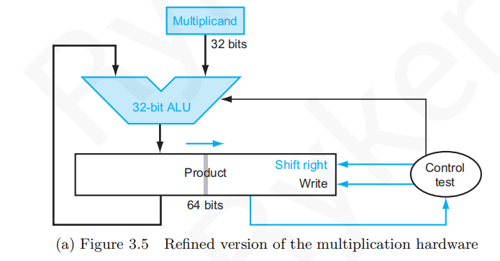

Solution:

|  |  |  |  |
| --- | --- | --- | --- |
| Iteration | Step | Multiplicand | Product |
| 1 | 1:0→No operation | 00110010 | 0000 0000 0000 1010 |
| 2:Shift right Product | 00110010 | 0000 0000 0000 0101 |
| 2 | 1:1→Prod+=Multiplicand | 00110010 | 0011 0010 0000 0101 |
| 2:Shift right Product | 00110010 | 0001 1001 0000 0010 |
| 3 | 1:0→No operation | 00110010 | 0001 1001 0000 0010 |
| 2:Shift right Product | 00110010 | 0000 1100 1000 0001 |
| 4 | 1:1→Prod+=Multiplicand | 00110010 | 0011 1110 1000 0001 |
| 2:Shift right Product | 00110010 | 0001 1111 0100 0000 |
| 5 | 1:0→No operation | 00110010 | 0001 1111 0100 0000 |
| 2:Shift right Product | 00110010 | 0000 1111 1010 0000 |
| 6 | 1:0→No operation | 00110010 | 0000 1111 1010 0000 |
| 2:Shift right Product | 00110010 | 0000 0111 1101 0000 |
| 7 | 1:0→No operation | 00110010 | 0000 0111 1101 0000 |
| 2:Shift right Product | 00110010 | 0000 0011 1110 1000 |
| 8 | 1:0→No operation | 00110010 | 0000 0011 1110 1000 |
| 2:Shift right Product | 00110010 | 0000 0001 1111 0100 |

Exercise 3.14

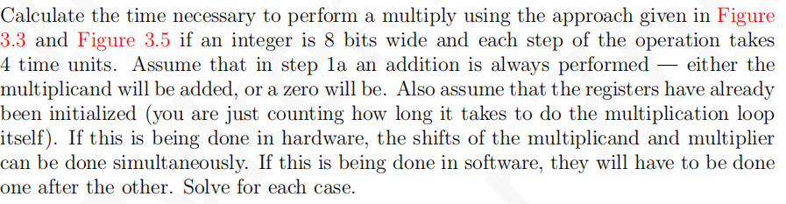

Solution :

For hardware described in Fig-3.3:

Hardware： 3×8×4=96 time cycle

Software： 5×8×4=160 time cycle

For hardware described in Fig-3.5:

Hardware：3×8×4=96 time cycle

Software： 4×8×4=96time cycle

Exercise 3.15

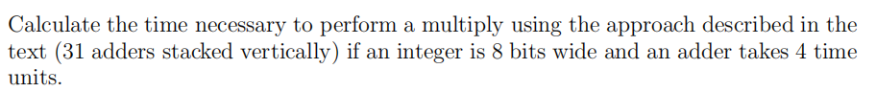

Solution:

7×4=28 time cycle

Exercise 3.18

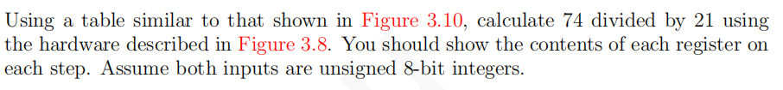

Solution:

|  |  |  |  |  |
| --- | --- | --- | --- | --- |
| Iteration | Step | Quotient | Divisor | Remainder |
| 0 | Initial Values | 00000000 | 0000 0000 01010001 | 1110 1011 0100 1010 |
| 1 | 1: Rem -= Div | 0000 0000 | 0001 0101 0000 0000 | 1110 1011 0100 1010 |
| 2b: Rem <0= +Div, LSL Q, Q0= 0 | 0000 0000 | 0001 0101 0000 0000 | 1110 1011 0100 1010 |
| 3: Shift Div right | 0000 0000 | 0000 1010 1000 0000 | 1110 1011 0100 1010 |
| 2 | 1: Rem -= Div | 0000 0000 | 0000 1010 1000 0000 | 1111 0101 1100 1010 |
| 2b: Rem <0= +Div, LSL Q, Q0= 0 | 0000 0000 | 0000 1010 1000 0000 | 0000 0000 0100 1010 |
| 3: Shift Div right | 0000 0000 | 0000 0101 0100 0000 | 0000 0000 0100 1010 |
| 3 | 1: Rem -= Div | 0000 0000 | 0000 0101 0100 0000 | 1111 1011 0000 1010 |
| 2b: Rem <0= +Div, LSL Q, Q0 = 0 | 0000 0000 | 0000 0101 0100 0000 | 0000 0000 0100 1010 |
| 3: Shift Div right | 0000 0000 | 0000 0010 1010 0000 | 0000 0000 0100 1010 |
| 4 | 1: Rem -= Div | 0000 0000 | 0000 0010 1010 0000 | 1111 1101 1010 1010 |
| 2b: Rem <0= +Div, LSL Q, Q0 = 0 | 0000 0000 | 0000 0010 1010 0000 | 0000 0000 0100 1010 |
| 3: Shift Div right | 0000 0000 | 0000 0001 0101 0000 | 0000 0000 0100 1010 |
| 5 | 1: Rem -= Div | 0000 0000 | 0000 0001 0101 0000 | 1111 1101 1111 1010 |
| 2b: Rem <0= +Div, LSL Q, Q0 = 0 | 0000 0000 | 0000 0001 0101 0000 | 0000 0000 0100 1010 |
| 3: Shift Div right | 0000 0000 | 0000 0000 1010 1000 | 0000 0000 0100 1010 |
| 6 | 1: Rem -= Div | 0000 0000 | 0000 0000 1010 1000 | 1111 1111 0100 0010 |
| 2b: Rem <0= +Div, LSL Q, Q0 = 0 | 0000 0000 | 0000 0000 1010 1000 | 0000 0000 0100 1010 |
| 3: Shift Div right | 0000 0000 | 0000 0000 0101 0100 | 0000 0000 0100 1010 |
| 7 | 1: Rem -= Div | 0000 0000 | 0000 0000 0101 0100 | 1111 1111 1111 0110 |
| 2b: Rem <0= +Div, LSL Q, Q0 = 0 | 0000 0000 | 0000 0000 0101 0100 | 0000 0000 0100 1010 |
| 3: Shift Div right | 0000 0000 | 0000 0000 0010 1010 | 0000 0000 0100 1010 |
| 8 | 1: Rem -= Div | 0000 0000 | 0000 0000 0010 1010 | 0000 0000 0010 0000 |
| 2a: Rem ≥ 0 = LSL Q, Q0 = 1 | 0000 0010 | 0000 0000 0001 0101 | 0000 0000 0010 0000 |
| 3: Shift Div right | 0000 0010 | 0000 0000 0001 0101 | 0000 0000 0000 1011 |
| 9 | 1: Rem -= Div | 0000 0010 | 0000 0000 0001 0101 | 0000 0000 0000 1011 |
| 2a: Rem ≥ 0 = LSL Q, Q0 = 1 | 0000 0011 | 0000 0000 0001 0101 | 0000 0000 0000 1011 |
| 3: Shift Div right | 0000 0011 | 0000 0000 0000 1010 | 0000 0000 0000 1011 |

Exercise 3.20：

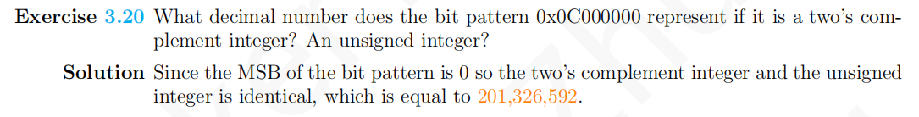

Exercise 3.21

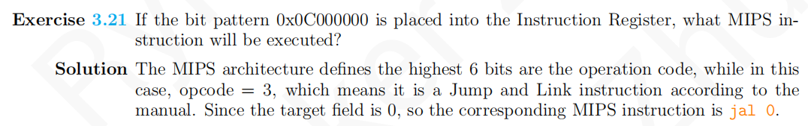

Exercise 3.22

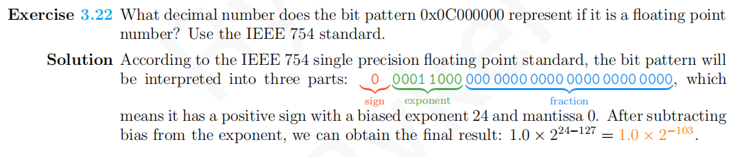

Exercise 3.23

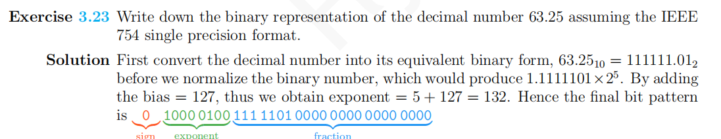

Exercise 3.24

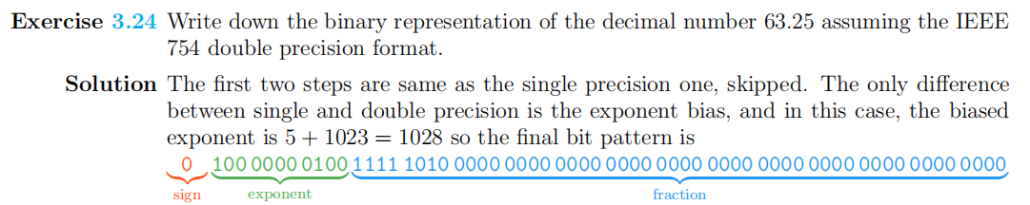

Exercise 3.27

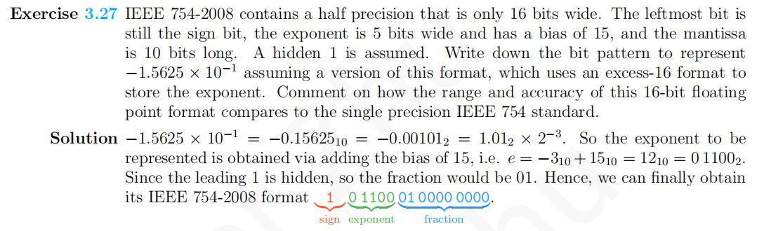

Exercise 3.41

