## LAB #02 Report

|  |  |  |
| --- | --- | --- |
| Name:黄家睿 | ID number:202283890036 | Major:IOT |

Task 1:

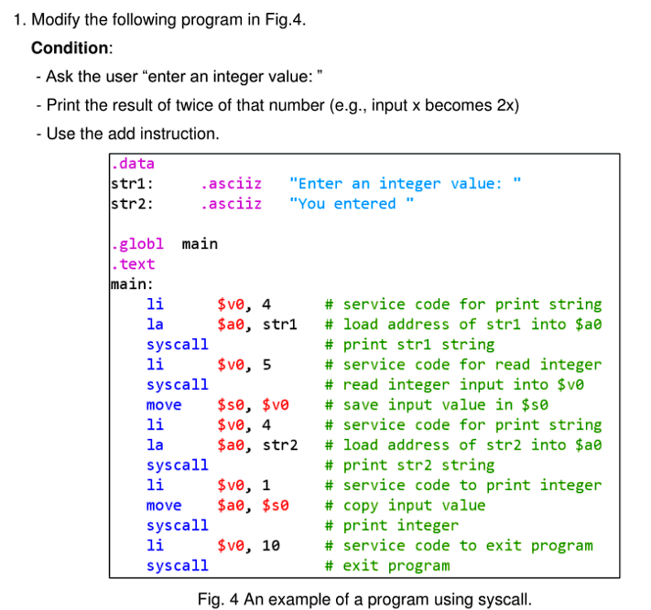

**Task 1 solution:**

Code:

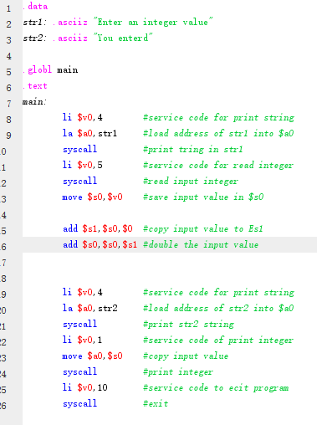

Output the result

Double the input integer

This part is used for input integer

**Mars screen capture:**

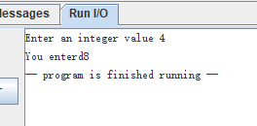

Output is 8,double the inpur

Input is 4

### Task2

**Task 2 solution:**

**Code:**

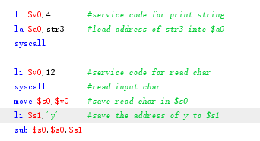

Compare input char with ‘y’,if equal, branch to main again

Input a char

**Mars screen capture:**

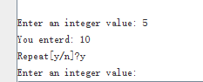

Here the input char is ‘y’, main function executed again

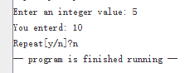

Here the input char is ‘n’, main function is not executed again

### Task 3

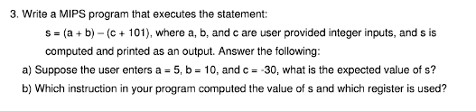

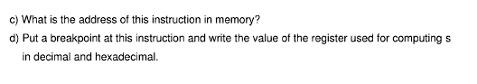

**Task 3 solution:**

**Code:**

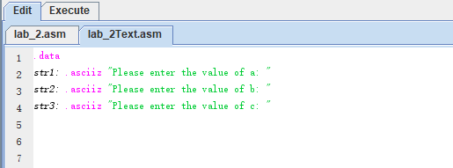

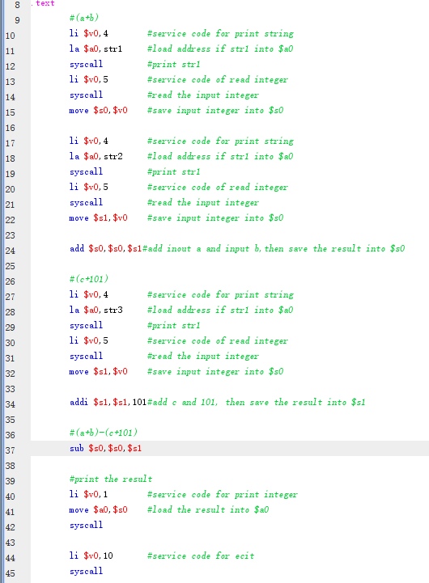

1. :

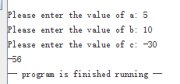

S=-56

1. :



The line 37 calculate the value of s

$s0,$s1 register is used

1. :



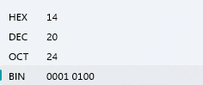

### Task4:

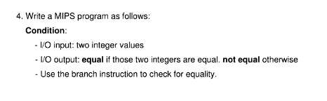

Task4 solution:

Code:

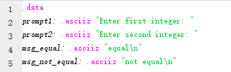

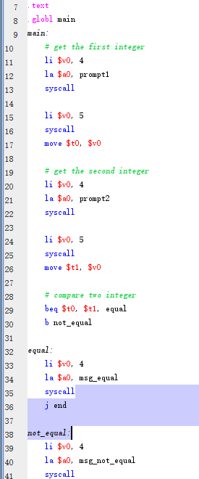

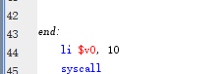

Mars screen capture:

