## LAB #04 Report

|  |  |  |
| --- | --- | --- |
| Name:黄家睿 | ID number:202283890036 | Major:IOT |

### Task1:

### 

**Solution:**

**Code:**

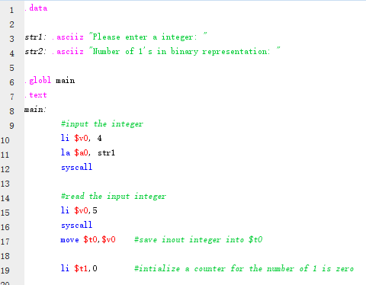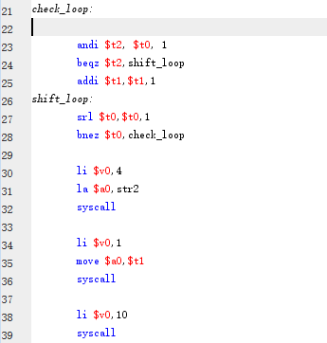

Input 9 and result is 2:

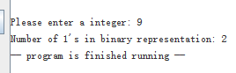

### Tast2:

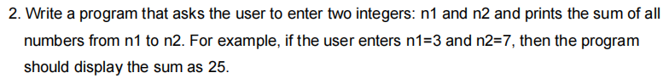

**Solution:**

**Code:**

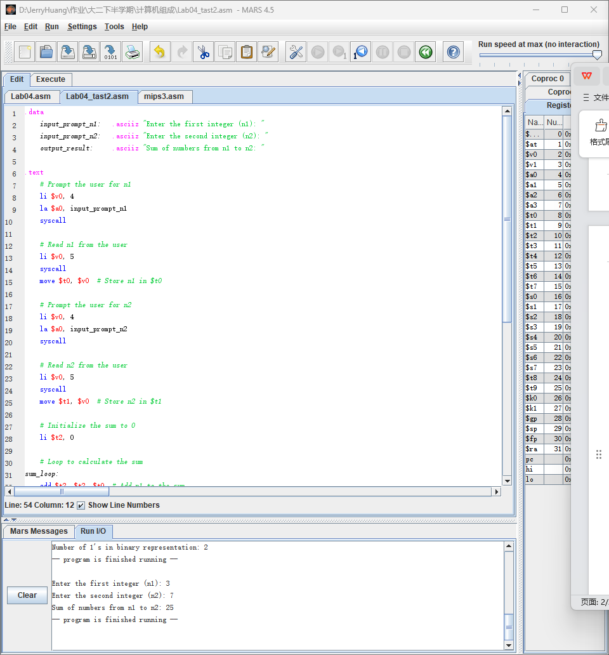

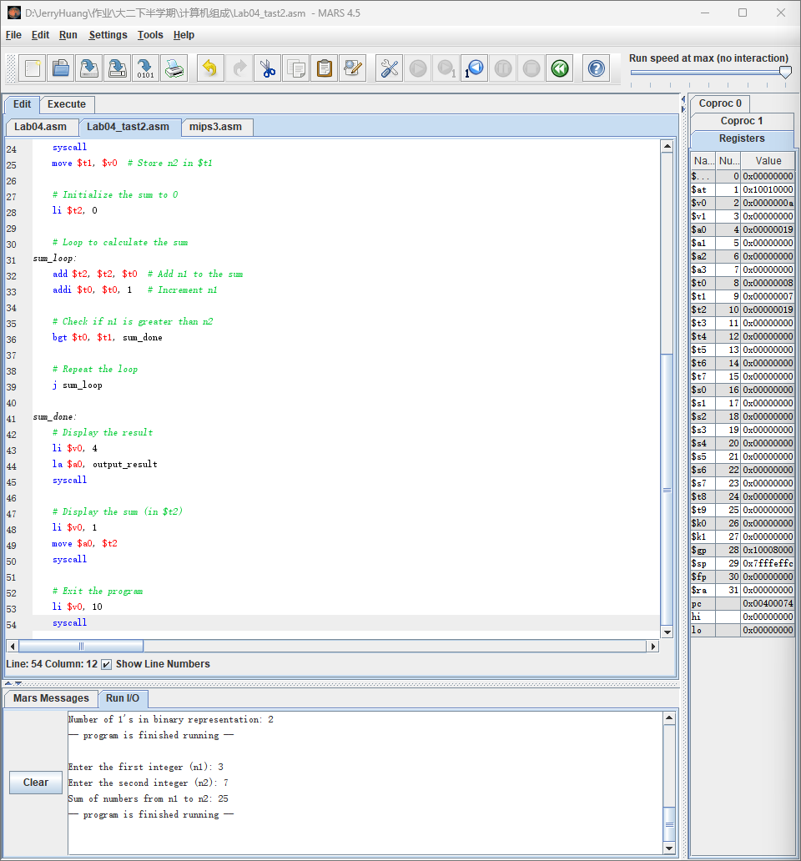

**Test & screenshot:**

Input 3 and 7, the output is 25:

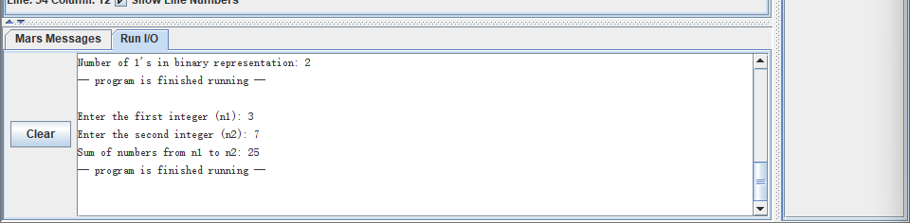

### Tast3:



**Solution:**

**Code:**

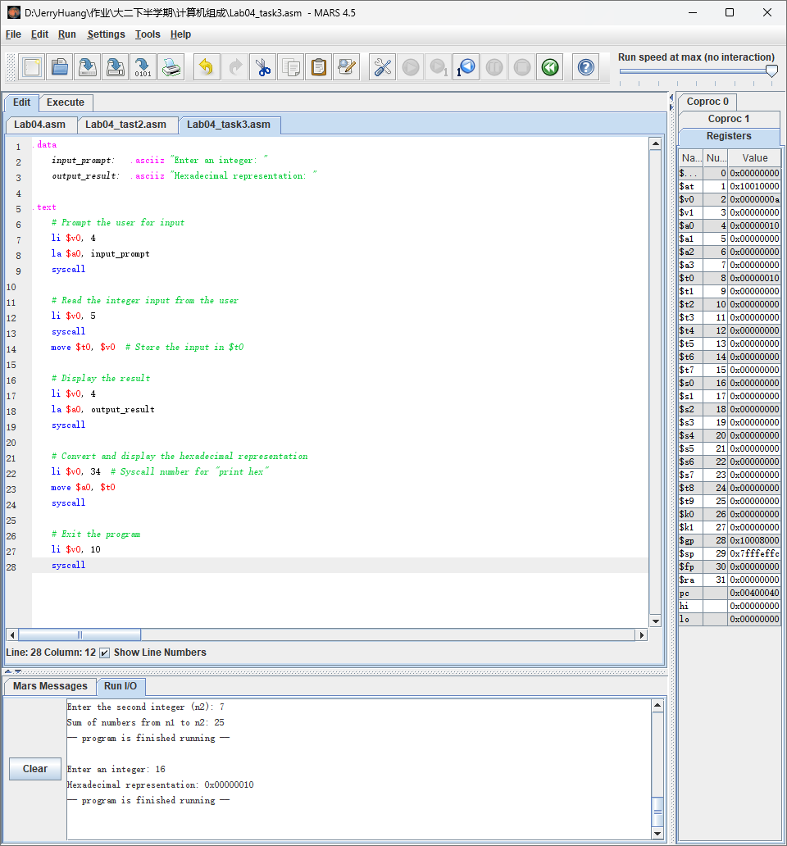

**Text & screenshot:**

Input 16 and the result should is 0x00000010



### Tast4:

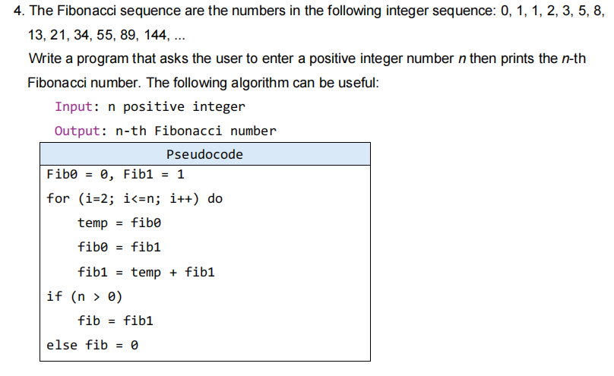

**Solution:**

**Code:**

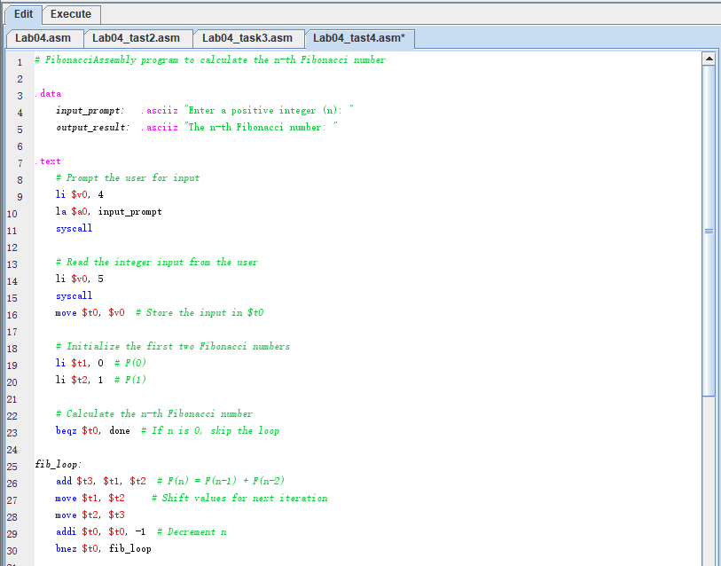

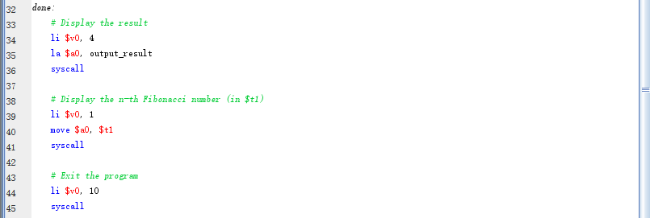

**Test & screenshot:**

