# Lab08# report

|  |  |  |
| --- | --- | --- |
| 202283890036 | Jiarui Huang | IOT |

## Task 1:

**Build 1-bit ALU**

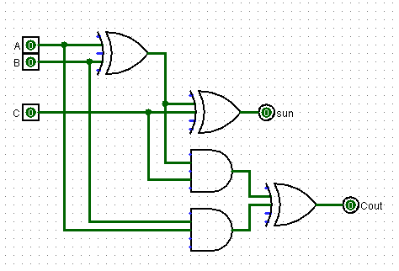

Figure 1: 1-bit adder

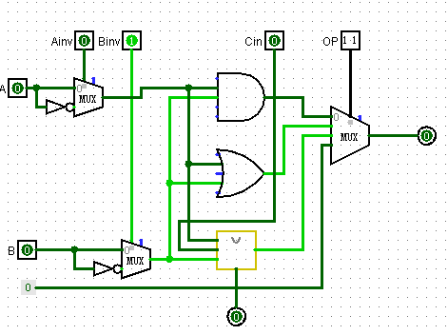

Figure 2: 1-bit ALU

A: one of the input

B: another input

Cin: The carry from previous ALU

Ainv : To control the signal

Binv: To control the signal

OP: To control which operation the ALU will do

## Task 2:

**With 1 bit ALU, make a 32 bit ripple carry adder and test your circuit.**

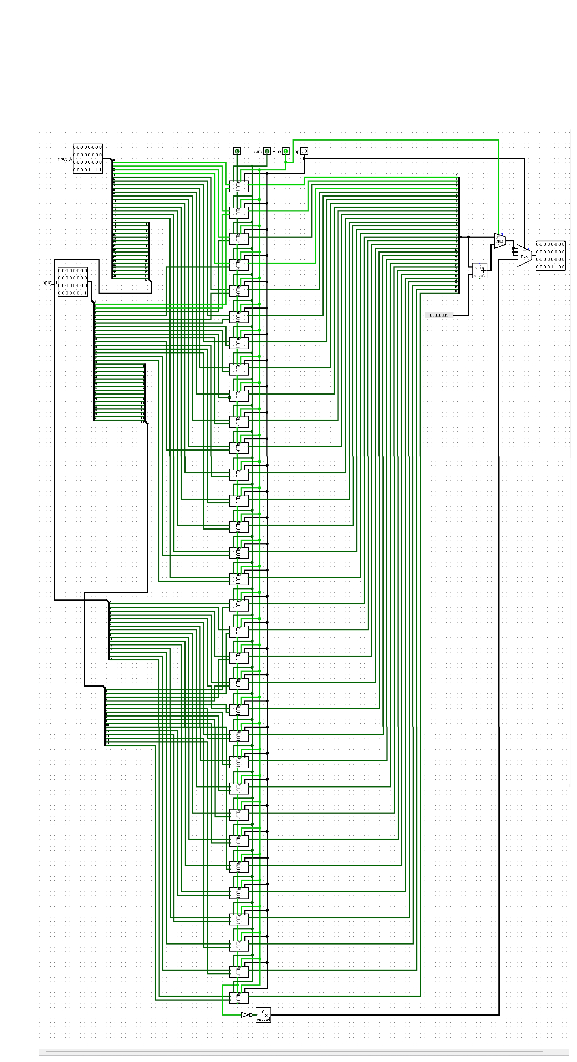

Figure 3: The 32 bits ripple

## Task3:

Complete your ALU with the following functions. (lecture slides 27). Test your circuit of

each function.

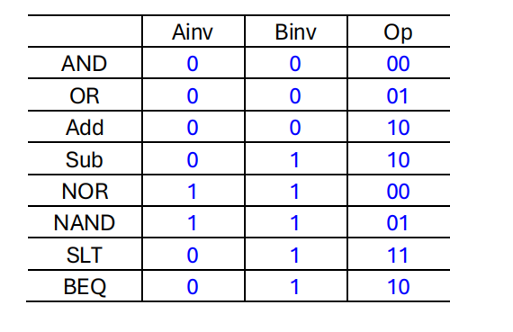

**The circule:**



**Test and operation:**

Input of A:

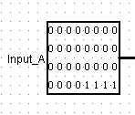

Input of B:

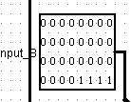

The op signal:



Result:

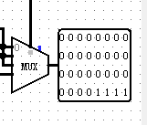

**Test of or operation:**

Input of A:

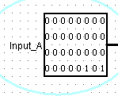

Input of B:

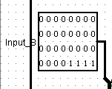

The op signal:



Result:

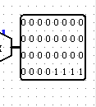

**Test of ADD operation:**

Input of A:

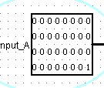

Input of B:

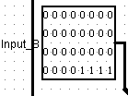

The op signal:



Result:

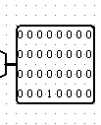

**Test of Sub operation:**

Input of A:

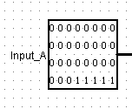

Input of B:

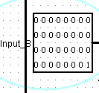

The op signal:



Result:

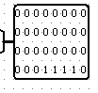

**Test NOR operation:**

Input of A:

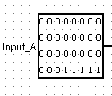

Input of B:

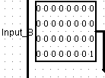

The op signal:

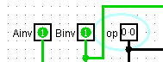

Result:

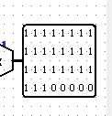

**Test NAND operation:**

Input of A:

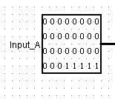

Input of B:



The op signal:



Result:

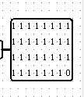

**Test slt operation:**

Input of A:

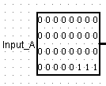

Input of B:

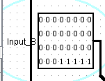

The op signal:



Result:

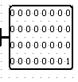

Because input a< input b, the result is 1.

**Test beq operation:**

Input of A:

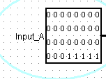

Input of B:

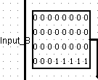

The op signal:



Result:

As input a = input B, the result is 0, if not equal, the result will not be 0.

