## LAB #05 Report

|  |  |  |
| --- | --- | --- |
| Name:黄家睿 | ID number:202283890036 | Major:IOT |

### Task 1:

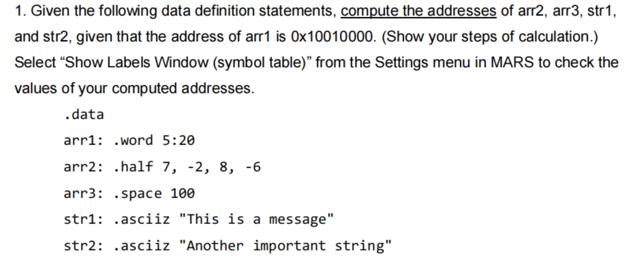

**Solution:**

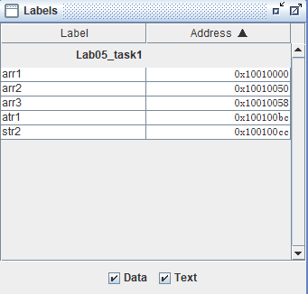

### Task 2:

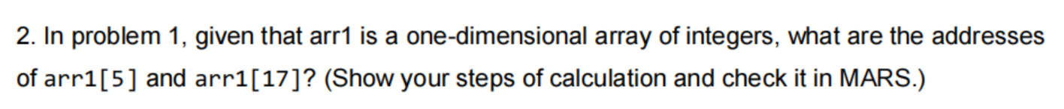

**Solution:**

For one-dimensional array of integers, one integer is 4 bits, the address of array[i] is:

$$\&array[i]=\&array+i×4$$

Thus, the address of arr1[5] is

$$0x10010000+5×4=0x10010014$$

The address of arr1[17] is

$$0x10010000+17×4=0x10010044$$

**Task 3:**

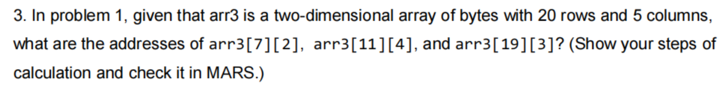

**Solution**

For two-dimensional array of bytes, one byte is 8 bits, the address of array[i][j] is:

$$\&array[i][j]=\&array+(i×5+j)×8$$

Thus, the address of arr3[7][2] is:

$$0x10010058+(7×5+2)×8=0x10010180$$

The address of arr3[11][4] is:

$$0x10010058+(11×5+4)×8=0x10010230$$

The address of arr3[19][3] is:

$$0x10010058+(19×5+3)×8=0x10010368$$