NUIST Experiment Report

Course name IOT communication Technology

Experiment name AM modulation and demodulation

Date 2024/04/29 Tuitor 谈玲

College waterford Major Iot

Grade 2022 Class Name 黄家睿

Student ID 202283890036

1. Experimental objective
2. Understand and master the principle of AM modulation.
3. Experimental equipment

Matlab

1. Experimental procedure (content)

（1）Complete the writing of each function;

（2）Call each function in the main function to realize the spectrum analysis of the signal.

1. Experimental result

4.1 carrier signal

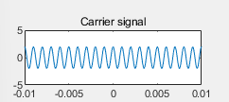

Figure 1 carrier signal

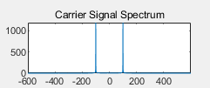

Figure 2 carrier signal Spectrum

4.2 modulating signal

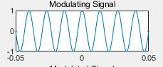

Figure 3 Modulating signal

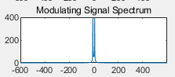

Figure 4 Modulating signal Spectrum

4.3 Modulated signal

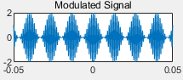

Figure 5 Modulated signal

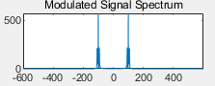

Figure 6 modulated signal spectrum

4.4

1. Conclusions

>> t0=0.1;

fs=12000;

fc=1000;

Vm=2;

A0=1;

n=-t0/2:1/fs:t0/2;

x=cos(150*pi*n);

y2=Vm*cos(2*pi*fc*n);

N=length(x);

Y2=fft(y2);

figure(1);

subplot(4,2,1);

plot(n,y2);

axis([-0.01,0.01, -5,5]);

title(' Carrier signal ');

w=(-N/2:1:N/2-1);

subplot(4,2,2);

plot(w, abs(fftshift(Y2)));

title(' Carrier Signal Spectrum ');

y=(A0+x).*cos(2*pi*fc*n);

subplot(4,2,3);

plot(n,x);

title(' Modulating Signal ');

X=fft(x);

Y=fft(y);

subplot(4,2,4);

plot(w, abs(fftshift(X)));

% axis([0, pi/4, 0, 1000]);

title(' Modulating Signal Spectrum ');

subplot(4, 2, 5);

plot(n, y);

title(' Modulated Signal ');

subplot(4, 2, 6);

plot(w, abs(fftshift(Y)));

% axis([pi/6, pi/4, 0, 1200]);

title(' Modulated Signal Spectrum ');

y2=y.*Vm.*cos(2*pi*fc*n);

wp=40/N*pi;

ws=60/N*pi;

Rp=1;

As=15;

T=1;

OmegaP=wp/T;

OmegaS=ws/T;

[cs, ds]=afd_butt(OmegaP, OmegaS, Rp, As);

[b, a]=imp_invr(cs, ds, T);

y3=filter(b, a, y2);

y=y3-A0;

subplot(4, 2, 7);

plot(n, y);

title(' Demodulated Signal ');

Y=fft(y);

subplot(4, 2, 8);

plot(w, abs(fftshift(Y)));

%axis([0, pi/4, 0, 1000]);

title(' Demodulated Signal Spectrum')

function [b, a]=afd_butt(Wp, Ws, Rp, As)

N=ceil((log10((10^(Rp/10)-1)/(10^(As/10)-1)))/(2*log10(Wp/Ws)));

fprintf('\n Butterworth Filter Order=%2.0f\n', N)

OmegaC=Wp/((10^Rp/10)-1)^(1/(2*N)));

[b, a]=u_buttap(N, OmegaC);

function [b, a]=u_buttap(N, Omegac);

[z, p, k]=buttap(N);

p=p*Omegac;

k=k*Omegac^N;

B=real(poly(z));

b0=k;

b=k*B;

a=real(poly(p));

function [b, a]=imp_invr(c, d, T)

[R, p, k]=residue(c, d);

p=exp(p*T);

[b, a]=residuez(R, p, k);

b=real(b');

a=real(a')