NUIST Experiment Report

Course name IOT communication Technology

Experiment name AM modulation and demodulation

Date 2024/04/29 Tuitor 谈玲

College waterford Major Iot

Grade 2022 Class Name 黄家睿

Student ID 202283890036

1. **Experimental objective**
2. Understand and master the principle of AM modulation.
3. **Experimental equipment**

Matlab

1. **Experimental procedure (content)**

（1）Complete the writing of each function;

（2）Call each function in the main function to realize the spectrum analysis of the signal.

1. **Experimental result**

**4.1 carrier signal**

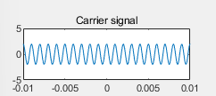

Figure 1 carrier signal

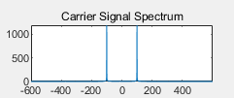

Figure 2 carrier signal Spectrum

**4.2 modulating signal**

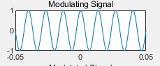

Figure 3 Modulating signal

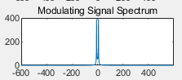

Figure 4 Modulating signal Spectrum

**4.3 Modulated signal**

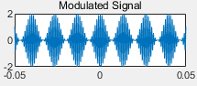

Figure 5 Modulated signal

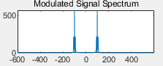

Figure 6 modulated signal spectrum

**4.4**

1. **Conclusions**

>> t0=0.1;

fs=12000;

fc=1000;

Vm=2;

A0=1;

n=-t0/2:1/fs:t0/2;

x=cos(150*pi*n);

y2=Vm*cos(2*pi*fc*n);

N=length(x);

Y2=fft(y2);

figure(1);

subplot(4,2,1);

plot(n,y2);

axis([-0.01,0.01, -5,5]);

title(' Carrier signal ');

w=(-N/2:1:N/2-1);

subplot(4,2,2);

plot(w, abs(fftshift(Y2)));

title(' Carrier Signal Spectrum ');

y=(A0+x).*cos(2*pi*fc*n);

subplot(4,2,3);

plot(n,x);

title(' Modulating Signal ');

X=fft(x);

Y=fft(y);

subplot(4,2,4);

plot(w, abs(fftshift(X)));

% axis([0, pi/4, 0, 1000]);

title(' Modulating Signal Spectrum ');

subplot(4, 2, 5);

plot(n, y);

title(' Modulated Signal ');

subplot(4, 2, 6);

plot(w, abs(fftshift(Y)));

% axis([pi/6, pi/4, 0, 1200]);

title(' Modulated Signal Spectrum ');

y2=y.*Vm.*cos(2*pi*fc*n);

wp=40/N*pi;

ws=60/N*pi;

Rp=1;

As=15;

T=1;

OmegaP=wp/T;

OmegaS=ws/T;

[cs, ds]=afd_butt(OmegaP, OmegaS, Rp, As);

[b, a]=imp_invr(cs, ds, T);

y3=filter(b, a, y2);

y=y3-A0;

subplot(4, 2, 7);

plot(n, y);

title(' Demodulated Signal ');

Y=fft(y);

subplot(4, 2, 8);

plot(w, abs(fftshift(Y)));

%axis([0, pi/4, 0, 1000]);

title(' Demodulated Signal Spectrum')

function [b, a]=afd_butt(Wp, Ws, Rp, As)

N=ceil((log10((10^(Rp/10)-1)/(10^(As/10)-1)))/(2*log10(Wp/Ws)));

fprintf('\n Butterworth Filter Order=%2.0f\n', N)

OmegaC=Wp/((10^Rp/10)-1)^(1/(2*N)));

[b, a]=u_buttap(N, OmegaC);

function [b, a]=u_buttap(N, Omegac);

[z, p, k]=buttap(N);

p=p*Omegac;

k=k*Omegac^N;

B=real(poly(z));

b0=k;

b=k*B;

a=real(poly(p));

function [b, a]=imp_invr(c, d, T)

[R, p, k]=residue(c, d);

p=exp(p*T);

[b, a]=residuez(R, p, k);

b=real(b');

a=real(a')