NUIST Experiment Report

Course name：IOT communication Technology

Experiment name Various simulated signal source experiments

Date2024/05/08 Tuitor:谈玲

College： water Ford Major： Iot Grade： 2022 Class： class1 Name： 黄家睿 Student ID 202283890036

1. Experimental objective
2. Familiar with the generation methods of various analog signals and their use
3. bserve and analyze the characteristics of various simulated signal waveforms。
4. Experimental equipment
5. Experiment equipment box
6. Oscilloscope
7. Experimental procedure (content）

1．Measure the point waveforms of TP 106, TP 107, TP 108, TP 109, TP 110, TP 112, TP 113, TP 114.(K101 is connected to 2-3)

2．When measuring the music signal, use K105 to turn on + 3.3V, and make the music piece add the control signal to produce the music signal output.

1. Experimental result

TP106：2 KHz or 1 KHz square wave, because the element parameters of the active low-pass filter are dominated by 2 KHz.:

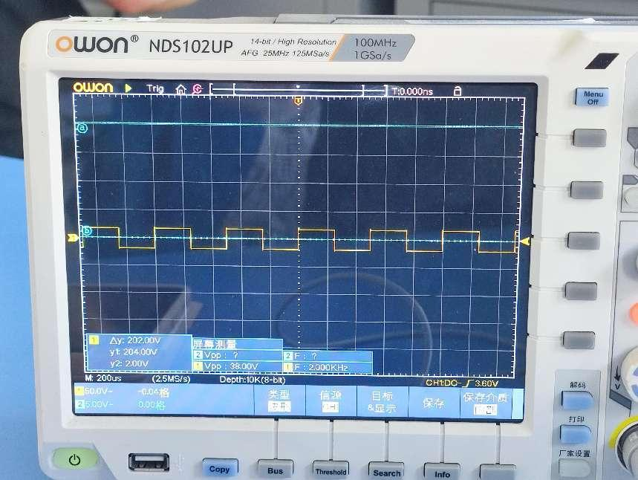

TP107：A 2 KHz or 1 KHz sine wave signal output synchronously with the working clock.(To draw)

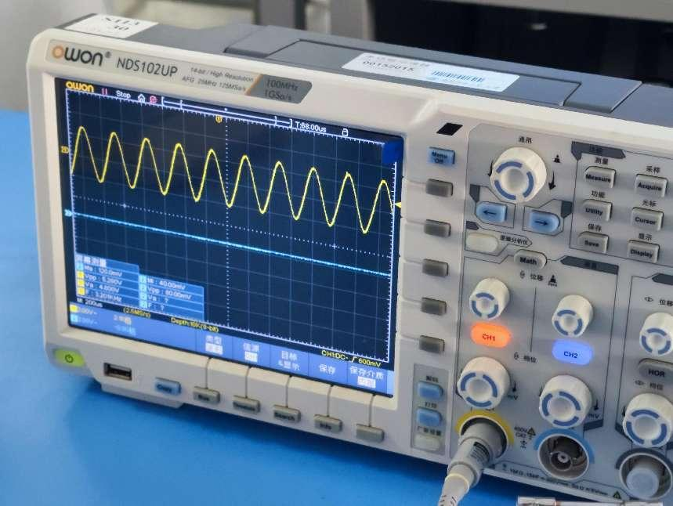

TP108：The sine wave of the 0.3~3.4KHz.(To draw)

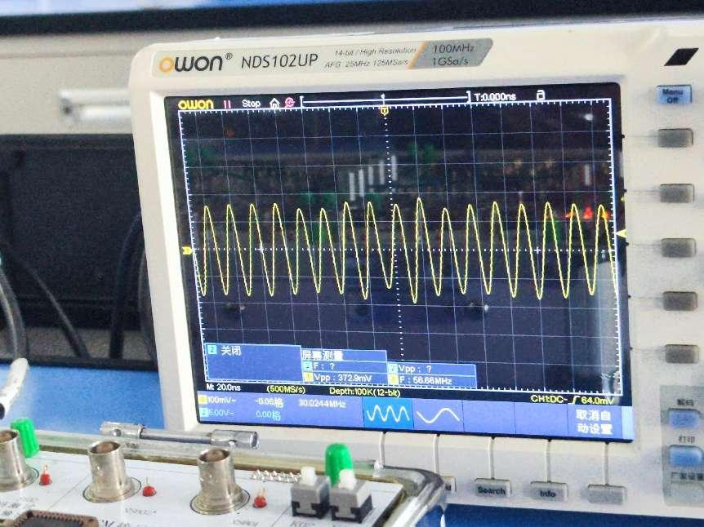

1. Conclusions

In this experiment, we learned how to use the communication equipment box, and got Familiar with the generation methods of various analog signals and their use by operating the Oscilloscope.