NUIST Experiment Report

Course name IOT communication Technology

Experiment name Implementing Digital Baseband Signal Encoding with NRZ Experiment in MATLAB

Date 2024/5/22 Tuitor 谈玲

College Waterford Major IOT Grade 2022 Class class 1 Name 黄家睿 Student ID 202283890036

1. Experimental objective

Learn to use MATLAB software for simple simulation, improve students' practical hands-on and programming skills through experiments, and lay a good foundation for future communication work.

1. Experimental equipment
   1. Communication principle test box (FSK modem module);
   2. Oscillograph.
2. Experimental procedure (content）

Observe the waveforms after modulation and demodulation of 2FSK, and record the waveforms after transmission and demodulation.

1. Experimental result
   1. Draw the curve of the function y=xe-x for x in the range of 0≤x≤1.
      1. Code

x=0:0.1:1 %定义自变量的采样点取值数组

y=x.*exp(-x) %利用数组运算计算各自变量采样点上的函数值

plot(x,y),xlabel('x'),ylabel('y'),title('y=x*exp(-x)') %绘图

* + 1. Output

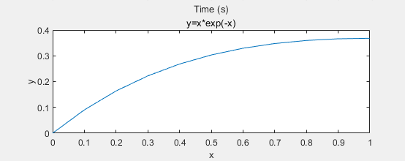

Figure 1: The output of the function

* 1. The code：
     1. Setting basic parameters

% 设置比特流

bitStream = [1 0 1 1 0 1 0 0 1 1];

% 设置比特速率

bitRate = 1; % 比特每秒

% 每个比特的时间

bitPeriod = 1 / bitRate;

% 采样率（每个比特的采样点数）

samplingRate = 100;

% 生成时间向量

t = 0:1/samplingRate:(length(bitStream)*bitPeriod) - 1/samplingRate;

* + 1. Generate NRZ unipolar non-return to zero code.

% 初始化NRZ单极性编码信号

nrz_unipolar = zeros(1, length(t));

% 生成NRZ单极性编码信号

for i = 1:length(bitStream)

if bitStream(i) == 1

nrz_unipolar((i-1)*samplingRate+1:i*samplingRate) = 1;

else

nrz_unipolar((i-1)*samplingRate+1:i*samplingRate) = 0;

end

end

% 绘制NRZ单极性编码信号

figure;

subplot(2,1,1);

plot(t, nrz_unipolar, 'LineWidth', 2);

title('NRZ Unipolar Encoding');

xlabel('Time (s)');

ylabel('Amplitude');

grid on;

* + 1. Generate NRZ unipolar non-return to zero code.

% 初始化NRZ双极性编码信号

nrz_bipolar = zeros(1, length(t));

% 定义当前电平

currentLevel = 1;

% 生成NRZ双极性编码信号

for i = 1:length(bitStream)

if bitStream(i) == 1

nrz_bipolar((i-1)*samplingRate+1:i*samplingRate) = currentLevel;

% 反转电平

currentLevel = -currentLevel;

else

nrz_bipolar((i-1)*samplingRate+1:i*samplingRate) = 0;

end

end

% 绘制NRZ双极性编码信号

subplot(2,1,2);

plot(t, nrz_bipolar, 'LineWidth', 2);

title('NRZ Bipolar Encoding');

xlabel('Time (s)');

ylabel('Amplitude');

grid on;

* + 1. output

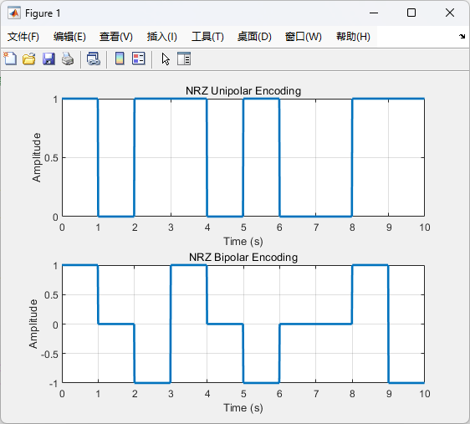

Figure 2：单极性不归零码和双极性不归零码

* 1. 学习使用simulink进行仿真建模
     1. Simulink figure

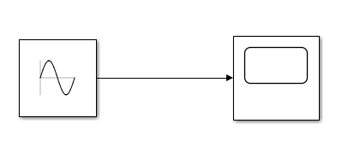

Figure 3: Simulink figure

* + 1. Output

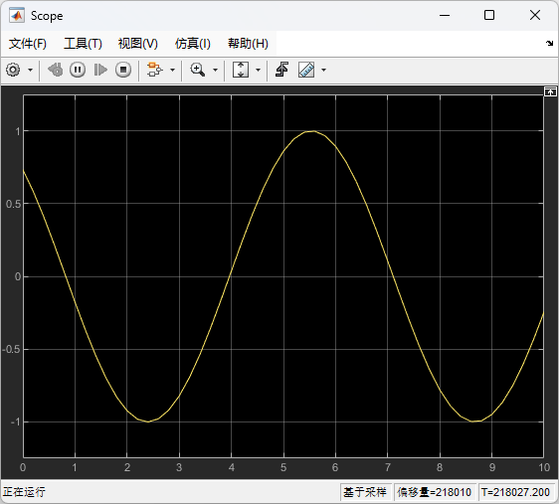

Figure 4: Output of simulink