NUIST Experiment Report

Course name IOT communication Technology

Experiment name Implementing Digital Baseband Signal Encoding with NRZ Experiment in MATLAB

Date 2024/5/22 Tuitor 谈玲

College Waterford Major IOT Grade 2022 Class class 1 Name 黄家睿 Student ID 202283890036

1. Experimental objective
2. Learn to use two MATLAB simulation methods for DSB simulation. Through the experiment to improve the students' practical ability and programming ability, for the future communication work to lay a good foundation.
3. Experimental equipment
4. MatLab software
5. Experimental procedure (content）

3.1. Set the modulation signal m (t) =cos (2 \* \* fmax\*t),fmax=0.2Hz,

DC component A=1, carrier c (t) =cos (2 \* pi \* fc \* t), fc = 2 Hz, program to draw the modulation signal, carrier and DSB graphics.

3.2. The DSB modulation and demodulation process was simulated using Simulink.

1. Experimental result

4.1.

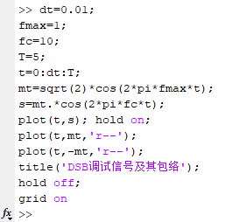

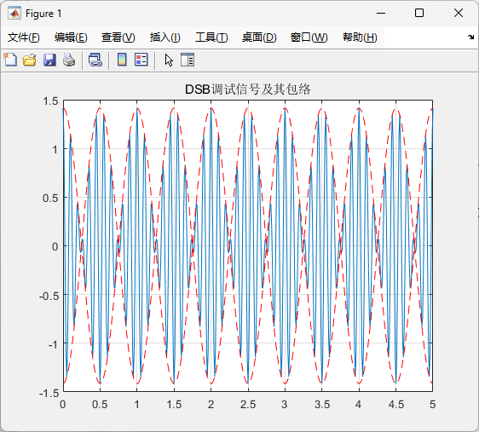

4.2.

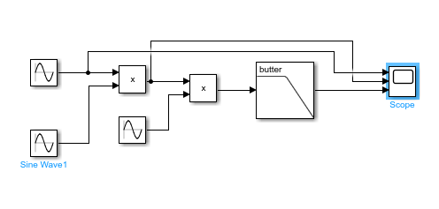

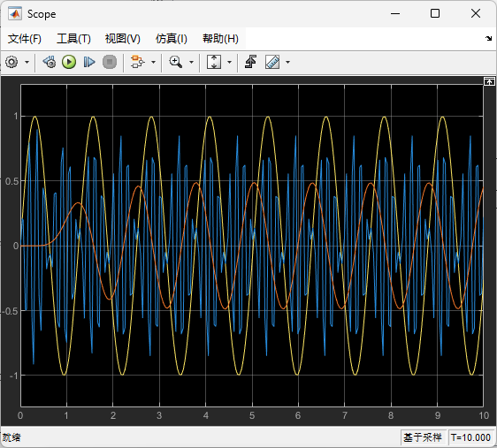

1. Conclusions

In this experiment, we designed and implemented a Butterworth low-pass filter to process sine wave signals of different frequencies. The main objectives were to analyze the behavior of the filter and observe its effect on the input signals.

1. Signal Generation: We generated two sine wave signals with frequencies of 5 rad/sec and 40 rad/sec, respectively. These frequencies were chosen to represent a low-frequency signal and a high-frequency signal relative to our filter's cutoff frequency.
2. Filter Design: A Butterworth low-pass filter was designed with a passband edge frequency of 6 rad/sec. The Butterworth filter was selected for its maximally flat frequency response in the passband, which helps in preserving the amplitude of the lower frequency components of the signal while attenuating the higher frequency components.
3. Filtering Process: The filter was applied to both sine wave signals. As expected, the low-frequency sine wave (5 rad/sec) passed through the filter with minimal attenuation, demonstrating the effectiveness of the Butterworth filter in preserving frequencies below the cutoff frequency. On the other hand, the high-frequency sine wave (40 rad/sec) was significantly attenuated, showcasing the filter's ability to remove high-frequency noise or components from the signal.
4. Results Visualization: The filtered signals were plotted alongside the original signals. The plots clearly illustrated that the low-frequency sine wave retained its shape after filtering, while the high-frequency sine wave was considerably attenuated.

In conclusion, the Butterworth low-pass filter effectively attenuates high-frequency components while preserving the low-frequency components of a signal. This experiment demonstrates the practical application of such filters in signal processing, where the goal is often to remove unwanted high-frequency noise while maintaining the integrity of the desired signal. The use of MATLAB for signal generation, filtering, and visualization provided a comprehensive understanding of the filter's behavior and performance.