NUIST Experiment Report

Course name: IoT Commnunication Technology

Experiment name: HDB3 encoding and decoding process

Date: 2024.6.5 Tuitor: Ling Tan

College: Waterford Major: IoT Grade:2022

Class: 1 Name:Jiarui Huang Student ID: 202283890036

1. Experimental objective

1. Familiar with the working process of HDB3 encoding and decoding.

2. Observe the measuring point waveform of the HDB3 code conversion encoding and decoding circuit

1. Experimental equipment

Oscilloscope, communication principle experiment box

1. Experimental procedure (content）

1. HDB3 code transformation coding observation experiment

2. HDB3 code transformation decoding observation experiment

1. Experimental result

4.1 10101010’s encoding and decoding

4.1.1 sender cell waveform at TPD07

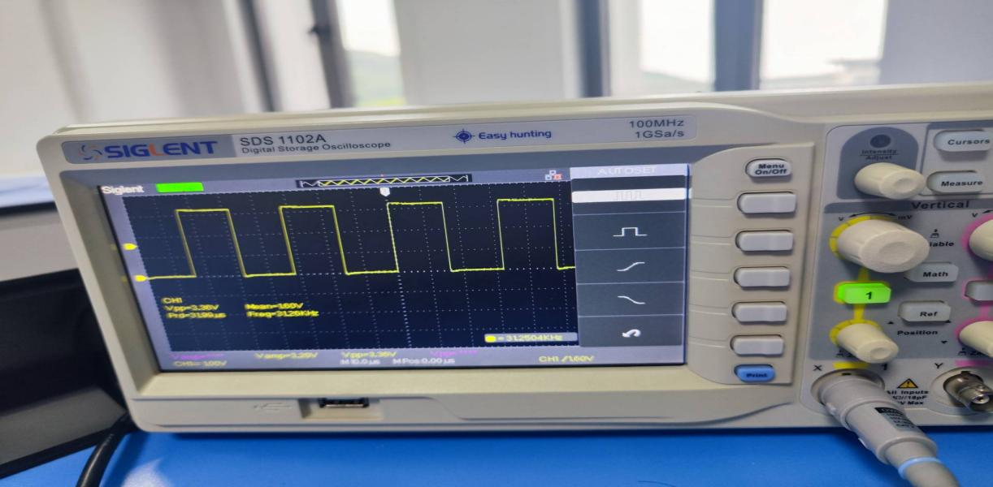

4.1.2 clock signal at TPD13

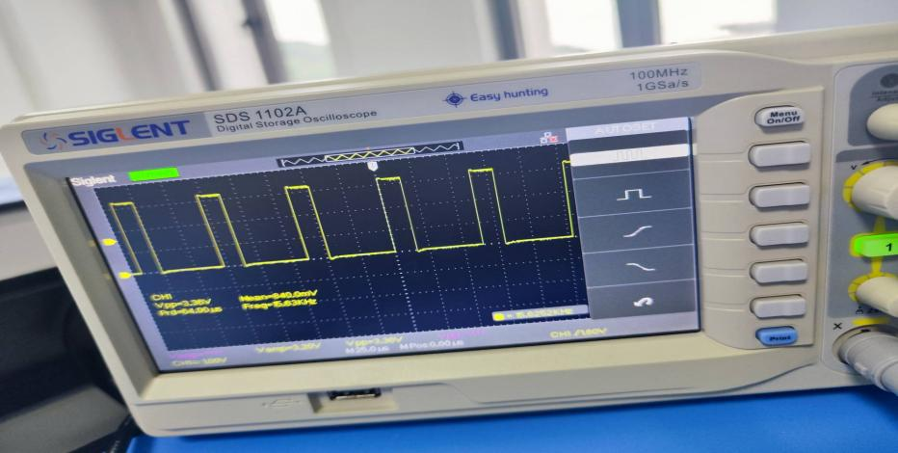

4.1.3 Display of light emitting tube from DD01 to DD08

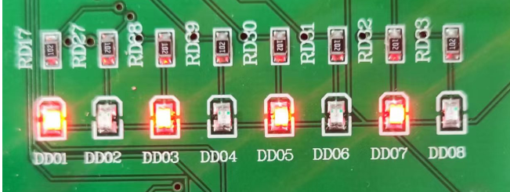

4.1.4 HDB3 encoded waveform at TPD02

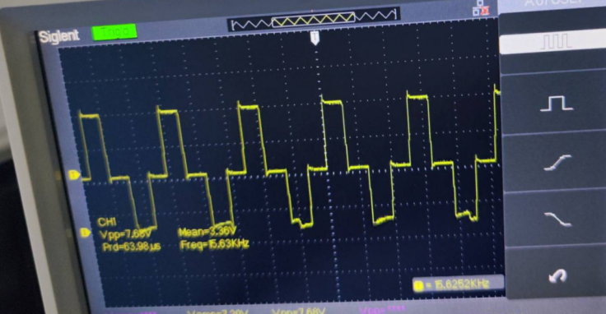

4.1.5 HDB3 decoder at TPD09

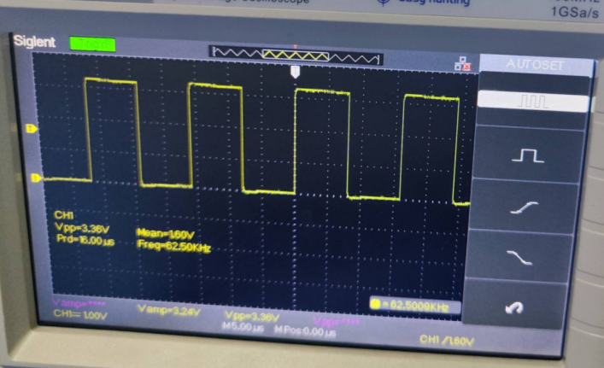

4.2 10000101’s encoding and decoding

4.2.1 HDB3 encoded waveform at TPD02

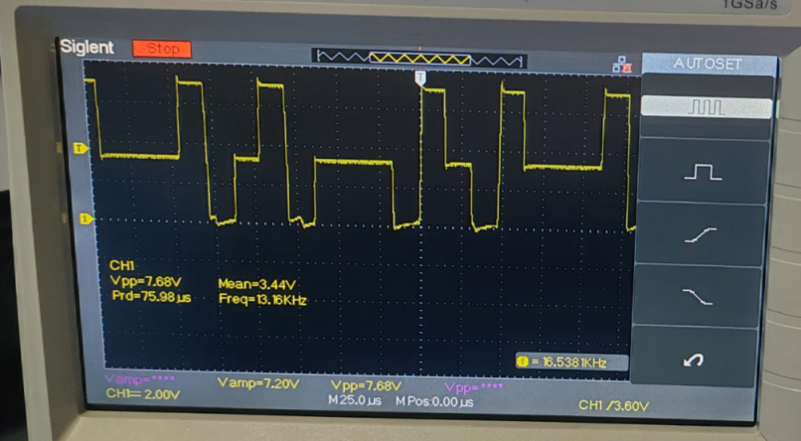

4.2.2 HDB3 decoder at TPD09

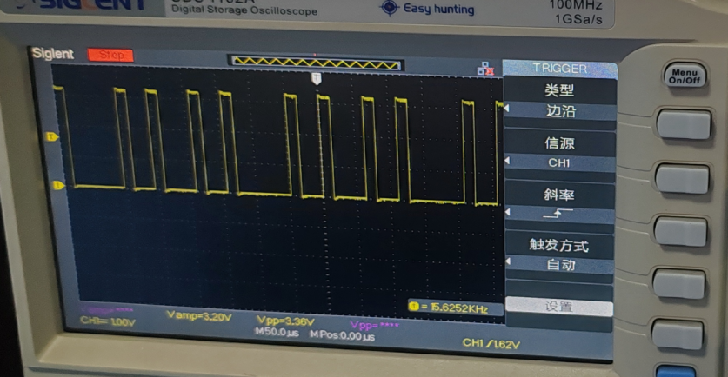

1. Conclusions

I am familiar with the process of HDB3 code transformation encoding and decoding, and have successfully completed the experiment by hands-on operation in the laboratory.