**Lab 1 Exercises**

|  |  |  |
| --- | --- | --- |
| Huang Jiarui | W20109685 | Internet of things |

**Quiz - 1**

1. **What is now often the most important requirement for software systems ?**

Rapid software development and delivery.

1. **What process steps are inter-leaved?**

Specification, design and implementation

1. **How are stakeholders involved in the process?**

Through continuous evaluation of system iterations.

1. **What tools are used to develop User interfaces?**

IDEs and graphical toolsets.

1. **What did dissatisfaction with the overheads involved in software design methods of the 1980s and 1990s lead to the creation of?**

Agile methods

1. **List the 2 key aims of *Agile* methods.**

Deliver working software methods.

Adapt to changing requirements through iterative refinement.

**Quiz - 2**

**Identify which Agile Principles the follow definitions refer to?**

1. **The skills of the development team should be recognized and exploited. Team member should be left to develop their own ways of working without prescriptive processes.**

People Not Process

1. **The software is developed in increments with the customer specifying the requirements to be included in each increments.**

Incremental Delivery

1. **Focus on simplicity in both the software being developed and in the development process. Wherever possible, actively work to eliminate complexity from the system.**

Maintain Simplicity

1. **Expect the system requirements to change and so design the system to accommodate these changes.**

Embrace Change

**Quiz -3**

1. **Agile methods may be used for product development where a software company is developing a small or medium-sized product for sale.**

True

1. **Custom system development within an organization, where there is NO clear commitment from the customer to become involved in the development process.**

False

1. **There are NO problems in scaling agile methods to large systems.**

False

**Quiz - 4**

Most organizations spend more on maintaining existing software than they do on new sodtware development. So, if agile methods are to be successful, thay have to support maintenance as well as original development

1. **Explain what the Two key issues are in this process:**

Minimizing documentation conflicts with maintenance needs.

Ensuring team stability for long-term support.

1. **Why is it a problem if teams cannot be consistently maintained?**

Inconsistent teams risk knowledge loss and reduced collaboration.

**Quiz - 5**

1. **Explain the essential difference between Plan-driven and Agile development.**

Plan-driven: Phased planning with upfront design

Agile: Iterative, adaptive with interleaved activities.

1. **Do ALL projects include elements of plan-driven and agile processes? Give 2 reasons for your answer**

Detailed design required for complex systems.

Need for rapid feedback in incremental deliveries.

1. **Which type of development is best suited to small team sizes?**

Small, co-located teams.

1. **Which system is preferred when rapid feedback from the client is required?**

Agile development

**Quiz - 6**

1. **What is the best-known and most widely used agile method?**

Extreme programming (XP)

1. **What are the commonly accepted 6 cycle steps of this method? Draw a diagram to explain your answer.**

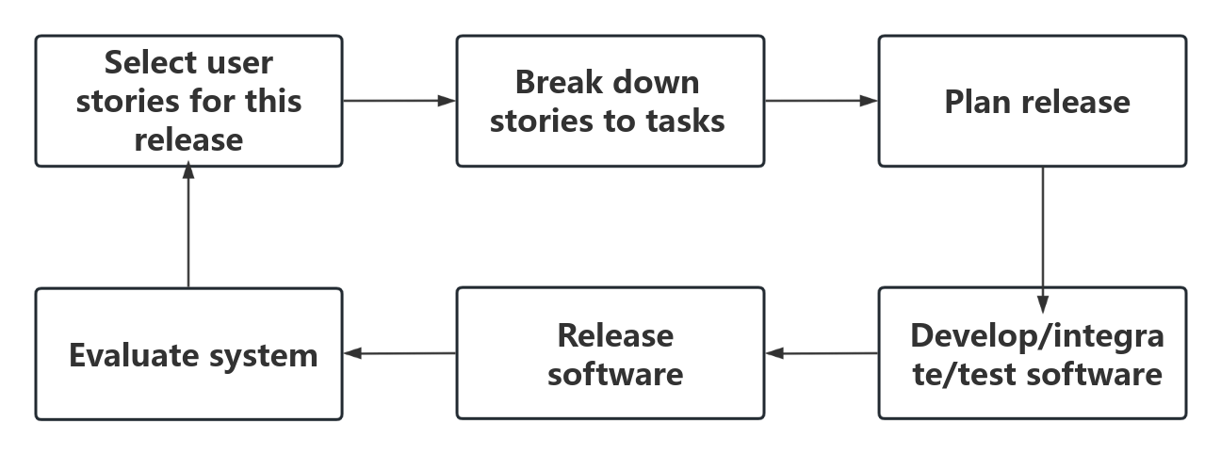

**Quiz - 7**

1. **Explain what is meant by the following XP practices**
   1. **Refactoring :** Improves code structure without altering external behavior.
   2. **Collective Ownership :** All developers share responsibility for code.
2. **How dose the XP approach impact the requirements for Change and Maintaining simplicity?**

Change: Supported through regular system releases.

Maintain simplicity: through constant refactoring of code.

**User stories 1**

**Create a user story for a system to allow Registered Users on a Website to get product updates from the website.**

**As a** registered user

**I want to** get product updates from the website.

**So i can** stay informed about new features

**User stories 2**

Create a User story for a system to allow a System Administrator to prevent unauthorized logins from past employees.

**As a** System administrator.

**I want to** prevent unauthorized logins from past employees.

**So i can** ensure the system security of the company.