**Lab #4: Git Exercises**

|  |  |  |
| --- | --- | --- |
| Jiarui Huang | w20109685 | Internet of Thing |

**Exercise 1: Check git log command output in that directory**

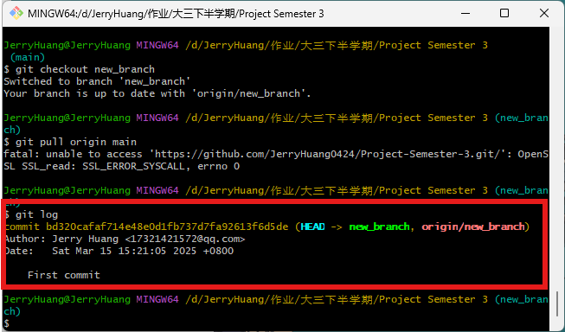

**Exercise 2: Create a new branch named “Lab4”. And make sure to checkout the branch.**

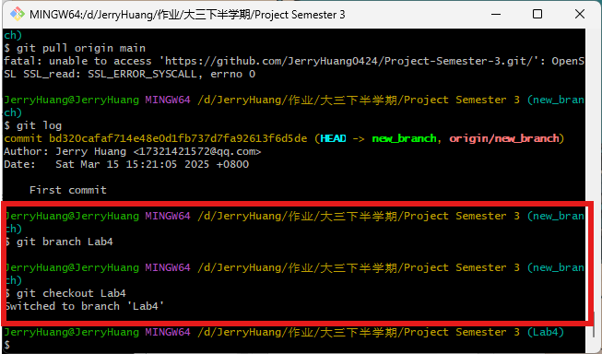

**Exercise 3: Using echo command, create 4 files**

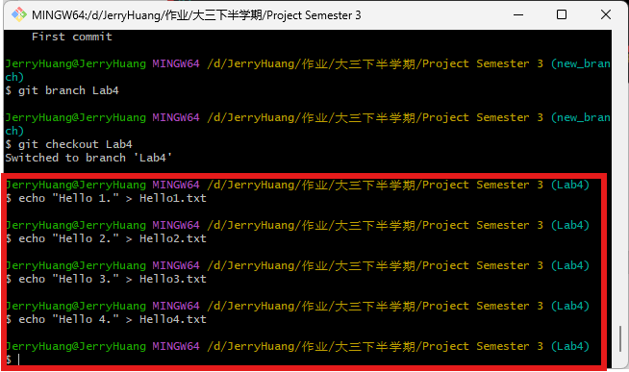

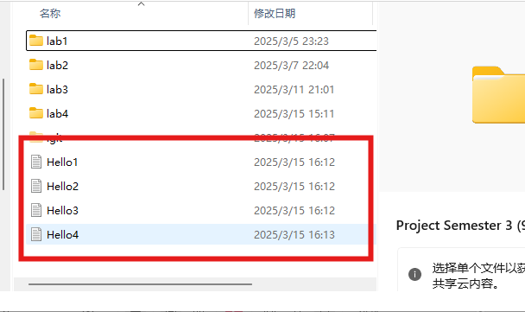

**Exercise 5: Add and commit all files to the repository. Check the log after the commit.**

The other folders is used to store the previous lab document, they are not the contents of this lab, so I won`t add and commit all files, only add and commit the HolleX.txt created in this lab.

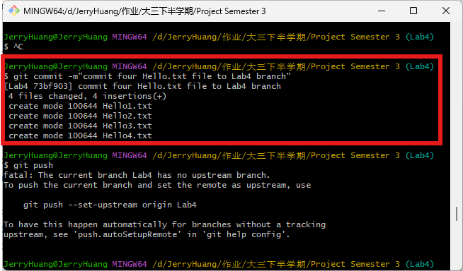

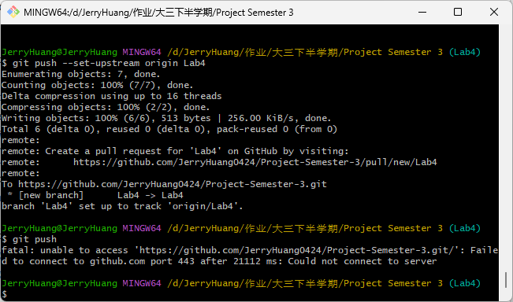

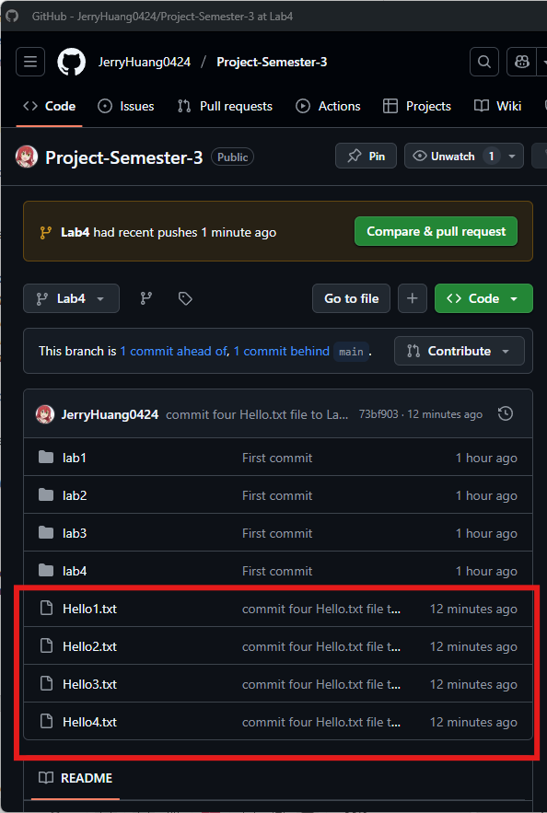

**Exercise 6: Create the following text file “LionAndMouse.txt” using the Nano editor.**

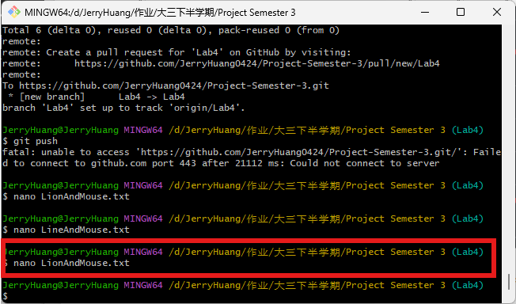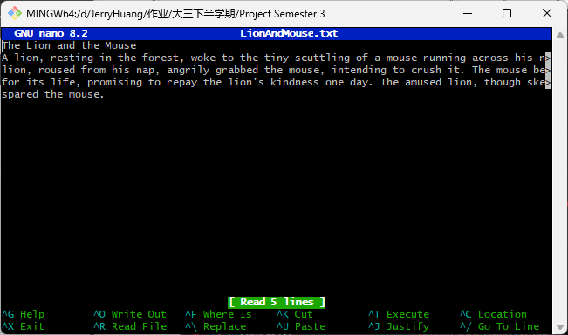

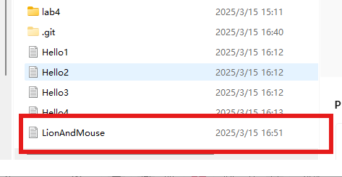

**Exercise 7: Add and commit this file to the Repository**

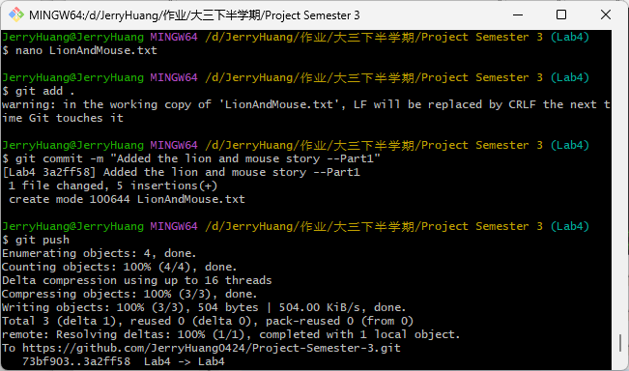

**Exercise 8: Check git log command output.**

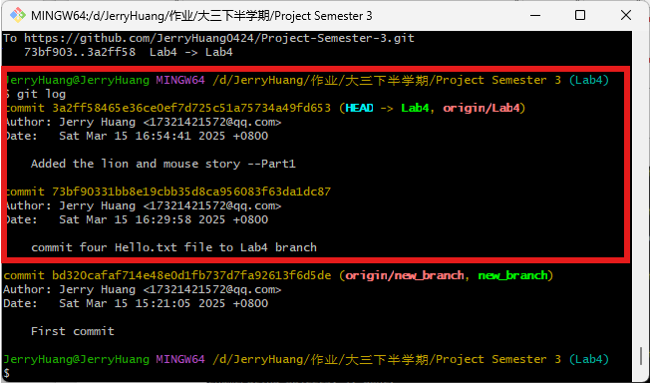

**Exercise 9: Add the following text to the file “LionAndMouse.txt”. Then add and commit the file to the Repository**

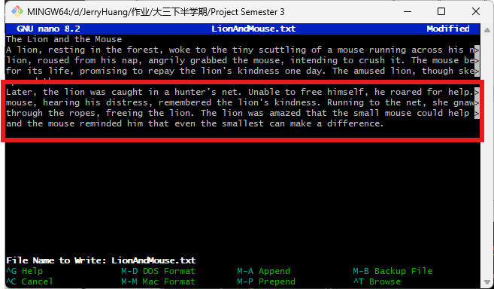

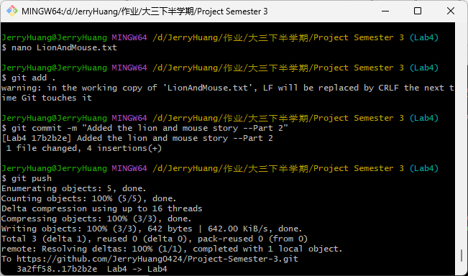

**Exercise 10: Check git log command output**

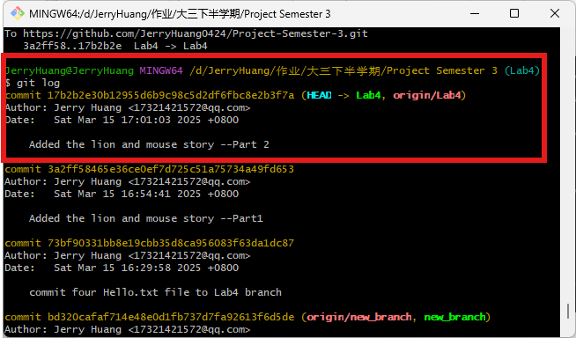

**Exercise 11: Rename Hello1.txt to Hello1A.txt**

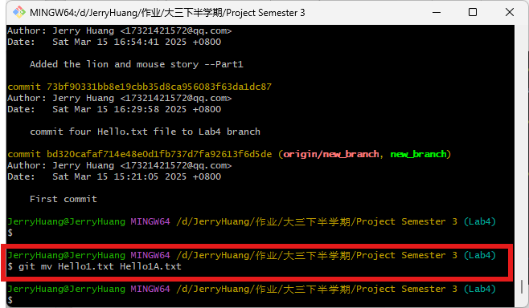

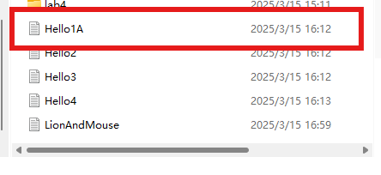

**Exercise 12 Add one extra line to each of the .txt files. Add and commit to the repository.**

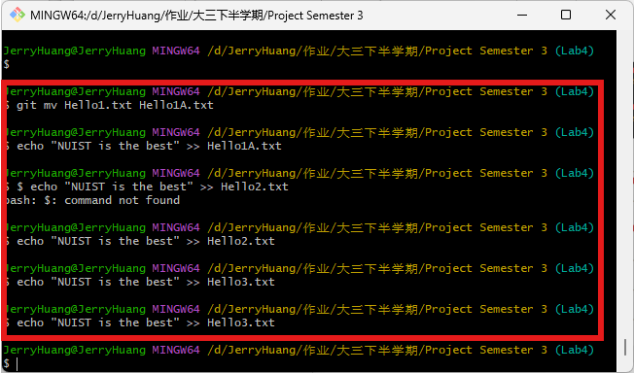

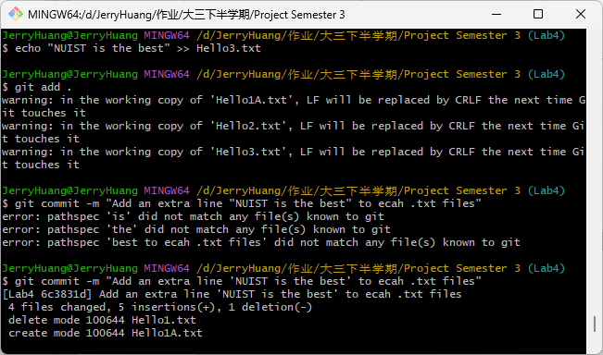

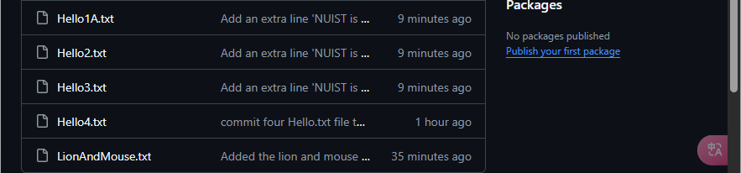

**Exercise 13: Check git log command and redirect (>) the output to a file myCurrentLog.txt**

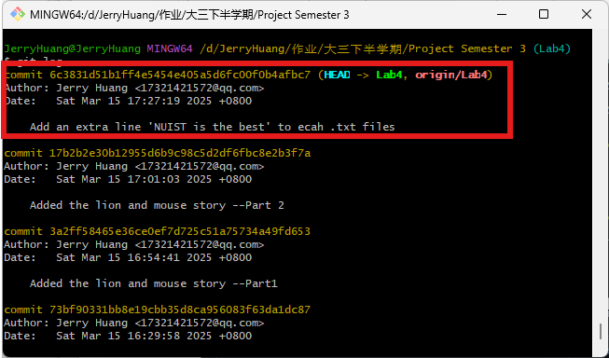

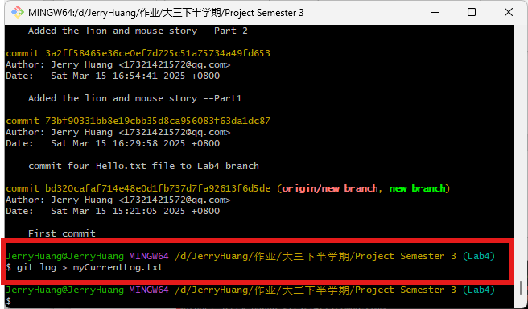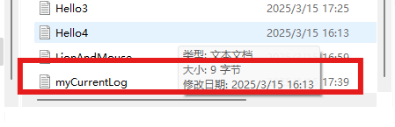

**Exercise 14: List the changed files using the --name-only**

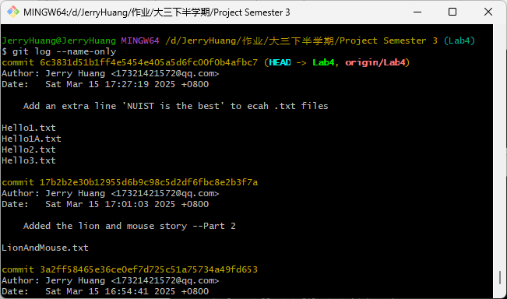

**Exercise 15 : Execute the git log command**

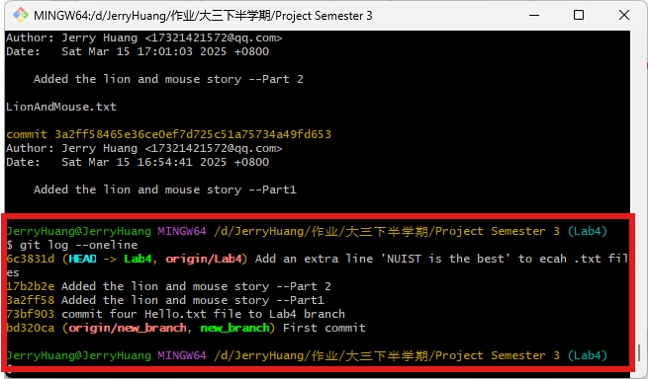

**Exercise 16: Run the git status and git log commands**

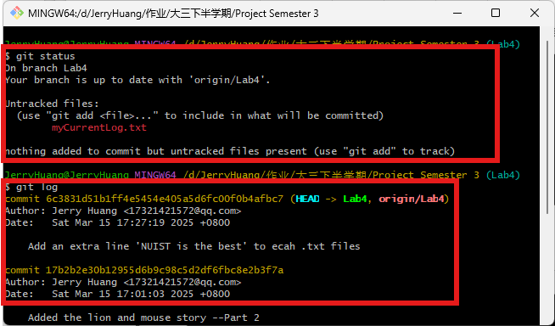

**Exercise 17: List the last few commits**

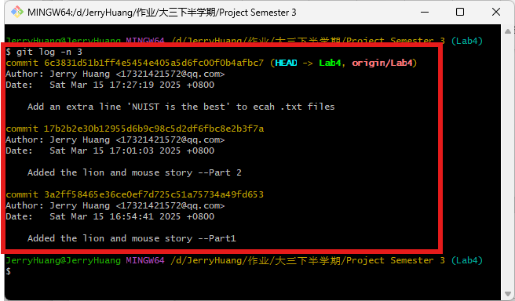

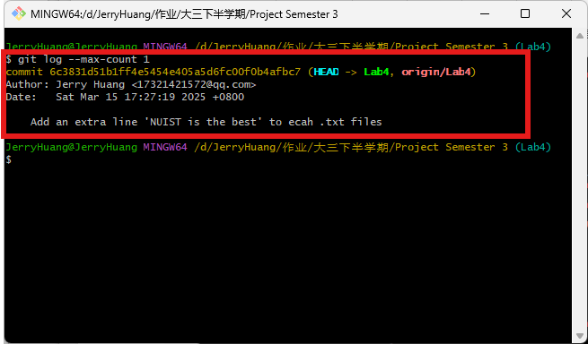

**Exercise 18: Run git log -n 1 command**

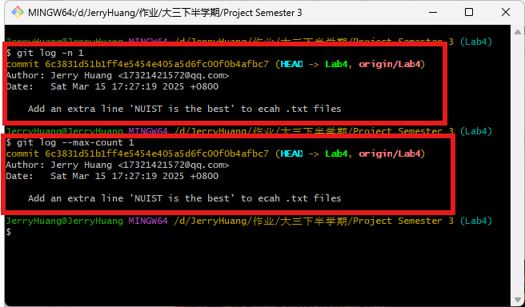

Exercise 19:



**Exercise 20: Merge the Lab4 branch in master branch**

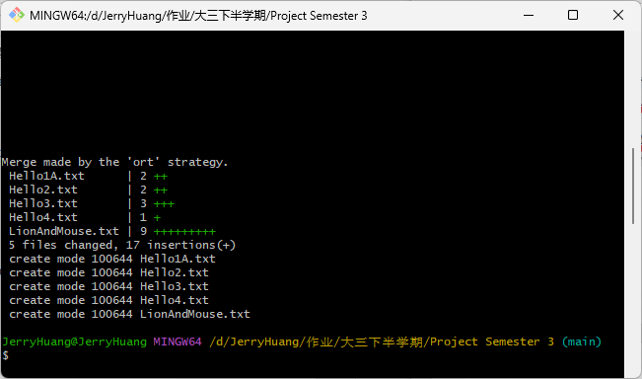

**Exercise 21: Update the Remote Repository and delete branch (from local and remote)**

