Compress-Transfer-Decompress for LLM Serving: cuSZp-Enabled CPU-GPU Data Pipeline in vLLM
KONG Zirui

Abstract — As context windows in Large Language Models (LLMs) expand, the Key-Value (KV) cache consumes massive amounts of memory, creating a severe bottleneck during inference. To prevent Out-Of-Memory errors, serving engines like vLLM swap inactive KV cache blocks to the host CPU. However, the physical PCIe bandwidth introduces a severe transmission latency. This project introduces a ``Compress-Transfer-Decompress'' pipeline integrating cuSZp, a GPU-accelerated lossy compression framework, into vLLM via Monkey-Patching. Operating under an absolute error bound of $1×{10}^{-4}$, the pipeline reduces the data payload by $2.42×$ to $3.06×$. Testing on an NVIDIA RTX 5080 GPU shows the effective Swap-Out bandwidth improved to $1.77×$, and Swap-In to $2.08×$, efficiently bypassing PCIe limitations while preserving generation quality.
Keywords — Large Language Models, KV Cache, GPU Compression, PCIe Bottleneck, vLLM

Introduction
Modern LLMs face a critical memory challenge during autoregressive inference. To manage the massive VRAM requirements of the KV cache, engines like vLLM [1] employ PagedAttention to dynamically offload inactive blocks to the host CPU. However, transmitting uncompressed Gigabyte tensor data across the narrow PCIe bus incurs substantial latency, creating a ``Memory Wall''. This project deploys an error-bounded lossy compression pipeline to drastically shrink the physical data volume before transmission.

design/methodology/implementation
  - C++ Backend Integration: A custom C++ wrapper utilizes PyBind11 to connect the underlying cuSZp [2] CUDA APIs to Python. The system dynamically converts relative error bounds into strict absolute errors ($ϵ_{abs}=ϵ_{rel}×\max\left(R,{10}^{-6}\right)$) to adapt to varying tensor magnitudes.
  - vLLM Monkey-Patching: Without modifying the core engine code, the pipeline uses dynamic Monkey-Patching to intercept vLLM's native $_swap_out_blocks_to_host$ and $_swap_in_blocks_from_host$ routines at runtime.
  - Pipeline Execution: During Swap-Out, KV tensors are natively compressed on the GPU. The output buffer is sliced, and only the minimized byte stream crosses the PCIe bus. Critical reconstruction metadata ($actual_eb$ and shape) is preserved within a host RAM dictionary (Refer to Fig. 1). During Swap-In, the byte stream is asynchronously retrieved and decompressed back into VRAM.
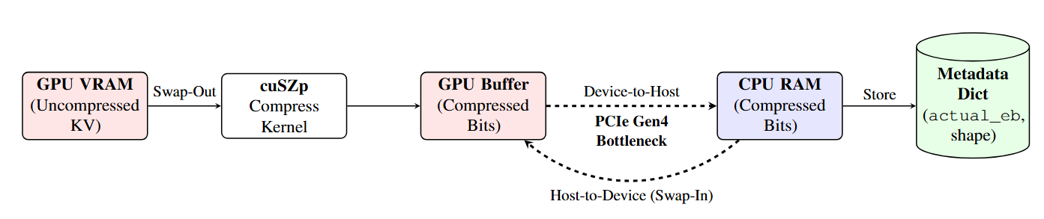
Fig. 1. Architectural flowchart of the Compress-Transfer-Decompress paradigm. Massive uncompressed KV tensors are compressed locally on the GPU, transmitting only the minimized bitstream across the PCIe bottleneck. Critical reconstruction metadata is preserved within the host RAM dictionary.

evalauation and Results
- Experimental Setup: The pipeline was benchmarked on an NVIDIA RTX 5080 GPU using true Layer-0 key embeddings extracted from 8 advanced causal language models.
- Compression Efficiency & Trade-offs: The system achieved compression ratios ranging from $2.42×$ to $3.06×$. An optimal relative error bound of ${10}^{-4}$ was selected. Relaxing this bound to ${10}^{-3}$ yields higher compression but introduces severe absolute errors that get exponentially amplified by transformer Softmax operations, destroying the generative quality.
- Throughput Acceleration: Because the GPU executes compression in under one millisecond, the time saved on PCIe transfer completely swallows the computational overhead. For instance, the Qwen2.5-1.5B model achieved a $2.08×$ Swap-In speedup, doubling the perceived interconnect throughput from 16.32 GB/s to 33.86 GB/s. Other evaluated models achieved consistent speedups of over $1.44×$.

conclusion
This project confirms that error-bounded lossy compression is a highly practical memory optimization for modern LLM serving. By achieving up to $2.08×$ effective bandwidth acceleration, splicing a high-speed software compressor directly into the KV cache lifecycle offers a direct workaround for the hardware memory wall without requiring massive physical hardware scaling.

References
- W. Kwon, Z. Li, S. Zhuang, Y. Sheng, L. Zheng, C. H. Yu, J. E. Gonzalez, H. Zhang, and I. Stoica, “Efficient memory management for large language model serving with pagedatten tion,” in Proceedings of the ACM SIGOPS 29th Symposium on Operating Systems Principles, 2023.
- Y. Huang, S. Di, X. Yu, G. Li, and F. Cappello, “cuszp: An ultra-fast gpu error-bounded lossy compression framework with optimized end-to-end performance,” in Proceedings of the International Conference for High Performance Computing, Networking, Storage and Analysis, 2023, pp. 1–13.

