Reflection on Assignment 2

Assignment 2 was quite intense for me to finish. There are many things I learned during the implementation of the project. For example, convert infix to postfix and postfix to infix. The part that I learned in the hard way to the logic error. After I followed the algorithm and wrote my code, exceptions occur not as expected. I realized that I was throwing Stack or Queue Underflow exception constantly instead of throwing the invalidNotationFormat exception. As I debug the program, I realized that when I pop() the element from stack, the logic in my program ignores the invalidnotationFormat exception, which was why it keeps catching underflow exceptions.

The part I found most challenging was the queue structure. When I tried to create the third constructor in the NotationQueue class, I learned that I did not know what queue is. Even though I got the queue running, I did not think about or have an imagery of what is happening in the array. That is fatal when doing a project like this. Since I am a slow learner, I had to review what queue is over and over. As a result, I resolved the issue I had at the beginning.

I decided to not get to excited—that is, suppress the urgent of implementing the code in the first place. I should try out examples before working on the project. I know my study habit in computer science is not good. I am going to move slowly next time.

Test output:

NotationQueue Test:

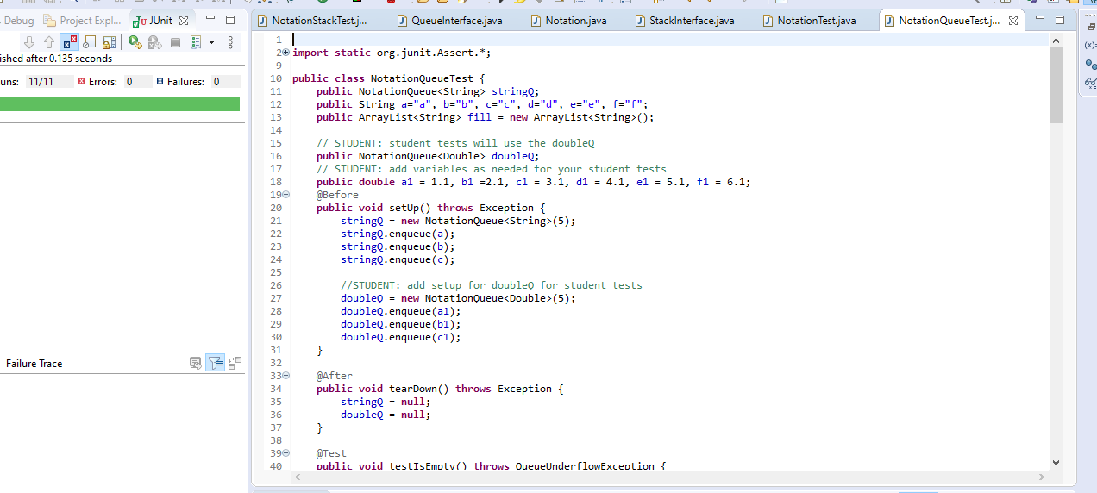

NotationStack Test:

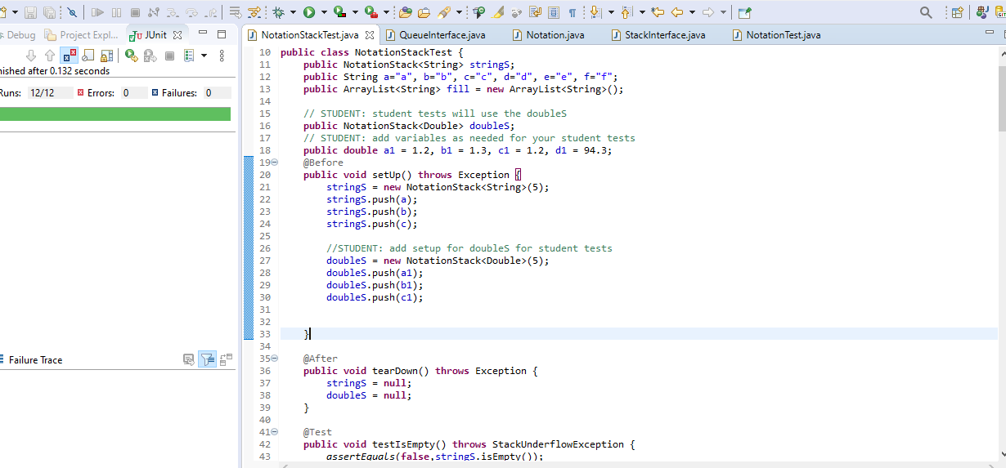

Notation Test:

