|  |  |  |  |  |  |  |  |
| --- | --- | --- | --- | --- | --- | --- | --- |
| ID | H(s0) | Thresholds | Moves | Generated nodes | Expanded  nodes | Expanded  Nodes per second | Total time |
| 1 | 41 | 43 45 47 49 51 53 55 57 59 | 59 | 738,938,399 | 367,182,860 | 1,993,197 | 19.53 |
| 2 | 43 | 45 47 49 51 53 55 | 55 | 18,983,862 | 9,206,051 | 6,975,343 | 1.32 |
| 3 | 41 | 43 45 47 49 51 53 55 57 59 | 59 | 140,704,815 | 69,688,311 | 7,167,719 | 9.72 |
| 4 | 42 | 44 46 48 50 52 54 56 | 56 | 82,631,583 | 40,942,529 | 2,163,867 | 18.92 |
| 14 | 41 | 43 45 47 49 51 53 55 57 59 | 59 | 937,956,626 | 462,846,695 | 2,169,495 | 213.34 |

Optimizations：

For every ida avoid it go back at next step.

I used Linear Conflict Heuristic and Corner-Tiles Heuristic in this program Linear Conflict Heuristic to check whether there is more than 2 ‘correct row’ or ‘correct column’ value and add sum 2 times number of pairs of those value(2 -> sum+=2 3-> sum+=4 4->sum+=6). Corner-Tiles Heuristic used to determine if there is incorrect corner with correct tile next to it（every time sum+=2）.

However those Heuristic contain many for loop it increase program run time and potential errors, so i choose to quote those lines.(since i did not experiments many times due to time consuming with those Heuristic method so i not sure whether there is error)

One easy example Run example with N = 2;

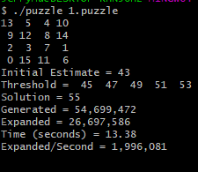

N = 1 example

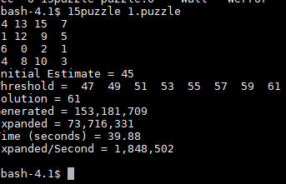

Run time increase times but nodes number decreased a lot.