作业一

1，在进行数值计算的时候我们常听到Rounding Error, Underflow, Overflow这些概念。我们在优化模型的时候也常会需要计算 $log(sum(exp(a_{i:n})))$ 这样形式的式子。如果直接计算，向量a里面有大的数值时，exp会overflows (Inf); 向量a里面的数字都是很小的负数时，log会underflow (-Inf);为了克服这些数值计算的问题，请提出一个通用的解决办法，描述思路和数学式子，并证明该计算方法可以得到**精确的结果**；用Python实现该函数，并提供一些运行例子（数学算法推导请用该word提交；函数代码、运行例子和计算结果请放在python notebook随word一并提交）。

**对应markdown和latex源码在jupyter nootbook中，此处就以图片的形式展示啦。函数代码、实例、结果在notebook中**

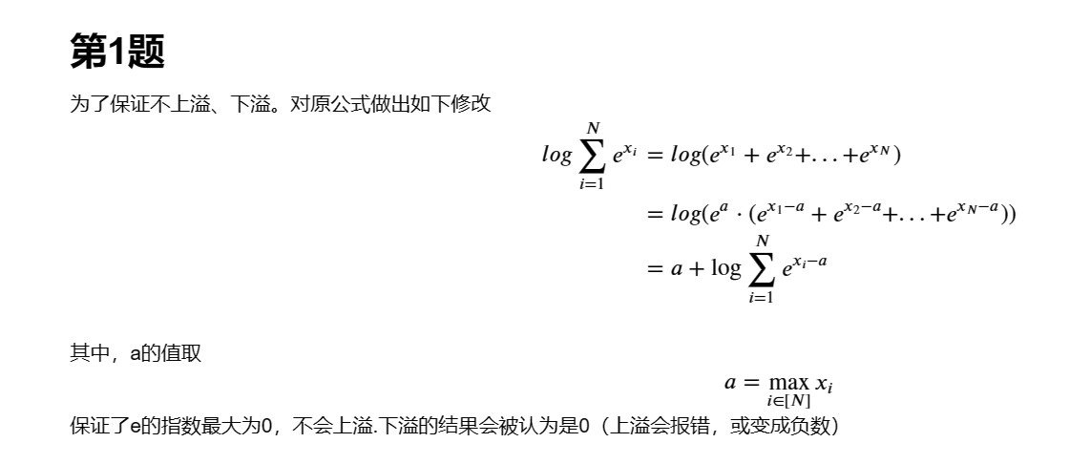

2. 假设你构建了一个CNN模型，里面主要用到CONV和POOL操作，具体的操作注释如下：

• CONV-K-N 表示CONV layer含N个K×K 的filters，Padding 0, Stride 1

• POOL-K 表示 K × K pooling layer, Stride K, Padding 0

• FC-N 表示有N neurons 的fully-connected layer

1. 请计算下面模型每个layer的输出维度，参数数目，和bias的数目

|  |  |  |  |
| --- | --- | --- | --- |
| Layer | Output dimensions | Number of weights | Number of biases |
| INPUT | 128×128×3 (3是channel） | 0 | 0 |
| CONV-9-32 | 120×120×32 | 3×9×9×32 | 32 |
| POOL-2 | 60×60×32 | 0 | 0 |
| CONV-5-64 | 56×56×64 | 32×5×5×64 | 64 |
| POOL-2 | 28×28×64 | 0 | 0 |
| CONV-5-64 | 24×24×64 | 64×5×5×64 | 64 |
| POOL-2 | 12×12×64 | 0 | 0 |
| FLATTEN | 9216×1 | 0 | 0 |
| FC-3 | 3×1 | 9216×3 | 3 |

1. 请根据上表的网络结构用Pytorch实现(Activation function用ReLU)

**对应源码在jupyter nootbook中，额外给出了一个随机化样本输入，验证了网络结构的正确性。**

3，下面是一段摘自Wikipedia关于Variational autoencoder的描述：

From a formal perspective, given an input dataset *X* characterized by an unknown probability distribution *P(X),* the objective is to model or approximate the data’s true distribution ***P*** using a parametrized distribution $P_{θ}$ having parameters $θ$. Let *Z* be a random vector jointly-distributed with *X*. Conceptually, *Z* will represent a latent encoding of *X*. Marginalizing over *Z* gives

$$P_{θ}\left(X\right)=\int_{Z}{P_{θ}\left(X, Z\right)dZ}$$

, where $P_{θ}(X,Z)$ represents the joint distribution under $θ$ of the observable data $X$ and its latent representation or encoding $Z$. According to the chain rule, the equation can be rewritten as

$$P_{θ}\left(X\right)=\int_{Z}{P_{θ}\left(X, Z\right)dZ=}\int_{Z}{P_{θ}\left(X|Z\right)P_{θ}\left(Z\right)dZ.}$$

In the vanilla variational autoencoder, $Z$ is usually taken to be a finite-dimensional vector of real numbers, and $P_{θ}\left(X|Z\right)$ to be a Gaussian distribution. Then $P_{θ}\left(X\right)$ is a mixture of Gaussian distributions.

It is now possible to define the set of the relationships between the input data and its latent representation as follows:

Prior $P_{θ}(Z)$

Likelihood $P_{θ}\left(X|Z\right)$

Posterior $P_{θ}\left(Z|X\right)$

Unfortunately, the computation of $P_{θ}\left(X\right)$ is expensive and in most cases intractable. To speed up the calculus to make it feasible, it is necessary to introduce a further function to approximate the posterior distribution as

$${Q_{Φ}\left(Z | X\right)≈P}_{θ}\left(Z|X\right)$$

with $Φ$ defined as the set of real values that parametrize $Q$.

In this way, the overall problem can be easily translated into the autoencoder domain, in which the conditional likelihood distribution $P_{θ}\left(X|Z\right)$ is carried by the probabilistic decoder, while the approximated posterior distribution $Q_{Φ}\left(Z | X\right)$ is computed by the probabilistic encoder.

请根据以上描述求解Variational autoencoder 的ELBO loss function（请使用描述中的notation写出具体计算过程）？并解释为什么优化ELBO loss function能够“Maximize Likelihood”？

**对应markdown和latex源码在jupyter nootbook中，此处就以图片的形式展示啦**

