Low-Light Image Enhancement with Multi-stage Residue Quantization and Brightness-aware Attention
Yunlong Liu^{1,*} Tao Huang^{1,*} Weisheng Dong^{1,+} Fangfang Wu¹ Xin Li² Guangming Shi¹
¹School of Artificial Intelligence, Xidian University ²University at Albany

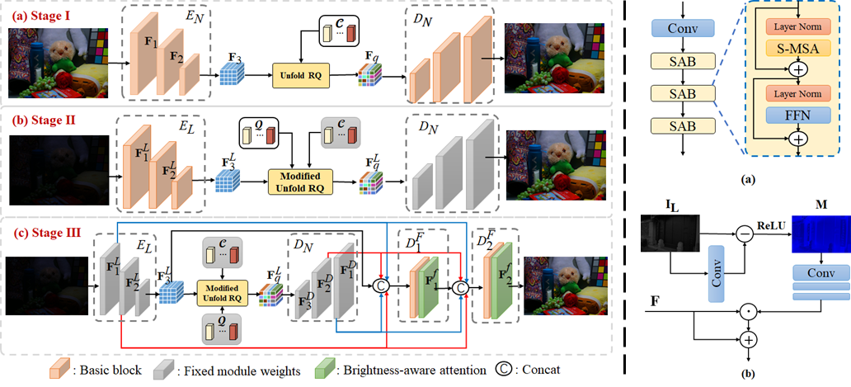
Figure 1. Architecture of the proposed network RQ-LLIE for low-light image enhancement (LLIE). Left: The architecture of the overall network.
Right (a): The structure of the Basic block in the left figure. Right (b): The structure of the Brightness-aware attention in the left figure.

Abstract
Low-light image enhancement (LLIE) aims to recover illumination and improve the visibility of low-light images. Conventional LLIE methods often produce poor results because they neglect the effect of noise interference. Deep learning-based LLIE methods focus on learning a mapping function between low-light images and normal-light images that outperforms conventional LLIE methods. However, most deep learning-based LLIE methods cannot yet fully exploit the guidance of auxiliary priors provided by normal-light images in the training dataset. In this paper, we propose a brightness-aware network with normal-light priors based on brightness-aware attention and residual quantized codebook. To achieve a more natural and realistic enhancement, we design a query module to obtain more reliable normal-light features and fuse them with lowlight features by a fusion branch. In addition, we propose a brightness-aware attention module to further retain the color consistency between the enhanced results and the normal-light images. Extensive experimental results on both real-captured and synthetic data show that our method outperforms existing state-of-the-art methods.

Paper

ICCV 2023

Citation
Liu Y, Huang T, Dong W, et al. Low-Light Image Enhancement with Multi-Stage Residue Quantization and Brightness-Aware Attention[C]//Proceedings of the IEEE/CVF International Conference on Computer Vision. 2023: 12140-12149.
Bibtex
@InProceedings{Liu_2023_ICCV,
author = {Liu, Yunlong and Huang, Tao and Dong, Weisheng and Wu, Fangfang and Li, Xin and Shi, Guangming},
title = {Low-Light Image Enhancement with Multi-Stage Residue Quantization and Brightness-Aware Attention},
booktitle = {Proceedings of the IEEE/CVF International Conference on Computer Vision (ICCV)},
month = {October},
year = {2023},
pages = {12140-12149}
}

Download


Code

Results
Comparison with State-of-the-art Reconstruction Methods:
Table 1. Quantitative comparison on the LOLv1 dataset.

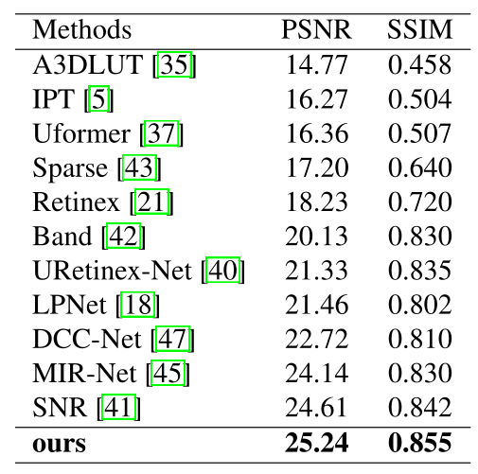
Table 2. Quantitative comparison on the LOLv2-Real and LOLv2-Synthetic dataset.
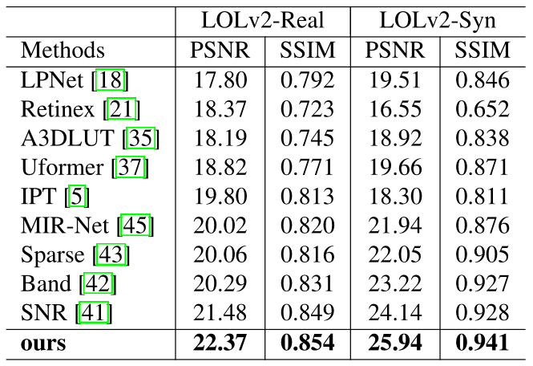

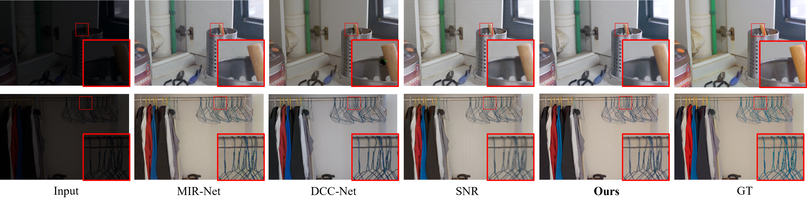
Figure 2. Visual quality comparisons of different low-light image enhancement methods on the LOLv1 dataset.

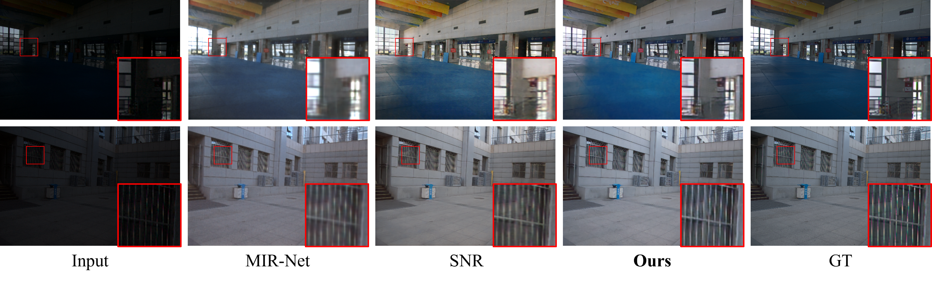
Figure 3. Visual quality comparisons of different low-light image enhancement methods on the LOLv2-Real dataset.

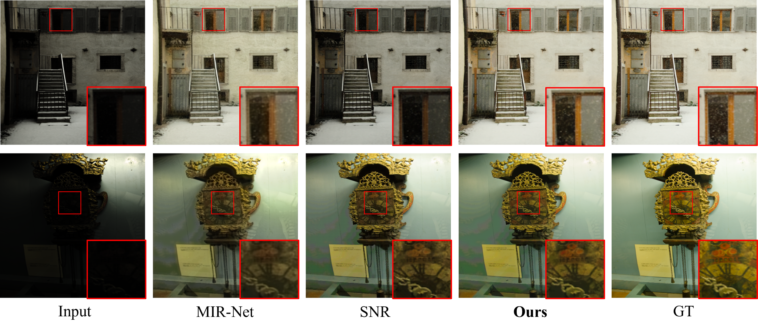
Figure 4. Visual quality comparisons of different low-light image enhancement methods on the LOLv2-Synthetic dataset.

References
[1] Y uanhao Cai, Jing Lin, Xiaowan Hu, Haoqian Wang, Xin Yuan, Y ulun Zhang, Radu Timofte, and Luc V an Gool. Mask-guided spectral-wise transformer for efficient hyperspectral image reconstruction. In Proceedings of the IEEE/CVF Conference on Computer Vision and Pattern Recognition, pages 17502–17511, 2022.
[2] Y uanhao Cai, Jing Lin, Zudi Lin, Haoqian Wang, Yulun Zhang, Hanspeter Pfister, Radu Timofte, and Luc V an Gool. Mst++: Multi-stage spectral-wise transformer for efficient
spectral reconstruction. In Proceedings of the IEEE/CVF Conference on Computer Vision and Pattern Recognition, pages 745–755, 2022.
[3] Kelvin CK Chan, Xintao Wang, Xiangyu Xu, Jinwei Gu, and Chen Change Loy. Glean: Generative latent bank for large-factor image super-resolution. In Proceedings of the IEEE/CVF conference on computer vision and pattern recognition, pages 14245–14254, 2021.
[4] Chaofeng Chen, Xinyu Shi, Yipeng Qin, Xiaoming Li, Xiaoguang Han, Tao Yang, and Shihui Guo. Real-world blind super-resolution via feature matching with implicit high- resolution priors. In Proceedings of the 30th ACM International Conference on Multimedia, pages 1329–1338, 2022.
[5] Hanting Chen, Y unhe Wang, Tianyu Guo, Chang Xu, Yiping Deng, Zhenhua Liu, Siwei Ma, Chunjing Xu, Chao Xu, and Wen Gao. Pre-trained image processing transformer. In Proceedings of the IEEE/CVF Conference on Computer Vision and Pattern Recognition, pages 12299–12310, 2021.
[6] Jiankang Deng, Jia Guo, Niannan Xue, and Stefanos Zafeiriou. Arcface: Additive angular margin loss for deep face recognition. In Proceedings of the IEEE/CVF conference on computer vision and pattern recognition, pages 4690–4699, 2019.
[7] Patrick Esser, Robin Rombach, and Bjorn Ommer. Taming transformers for high-resolution image synthesis. In Proceedings of the IEEE/CVF conference on computer vision and pattern recognition, pages 12873–12883, 2021.
[8] Jun Fu, Jing Liu, Haijie Tian, Y ong Li, Y ongjun Bao, Zhiwei Fang, and Hanqing Lu. Dual attention network for scene segmentation. In Proceedings of the IEEE/CVF conference on computer vision and pattern recognition, pages 3146–3154, 2019.
[9] Xueyang Fu, Delu Zeng, Y ue Huang, Xiao-Ping Zhang, and Xinghao Ding. A weighted variational model for simultaneous reflectance and illumination estimation. In Proceedings of the IEEE conference on computer vision and pattern recognition, pages 2782–2790, 2016.
[10] Jinjin Gu, Y ujun Shen, and Bolei Zhou. Image processing using multi-code gan prior. In Proceedings of the IEEE/CVF conference on computer vision and pattern recognition, pages 3012–3021, 2020.
[11] Y uchao Gu, Xintao Wang, Liangbin Xie, Chao Dong, Gen Li, Ying Shan, and Ming-Ming Cheng. Vqfr: Blind face restoration with vector-quantized dictionary and parallel de-
coder. In Computer Vision–ECCV 2022: 17th European Conference, Tel Aviv, Israel, October 23–27, 2022, Proceedings, Part XVIII, pages 126–143. Springer, 2022.
[12] Shih-Chia Huang, Fan-Chieh Cheng, and Yi-Sheng Chiu. Efficient contrast enhancement using adaptive gamma correction with weighting distribution. IEEE transactions on image processing, 22(3):1032–1041, 2012.
[13] Diederik P Kingma and Jimmy Ba. Adam: A method for stochastic optimization. arXiv preprint arXiv:1412.6980, 2014.
[14] Edwin H Land. The retinex theory of color vision. Scientific american, 237(6):108–129, 1977.
[15] Chulwoo Lee, Chul Lee, and Chang-Su Kim. Contrast enhancement based on layered difference representation of 2d histograms. IEEE transactions on image processing, 22(12):5372–5384, 2013.
[16] Doyup Lee, Chiheon Kim, Saehoon Kim, Minsu Cho, and Wook-Shin Han. Autoregressive image generation using residual quantization. In Proceedings of the IEEE/CVF Conference on Computer Vision and Pattern Recognition, pages 11523–11532, 2022.
[17] Chongyi Li, Jichang Guo, Fatih Porikli, and Yanwei Pang. Lightennet: A convolutional neural network for weakly illuminated image enhancement. Pattern recognition letters, 104:15–22, 2018.
[18] Jiaqian Li, Juncheng Li, Faming Fang, Fang Li, and Guixu Zhang. Luminance-aware pyramid network for low-light image enhancement. IEEE Transactions on Multimedia, 23:3153–3165, 2020.
[19] Mading Li, Jiaying Liu, Wenhan Yang, Xiaoyan Sun, and Zongming Guo. Structure-revealing low-light image enhancement via robust retinex model. IEEE Transactions on Image Processing, 27(6):2828–2841, 2018.
[20] Jingyun Liang, Jiezhang Cao, Guolei Sun, Kai Zhang, Luc Van Gool, and Radu Timofte. Swinir: Image restoration using swin transformer. In Proceedings of the IEEE/CVF international conference on computer vision, pages 1833–1844, 2021.
[21] Risheng Liu, Long Ma, Jiaao Zhang, Xin Fan, and Zhongxuan Luo. Retinex-inspired unrolling with cooperative prior architecture search for low-light image enhancement. In Proceedings of the IEEE/CVF Conference on Computer Vision and Pattern Recognition, pages 10561–10570, 2021.
[22] Sachit Menon, Alexandru Damian, Shijia Hu, Nikhil Ravi, and Cynthia Rudin. Pulse: Self-supervised photo upsampling via latent space exploration of generative models. In Proceedings of the ieee/cvf conference on computer vision and pattern recognition, pages 2437–2445, 2020.
[23] Adam Paszke, Sam Gross, Francisco Massa, Adam Lerer, James Bradbury, Gregory Chanan, Trevor Killeen, Zeming Lin, Natalia Gimelshein, Luca Antiga, et al. Pytorch: An imperative style, high-performance deep learning library. Advances in neural information processing systems, 32, 2019.
[24] Jialun Peng, Dong Liu, Songcen Xu, and Houqiang Li. Generating diverse structure for image inpainting with hierarchical vq-vae. In Proceedings of the IEEE/CVF Conference on Computer Vision and Pattern Recognition, pages 10775–10784, 2021.
[25] Stephen M Pizer. Contrast-limited adaptive histogram equalization: Speed and effectiveness stephen m. pizer, r. eugene johnston, james p. ericksen, bonnie c. yankaskas, keith e.muller medical image display research group. In Proceedings of the first conference on visualization in biomedical computing, Atlanta, Georgia, volume 337, page 1, 1990.
[26] Stephen M Pizer, E Philip Amburn, John D Austin, Robert Cromartie, Ari Geselowitz, Trey Greer, Bart ter Haar Romeny, John B Zimmerman, and Karel Zuiderveld. Adaptive histogram equalization and its variations. Computer vision, graphics, and image processing, 39(3):355–368, 1987.
[27] Shanto Rahman, Md Mostafijur Rahman, Mohammad Abdullah-Al-Wadud, Golam Dastegir Al-Quaderi, and Mohammad Shoyaib. An adaptive gamma correction for image enhancement. EURASIP Journal on Image and Video Processing, 2016(1):1–13, 2016.
[28] Zia-ur Rahman, Daniel J Jobson, and Glenn A Woodell. Retinex processing for automatic image enhancement. Journal of Electronic imaging, 13(1):100–110, 2004.
[29] Joseph Redmon, Santosh Divvala, Ross Girshick, and Ali Farhadi. Y ou only look once: Unified, real-time object detection. In Proceedings of the IEEE conference on computer vision and pattern recognition, pages 779–788, 2016.
[30] Shaoqing Ren, Kaiming He, Ross Girshick, and Jian Sun. Faster r-cnn: Towards real-time object detection with region proposal networks. Advances in neural information processing systems, 28, 2015.
[31] Olaf Ronneberger, Philipp Fischer, and Thomas Brox. Unet: Convolutional networks for biomedical image segmentation. In Medical Image Computing and Computer-Assisted Intervention–MICCAI 2015: 18th International Conference, Munich, Germany, October 5-9, 2015, Proceedings, Part III 18, pages 234–241. Springer, 2015.
[32] Aaron V an Den Oord, Oriol Vinyals, et al. Neural discrete representation learning. Advances in neural information processing systems, 30, 2017.
[33] Ziyu Wan, Bo Zhang, Dongdong Chen, Pan Zhang, Dong Chen, Jing Liao, and Fang Wen. Bringing old photos back to life. In proceedings of the IEEE/CVF conference on computer vision and pattern recognition, pages 2747–2757, 2020.
[34] Ruixing Wang, Qing Zhang, Chi-Wing Fu, Xiaoyong Shen, Wei-Shi Zheng, and Jiaya Jia. Underexposed photo enhancement using deep illumination estimation. In Proceedings of the IEEE/CVF conference on computer vision and pattern recognition, pages 6849–6857, 2019.
[35] Tao Wang, Y ong Li, Jingyang Peng, Yipeng Ma, Xian Wang, Fenglong Song, and Y ouliang Yan. Real-time image enhancer via learnable spatial-aware 3d lookup tables. In Proceedings of the IEEE/CVF International Conference on Computer Vision, pages 2471–2480, 2021.
[36] Zhou Wang, Alan C Bovik, Hamid R Sheikh, and Eero P Simoncelli. Image quality assessment: from error visibility to structural similarity. IEEE transactions on image processing, 13(4):600–612, 2004.
[37] Zhendong Wang, Xiaodong Cun, Jianmin Bao, Wengang Zhou, Jianzhuang Liu, and Houqiang Li. Uformer: A general u-shaped transformer for image restoration. In Proceedings of the IEEE/CVF Conference on Computer Vision and Pattern Recognition, pages 17683–17693, 2022.
[38] Zhouxia Wang, Jiawei Zhang, Runjian Chen, Wenping Wang, and Ping Luo. Restoreformer: High-quality blind face restoration from undegraded key-value pairs. In Proceedings of the IEEE/CVF Conference on Computer Vision and Pattern Recognition, pages 17512–17521, 2022.
[39] Chen Wei, Wenjing Wang, Wenhan Yang, and Jiaying Liu. Deep retinex decomposition for low-light enhancement. arXiv preprint arXiv:1808.04560, 2018.
[40] Wenhui Wu, Jian Weng, Pingping Zhang, Xu Wang, Wenhan Yang, and Jianmin Jiang. Uretinex-net: Retinex-based deep unfolding network for low-light image enhancement. In Proceedings of the IEEE/CVF Conference on Computer Vision and Pattern Recognition, pages 5901–5910, 2022.
[41] Xiaogang Xu, Ruixing Wang, Chi-Wing Fu, and Jiaya Jia. Snr-aware low-light image enhancement. In Proceedings of the IEEE/CVF Conference on Computer Vision and Pattern Recognition, pages 17714–17724, 2022.
[42] Wenhan Yang, Shiqi Wang, Y uming Fang, Y ue Wang, and Jiaying Liu. Band representation-based semi-supervised low-light image enhancement: Bridging the gap between signal fidelity and perceptual quality. IEEE Transactions on Image Processing, 30:3461–3473, 2021.
[43] Wenhan Yang, Wenjing Wang, Haofeng Huang, Shiqi Wang, and Jiaying Liu. Sparse gradient regularized deep retinex network for robust low-light image enhancement. IEEE Transactions on Image Processing, 30:2072–2086, 2021.
[44] Syed Waqas Zamir, Aditya Arora, Salman Khan, Munawar Hayat, Fahad Shahbaz Khan, and Ming-Hsuan Yang. Restormer: Efficient transformer for high-resolution image restoration. In Proceedings of the IEEE/CVF Conference on Computer Vision and Pattern Recognition, pages 5728–5739, 2022.
[45] Syed Waqas Zamir, Aditya Arora, Salman Khan, Munawar Hayat, Fahad Shahbaz Khan, Ming-Hsuan Yang, and Ling Shao. Learning enriched features for real image restoration and enhancement. In Computer Vision–ECCV 2020: 16th European Conference, Glasgow, UK, August 23–28, 2020, Proceedings, Part XXV 16, pages 492–511. Springer, 2020.
[46] Hui Zeng, Jianrui Cai, Lida Li, Zisheng Cao, and Lei Zhang. Learning image-adaptive 3d lookup tables for high performance photo enhancement in real-time. IEEE Transactions
on Pattern Analysis and Machine Intelligence, 44(4):2058–2073, 2020.
[47] Zhao Zhang, Huan Zheng, Richang Hong, Mingliang Xu, Shuicheng Yan, and Meng Wang. Deep color consistent net- work for low-light image enhancement. In Proceedings of
the IEEE/CVF Conference on Computer Vision and Pattern Recognition, pages 1899–1908, 2022.
[48] Shangchen Zhou, Kelvin CK Chan, Chongyi Li, and Chen Change Loy. Towards robust blind face restoration with codebook lookup transformer. arXiv preprint arXiv:2206.11253, 2022.

Contact
Yunlong Liu, Email: liuyunlong@stu.xidian.edu.cn
Tao Huang, Email: thuang_666@stu.xidian.edu.cn
Weisheng Dong, Email: wsdong@mail.xidian.edu.cn
Fangfang Wu, Email: wufangfang@xidian.edu.cn
Xin Li, Email: xli48@albany.edu
Guangming Shi, Email: gmshi xidian@163.com

