Deep Hyperspectral Image Fusion Network with
Iterative Spatio-Spectral Regularization

Tao Huang¹ Weisheng Dong¹* Leida Li¹ Jinjian Wu¹ Xin Li² Guangming Shi¹
¹School of Artificial Intelligence, Xidian University ²West Virginia University

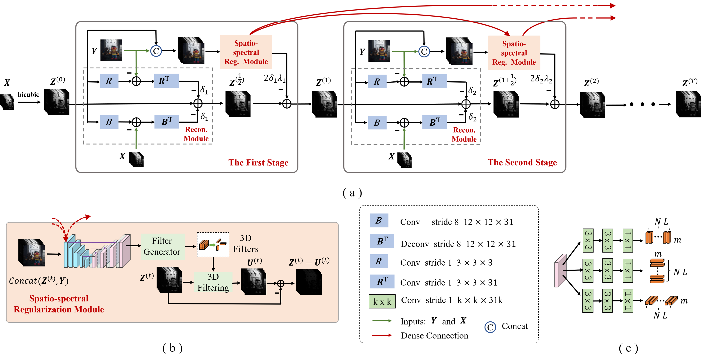
Figure 1. Architecture of the proposed network for hyperspectral image fusion. The architecture of (a) the overall network;
(b) the spatio-spectral regularization module; (c) the 3D filter generator.

Abstract
Physical acquisition of high-resolution hyperspectral images (HR-HSI) has remained difficult, despite its potential of resolving material-related ambiguities in vision applications. Deep hyperspectral image fusion, aiming at reconstructing an HR-HSI from a pair of low-resolution hyperspectral image (LR-HSI) and high-resolution multispectral image (HR-MSI), has become an appealing computational alternative. Existing fusion methods either rely on hand-crafted image priors or treat fusion as a nonlinear mapping problem, ignoring important physical imaging models. In this paper, we propose a novel regularization strategy to fully exploit the spatio-spectral dependency by a spatially adaptive 3D filter. Moreover, the joint exploitation of spatio-spectral regularization and physical imaging models inspires us to formulate deep hyperspectral image fusion as a differentiable optimization problem. We show how to solve this optimization problem by an end-to-end training of a model-guided unfolding network named DHIF-Net. Unlike existing works of simply concatenating spatial with spectral regularization, our approach aims at an end-to-end optimization of iterative spatio-spectral regularization by multistage network implementations. Our extensive experimental results on both synthetic and real datasets have shown that our DHIF-Net outperforms other competing methods in terms of both objective and subjective visual quality.

Paper

TCI 2022

Citation
T. Huang, W. Dong, J. Wu, L. Li, X. Li and G. Shi, "Deep Hyperspectral Image Fusion Network With Iterative Spatio-Spectral Regularization," in IEEE Transactions on Computational Imaging, vol. 8, pp. 201-214, 2022, doi: 10.1109/TCI.2022.3152700.

Bibtex
@ARTICLE{Huang2022Deep,
author={Huang, Tao and Dong, Weisheng and Wu, Jinjian and Li, Leida and Li, Xin and Shi, Guangming},
journal={IEEE Transactions on Computational Imaging},
title={Deep Hyperspectral Image Fusion Network With Iterative Spatio-Spectral Regularization},
year={2022},
volume={8},
number={},
pages={201-214},
doi={10.1109/TCI.2022.3152700}}

Download





Code Dataset (CAVE) Dataset (Harvard) WV2 (real data)

Results
Comparison with State-of-the-art Fusion Methods:
Table 1. The average PSNR, SAM, ERGAS, and SSIM results of the test methods on the CAVE dataset and the Harvard
dataset for Gaussian blur kernel and scaling factors 8/16/32.
Factor | 8
Dataset | CAVE |  |  |  | Harvard
Method | PSNR | SAM | ERGAS | SSIM | PSNR | SAM | ERGAS | SSIM
CSU [1] | 41.23 | 6.58 | 1.15 | 0.982 | 45.41 | 3.88 | 1.39 | 0.984
HySure [2] | 37.04 | 11.19 | 1.85 | 0.960 | 42.02 | 4.67 | 1.79 | 0.977
CSTF [3] | 42.34 | 6.48 | 0.98 | 0.975 | 42.24 | 5.16 | 1.62 | 0.961
NSSR [4] | 44.07 | 4.40 | 0.83 | 0.987 | 46.08 | 3.68 | 1.28 | 0.984
DHSIS [5] | 46.48 | 3.89 | 0.66 | 0.992 | 46.53 | 3.57 | 1.27 | 0.985
MHF-net [6] | 46.46 | 4.37 | 0.67 | 0.992 | 46.89 | 3.61 | 1.27 | 0.985
DBIN [7] | 48.73 | 3.11 | 0.55 | 0.994 | 47.39 | 3.47 | 1.19 | 0.985
DHIF-Net | 49.79 | 3.01 | 0.51 | 0.995 | 47.55 | 3.40 | 1.14 | 0.986
Factor | 16
Dataset | CAVE |  |  |  | Harvard
Method | PSNR | SAM | ERGAS | SSIM | PSNR | SAM | ERGAS | SSIM
CSU [1] | 38.73 | 8.58 | 0.76 | 0.970 | 44.18 | 4.23 | 0.77 | 0.982
HySure [2] | 32.17 | 17.55 | 1.59 | 0.908 | 37.92 | 5.75 | 1.28 | 0.959
CSTF [3] | 40.59 | 7.57 | 0.59 | 0.971 | 42.94 | 5.41 | 0.83 | 0.961
NSSR [4] | 39.62 | 6.46 | 0.68 | 0.979 | 44.44 | 3.98 | 0.79 | 0.982
DHSIS [5] | 39.71 | 6.00 | 0.74 | 0.976 | 45.63 | 3.88 | 0.70 | 0.984
MHF-net [6] | 44.56 | 4.76 | 0.40 | 0.990 | 46.24 | 3.73 | 0.64 | 0.984
DBIN [7] | 44.15 | 4.00 | 0.43 | 0.992 | 46.38 | 3.61 | 0.63 | 0.985
DHIF-Net | 46.46 | 3.66 | 0.34 | 0.993 | 46.61 | 3.60 | 0.60 | 0.985
Factor | 32
Dataset | CAVE |  |  |  | Harvard
Method | PSNR | SAM | ERGAS | SSIM | PSNR | SAM | ERGAS | SSIM
CSU [1] | 36.52 | 9.61 | 0.48 | 0.959 | 42.27 | 4.74 | 0.43 | 0.978
HySure [2] | 26.62 | 23.36 | 1.60 | 0.822 | 35.10 | 8.04 | 0.82 | 0.931
CSTF [3] | 38.99 | 9.08 | 0.34 | 0.968 | 41.72 | 5.39 | 0.43 | 0.962
NSSR [4] | 36.78 | 10.46 | 0.46 | 0.974 | 43.08 | 4.39 | 0.47 | 0.982
DHSIS [5] | 38.36 | 8.45 | 0.45 | 0.963 | 44.44 | 4.29 | 0.38 | 0.983
MHF-net [6] | 42.17 | 6.03 | 0.26 | 0.986 | 45.26 | 4.00 | 0.34 | 0.984
DBIN [7] | 40.72 | 4.86 | 0.33 | 0.989 | 44.91 | 0.94 | 0.34 | 0.984
DHIF-Net | 42.83 | 4.89 | 0.24 | 0.989 | 45.55 | 3.80 | 0.31 | 0.985

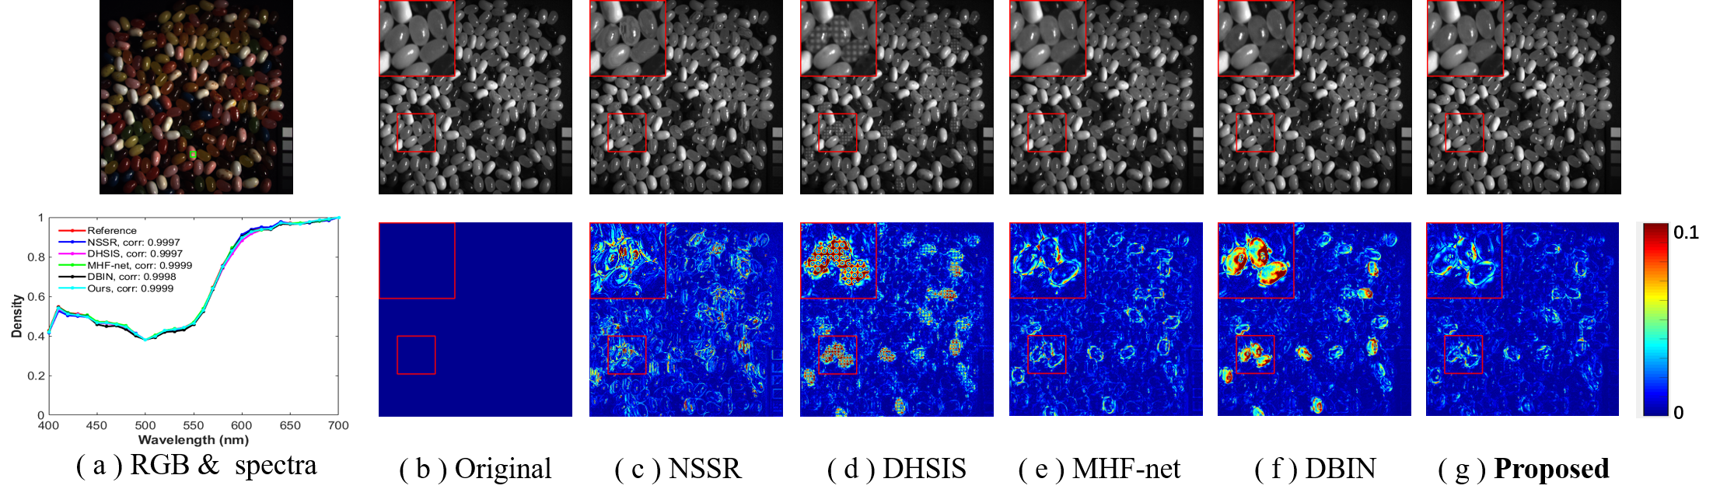
Figure 2. Reconstructed images of jelly beans in CAVE dataset at 700nm with Gaussian blur kernel and scaling factor s = 8. The first row shows the reconstructed images, and the second row shows the error images of the competing methods. (a) the RGB image and the reconstructed spectra of the selected patch (indicated by a green box); (b) the ground truth images ; (c) the NSSR method [24] (PSNR = 39.49 dB, SAM = 4.00, ERGAS = 1.10, SSIM = 0.984) ; (d) the DHSIS method [49] (PSNR= 41.98 dB, SAM = 3.88, ERGAS = 0.79, SSIM = 0.987); (e) the MHF-net method [31] (PSNR = 44.04 dB, SAM = 3.58, ERGAS = 0.64, SSIM = 0.992); (f) the DBIN method [10] (PSNR = 43.76 dB, SAM = 3.00, ERGAS = 0.60, SSIM = 0.993); (g) the proposed DHIF-Net method (PSNR = 46.09 dB, SAM = 2.66, ERGAS = 0.52, SSIM = 0.995).

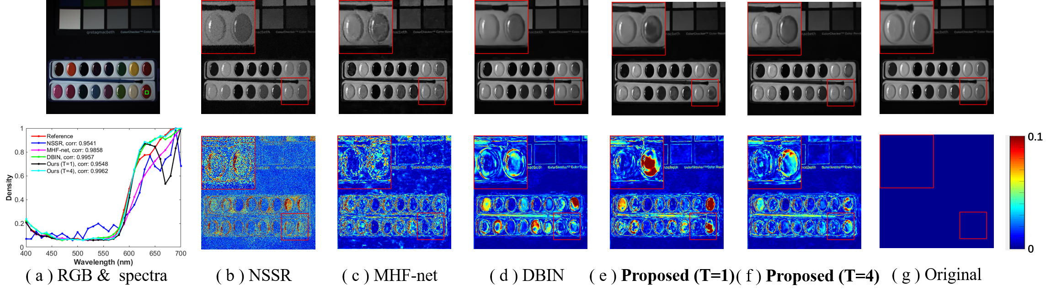
Figure 3. Reconstructed images of paints in CAVE dataset at 670 nm with noise level σ = 30 and scaling factor s = 8. The first row shows the reconstructed images, and the second row shows the error images of the competing methods. (a) the RGB image and the reconstructed spectra of the selected patch (indicated by a green box); (b) the NSSR method [24] (PSNR = 26.49 dB, SAM = 24.58, ERGAS = 3.24, SSIM = 0.613) ; (c) the MHF-net method [31] (PSNR = 30.66 dB, SAM = 10.90, ERGAS = 1.97, SSIM = 0.892); (d) the DBIN method [10] (PSNR = 30.20 dB, SAM = 8.79, ERGAS = 2.10, SSIM = 0.939); (e) the proposed DHIF-Net (T = 1) method (PSNR = 29.87 dB, SAM = 10.17, ERGAS = 2.18, SSIM = 0.930); (f) the proposed DHIF-Net (T = 4) method (PSNR = 31.20 dB, SAM = 8.19, ERGAS = 1.87, SSIM = 0.943); (g) the ground truth images.

References
[1] C. Lanaras, E. Baltsavias, and K. Schindler, “Hyperspectral super-resolution by coupled spectral unmixing,” in Proceedings of the IEEE international conference on computer vision, 2015, pp. 3586–3594.
[2] M. Simoes, J. Bioucas-Dias, L. B. Almeida, and J. Chanussot, “A convex formulation for hyperspectral image superresolution via subspace-based regularization,” IEEE Transactions on Geoscience and Remote Sensing, vol. 53, no. 6, pp. 3373–3388, 2014.
[3] S. Li, R. Dian, L. Fang, and J. M. Bioucas-Dias, “Fusing hyperspectral and multispectral images via coupled sparse tensor factorization,” IEEE Transactions on Image Processing, vol. 27, no. 8, pp. 4118–4130, 2018.
[4] W. Dong, F. Fu, G. Shi, X. Cao, J. Wu, G. Li, and X. Li, “Hyperspectral image super-resolution via non-negative structured sparse representation,” IEEE Transactions on Image Processing, vol. 25, no. 5, pp. 2337–2352, 2016.
[5] R. Dian, S. Li, A. Guo, and L. Fang, “Deep hyperspectral image sharpening,” IEEE transactions on neural networks and learning systems, no. 99, pp. 1–11, 2018.
[6] Q. Xie, M. Zhou, Q. Zhao, D. Meng, W. Zuo, and Z. Xu, “Multispectral and hyperspectral image fusion by ms/hs fusion net,” in Proceedings of the IEEE Conference on Computer Vision and Pattern Recognition, 2019, pp. 1585–1594.
[7] W. Wang, W. Zeng, Y. Huang, X. Ding, and J. Paisley, “Deep blind hyperspectral image fusion,” in Proceedings of the IEEE International Conference on Computer Vision, 2019, pp. 4150–4159.

Contact
Tao Huang, Email: thuang_666@stu.xidian.edu.cn
Weisheng Dong, Email: wsdong@mail.xidian.edu.cn
Leida Li, Email: ldli@xidian.edu.cn
Jinjian Wu, Email: jinjian.wu@mail.xidian.edu.cn
Xin Li, Email: xin.li@ieee.org
Guangming Shi, Email: gmshi@xidian.edu.cn

