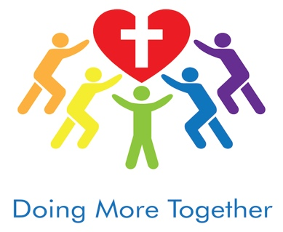

Tax Summary 01/01/2025 - 12/31/2025

«First_Name» «Last_Name»
«Address»
«Address_2»
«City_», «State» «Zip_Code»
Thank you for your generous gift to Loving InDeed and the Help Them Finish project.
Your support changed lives this year—we built a safe home for a mother and her seven children.
We also expanded the scholarship program by launching a business that teaches the young people real work skills and provides income as they pursue a job in their field of education. For sure. It will be a process. Because the business will be profitable and the kids are eager to give back, it will help fund the scholarships—creating a sustainable way to educate and employ many more youth for years to come.
Your partnership is building brighter futures. Thank you—we're deeply grateful to have you with us.
Tax Deductible Total: «Total_Donation_Amt_»
Blessings to you,

Loving InDeed Board

Luke 6:38 (NIV)
Give, and it will be given to you. A good measure, pressed down, shaken together and running over, will be poured into your lap. For with the measure you use, it will be measured to you.

No goods or services were exchanged for the charitable contribution represented in "tax deductible total"
Loving InDeed, Inc. is a 501(c)(3) nonprofit organization. Its EIN is 81-0894768. Donations are tax deductible to extent allowed by law. Reference IRS Publication 526. This is your tax receipt.«First_Name»

